GWF_PublicOutreach_Katie_DeCecco_4July2013

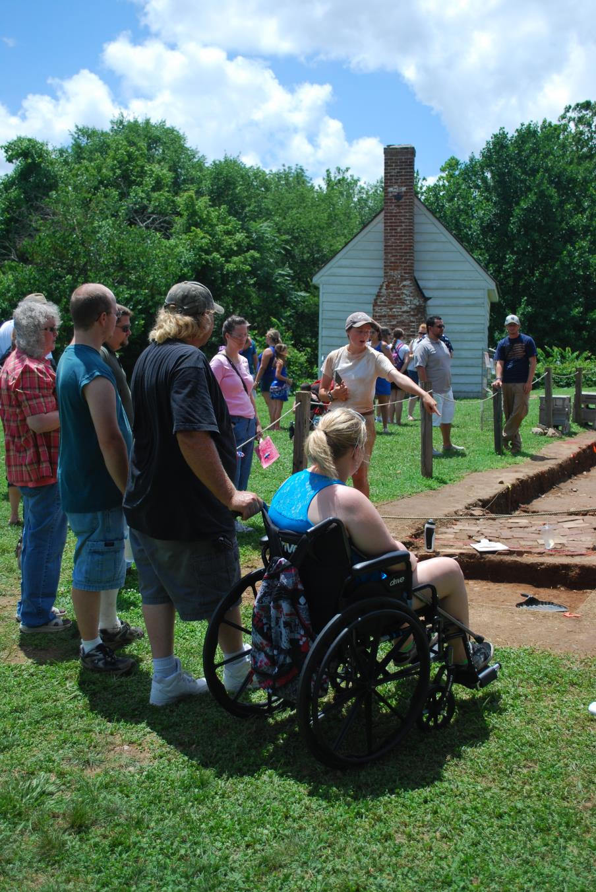

Public Outreach at Washington’s Boyhood Home, July 4, 2013.