EOkul

Main Class

import java.util.List;

import java.util.Scanner;

import javax.swing.JFrame;

import javax.swing.JOptionPane;

public class EOkul extends JFrame{

public static Scanner input = new Scanner(System.in);

public static void main(String[] args) {

while (true) {

String response =JOptionPane.showInputDialog("Console:0, GUI:1");

if(response.equals("0")) {

runConsole();

break;

} else if (response.equals("1")) {

System.out.println("GUI");

break;

}

}

}

public static void myConsoleMessage() {

System.out.println("---------------------------------");

System.out.println("Öğrenci Ekle:1, Öğrenci Listele:2, Ders Ekle:3, Ders Listele:4");

System.out.println("Çıkış:0");

}

public static void runConsole() {

boolean isRunning = true;

while (isRunning) {

myConsoleMessage();

String response = input.next();

switch (response) {

case "1": {

addStudent();

break;

}

case "2":{

listStudent();

break;

}

case "3":{

addLesson();

break;

}

case "4":{

listLesson();

break;

}

case "0":{

isRunning=false;

System.out.println("Uygulama kapanıyor");

System.out.println("---------------------------");

break;

}

default:

throw new IllegalArgumentException("Unexpected value: " + response);

}

}

}

private static void listLesson() {

List<Lesson> lessonData = Lesson.listLesson();

if (lessonData.isEmpty()) {

System.out.println("Hiçbir Ders kayıtlı değil");

} else {

System.out.println("Ders No\tDers Adı");

for (Lesson lesson : lessonData) {

System.out.println("--------------------------------------------------");

System.out.println(lesson.getLessonNo()+"\t"+lesson.getLessonName());

}

System.out.println("--------------------------------------------------");

}

}

private static void addLesson() {

System.out.print("Ders No: ");

String lessonNo = input.next();

System.out.print("Ders Adı: ");

String lessonName = input.next();

boolean response =Lesson.saveLesson(lessonNo, lessonName);

if(response)

System.out.println("Ders başarılı bir şekilde kayıt edildi");

else

System.out.println("Ders kayıt edilirken bir hata oldu");

}

private static void listStudent() {

List<Student> studentData = Student.listStudent();

if (studentData.isEmpty()) {

System.out.println("Hiçbir öğrenci kayıtlı değil");

} else {

System.out.println("Öğrenci No\tÖğrenci Adı");

for (Student student : studentData) {

System.out.println("--------------------------------------------------");

System.out.println(student.getStudentNo()+"\t"+student.getStudentName());

}

System.out.println("--------------------------------------------------");

}

}

private static void addStudent() {

System.out.print("Öğrenci No: ");

String studentNo = input.next();

System.out.print("Öğrenci Adı: ");

String studentName = input.next();

boolean response =Student.saveStudent(studentNo, studentName);

if(response)

System.out.println("Öğrenci başarılı bir şekilde kayıt edildi");

else

System.out.println("Öğrenci kayıt edilirken bir hata oldu");

}

}

**Student Class**

import java.io.BufferedReader;

import java.io.BufferedWriter;

import java.io.File;

import java.io.FileReader;

import java.io.FileWriter;

import java.io.IOException;

import java.util.ArrayList;

import java.util.List;

public class Student {

public Student(String studentNo,String studentName) {

this.studentNo = !studentNo.isEmpty()?studentNo:"";

this.studentName = !studentName.isEmpty()?studentName:"";

}

private String studentNo;

private String studentName;

public static boolean saveStudent(String studentNo,String studentName) {

File file = new File("/Users/ataemir/projects/Java Projects/AdvancedJava/EOkul/src/Student");

try {

FileWriter fileWriter = new FileWriter(file,true);

BufferedWriter bufferWriter = new BufferedWriter(fileWriter);

bufferWriter.append(studentNo+";"+studentName+"\n");

bufferWriter.close();

return true;

} catch (IOException e) {

// TODO Auto-generated catch block

e.printStackTrace();

return false;

}

}

public static List<Student> listStudent(){

File file = new File("/Users/ataemir/projects/Java Projects/AdvancedJava/EOkul/src/Student");

try {

FileReader fileReader = new FileReader(file);

BufferedReader bufferReader = new BufferedReader(fileReader);

ArrayList<Student> studentList = new ArrayList<Student>();

while (bufferReader.ready()) {

String line =bufferReader.readLine();

String[] parts = line.split(";");

studentList.add(new Student(parts[0], parts[1]));

}

return studentList;

} catch (IOException e) {

// TODO Auto-generated catch block

//e.printStackTrace();

}

return null;

}

public String getStudentNo() {

return studentNo;

}

public void setStudentNo(String studentNo) {

this.studentNo = studentNo;

}

public String getStudentName() {

return studentName;

}

public void setStudentName(String studentName) {

this.studentName = studentName;

}

}

**Lesson Class**

import java.io.BufferedReader;

import java.io.BufferedWriter;

import java.io.File;

import java.io.FileReader;

import java.io.FileWriter;

import java.io.IOException;

import java.util.ArrayList;

import java.util.List;

public class Lesson {

public Lesson(String lessonNo,String lessonName) {

this.setLessonNo(!lessonNo.isEmpty()?lessonNo:"");

this.setLessonName(!lessonName.isEmpty()?lessonName:"");

}

private String lessonNo;

private String lessonName;

public static boolean saveLesson(String lessonNo,String lessonName) {

File file = new File("/Users/ataemir/projects/Java Projects/AdvancedJava/EOkul/src/Lesson");

try {

FileWriter fileWriter = new FileWriter(file,true);

BufferedWriter bufferWriter = new BufferedWriter(fileWriter);

bufferWriter.append(lessonNo+";"+lessonName+"\n");

bufferWriter.close();

return true;

} catch (IOException e) {

// TODO Auto-generated catch block

e.printStackTrace();

return false;

}

}

public static List<Lesson> listLesson(){

File file = new File("/Users/ataemir/projects/Java Projects/AdvancedJava/EOkul/src/Lesson");

try {

FileReader fileReader = new FileReader(file);

BufferedReader bufferReader = new BufferedReader(fileReader);

ArrayList<Lesson> lessonList = new ArrayList<Lesson>();

while (bufferReader.ready()) {

String line =bufferReader.readLine();

String[] parts = line.split(";");

lessonList.add(new Lesson(parts[0], parts[1]));

}

return lessonList;

} catch (IOException e) {

// TODO Auto-generated catch block

//e.printStackTrace();

}

return null;

}

public String getLessonName() {

return lessonName;

}

public void setLessonName(String lessonName) {

this.lessonName = lessonName;

}

public String getLessonNo() {

return lessonNo;

}

public void setLessonNo(String lessonNo) {

this.lessonNo = lessonNo;

}

}

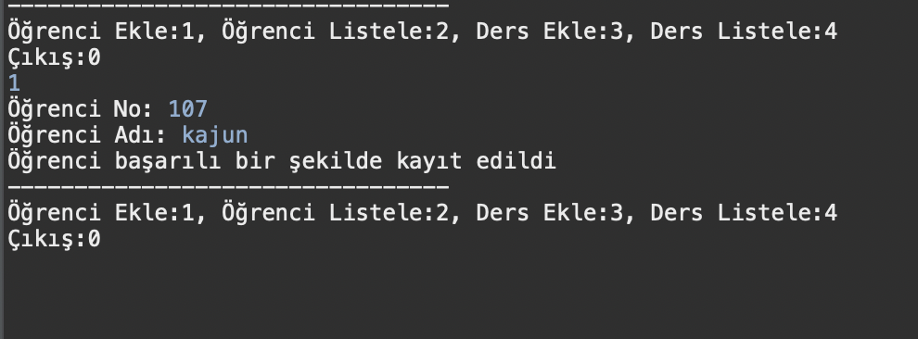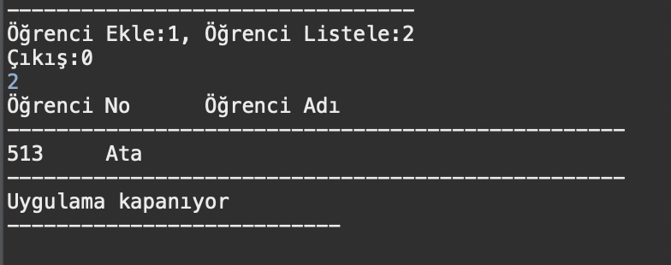

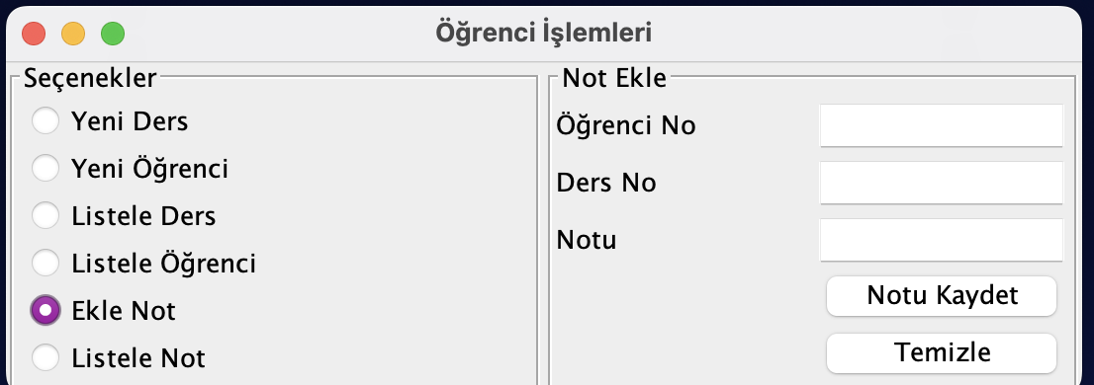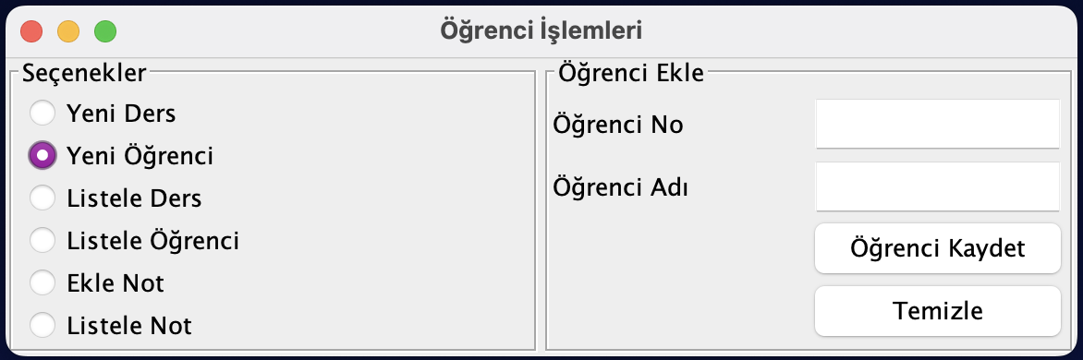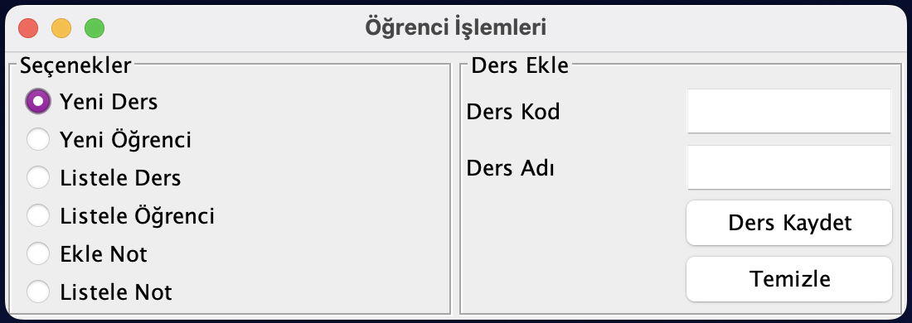

**List kısımlarında biraz problem yaşadım. Bunları ders arası sizinle konuşmak isterdim ama dersimiz iptal olduğu için çözüm bulamadım. Ekleme işlemlerim düzgün çalışıyor ama.**