**Exceptions**

Animal Exceptions

import java.util.Random;

public class AnimalExecptions {

public static void main(String[] args) {

String[] unluHarf = { "a", "e", "ı", "i", "o", "ö", "u", "ü" };

String[] unsuzHarf = { "b", "c", "ç", "d", "f", "g", "ğ", "h", "j", "k", "l", "m", "n", "p", "r", "s", "ş", "t",

"v", "y", "z" };

String[][] Hayvanlar = { { "Köpek", "" }, { "Kedi", "" }, { "Kurbağa", "" } };

boolean myExec = true;

for (int i = 0; i < Hayvanlar.length; i++) {

int uzunluk = createRandomNum(3, 10);

for (int j = 0; j < uzunluk; j++) {

myExec = true;

do {

try {

if (j % 2 == 0) {

Hayvanlar[i][1] += unluHarf[createRandomNum(0,10)];

} else {

Hayvanlar[i][1] += unsuzHarf[createRandomNum(0,22)];

}

myExec = false;

} catch (ArrayIndexOutOfBoundsException e) {

System.out.println(e.getLocalizedMessage());

}

} while (myExec);

}

}

showAnimalList(Hayvanlar);

}

public static int createRandomNum(int startNum,int finishNum) {

Random rnd = new Random();

return rnd.nextInt(startNum,finishNum);

}

public static void showAnimalList(String[][] animalList) {

for (int i = 0; i < animalList.length; i++) {

System.out.println(animalList[i][0] + " " + animalList[i][1]);

}

}

}

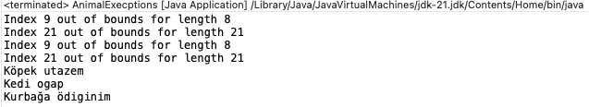

Arithmetic Exceptions

import java.util.Scanner;

public class ArithmeticExecptionsExample1 {

public static void main(String[] args) {

Scanner input = new Scanner(System.in);

Boolean myExec = true;

do {

try {

System.out.print("Please, enter an integer numerator: ");

int a=input.nextInt();

System.out.print("Please, enter an integer numerator: ");

int b=input.nextInt();

System.out.println("Result: "+quantient(a, b));

myExec=false;

} catch (Exception e) {

// Tümünde direk Exception kullanma hata Input hatası ise

// input execptionu kullan. değilse bunu buna dikkat et

// ArithmeticExecption da sayısal hataları yakalar

System.out.println(e.toString());

}

} while(myExec);

System.out.println("I am in row 17");

}

public static int quantient(int numerator,int denominator) {

return numerator/denominator;

}

}

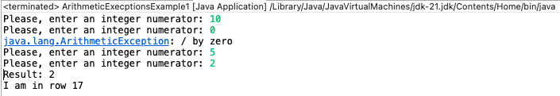

ArrayIndexOutof Exceptions

public class ErrayIndexOutOfExecptionExample1 {

public static void main(String[] args) {

int[] myArray = {5,7,8,9,14};

//for (int value : myArray) {

// System.out.println(value);

//}

try {

System.out.println(myArray[7]);

} catch (ArrayIndexOutOfBoundsException e) {

System.out.println(e.getLocalizedMessage());

} finally {

System.out.println("İleri Java Programlama...");

}

System.out.println("I am in 18 row");

}

}

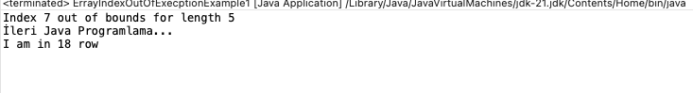

InputMisMatch Exceptions

import java.util.InputMismatchException;

import java.util.Scanner;

public class InputMisMatchExecptionExample1 {

public static void main(String[] args) {

Scanner input = new Scanner(System.in);

Boolean myExec = true;

do {

try {

System.out.print("Birinci sayıyı girin: ");

int a=input.nextInt();

System.out.print("İkinci sayıyı girin: ");

int b=input.nextInt();

System.out.println("Result: "+myPow(a, b));

myExec = false;

} catch (InputMismatchException e) {

System.out.println(e.getMessage());

input.nextLine();

}

} while (myExec);

System.out.println("I am run at now");

input.close();

}

public static double myPow(int number1,int number2) {

return Math.pow(number1, number2);

}

}

