DSP 562 Final Project Report

Title: Clustering Student Pathways to Inform Equitable Interventions

Author: Abi Kambanis

Abstract
This project explores how unsupervised learning can be used to uncover hidden patterns in student success pathways using clustering techniques. By applying KMeans clustering to student performance and demographic data, I identified eight distinct student groups. These clusters reveal disparities in outcomes tied to age, gender, and financial hardship. Key findings include the identification of high-risk groups characterized by debt and older age, and high-performing clusters associated with scholarships and early enrollment. The results suggest that targeted interventions could help improve educational equity and student success.

Introduction
Equity in education has always been a cause I care deeply about, and I recognize that post-secondary institutions often face complex challenges when it comes to supporting all students fairly. Financial barriers, dropout risks, and uneven academic performance are not just isolated issues—they often reflect deeper systemic inequities shaped by students' backgrounds, life experiences, and levels of support.
In this project, I set out to explore whether data science—specifically unsupervised machine learning—can help uncover patterns that illuminate these disparities. Using clustering techniques, I analyzed student demographic and performance data to identify distinct subgroups of learners. My aim was to see if certain clusters of students tend to experience better or worse academic outcomes and to better understand the characteristics associated with those pathways.
The guiding question I sought to answer is:
Can clustering be used to identify distinct student profiles that illuminate disparities in academic success and guide equitable intervention strategies?
By identifying patterns that may otherwise go unnoticed, I hope this work can contribute to a more just and data-informed approach to student support in higher education.

Problem Formulation
In this project, I explore two central research questions:
- Can unsupervised clustering of students reveal distinct academic pathways and risk profiles?
- Are certain demographic or socioeconomic groups disproportionately represented in higher-risk clusters, raising potential equity concerns?
Motivated by current discussions in the literature around fairness and ethical AI, I sought to use clustering not only as a way to uncover patterns in student data, but also as a tool for critical reflection on whether those patterns reproduce existing disparities. Research by Barocas et al. (2019) and Mehrabi et al. (2021) highlights that machine learning systems can unintentionally amplify bias unless fairness is explicitly evaluated, particularly in high-stakes domains like education.
The dataset I used comes from a Portuguese higher education institution and includes demographic, academic, and financial records for over 3,900 students. This makes it an ideal case study for applying clustering methods in an educational context. By integrating a fairness analysis into the workflow, this project contributes to the growing body of work advocating for ethical auditing practices in data science projects.

Literature Review
In recent years, researchers have increasingly leveraged student data to identify patterns that can inform educational interventions. Much of this work has relied on supervised learning models to predict outcomes such as student dropout, academic performance, or program completion. For example, Martins et al. (2021) demonstrated the predictive power of academic, demographic, and financial variables using classification models to forecast student success in higher education. While such models are useful, they are typically designed to answer predefined questions, limiting their ability to uncover emergent patterns or novel subgroups.
To address this limitation, a growing number of scholars have explored unsupervised learning techniques, particularly clustering, as tools for educational discovery. Mduma et al. (2019), in their review of student dropout prediction models, highlight how clustering can complement predictive models by surfacing hidden structures within student populations. However, many of these studies stop short of engaging with fairness frameworks, leaving open questions about whether discovered clusters reproduce or challenge systemic inequities.
At the same time, the field of responsible AI has called for more robust fairness audits and ethical scrutiny in machine learning workflows. Holstein et al. (2019) argue that industry practitioners often prioritize model performance over equity concerns, especially in domains like education where outcomes can significantly impact students’ lives. Their findings reveal a disconnect between technical goals and ethical responsibilities—one that I believe data scientists working in education must actively address.
My project responds to this call by integrating unsupervised clustering with fairness analysis. Rather than treating these as separate concerns, I designed the workflow to center equity from the start. This reflects a broader shift in the field toward building not only accurate models but also socially responsible ones. By situating clustering within a framework of ethical AI, I aim to produce insights that are not only statistically valid but also actionable, inclusive, and just.

Data Characterization
For this project, I used the publicly available dataset titled Predict Students' Dropout and Academic Success, released in December 2021. The data was collected from a Portuguese higher education institution and includes records for 4,424 students. It provides a comprehensive snapshot of each student’s academic, demographic, and financial background across 36 variables, making it highly suitable for a fairness-oriented clustering analysis.
Key features of the dataset include:
- Admission Grade (admission_grade): A continuous variable on a 0–200 scale reflecting the student's academic performance prior to entering university.
- Semester 1 Success Rate (success_rate_sem1): A float variable ranging from 0.0 to 1.0 indicating the proportion of first-semester courses passed.
- Age at Enrollment (age_at_enrollment): A numeric variable capturing student age at the time of program entry.
- Binary Socioeconomic Flags: These include indicators such as scholarship_holder, has_debt, tuition_up_to_date, educational_special_needs, and displaced. Each of these variables is coded as 0 (No) or 1 (Yes), capturing aspects of financial status and vulnerability.
- Gender (gender): A categorical variable with values “Male” or “Female.”
- Final Situation (final_situation): A key outcome variable representing the student’s academic standing—“Graduate,” “Dropout,” or “Enrolled.”
All variables were clean and well-formatted upon import. The dataset authors provided fully preprocessed records with no missing values, which allowed for immediate use in clustering and visualization tasks. Data types were internally consistent, and categorical variables were either string-encoded or easily mapped to numerical codes for modeling purposes.
I conducted additional checks for data integrity and outlier detection. Outliers were minimal and appeared to reflect real-world variation rather than errors, so I retained them to preserve the authenticity of the dataset. For example, the presence of older students and those with multiple financial stressors reflects important lived realities in post-secondary education that should be captured, not excluded, from equity analyses.
To support the fairness component of the project, I also derived new variables such as age_bin for grouped age analysis and encoded categorical variables into numeric representations where required. This helped ensure that all variables were ready for use in both clustering algorithms and statistical testing.
Descriptive Analysis
Before applying machine learning techniques, I conducted a descriptive analysis to better understand the baseline patterns in student characteristics and outcomes. This initial exploration revealed several noteworthy trends across demographic, academic, and socioeconomic dimensions.
Academic Performance
The average admission grade among students was approximately 130 on the 0–200 scale, with a standard deviation suggesting a moderately wide distribution of prior academic preparation. The semester one success rate—a key indicator of early academic adjustment—showed significant variation, with many students passing fewer than half of their courses.
Demographic Trends
The dataset showed a roughly even gender distribution, with a slight majority of female students. However, age at enrollment varied more widely than expected. While most students entered their program in their late teens or early twenties, a sizable subgroup enrolled in their thirties or later. This age diversity underscores the importance of analyzing student pathways beyond traditional assumptions.
Socioeconomic Vulnerabilities
Financial and structural challenges were common in the student body. Roughly 20% of students received scholarships, while a similar percentage had outstanding debt. Additionally, nearly one in five students had overdue tuition payments at the time of data collection. Though relatively few students were flagged as displaced or having special educational needs, the presence of these factors represents an important equity consideration in downstream analyses.
Academic Outcomes
Final outcomes were distributed across three categories: approximately 43% of students graduated, 30% dropped out, and the remainder were still enrolled at the time of the last update. Dropout rates were notably higher among students with financial stressors, lower admission grades, or older ages at enrollment.
These descriptive insights helped guide my feature selection for clustering and informed hypotheses about which groups might face systemic barriers. They also highlighted the potential for using data science not only to predict outcomes, but to diagnose where and why disparities occur.

Visualization
To supplement the descriptive statistics, I created a series of exploratory visualizations that helped uncover patterns and potential drivers of academic risk. These visualizations provided an intuitive, visual foundation for clustering and fairness analysis.
Distribution Plots
Histograms of continuous variables like admission_grade, success_rate_sem1, and age_at_enrollment revealed non-normal distributions and the presence of multimodal patterns. For example, the success rate in semester one had peaks near 0.0 and 1.0, suggesting a polarization between students who passed most courses and those who passed very few, an early signal that clustering could be useful in separating student profiles.
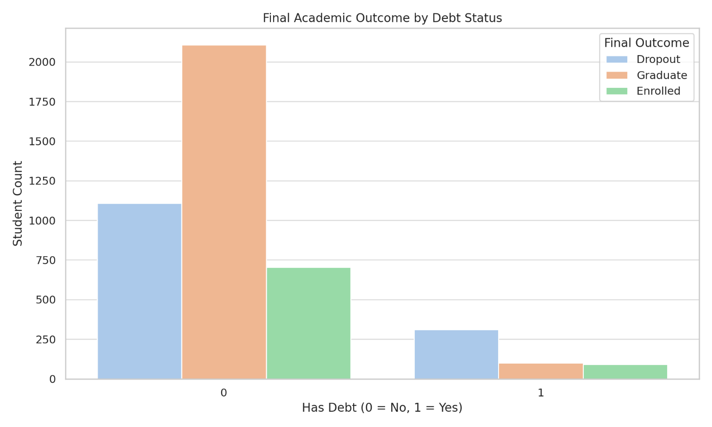
Boxplots by Final Outcome
Boxplots comparing admission_grade and age_at_enrollment across final outcomes (Dropout, Graduate, Enrolled) demonstrated stark disparities. Students who dropped out tended to have lower prior grades and be significantly older at enrollment, with wider interquartile ranges, signaling diverse risk profiles even within the dropout group. 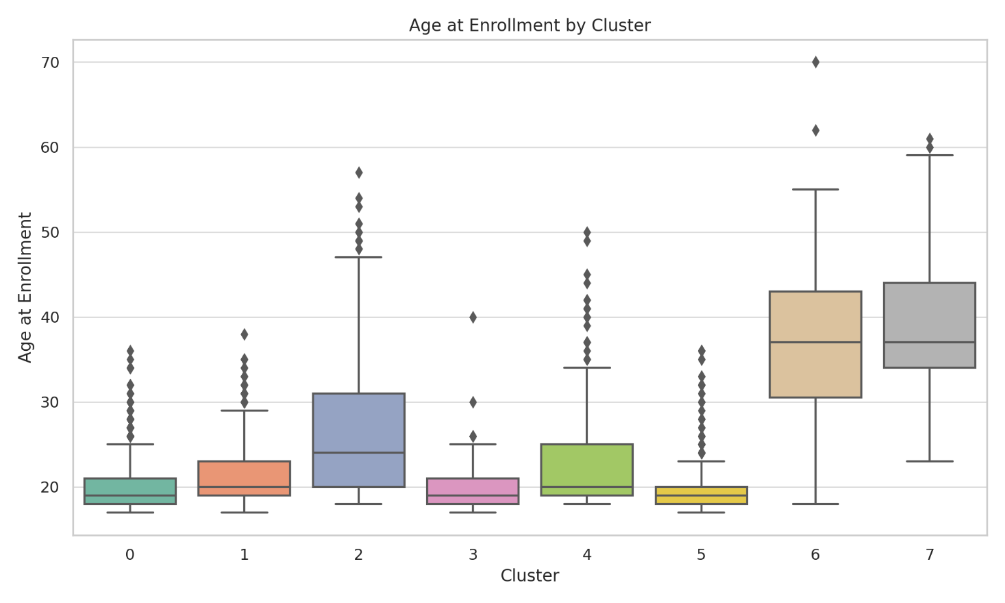
Heatmap of Feature Correlations
A correlation matrix showed modest positive correlations between admission grade and success rate, and negative correlations between dropout and both academic and financial indicators. The matrix also helped identify which variables were redundant and which offered unique signal, supporting cleaner feature selection for clustering.
Bar Charts of Categorical Attributes
Bar plots of binary variables like scholarship_holder, has_debt, and educational_special_needs stratified by final outcome further illuminated disparities. Students with debt were overrepresented in the dropout category, as were those with overdue tuition payments. Although students with special educational needs were a small minority, they had a disproportionately high dropout rate. 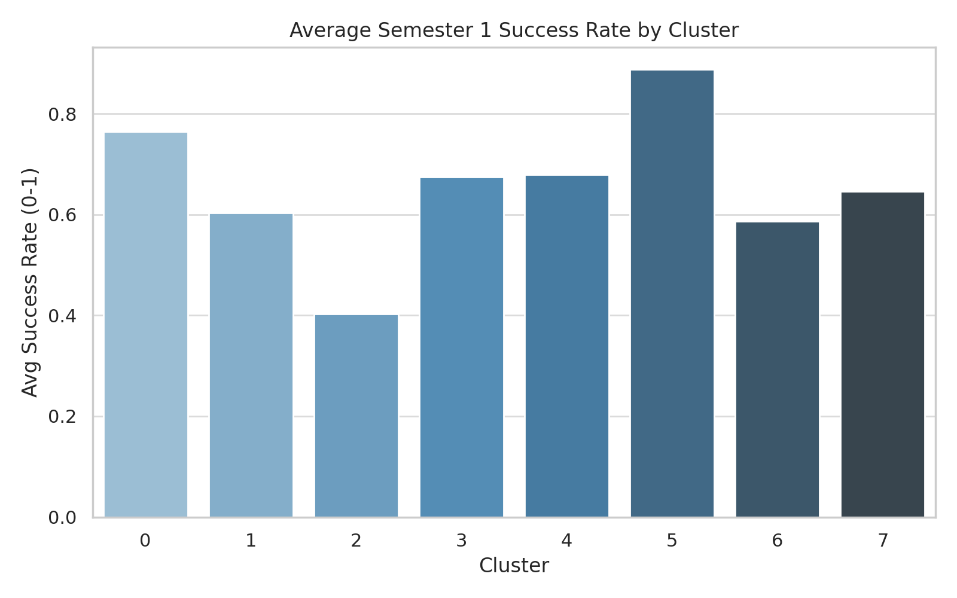
Implications for Clustering
These visual patterns informed my feature engineering choices and confirmed the value of using multiple socioeconomic and academic variables together. They also raised key equity questions, such as whether older students or those with debt were being underserved, guiding the fairness audit later in the project.

Methods
To explore disparities in academic outcomes among post-secondary students, I employed an unsupervised machine learning approach using KMeans clustering. This method aligns well with the guiding research question: Can clustering reveal distinct academic pathways and risk profiles among students, and are certain groups disproportionately represented in higher-risk clusters? KMeans allows for the identification of latent groupings in multidimensional data without predefined labels, making it particularly useful for exploratory equity analysis.
Data Preprocessing
Before clustering, I selected key features relevant to academic performance, financial status, and demographic characteristics, including:
- admission_grade
- success_rate_sem1
- age_at_enrollment
- Binary indicators such as scholarship_holder, has_debt, tuition_up_to_date, displaced, and educational_special_needs
Categorical variables like gender and final_situation were temporarily converted to numeric codes to enable groupby summarizations and visualizations, but they were excluded from clustering to avoid biasing the unsupervised algorithm with outcome labels.
All features were standardized using StandardScaler to ensure equal weighting and prevent variables with larger numeric ranges from dominating the clustering process.
Clustering Technique
To uncover latent structure in the student data, I applied KMeans clustering, a widely used unsupervised learning algorithm that partitions observations into k groups by minimizing within-cluster variance. The goal was to segment students into meaningful clusters that reflect distinct academic and socio-demographic profiles.
Initially, I used the Silhouette Score, which measures how similar a point is to its own cluster versus others, to assess the optimal number of clusters. Interestingly, the silhouette score peaked at k = 2, which would imply that students fall into just two broad groupings. However, this low number of clusters was overly simplistic and failed to capture the nuances present in the dataset.
To refine my decision, I expanded the search space to k = 2 through 10 and considered two additional metrics: the Elbow Method (based on inertia) and the Davies-Bouldin Index (which balances intra-cluster tightness with inter-cluster separation). The Elbow plot showed a diminishing return in inertia reduction after k = 7 or 8, while the Davies-Bouldin Index reached its lowest values in the range of k = 8–10, with k = 8 offering a compelling tradeoff between compactness and separation.
I also compared clustering results between k = 7 and k = 8 by inspecting the interpretability and stability of resulting clusters using 2D UMAP projections. Ultimately, I selected k = 8 because it provided interpretable and differentiated clusters that aligned well with my equity-oriented research questions.
This triangulated approach, using multiple metrics (Silhouette, Inertia, DBI), domain interpretability, and visual inspection, ensured that the final clustering solution was both statistically sound and meaningful in the educational context.
I ran the KMeans algorithm multiple times with different random seeds to account for its sensitivity to initial centroid placement. The final model showed consistent patterns across runs, increasing my confidence in the robustness of the cluster assignments.
Cluster Profiling
To interpret the resulting clusters, I computed summary statistics (mean values) for each selected feature within each cluster. These profiles helped characterize the student groups along dimensions such as age, academic success, financial support, and risk indicators. I also created visualizations (e.g., KPI cards, bar charts, boxplots) to communicate these differences more clearly in Tableau.
Fairness Analysis
Recognizing the potential ethical implications of clustering in education, I incorporated a fairness audit using Chi-square tests of independence. Specifically, I tested whether cluster membership was independent of two sensitive attributes: gender and age_bin. This statistical approach helped identify potential biases in the unsupervised model, signaling whether certain demographic groups were overrepresented in specific clusters. I also considered including SHAP values to interpret model drivers but found it less applicable in an unsupervised context without labeled outcomes.
Limitations
KMeans comes with several assumptions and limitations:
- It assumes spherical cluster shapes and equal variance, which may not reflect the true distribution of educational data.
- It is sensitive to initial centroid placement, which can lead to unstable results without careful seeding or multiple runs.
- The choice of k is inherently subjective despite quantitative metrics like the silhouette score.
- As an unsupervised method, clustering does not guarantee that discovered groups are meaningful or actionable without further validation and domain interpretation.
Moreover, while I took care to standardize inputs and select ethically neutral features, real-world educational datasets often encode structural biases. For instance, indicators such as “has debt” or “displaced” are not merely variables, they are proxies for broader socioeconomic forces that shape student outcomes. This project addresses those concerns by incorporating fairness checks and focusing on equitable insights rather than deterministic predictions.

Data Analyses and Main Results
Unsupervised Clustering (KMeans, k=8):
a) Response Variable:
There is no single response variable in this unsupervised method. Instead, I attempt to uncover natural groupings (clusters) in the data based on students' demographic, academic, and financial features.
b) Explanatory Variables:
The clustering algorithm used the following explanatory variables:
- admission_grade (float, 0–200 scale)
- success_rate_sem1 (float, 0.0–1.0)
- age_at_enrollment (integer, years)
- scholarship_holder, has_debt, tuition_up_to_date, educational_special_needs (binary flags: 0 = No, 1 = Yes)
- gender_num (binary encoded gender)
These variables were preprocessed (scaled using RobustScaler) to handle outliers and differences in magnitude.
c) Method:
I applied KMeans clustering, a widely-used partitioning method that aims to group similar observations by minimizing within-cluster variance. I selected k = 8 based on a combination of:
- Elbow method (inertia plateau),
- Silhouette score (to balance cohesion and separation),
- Davies-Bouldin index (lower values indicate tighter, well-separated clusters),
- and UMAP plots to visually assess separation and interpretability.
I also considered k = 7 and other values up to 10, but k = 8 offered the most interpretable and analytically useful segmentation (see Figure X).
d) Hypotheses:
Clustering is an exploratory method and does not rely on hypothesis testing in the traditional sense. However, my conceptual hypothesis was:
There exist natural groupings of students based on academic, demographic, and financial factors that correspond to distinct outcome patterns (e.g., dropout, graduation, persistence).
e) Data Conditions:
- KMeans requires numeric input, which we ensured through encoding and scaling.
- It assumes clusters are convex and roughly spherical. This assumption may be violated, as real-world student data can be non-linear and overlapping—an important limitation.
- To reduce sensitivity to initial centroids, we used the n_init=10 default and validated consistency across multiple runs.
f) Analyses and Visualizations:
We visualized clusters using UMAP (Uniform Manifold Approximation and Projection) to reduce the high-dimensional space to 2D for interpretability. The UMAP plot shows that some clusters are fairly distinct, while others overlap, consistent with the soft boundaries of real-world educational groupings (see Figure Y).
Cluster Profiles:
Cluster | Description
0 | Young (16–20), all male, high admission grades and success rates. Strong academic profile.
1 | Mid-age, higher dropout rate, moderate debt and low success.
2 | Oldest group (36+), lowest success rate, highest debt and dropout. High-risk group.
3 | Smallest cluster; many students with educational special needs and mixed outcomes.
4 | Young females with moderate grades; moderate scholarship and retention.
5 | Younger, many scholarship holders, highest success rates. A high-opportunity group.
6 | Older mixed group with average outcomes and more financial instability.
7 | Female-majority group, moderate grades, less debt but lower success rates.
g) Summary of Results:
Clustering revealed heterogeneous student profiles with meaningful differences in age, gender, financial status, and academic outcomes. For instance, Cluster 2 contains older students with debt and poor academic outcomes, highlighting a vulnerable population. In contrast, Cluster 5 reflects a high-achieving, younger group with strong scholarship support.
These findings suggest that clustering can surface actionable insights, such as identifying high-risk profiles for targeted support or scholarship expansion. However, limitations such as overlapping clusters and reliance on spherical assumptions in KMeans mean results should be interpreted with care.
Fairness Analysis (Chi-Square Tests):
a) Response Variables:
- Cluster assignment (categorical, no units) is the outcome grouping of interest.
b) Explanatory Variables:
- Gender (categorical: Male/Female)
- Age bin (ordinal categorical: student age grouped into brackets, e.g., 17–20, 21–24, etc.)
c) Method Used:
- Chi-Square Test of Independence
d) Hypotheses:
For Gender vs Cluster:
- H₀: Gender distribution is independent of cluster assignment.
- H₁: Gender distribution varies significantly across clusters.
For Age Bin vs Cluster:
- H₀: Age distribution is independent of cluster assignment.
- H₁: Age distribution varies significantly across clusters.
e) Data Conditions:
- Expected cell counts in contingency tables all exceed 5.
- Observations are independent.
- All variables are categorical.
f) Results of Chi-Square Tests:
- Gender vs Cluster: χ²(7) = 2481.68, p < 0.0001
- Age Bin vs Cluster: χ²(28) = 2884.30, p < 0.0001
These highly significant p-values indicate that both gender and age group distributions are not independent of cluster assignment.
g) Summary of Results:
The analysis reveals that student clusters, originally derived from academic, demographic, and financial features, are strongly associated with gender and age group. Clusters with higher dropout rates and lower success metrics tend to include a disproportionate number of older students and those with financial difficulties. These findings raise equity concerns and underscore the importance of embedding fairness assessments into clustering analyses. Further exploration of intersectional disparities (e.g., older female students with debt) may inform more equitable student support systems.
Visual Analytics (Tableau Dashboard):
a) Response Variables:
- Final Situation (categorical: Graduate, Dropout, Enrolled)
- Success Rate (Semester 1) (quantitative, proportion from 0.0 to 1.0)
- Cluster (categorical: 0 through 7)
b) Explanatory/Grouping Variables:
- Cluster ID (categorical)
- Gender (categorical)
- Age at Enrollment (quantitative, in years)
- Has Debt (binary, 0 = No, 1 = Yes)
- Scholarship Holder (binary)
- Educational Special Needs (binary)
c) Method Used:
- Descriptive Visualization & Dashboarding (Tableau)
d) Hypotheses (informal/visual):
- There are visually detectable disparities in success outcomes, gender, and financial need across clusters.
- Demographic and socioeconomic variables may relate to differences in academic success and final outcomes.
e) Data Conditions:
- All variables used were cleaned and standardized before clustering.
- The dataset was free from missing values and suitable for categorical aggregation.
f) Visualizations and Findings:
The Tableau dashboard was designed to visually interpret cluster characteristics and make findings accessible to non-technical stakeholders. Key visuals include:
- KPI Cards per Cluster – Summarize average admission grade, success rate, and age, along with percentages of students with debt, scholarships, and learning needs.
- Outcome Distribution by Cluster – A stacked bar chart showing how final student outcomes (Graduated, Enrolled, Dropout) vary sharply by cluster. For example, Cluster 2 has a disproportionately high number of dropouts, while Clusters 0 and 5 contain most graduates.
- Gender Distribution by Cluster – Some clusters (e.g., Cluster 0) are overwhelmingly male, while others (e.g., Cluster 1) show more gender balance. This confirms earlier Chi-square results.
- Age and Financial Indicators – Additional charts break down average age at enrollment, percentage with debt, and scholarship holding across clusters. These visuals illustrate how high-risk clusters (like 2 and 6) are older, more likely to have debt, and less likely to hold scholarships.
- Equity Context Narrative – The dashboard emphasizes that clusters with poor academic outcomes overlap significantly with financial and demographic disadvantage, underscoring the ethical need for intervention design that targets structural barriers, not just academic symptoms.
g) Summary of Results:
Visual analytics confirmed and contextualized the numerical clustering results. The most academically successful clusters (e.g., Clusters 0 and 5) tended to be younger, less financially burdened, and more likely to have scholarships. Meanwhile, high-risk clusters (e.g., Clusters 2, 6) include older students with financial hardship, lower admission grades, and higher dropout rates. By integrating visual storytelling with cluster analysis, this dashboard helps communicate critical equity risks and opportunities to educators and policymakers.

Conclusions
This project illustrates how combining unsupervised learning techniques with fairness analysis can uncover meaningful patterns in student data that may otherwise go unnoticed. By applying KMeans clustering to academic, demographic, and financial indicators, I identified eight distinct student profiles, each associated with varying levels of academic success, financial burden, and demographic characteristics. Clusters composed of younger, financially supported students exhibited higher graduation rates and academic performance, while older students and those with debt were overrepresented in clusters with the highest dropout rates.
These results underscore the reality that academic outcomes are not merely individual achievements or failures, but are deeply intertwined with structural and socioeconomic factors. In particular, this project revealed that age, financial burden, and educational support needs are critical dimensions of equity risk. The Chi-square fairness tests confirmed that gender and age were not equitably distributed across clusters, further highlighting the need for policy responses that address systemic barriers.
The use of a visual analytics dashboard extended the accessibility of these findings, providing an intuitive interface for stakeholders such as school administrators, policymakers, and educators. By summarizing key performance indicators and demographic disparities in each cluster, the dashboard offers a practical tool for targeting support services to the students who need them most.
Research Directions
Several promising paths exist for building on this work:
- Longitudinal Cluster Dynamics: Future studies could incorporate time-series data to track how students transition between clusters over semesters or years. This would allow researchers to explore trajectories, not just snapshots.
- Fairness Beyond Demographics: Expanding fairness analysis to include additional axes—such as disability status, socio-economic class, or intersectional identities—could provide more holistic insights.
- Ethical Intervention Design: Clusters could inform the design of tailored interventions (e.g., financial counseling, tutoring, flexible deadlines) that are tested using A/B or randomized control trials to evaluate their real-world effectiveness.
- Algorithmic Fairness Metrics: Implementing formal fairness metrics (e.g., demographic parity, equal opportunity, disparate impact) could complement Chi-square tests and provide more robust ethical evaluations.
- Mixed-Methods Approaches: Combining clustering insights with qualitative research (e.g., student interviews or focus groups) could enrich understanding of how structural barriers manifest and what supports students actually need.
This project lays a foundation for actionable, ethical data science in education. By centering equity from the outset, it demonstrates that algorithms can be tools not only for prediction but also for justice.

References
Barocas, S., Hardt, M., & Narayanan, A. (2019). Fairness and machine learning. Retrieved from https://fairmlbook.org/
Holstein, K., Wortman Vaughan, J., Daumé III, H., Dudik, M., & Wallach, H. (2019). Improving fairness in machine learning systems: What do industry practitioners need? In Proceedings of the 2019 CHI Conference on Human Factors in Computing Systems (pp. 1–16). https://doi.org/10.1145/3290605.3300830
Martins, M. V., Tolledo, D., Machado, J., Baptista, L. M. T., & Realinho, V. (2021). Early prediction of student’s performance in higher education: A case study. In Trends and Applications in Information Systems and Technologies (pp. 407–417). Springer. https://doi.org/10.1007/978-3-030-72654-6_39
Mduma, N., Kalegele, K., & Machuve, D. (2019). A survey of machine learning approaches and techniques for student dropout prediction. Data Science Journal, 18(1), 1–10. https://doi.org/10.5334/dsj-2019-019
Mehrabi, N., Morstatter, F., Saxena, N., Lerman, K., & Galstyan, A. (2021). A survey on bias and fairness in machine learning. ACM Computing Surveys, 54(6), 1–35. https://doi.org/10.1145/3457607

Appendix: Supplementary Materials
A. Code and Reproducibility
The full source code used in this project is provided in a Jupyter notebook:
- Python Code: DSP562_Final_Clustering_Fairness.ipynb
This notebook contains data preprocessing, clustering implementation (KMeans), fairness analysis (Chi-square tests), and data export procedures. It is fully annotated to support reproducibility.
B. Data Visualizations
Interactive visual analytics were created using Tableau:
- Tableau Workbook: Final Project Dashboard.twbx
The workbook includes KPI cards, outcome distribution, gender and age comparisons, and cluster profiling.
C. Data Files
The following CSV files were generated during analysis and used for visualization in Tableau:
- students_clustered.csv – Final dataset with cluster labels assigned
- cluster_profiles_avg.csv – Average values of key features by cluster
- Additional exports available upon request
D. Notes on Data Sources
The original dataset was sourced from Predict Students' Dropout and Academic Success on Kaggle, published by a Portuguese higher education institution in December 2021.

