Slicing

# Setup

## Installation

1. Install from here: <https://ultimaker.com/software/ultimaker-cura/#downloads>
2. Open Cura
3. Initial configuration:

|  |  |
| --- | --- |
| * 1. Click **[Get Started]** |  |
| * 1. Click **[Agree]** |  |
| * 1. Click **[Next]** |  |
| * 1. Click **[Skip]** |  |
| * 1. Click **[Non-Ultimaker printer]** |  |
| * 1. Scroll down to Creality   2. Select Creality Ender-3 / Ender-3 v2 |  |
| * 1. Make sure your machine settings appear as follows: |  |

1. Done!

# Plugins

## Installing Plugins:

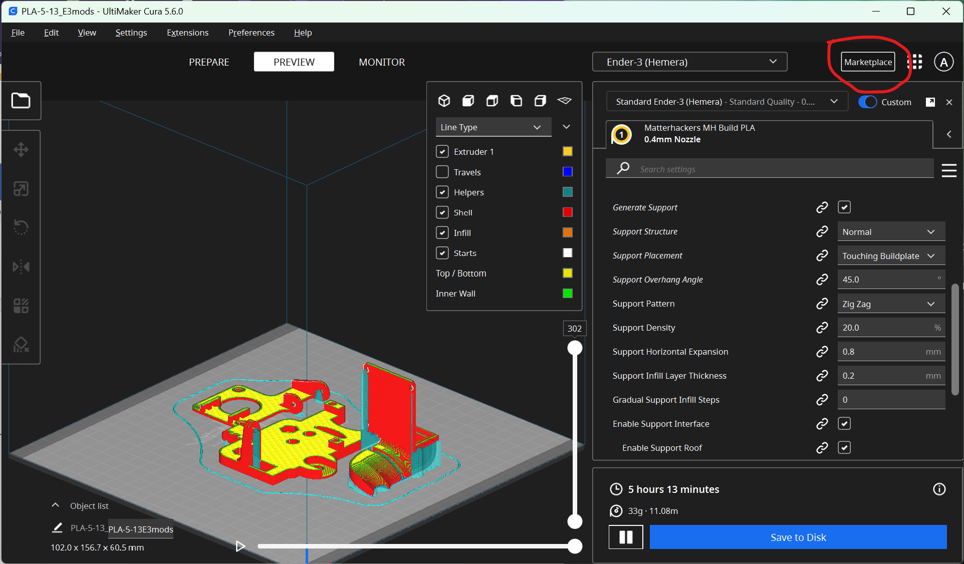 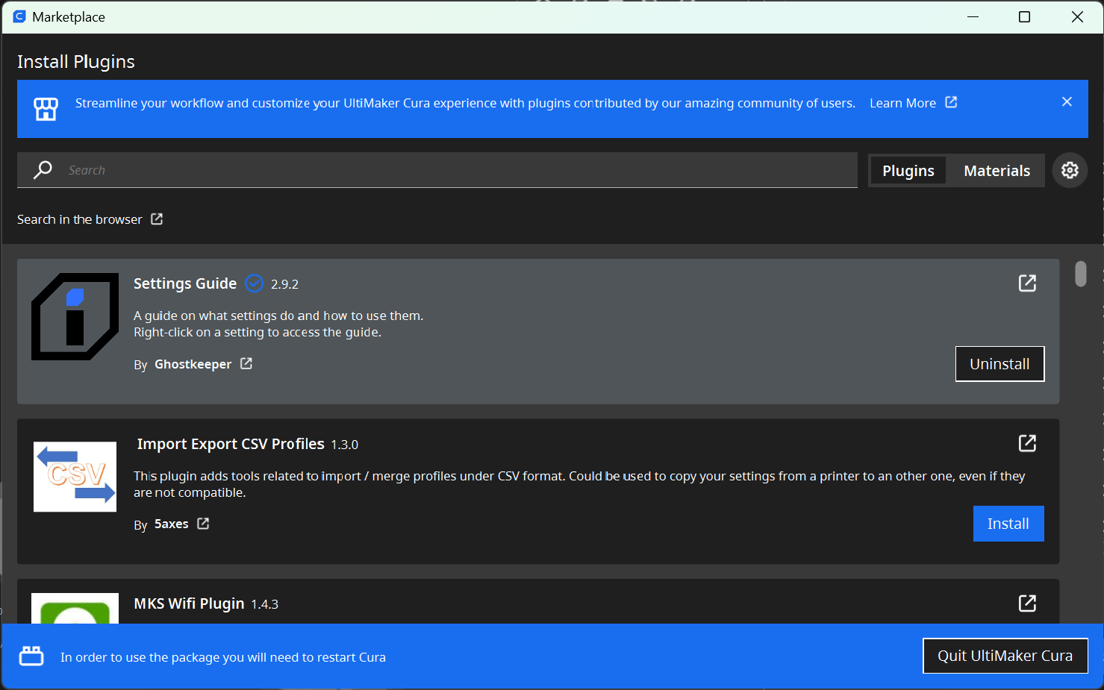

## Recommended Plugins:

* Settings Guide by Ghostkeeper
* Automatic Slicing Toggle by fieldOfView
* Calibration Shapes by 5axes
* Barbarian Units by nallath