NFL Predictions Report

Tony

November 14, 2017

Table of Contents

# Current Season

## By Week

## # A tibble: 5 x 5  
## # Groups: season [1]  
## season wk a t tie  
## <dbl> <dbl> <int> <int> <int>  
## 1 2017 7 10 3 2  
## 2 2017 8 5 7 1  
## 3 2017 9 5 6 2  
## 4 2017 10 5 8 1  
## 5 2017 11 13 NA 1

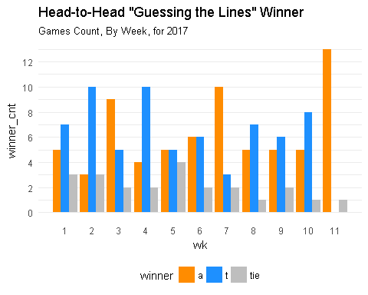

## # A tibble: 10 x 7  
## # Groups: season, person [2]  
## season wk person correct incorrect correct_pct correct_pct_td  
## <dbl> <dbl> <chr> <int> <int> <dbl> <dbl>  
## 1 2017 6 a 5 9 0.3571429 0.4395604  
## 2 2017 6 t 7 7 0.5000000 0.5384615  
## 3 2017 7 a 4 11 0.2666667 0.4150943  
## 4 2017 7 t 5 10 0.3333333 0.5094340  
## 5 2017 8 a 7 6 0.5384615 0.4285714  
## 6 2017 8 t 6 7 0.4615385 0.5042017  
## 7 2017 9 a 6 7 0.4615385 0.4318182  
## 8 2017 9 t 7 6 0.5384615 0.5075758  
## 9 2017 10 a NA 13 NA NA  
## 10 2017 10 t 7 6 0.5384615 0.5103448

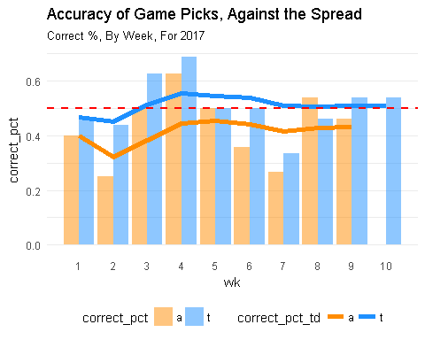

# All Seasons

## By Season

## # A tibble: 5 x 4  
## # Groups: season [5]  
## season a t tie  
## <dbl> <int> <int> <int>  
## 1 2013 9 7 1  
## 2 2014 12 4 1  
## 3 2015 12 3 2  
## 4 2016 9 7 1  
## 5 2017 6 2 2

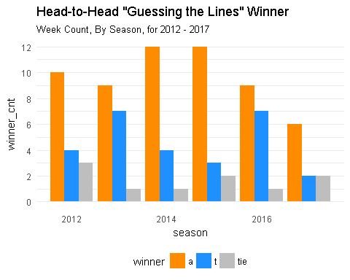

## # A tibble: 10 x 7  
## # Groups: season, person [2]  
## season wk person correct incorrect correct_pct correct_pct_td  
## <dbl> <dbl> <chr> <int> <int> <dbl> <dbl>  
## 1 2017 6 a 5 9 0.3571429 0.4395604  
## 2 2017 6 t 7 7 0.5000000 0.5384615  
## 3 2017 7 a 4 11 0.2666667 0.4150943  
## 4 2017 7 t 5 10 0.3333333 0.5094340  
## 5 2017 8 a 7 6 0.5384615 0.4285714  
## 6 2017 8 t 6 7 0.4615385 0.5042017  
## 7 2017 9 a 6 7 0.4615385 0.4318182  
## 8 2017 9 t 7 6 0.5384615 0.5075758  
## 9 2017 10 a NA 13 NA NA  
## 10 2017 10 t 7 6 0.5384615 0.5103448

