1. Consider the following, Input Data: {7, 28, 3, 9, 12, 82, 10, 31, 24}

a) Graphically build a Circular queue for input data. Discuss and show Head

and Tail pointers at each step:

i) enqueue all input data

ii) dequeue three elements

iii) enqueue two elements

iv) dequeue all elements

Ans: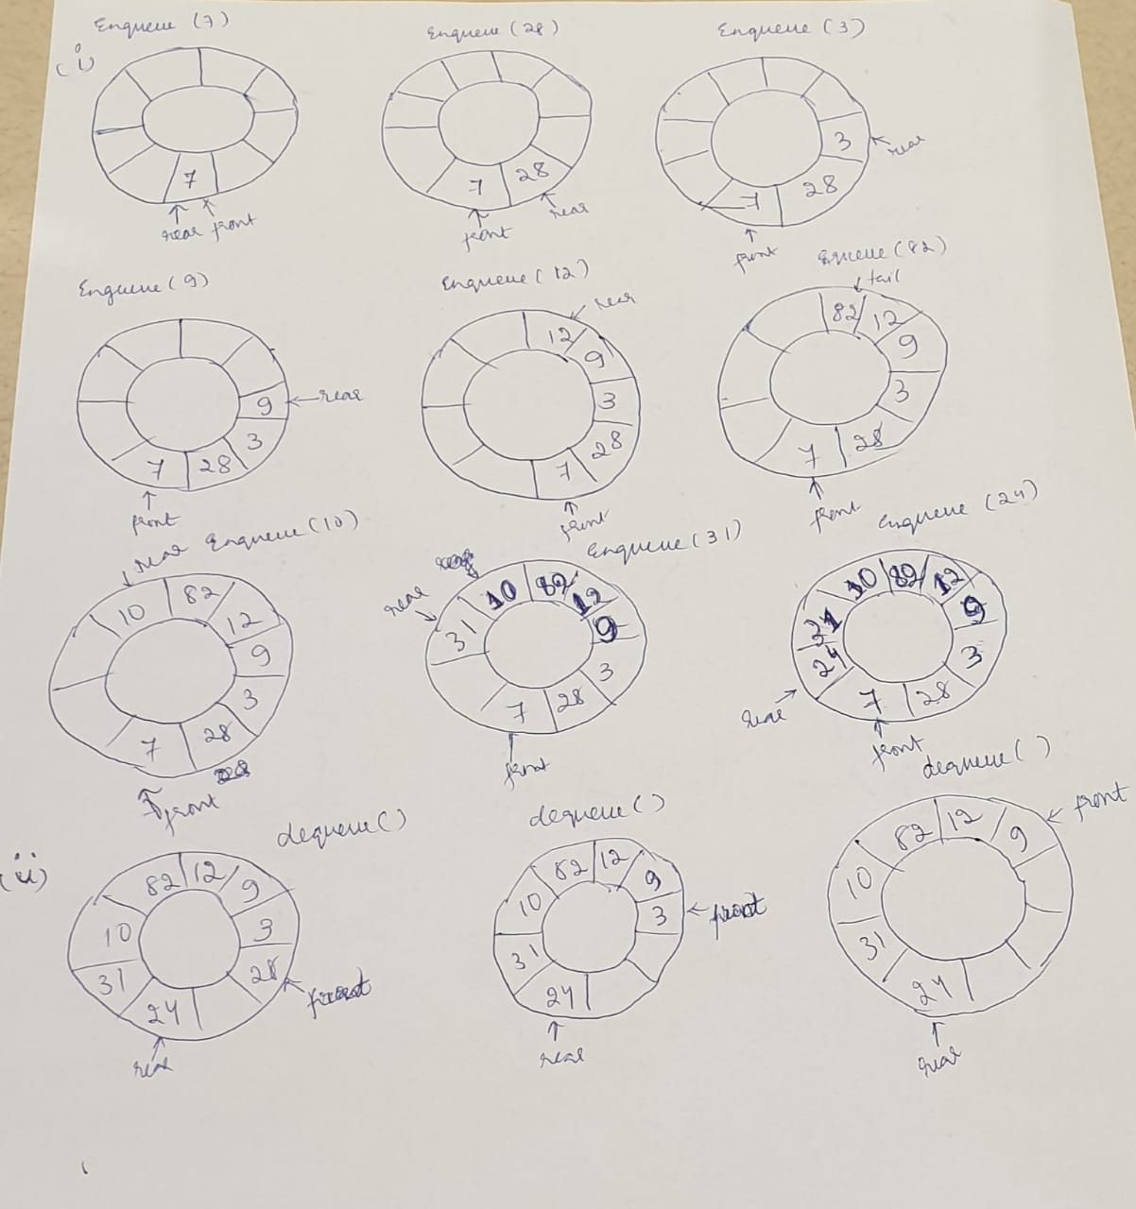

2. Consider signed byte X, and unsigned byte Y. What are the possible values for both

X and Y can have?

Ans: The possible value of X and Y can be from -128 to 127 because in Java, everything is in the form of signed.

5. Con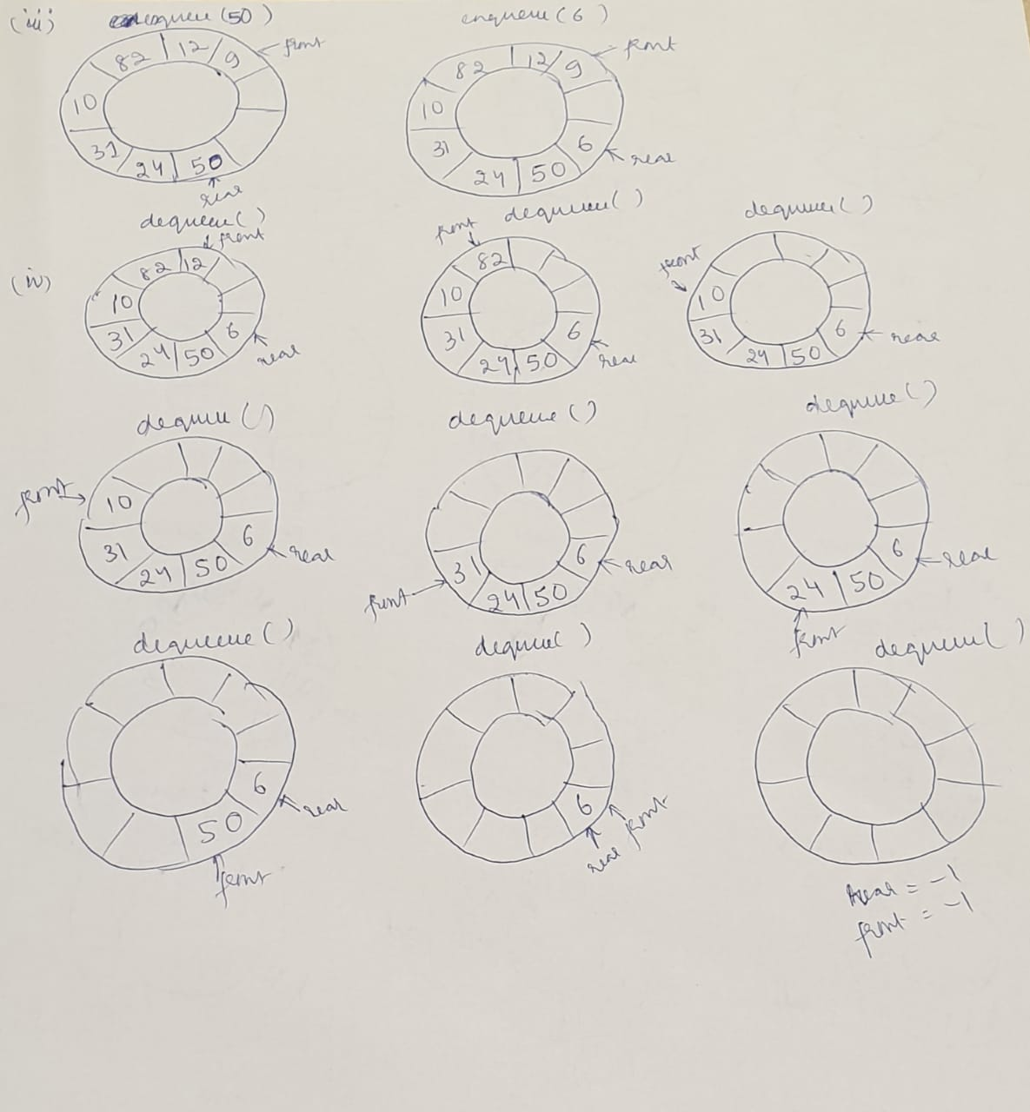sider the following MergeSort algorithm with Input Data:

{27, 43, 38, 3, 9, 82, 10, 33, 19, 15}

MergeSort(arr[], l, r)

If r > l

1.Find the middle point to divide the array into

two halves: middle m = (l+r)/2

2.Call mergeSort for first half:

Call mergeSort(arr, l, m)

3. Call mergeSort for second half:

Call mergeSort(arr, m+1, r)

4.Merge the two halves sorted in step 2 and 3:

Call merge(arr, l, m, r)

a) Sort the data Graphically, show step-by-step, recursion on Stack

and what is Termination point?

Ans: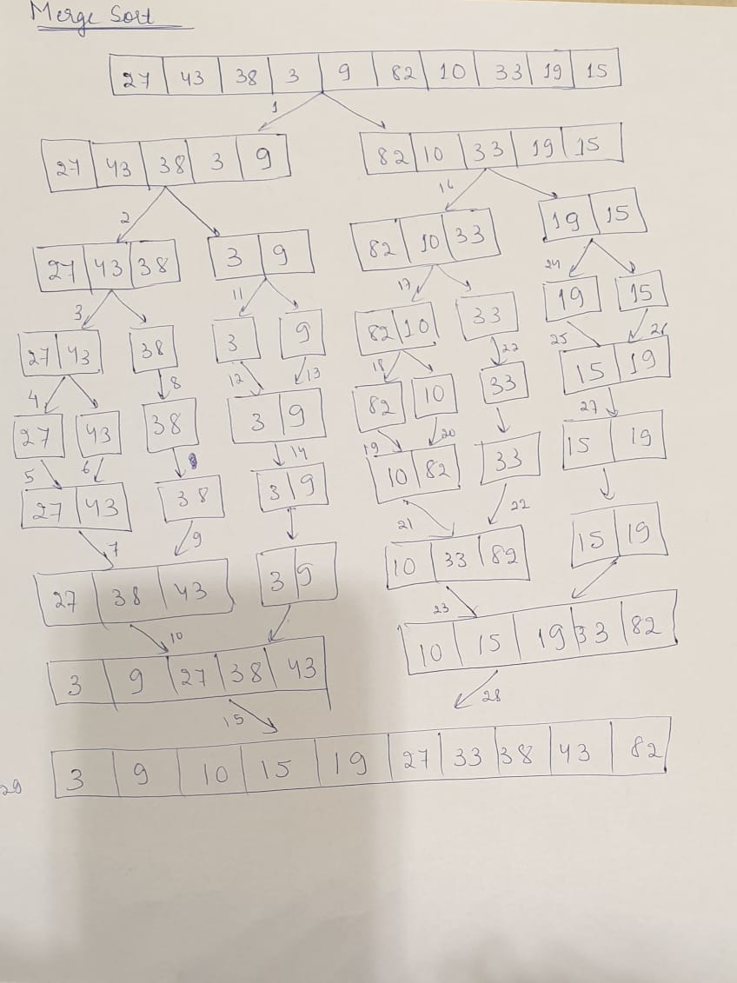

b) Write Java code and Compile and Run with provided data.

7. Consider mergeSort algorithm for the following input string. Show the stack operations push and pop step by step for call mergeSort(arr, l, m) and call mergeSort(arr, m+1, r). Note: I don’t need the entire program, just show step by step stack push and pop operations, the recursive Tree structure

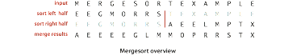

Ans:

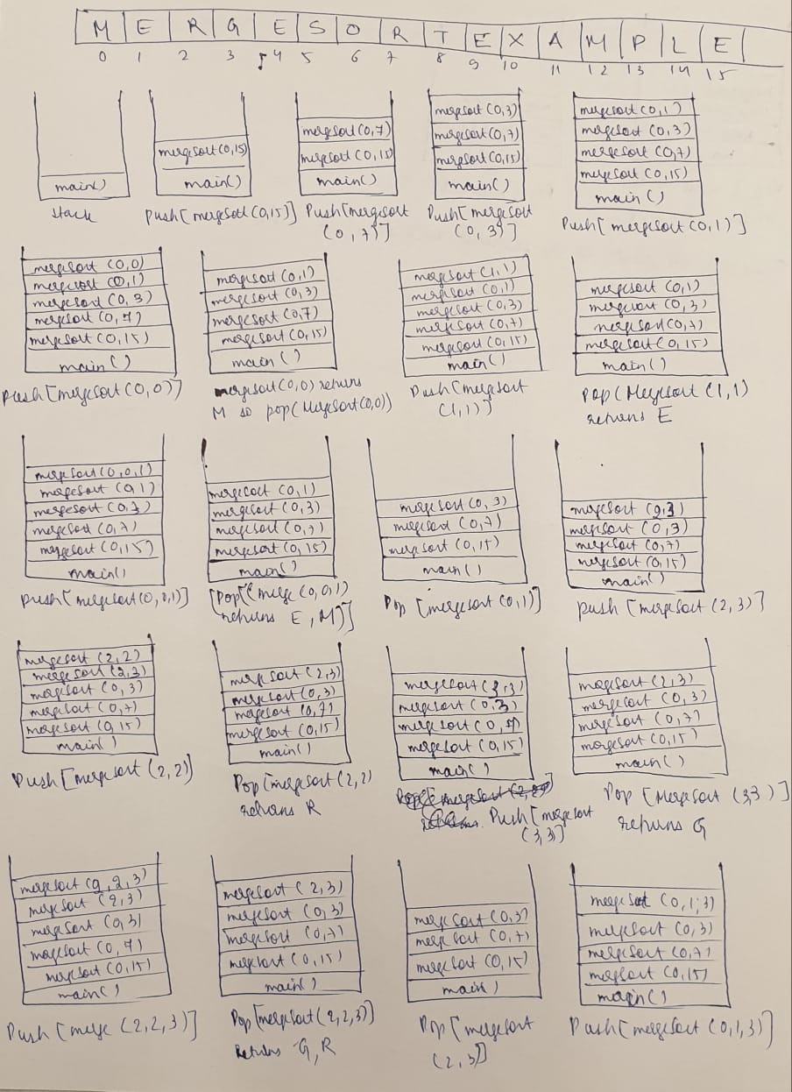

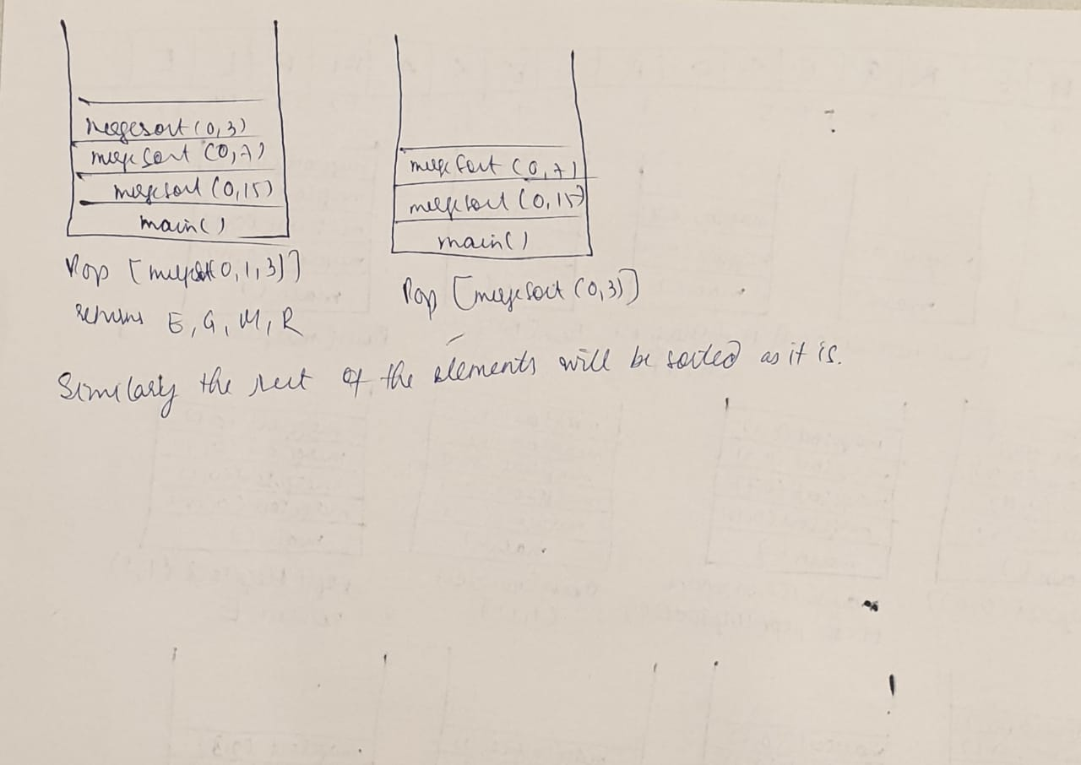

8. Java Generics allow you to build collections with unique data type. To perform uniqueness, comparisons of object types need to be made using Comparable interface, the equals, andpasted-image.tiff hashcode. Java **String** object hashcode is described as:

What is the hashcode 32-bit integer number for string =“Hello Sunny day“,

a) mathematically by hand, b) Write Java code

Ans: