Case Study on 48 V DC Supply

# Aim -

To show that using DC supply is beneficial than AC.

# Procedure -

To consider different parameters like generation, resources to generate them, cost to generate and transmit, efficiency. By studying all these we need to conclude which one has upper hand.

# Work -

### AC and DC -

### Alternating Current (AC) -

The name itself indicates that the current alters, which means the direction of current changes periodically with time.

### Generation of AC -

A loop of wire is spun inside of a magnetic field, which induces a current along the wire. The rotation of wire can come from any number of means: a wind turbine, a steam turbine, flowing water etc. Because the wire spins and enters a different magnetic polarity periodically, the voltage and current alternates on the wire.

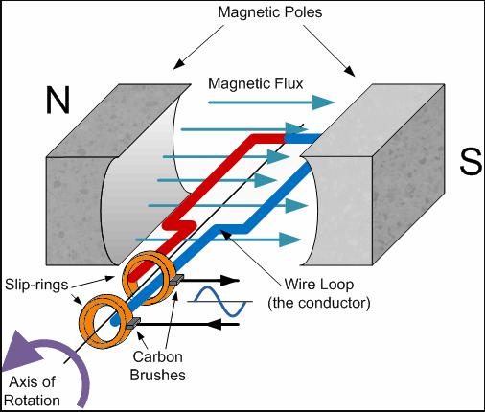

### Direct Current -

Direct Current means constant current (or) voltage.

### Generation of DC -

It can be generated in many ways like

->By using rectifier which converts AC into DC.

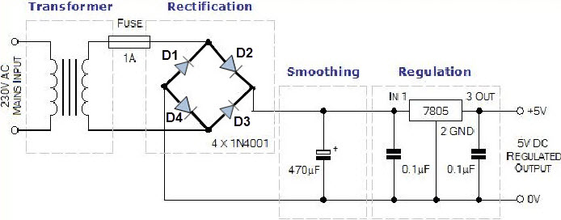

->From Batteries, DC is generated from the chemical reactions inside.

### Advantages of using DC supply -

->In DC supply as inductance will be absent power losses will be less.

->At high voltages AC will have skin effect which is absent in DC.

### Disadvantages of DC -

->For DC transformer will not work. Instead of that motor generator is used whose efficiency is less than transformer.

->Circuit breakers are costly in DC.

Preference of DC over AC –

->DC power is significantly more energy efficient than AC power.

->DC is inherently compatible with renewable sources of energy such as solar and wind.

->Reliance on electronic equipment creates a greater need for DC power. There is a loss of 5% to 20% when AC power is converted to DC power. Eliminating these conversion losses from AC to DC will become even more important and will motivate a shift to DC power.

After above study we started studying about generally how electricity is transmitted.

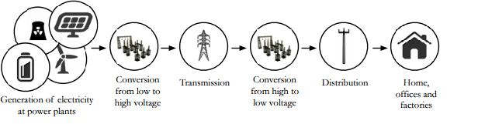

And difference in the architecture of AC transmission and DC transmission.

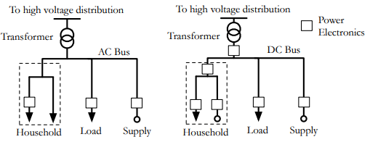

Then we started working on the characteristic graphs of DC supply.

We want to plot graphs involving the power of load, voltage rating of load and maximum distance of source from load to have maximum amount of allowed voltage drop. As we know efficiency is major advantage for DC supply. This is due to the absence of AC to DC conversions in DC supply. We will restrict our maximum drop to be 5% of total.

## Calculations –

Let Vo be the source voltage , R be the resistance of the copper wire, Pl be the power of load, xmax be the maximum distance, p be the resistivity of copper, I be the current in the circuit, Vdrop be the drop across the copper wires, A be the area of cross section of copper wires used.

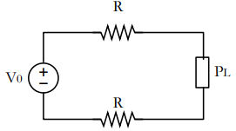

Pl= (Vo-Vdrop)*I

I =Vdrop/2*R but Vdrop=.05*Vo(as assumed)

R= p*xmax/A p of copper = 1.72*10^(-8) ohm-m

Pl=(Vo-Vdrop)*Vdrop*A/p*xmax let us take A= 4 mm^2

xmax = (Vo-Vdrop)*Vdrop*A/p*Pl

## Power of load(Pl) vs maximum distance graph(xmax) :

Here we considered Vo as 48 V

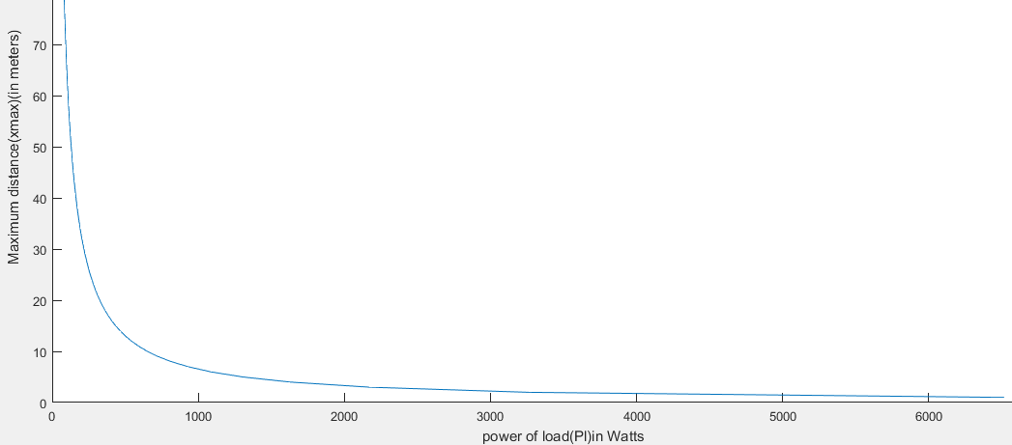

## Voltage of source vs max. distance graph -

# 

CONTRIBUTIONS

A.Abhilash reddy –Matlab work

S.Vishnu –Matlab work

J.Anirudh –Theory work

J.Vishwajith rathod –Theory work

REFERENCES

<https://www.tudelft.nl/en/eemcs/the-faculty/departments/electrical-sustainable-energy/dc-systems-energy-conversion-storage/research/dc-distribution-smart-grids/>

<http://www.topandtail.org.uk/publications/Report_ComparisonofCost.pdf>

<http://aceee.org/files/proceedings/2016/data/papers/1_156.pdf>