All code used for the results in the report is in the module pleased.py. Docstrings indicate the date and purpose of each function.

Data extraction
All readings are from data at 10Hz. Any data that is not 10Hz is discarded. The data is read directly from the text files, as the Matlab files appear to be incorrect in a few cases.
Datapoints are taken as one datapoint for each plant and each stimulus application. Most experiments involve two plants, so each stimulus application usually yields two datapoints. Each datapoint is a window on the readings of the plant from both electrodes with a length of 2000 samples, about 30 minutes. An additional 600 samples (10 minutes) are taken from before the stimulus application. This is done so the data can be used for eliminating linear trends. Before feature extraction or plotting, this pre-stimulus data is removed from each datapoint, leaving only the post-stimulus data.
Null data is data where no stimulus is occurring. This data is always taken from windows 10 minutes after the experiment starts, but prior to the first stimulus application. The window length is the same as in the stimulus data (2000 samples) and 600 samples from before the start point are taken as 'pre-stimulus' data, meaning the null data is in the exact same format as the stimulus data.
Before classification or plotting of data, the datasets are balanced by oversampling, where rare classes are duplicated such that each class has the same number of datapoints. The balancing is guaranteed to be as possible, each datapoint within a class will be duplicated either n or n+1 times, so no datapoint is over-represented within each class.

2014-07-11

Basic class separation
The plots below are separated by LDA with a minimum of pre-processing, comprised of taking the average of the two electrode readings and removing any pre-stimulus data.
Performing a simple separation of the classes ozone, H2SO4 and null using minimal pre-processing gives good results, especially for separating H2SO4 (1). The separation is so good that it may be worth investigating if there is information in the data unrelated to the stimulus applications.
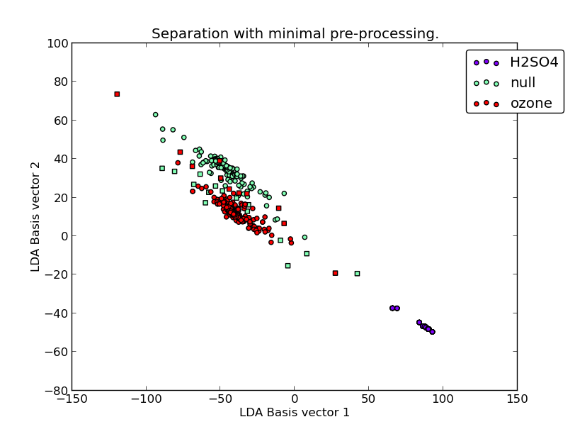Figure 1
The separation is very good despite no feature extraction, so it's possible this model is overfitting.
This can be checked by splitting the dataset into training and validation sets. The plants are split 75:25 and then the datapoints are extracted. The same plant will never be in both training and validation sets, so the chance of bias via the plant or experiment is reduced.
The LDA is trained on the training set of data, then both the training and validation sets are plotted (2). The result is much messier (there are also many outliers that are not visible in the plot), but the general projection is similar. This indicates that there is serious overfitting, but some small amount structure is still being recognized.
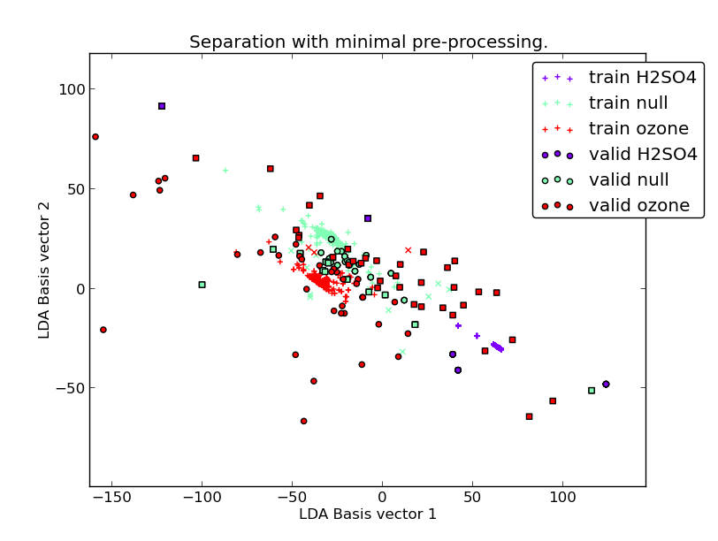Figure 2

Class separation of null data
If null data can be classified by experiment source well, this suggests that there is information in the data to discriminate between experiments, not just between stimulus. This information may come from the plants or from the environment of the experiment.
Separating null data alone appears to give a fairly good separation between different experiment types (3). The ozone data from different experiments are not very well separated. The class called 'Ozone' is from tomatoes and 'ozone-cabbage' is (obviously) from cabbages. The same is true for 'H2SO4' and 'H2SO4cabbage', which are very well separated. This seems to suggest the separation is not strongly related to the differences between the plants, but instead to the experimental environment.
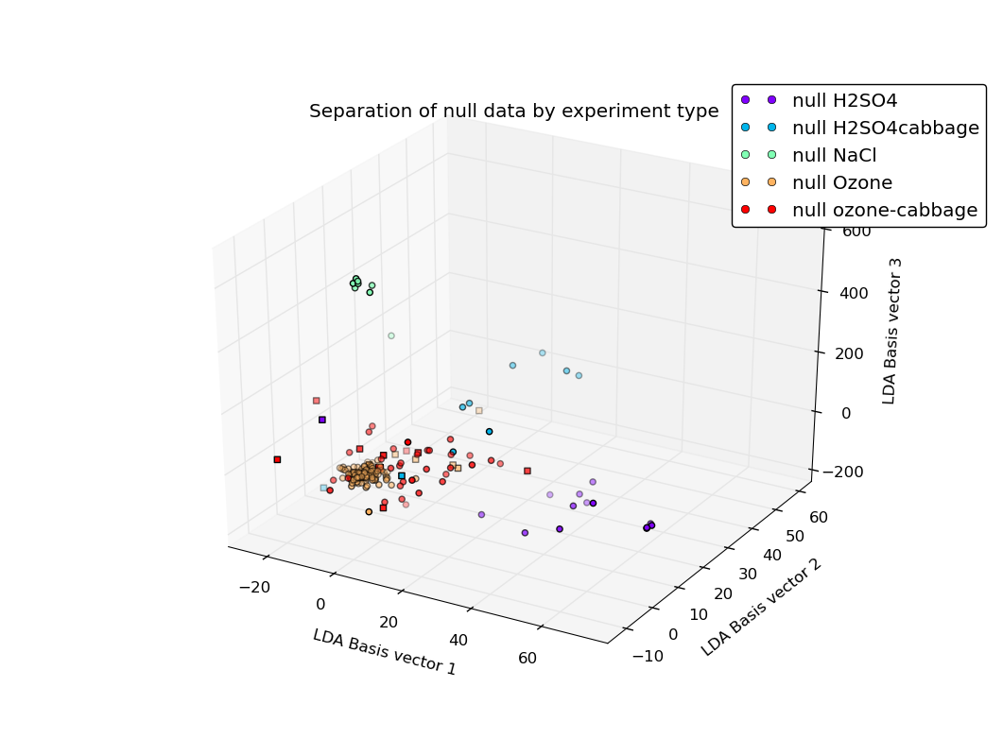Figure 3
When this is plotted alongside ozone and H2SO4 stimulus data, the separation is still fairly clear (4), on a similar magnitude to the separation between stimuli. H2SO4 is clearly distinguished from all null data, including null-H2SO4 data. The ozone data is less well separated from null and is not very easy to distinguish from null-ozone at all. In particular, the separation between 'ozone' and 'null ozone-cabbage' is very low. This suggests additional features should be found that can better distinguish ozone from null-ozone.
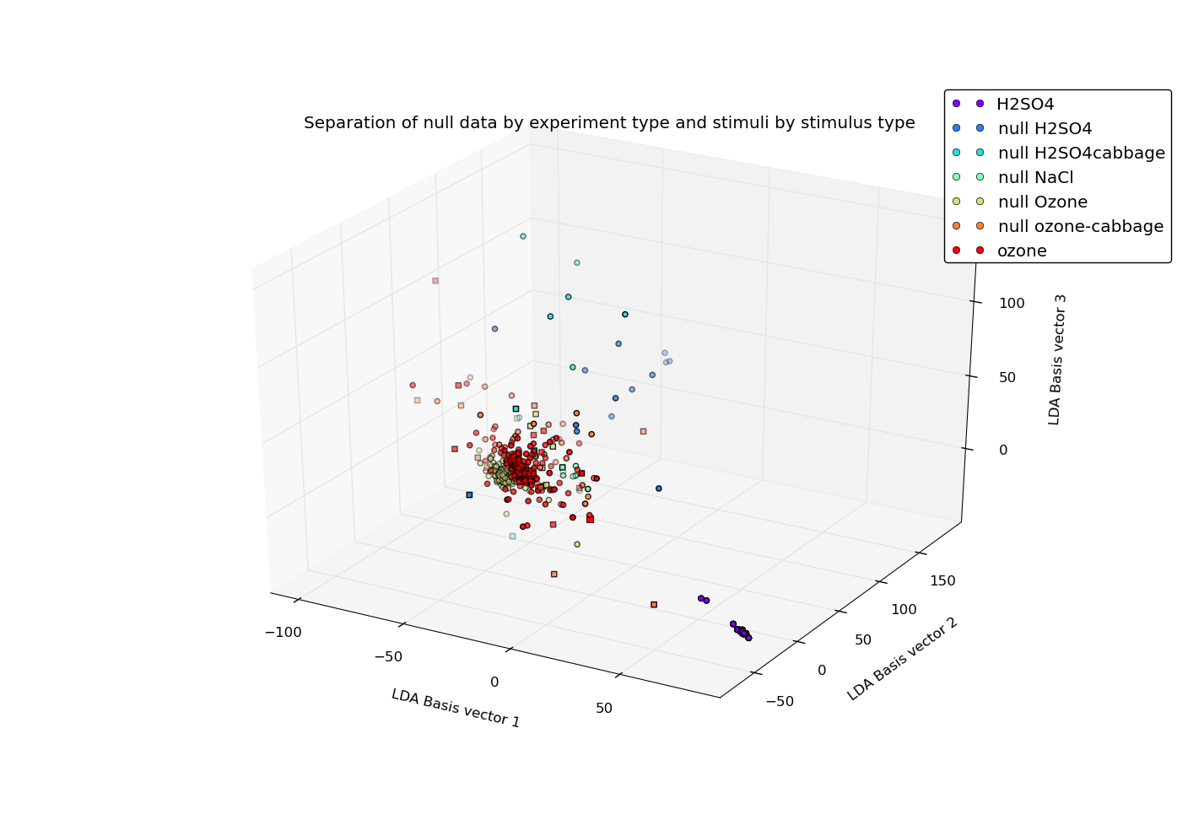Figure 4

Eliminating experiment bias
Removing the bias that appears to exist from each experiment could be done (as it is in the report Pleased D2.2) by subtracting the mean of the null data for each experiment from every datapoint from that experiment. This subtraction should occur as a final stage after feature extraction, as some features (such as variance) are independent of the mean of the original data.
It will also be worth seeing if linear de-trending will effect the bias.
To test if the bias is being reduced, we can look at both the null classification and performance on validation data. We would expect data with less experimental bias to perform worse at null classification and we would also expect it to perform better on validation data (as the validation data is from different experiments, the experimental bias becomes useless).

2014-07-14

Scaling of features by LDA
In order to better investigate which features are important with the LDA, they can be plotted as a graph where one axis is the feature number and the other axis indicates the amount of scaling squared along that feature performed by the LDA when projecting the data. The results of performing this on the minimally-processed readings is shown in figure 5. As can be seen, there's no obvious patterns except generally larger values at the start, perhaps suggesting the spike at the beginning of the data is important. Otherwise, this seems to be more of evidence of over-fitting, finding random patterns in the data that only occur due to chance and the large number of dimensions.
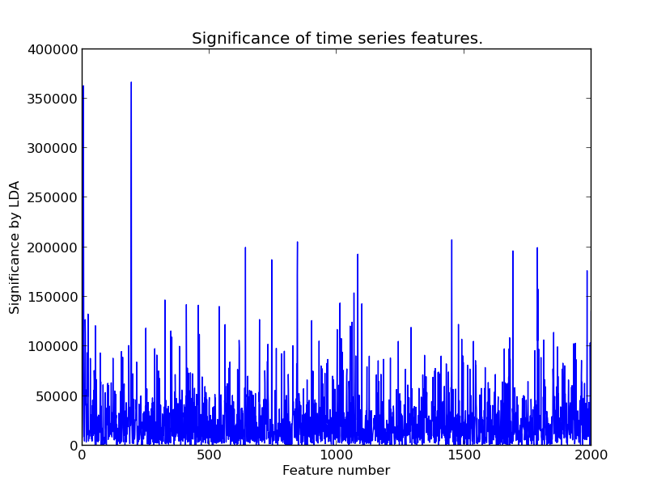Figure 5

Linear de-trending
In order to eliminate bias, I implemented linear de-trending. This is done by using readings from before each stimulus window, performing linear regression on that and then subtracting the extrapolated line from the entire window. This way, any linear trends present before the stimulus occurs are eliminated. After de-trending, the pre-stimulus data is removed. The results are shown in figures 6 and 7. The validation data set is still classified poorly (perhaps ozone is a little better?) and the null data set is still classified by experiment well, so linear de-trending doesn't appear to reduce experimental bias very effectively.
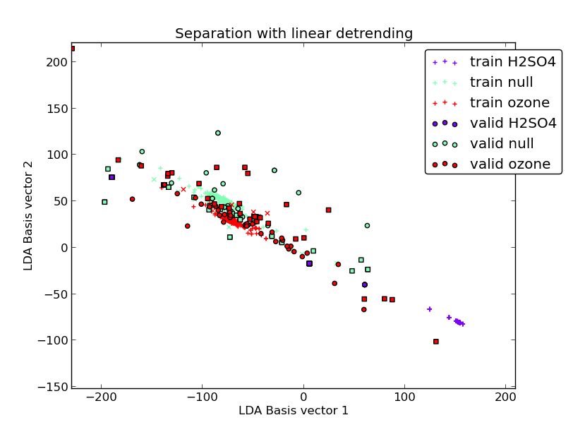Figure 6
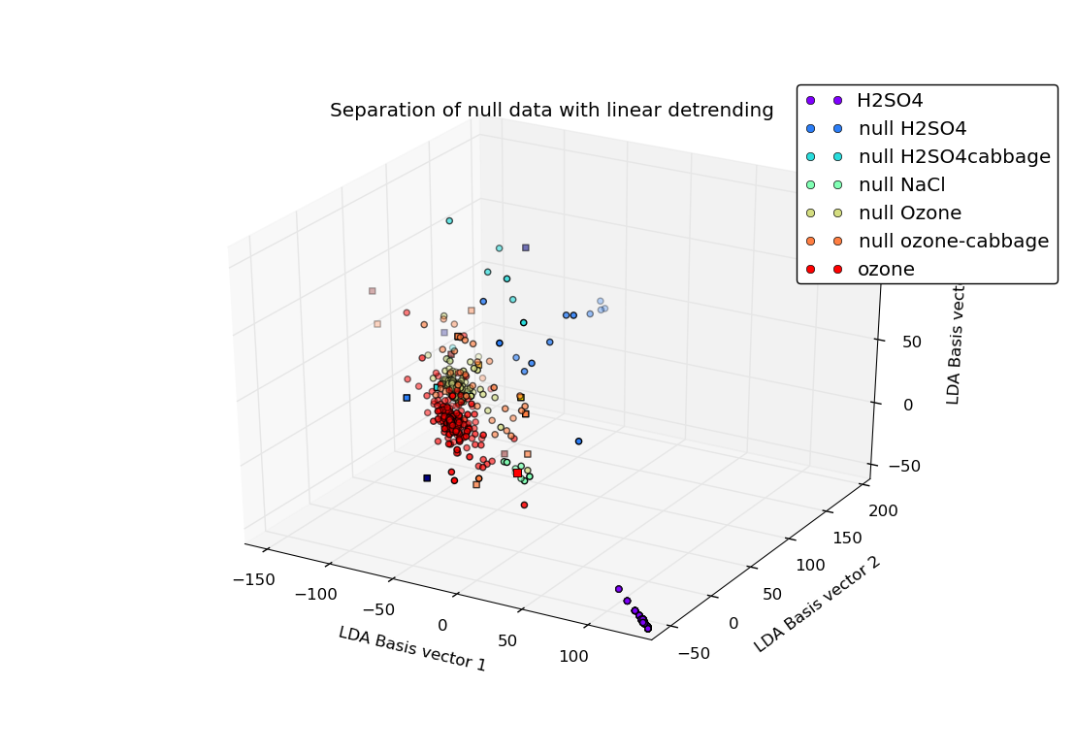Figure 7

Basic feature extraction
Features extracted were mean(x), mean(abs(diff(x))), and mean(abs(diff(diff(x))), representing the average value of the data, the average rate of change in the data and the average rate of change of the changes. The results for the training set are shown in figure 8 and the results for both training and validation sets are shown in figure 9. It can be seen that the data has been separated fairly well, although the null data continues to intrude on the ozone. In particular, the validation set also gives very similar results, indicating that these features are mostly independent of the source experiment.
The significance of each feature can be seen in figure 10, showing that the differential means are quite important, but the regular mean isn't. Although the readings aren't normalized, they are de-trended, which tends to mean the readings all start around zero. This could be the reason that the mean is not very informative.
Using a different set of features based on the variance, var(x), var(diff(x)) and var(diff(diff(x))) gives similar results (11). The significance of features is also the same, normal variance is not distinctive, but the differentials are.
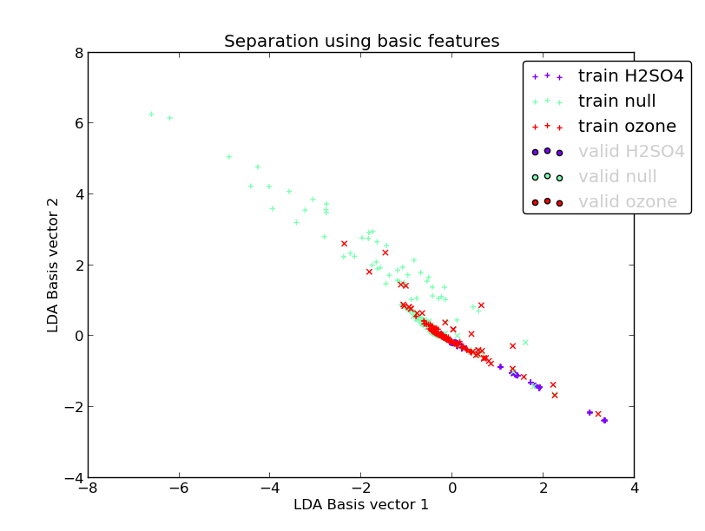Figure 8
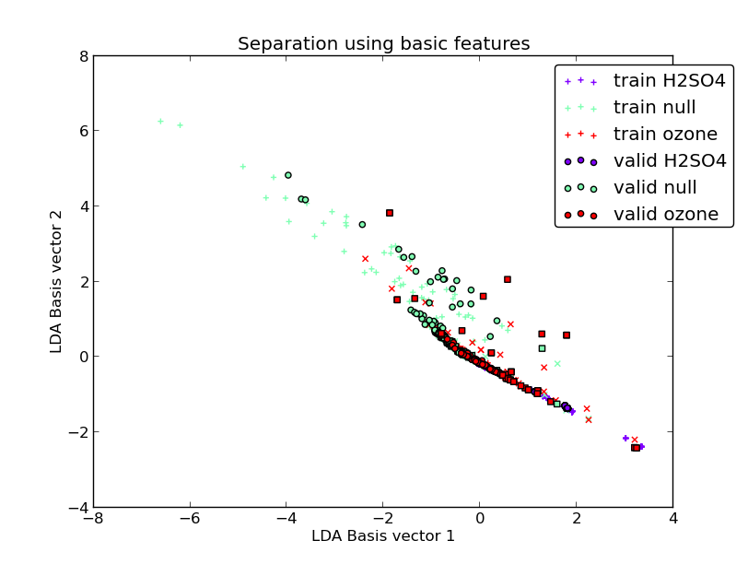Figure 9
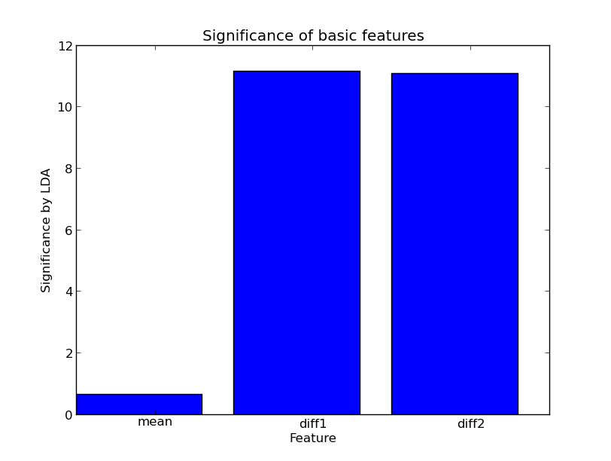Figure 10
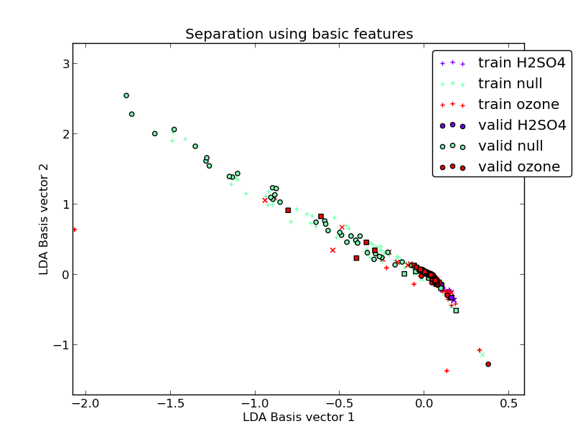Figure 11

2014-07-15

Ozone pulse data
The PLEASED dataset was updated to include new ozone data where ozone was applied at different intervals. Reading this in was a pain because the directory structure is different and there's only one plant instead of two, but it's done now.
The new data gives a lot of extra null data and several new ozone readings. In general, the plants don't seem extremely responsive to ozone, with only slight peaks at each application.

Feature ensemble
Continuing on from plotting basic features, using a set of features derived from both the deliverable and third year project: the mean and variance features described above, the Hjorth mobility, Hjorth complexity, skewness and kurtosis. The results are in figures 12 and 13.
These give an improved separation on the simple features, but there is still a very indistinct boundary between ozone and null. The most important features appear to be the differentials and to a lesser extent the two Hjorth features.
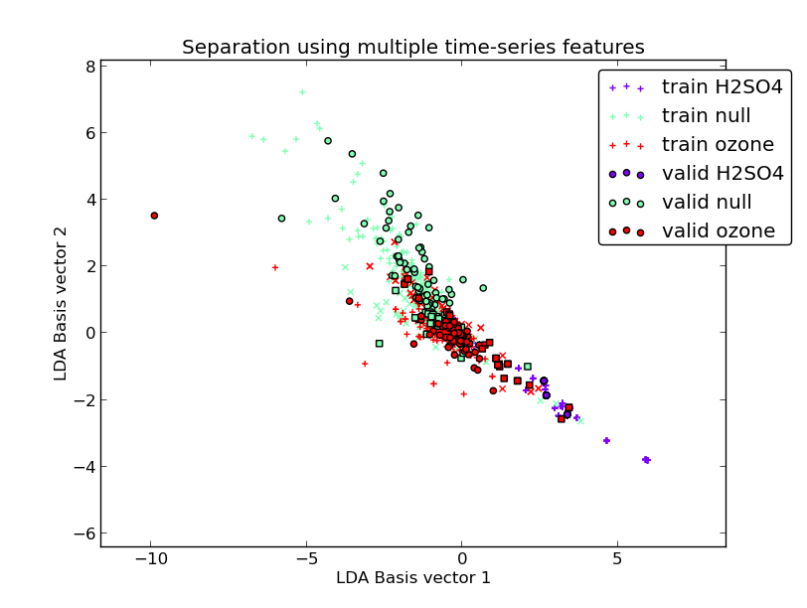Figure 12
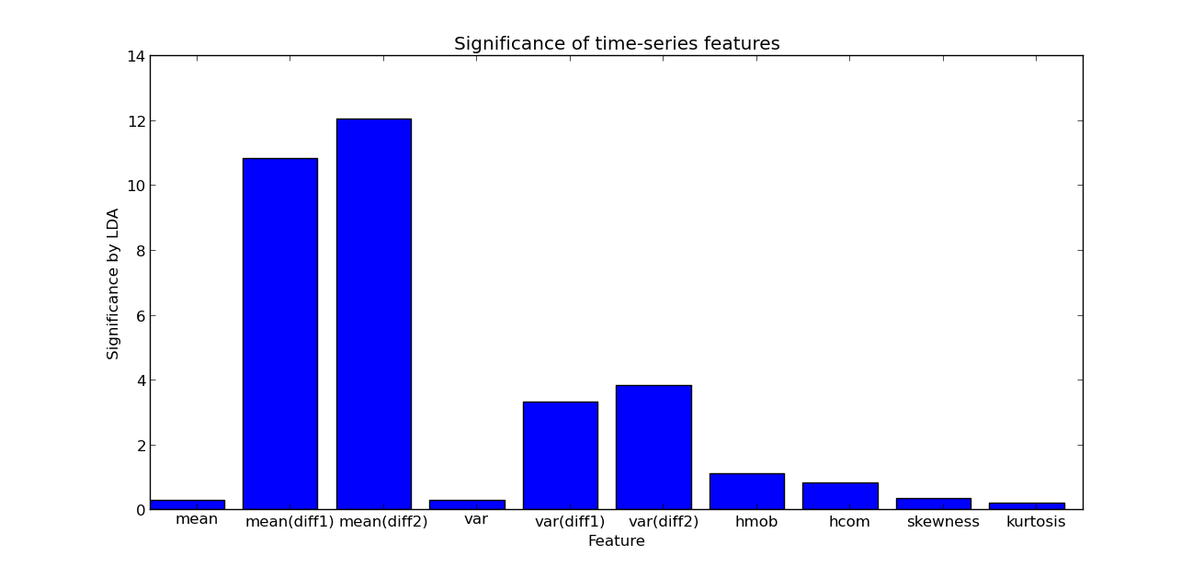Figure 13

Noise extraction
I attempted to extract the low-level variation in the signal by calculating a moving average (across 100 samples) on the data and subtracting the averaged signal from the original signal. Separating this on its own is a total mess (figure 14), but it may be possible there are other identifiable features (such as in the frequency domain).
Using the same noise extraction with the feature ensemble described above, a fairly similar separation is achieved (15) to the feature ensemble. The significance of features is also very similar to figure 13. This suggests that the features we are detecting in the feature ensemble are also present in the low-level noise data.
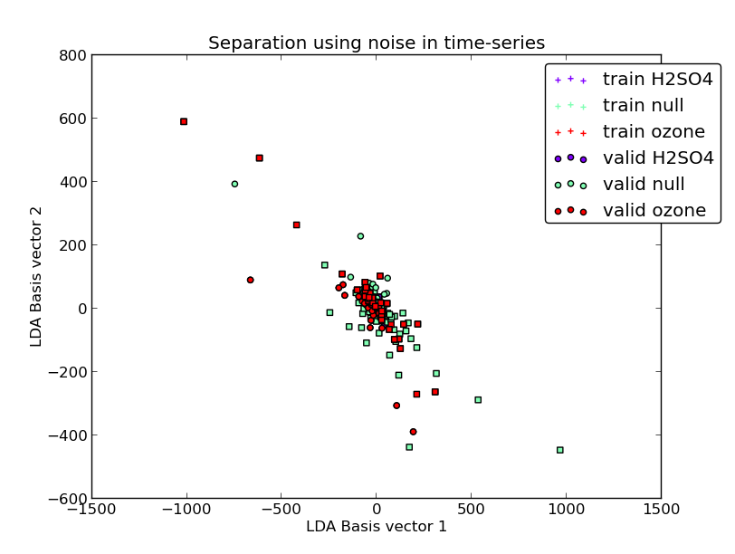Figure 14
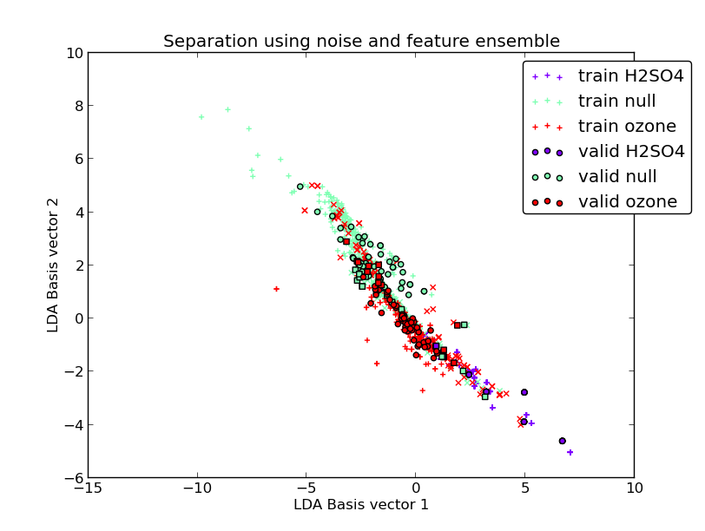Figure 15

2014-07-16

Electrode channels
Previously, all plots averaged the electrode channels. Instead, I tried performing all operations on them separately (de-trending, feature extraction etc.). The results were generally similar to the average, suggesting there is not much extra information between the channels.
I also tried taking the difference of the two channels and operating on that. Ideally, this should give the 'local' stimuli on a plant – stimuli that is impacting one electrode more than the other or a delayed propagation. In practice, the results were not very good, even after mixing up feature ensemble, noise extraction and raw data plots.

Fourier transform
Separating the data by performing a Fourier transform, on both the original and noise-extracted data gave very poor results.

2014-07-17

Sparse Discriminant Analysis
I attempted to separate the minimally-processed data using sparse discriminant analysis as implemented in the SpaSM MATLAB library. SDA is well-suited to datasets where the number of dimensions is more than the number of samples, because it uses an additional constraint to reduce the number of features used (many are reduced to a coefficient of zero).
The results are not as good as regular LDA (16). In particular, the validation set is not well separated, indicating that this method is (surprisingly) not reducing over-fitting.
Of particular notice is that because many features are reduced to zero, plotting the scaling of each feature gives much more informative results (17). This makes it very clear that the most relevant features are at the initial stimulus 'spike'. Although this initial spike is informative, it may not reflect real-life data well and perhaps should be removed.
SDA has many tuning parameters that should be looked into (such as reducing the number of relevant features even further). Here, half the features are still being used, which is still 1000 features!
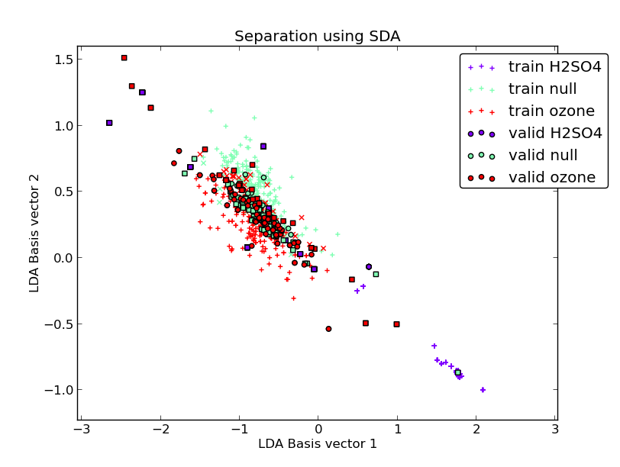Figure 16
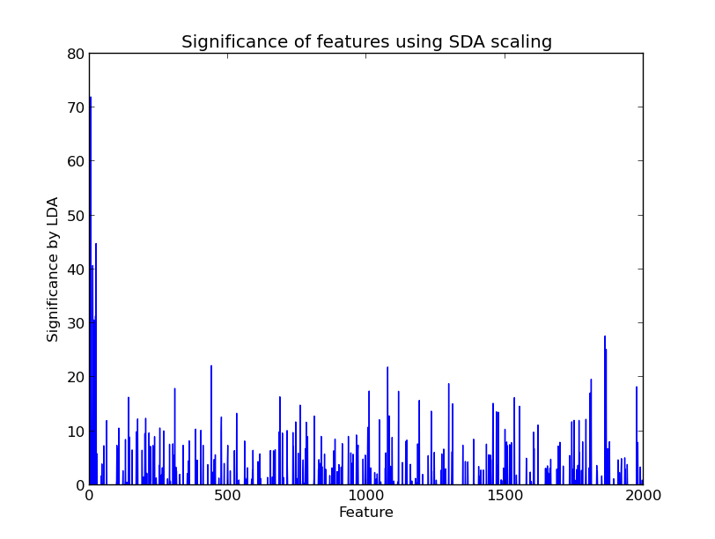Figure 17

2014-07-24

SDA separation with 50 features
Next, I tried separating the data using just 50 features, which is much less than the number of datapoints and therefore should seriously reduce overfitting. The results (18, 19) give poor results, but suggest the most important data is at the beginning of the window, plus two significant regions, one at 3 minutes and another at roughly 17 minutes, which seems to coincide with where the plant windows start increasing and where they peak.

Conclusions on overfitting and raw data as a feature
With so many samples and comparatively few datapoints, using the raw data alone is prone to considerable overfitting. The results from SDA, validation sets and plotting null data seem to indicate that most of the separation achieved with the raw data is actually overfitting and therefore the raw data alone cannot separate the data. On the other hand, calculating some simple features (on the raw data and on the noise) gives similar results with much lower overfitting. The next step is to investigate more sophisticated feature extraction methods (Fourier, wavelets) and use SDA to identify which features are important.
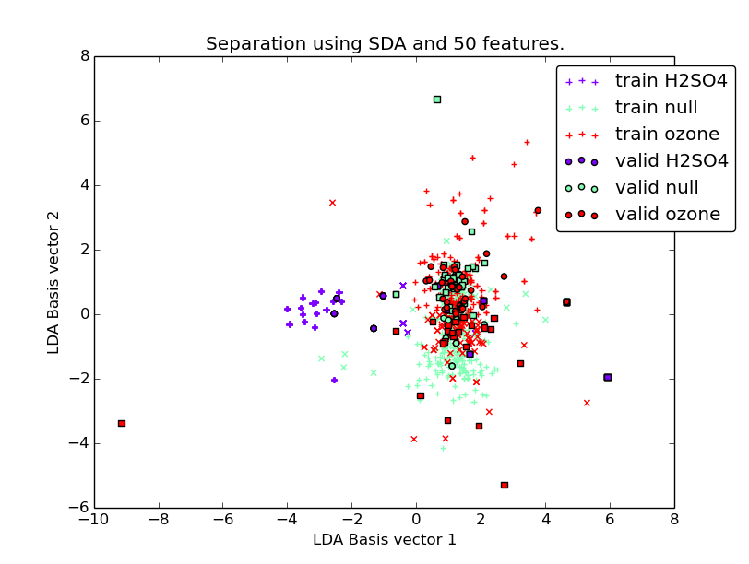Figure 18
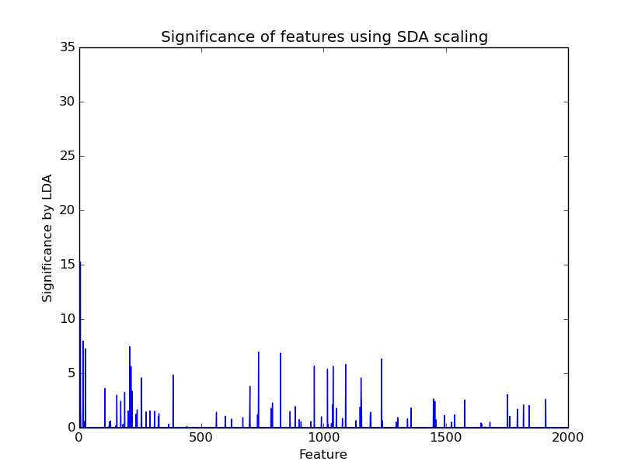Figure 19

Wavelets
Simply performing LDA on the wavelet transform (with all results concatenated) gave poor results. The software now plots wavelet transforms in script generate.py, which can be inspected to search for patterns within or between classes. It may be a good idea to analyze individual features of the wavelets. Doing this to the noise gave good results above and the Haar wavelet behaves similarly.
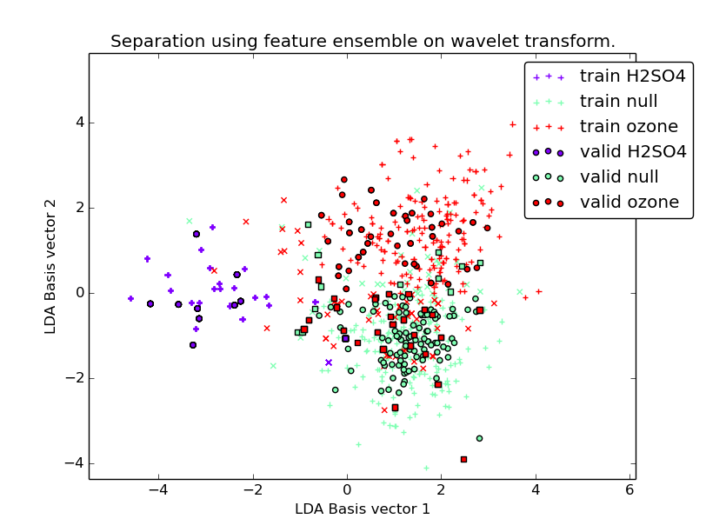Figure 20
Running the feature ensemble over every level of the wavelet gives impressive results (20), demonstrating a clear and similar separation in the training and validation data.
The significance of each feature by SDA (21) indicates that kurtosis and the Hjorth mobility are the most important features at multiple levels. The kurtosis is typically used in probability distributions. A high kurtosis indicates a steeper peak, while a low kurtosis is a more rounded peak. In this context, the kurtosis must be describing the general shape of the signal. The fact this is important on multiple levels using SDA suggests that each level's kurtosis is giving useful and different information about the shape of the signal.
In terms of wavelet levels, most of the features are being selected from the high frequency data (especially levels 6-8). The low frequency data is less important, except for level 0. This might be because very broad information about the signal can be inferred at that level, while levels 1-5 don't offer much additional information.
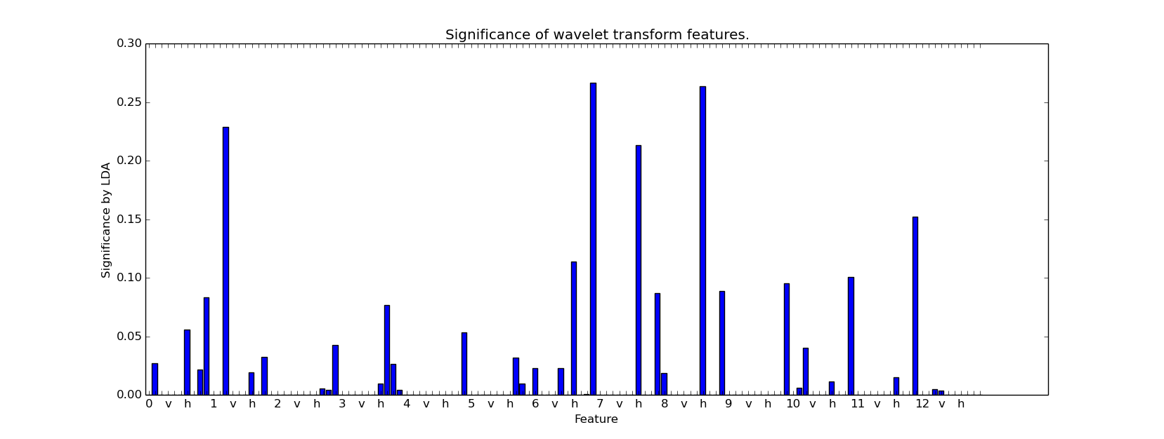Figure 21

2014-07-29

Derivatives
Smoothing the data (with moving average size 100), taking the first derivative of each electrode and then subtracting the mean gives interesting results. Subtracting the mean from the first derivative is essentially the same as eliminating linear trends
The correlation between H2SO4 electrodes is generally very high and in some cases there is a delay. The cross-correlation could be used to calculate this delay, which may characterize H2SO4.
The null data also exhibits correlation, so correlation probably cannot distinguish a stimulus from null.
Ozone appears to exhibit two very obvious properties in the derivative plots. First, one electrode experiences a steep decline shortly after stimulus application, while the other electrode does not (or it is much lesser). Otherwise, the two electrodes appear to be correlated and sometimes anticorrelated (where they move in opposite directions).
To test the anticorrelation in ozone, I tried plotting the data as above, but using the absolute value. Taking the absolute means that the anticorrelated features in the ozone are now correlated. Taking the absolute values means some windows are more correlated and some less, while somewhat improving ozone correlation. The correlation of both these transformations should be investigated.

2014-07-30

Cross-correlation
The data is cross-correlated and plotted. The maximum of the cross-correlation plot indicates the delay between the two signals, so it is usually towards the middle of the plot. Some of the electrode channels repeat themselves (autocorrelate), which means there are often multiple peaks in the cross-correlated plots. To prevent huge time delays being detected a Hanning window is applied to the result which emphasizes central maximums.
Performing SDA separation on the cross-correlation plots alone (with and without windowing) and on the maximum index of these plots (the time delay) gives very poor results.
On the other hand, running the feature ensemble on the cross-correlation data gives yet another very good separation (22). The most significant features appear to be the mean of the derivatives and the Hjorth mobility (23).
Considering how well the feature ensemble performs on multiple different kinds of data, it is definitely worthwhile to see if a combination of feature ensembles on different transforms of the data (raw data, wavelets and cross-correlation) give better results. If the results are not improved, then it's likely the multiple feature ensembles are redundant.
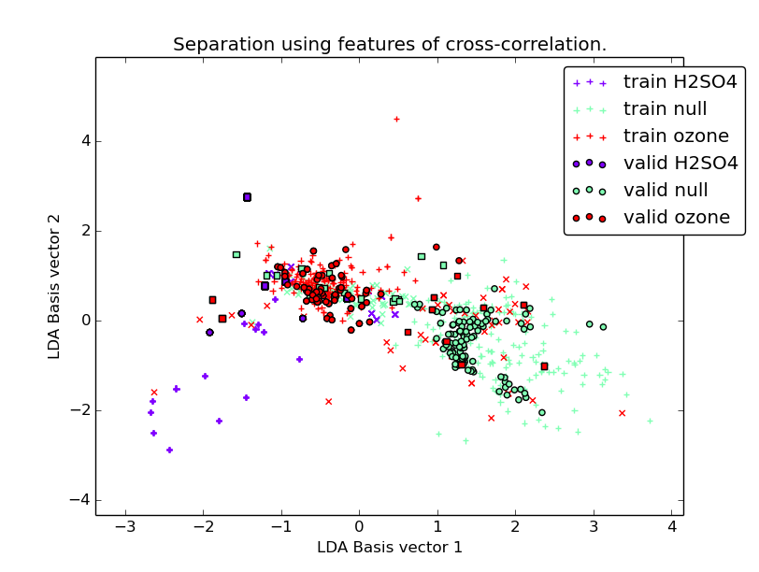Figure 22
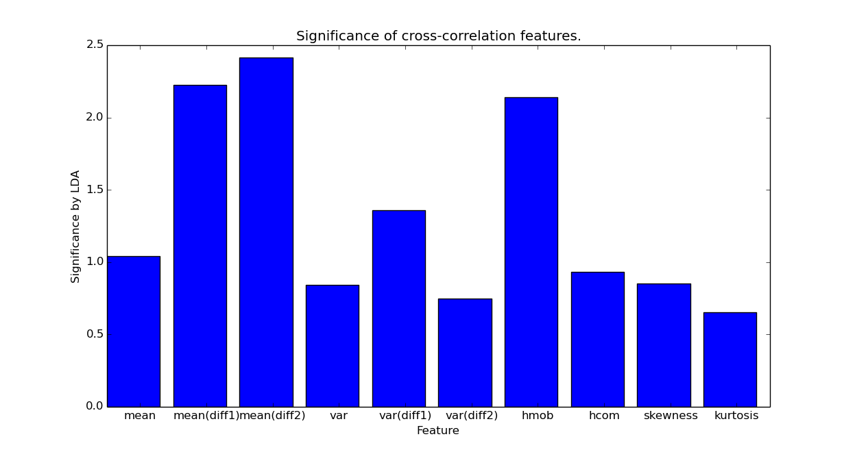Figure 23

Multiple feature ensembles
Four different feature ensembles were used from:
- The average of the two electrode channels.
- The noise of the averaged electrode channels.
- The wavelet transform.
- The cross-correlation.
The results are shown in figure 24. The separation is about on par with the separation of other feature ensembles, so this combination doesn't give hugely improved results. This would suggest that the various feature ensembles are somewhat redundant, that they are describing the same characteristics.
The significance of features (25) shows that the same wavelet features as above are significant. The Hjorth, skewness and kurtosis features of the average and noise are useful and Hjorth features of the cross-correlation are extremely important.
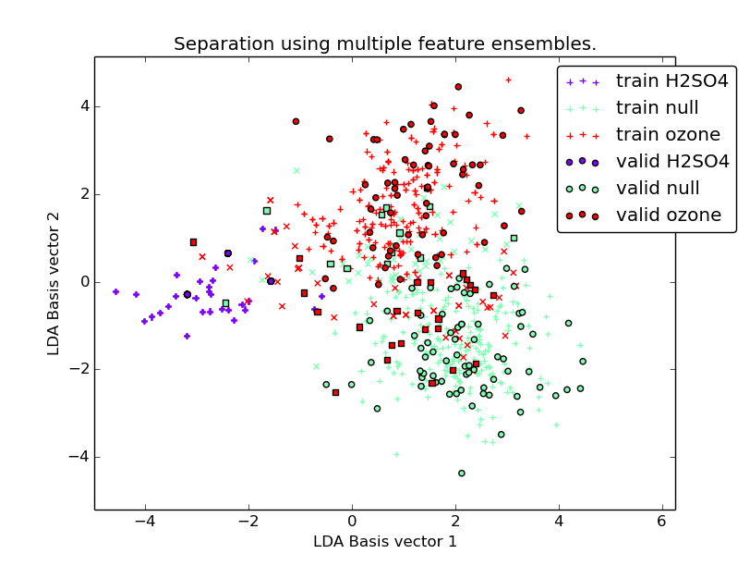Figure 24
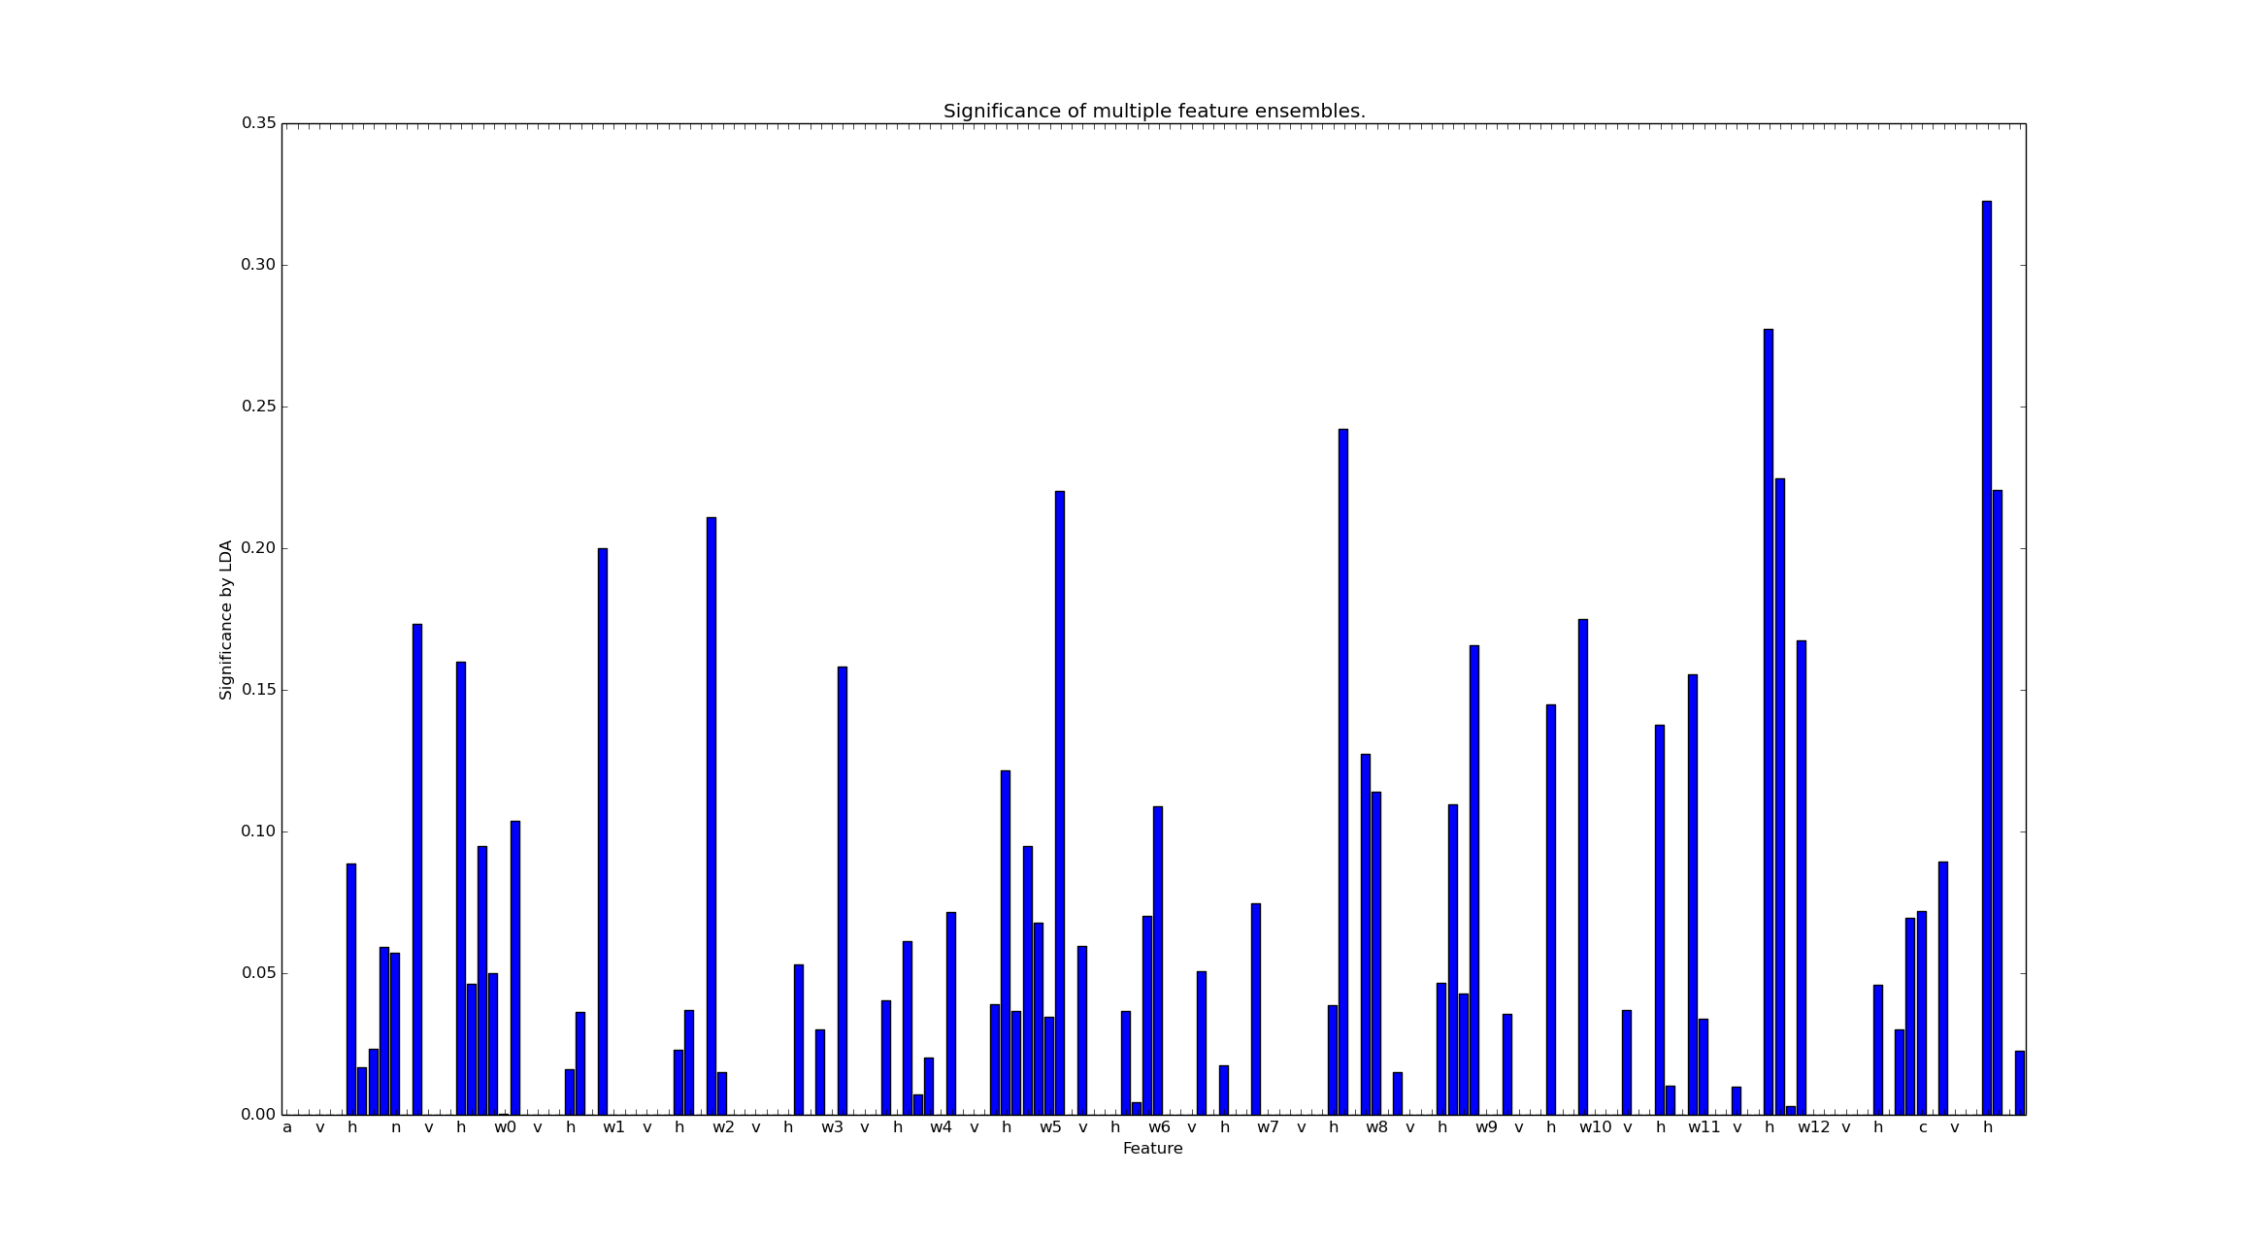Figure 25

2014-07-31

Null separation again
This time, null separation is done with train/validation sets. First, I tried the previous null separation test again. With a validation set, there is no clear separation among null data and some with the ozone and H2SO4. This suggests that the previous null separation was just a matter of overfitting and not indicative of any general trends within the experiments.

2014-08-01

Noise Cross-correlation
Plotting the cross-correlation of the derivative of the extracted noise (as calculated previously), without windowing, gives a much more consistent normally distributed plot than performing it on the raw series. In general the noise of the two electrode channels correlates as well - if not better than - the raw time series.
Using this as a classifier gives acceptable results (26), but not quite as good as the cross-correlation on the raw data series. The significant features are similarly evenly distributed
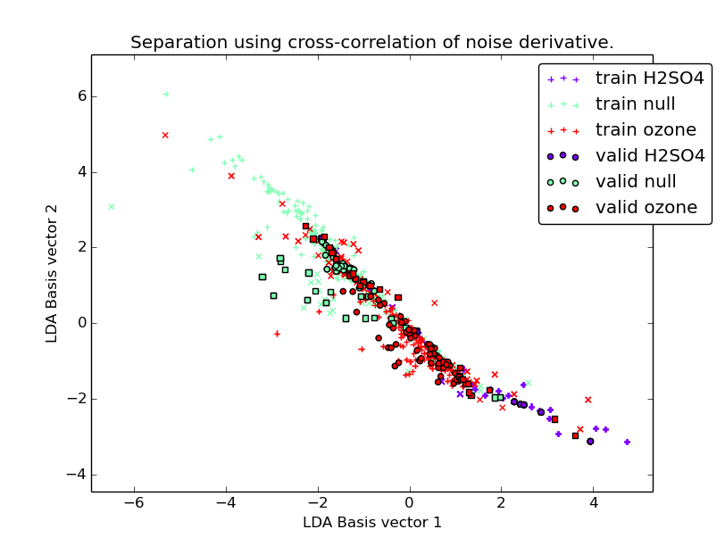Figure 26

2014-08-05

Independent Component Analysis
ICA is used to separate a signal into its independent sources, given multiple 'mixtures' of that data. Our electrode readings are coming from multiple different sources in the plant, so separating them may reveal important patterns. In this case I'm using the algorithm FastICA. Because we have two electrodes, ICA can separate the readings into two sources. One downside of ICA is that it assumes there is no delay. Unfortunately, some of the plant readings appear to demonstrate some amount of delay.
The results of plotting ICA on each plant and each stimulus window are in the folders 'ica' and 'ica_plants'. The results don't appear to show any consistent patterns, although some stimulus applications 'leap out' more after ICA is applied.
Plotting ICA on the 'noise' of each plant gives more interesting results. Patterns that clearly occur on both electrodes are separated, often leaving one source as the 'real' signal and the other source the residual noise. It's definitely worth investigating if this can produce a better separation.

2014-08-12

DUET algorithm
The DUET algorithm is another ICA algorithm that assumes sources are separated in the time-frequency domain. Meaning, sources occur at different times or at different frequency ranges. This allows the separation of more than two sources from two sets of readings as well as allowing for small amounts of delay.
The results for DUET don't come out as well. DUET is mostly designed for audio and reconstructs the signals from the time-frequency domain. This combined with the assumption that the data can be separated by frequency gives some ugly results, with lots of fluctuations that don't appear in the original series. However, some of the lower-magnitude components appear to display noticable increases in variance at each stimulus application, especially with the acid data.

Separation by ICA
I tried to separate the data using the FastICA algorithm on the noise of the electrode channels, followed by a feature ensemble. While the separation wasn't exceptional, the results were very unusual (27). Firstly, the training and validation sets all seem to match very closely (28, 29, 30). Secondly, all the classes have unusual distributions, in particular H2SO4 which is clearly split into two distinct clusters (a multi-Gaussian might better separate them). The features identified as important were the mean and variance differentials on both channels.
My next step will be to investigate these results. In particular, identify what/why features are important to the separation and what is causing the unusual clustering, especially in the H2SO4.
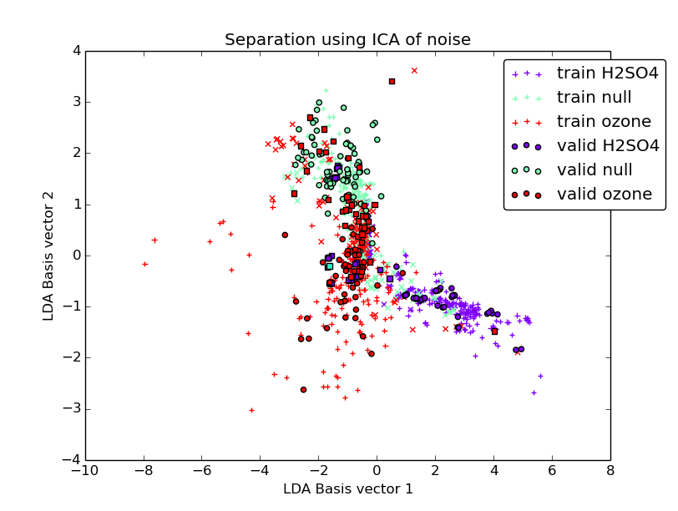Figure 27
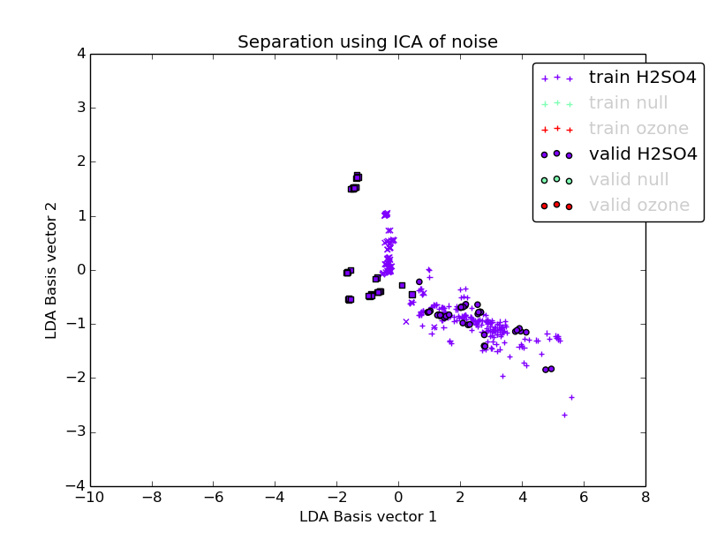Figure 28
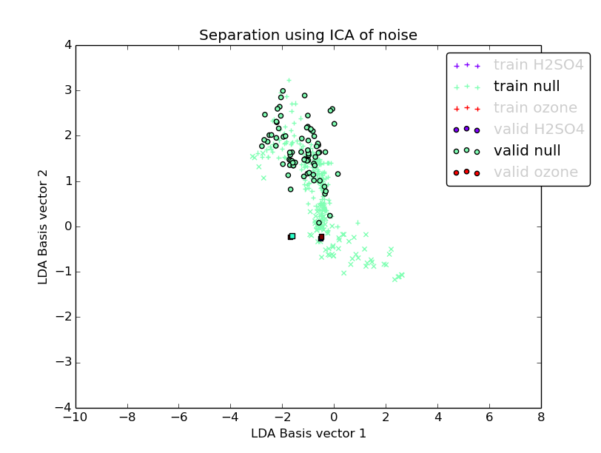Figure 29
the covariance matrices are computed and stored in the self.covariances_ attribute.
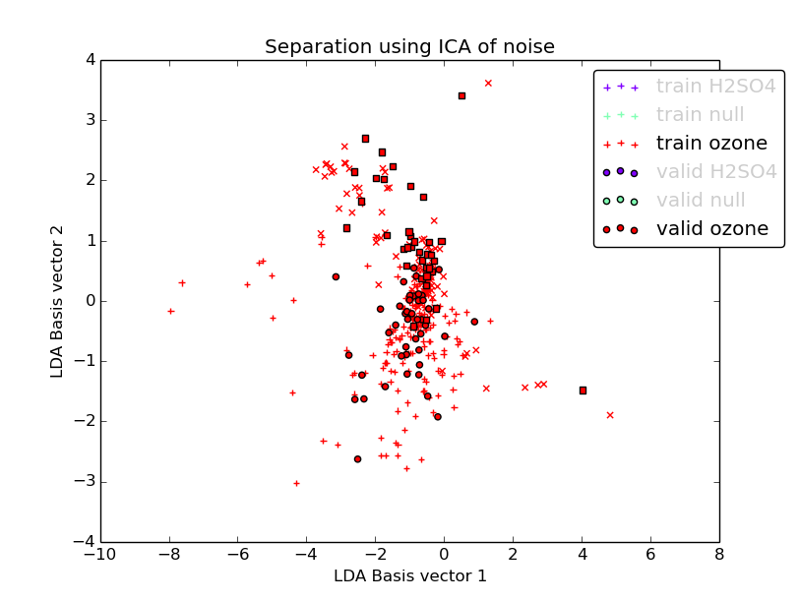Figure 30

2014-08-13

Investigation of ICA separation
Looking at the plotted ICA noise, it seems clear that the H2SO4 can be split into two categories: high-variance data with a big difference between the two sources and low-variance data very close to zero. This would explain the two clusters described above. The very tight H2SO4 cluster close to the origin is likely the low-variance cluster, which is incorrectly classified and shares space with lots of ozone and null datapoints. Looking at the original data, these datapoints appear to show obvious long-term trends with little noise (very clear curves). The basic features of the high-frequency noise cannot distinguish these points, but it's likely they can be told apart using lower-frequency information.
There are two approaches that could be taken for this. Either, increase the moving average window when calculating the noise, which will include more low-frequency features or a wavelet approach. Haar wavelets will retain the low-frequency information as well as the high frequencies. The issue with this approach is how/if ICA can be applied to the wavelet levels.

2014-08-18

Multiplied noise
As a further investigation into the correlation of the noise between the two channels I plotted the results of taking the noise and performing an element-wise multiplication between the two channels (essentially the cross product). A positive value would indicate both channels have the same sign, negative that they are opposite. This way, it can be seen when the two channels strongly correlate and when they do not.
Although the plotted results looked promising, actual classification by feature ensemble or raw data series was not.

2014-08-19

Online learning
In order to get a feel for how a classification method would work in real life and also to identify weaknesses of various classifiers, I implemented pretend online learning, by plotting the LDA classifier's class probabilities on overlapping windows for each experiment. I used the feature ensemble in this case because it gives reasonable results.
The plots (in 'plots/online') show where classification succeeds and fails. In general, the classifier seems extremely confident about when H2SO4 occurs and when it does not, except for the H2SO4 ural testscabbage experiments, where it consistently fails. The classifier does a much worse job at differentiating ozone and null.
This method also illustrates overfitting very well. To demonstrate, I plotted online learning using the minimal classifier that uses all datapoints as features. The results show sudden spikes around each stimulus giving the correct classification and almost randomly changing between 0 and 1 probability elsewhere.

2014-08-21

Power Spectral Density
Plotting the power spectral density (squared fourier transform) across time gives promising results, with certain properties across classes that are not obvious in the time series data. However, attempting to separate on just the power spectral density values does not give good results.
It seems likely there are some properties that can be calculated from the power spectral density that will reveal patterns in the data in a linearly separable way.

2014-08-28

Power Spectral Density PCA
I looked at the way PSD behaved within each class, by summing together the 2D power spectral density plots and also identifying the principal components within each.
The summed together results show some distinct patterns within each class. H2SO4 (31) didn't reveal anything obvious in the frequency ranges, but does demonstrate the characteristic spike at the start of each window. Although I haven't looked at this class much, the stimulus for when the light is turned on (32) is very interesting, with an extremely clear frequency band (but this may be a result of mains 'hum'). The null plot (33) is exactly as borrowing as you would hope, with no defining features at all. Finally, the ozone plot (34) at first glance is very plain, but looking closer has a few very distinct high frequencies.
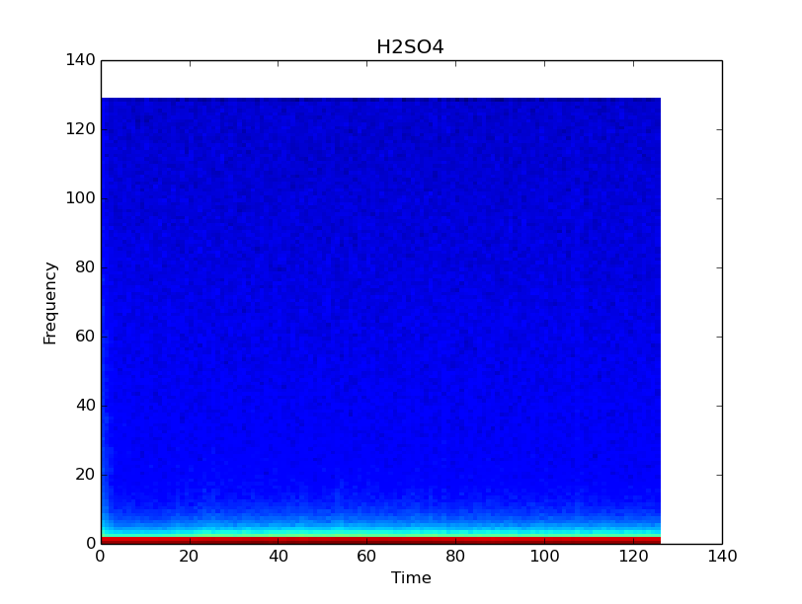Figure 31
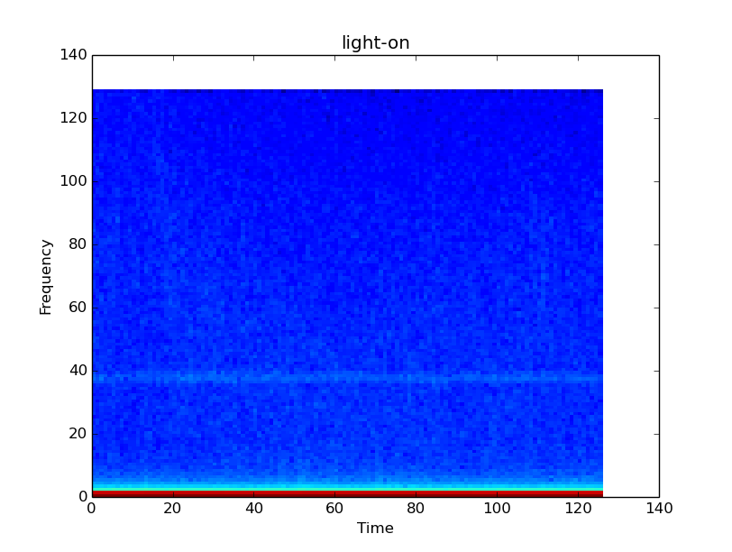Figure 32
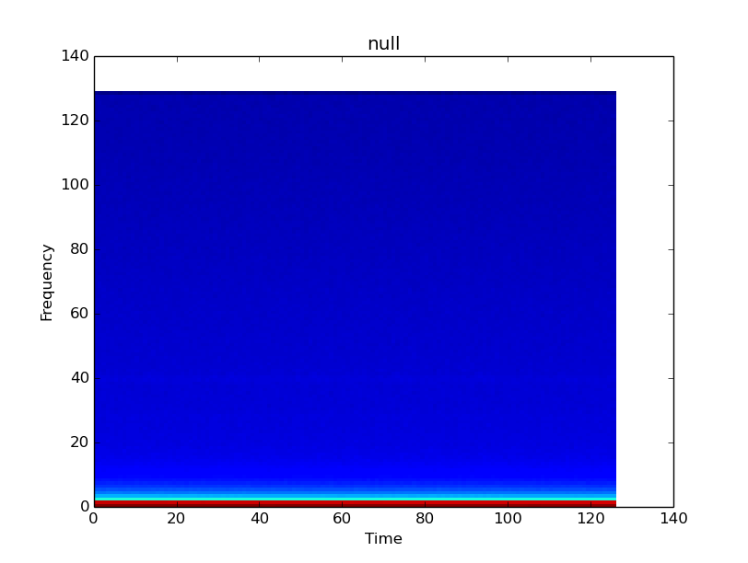Figure 33
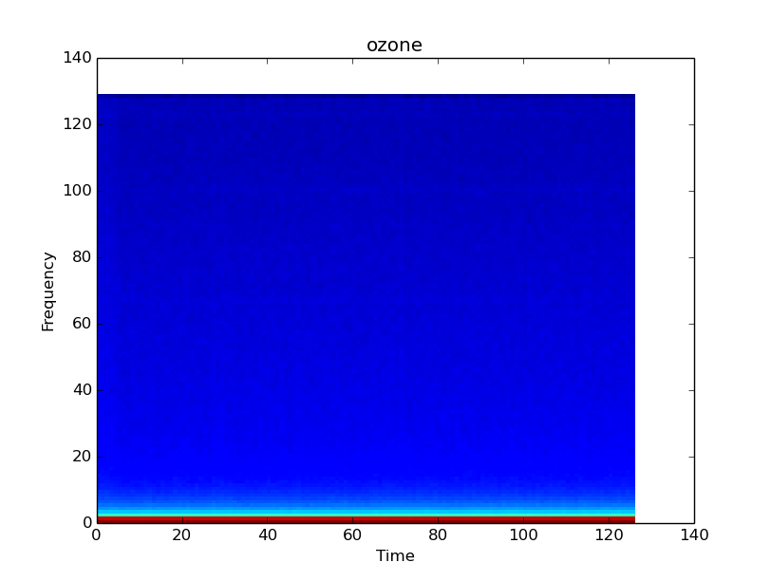Figure 34
When performing PCA on each of these classes I looked at both the high-variance and low-variance components. I expected the low-variance components to reveal similarities within each class, but they were mostly just noise. The high-variance components helped identify some of the more distinct frequency bands, such as in the null (36) and ozone (37). However, the fact these are high-variance means they are not characteristic of every stimulus application in the class! They may help better classify some data points, but not others.
Figure 35
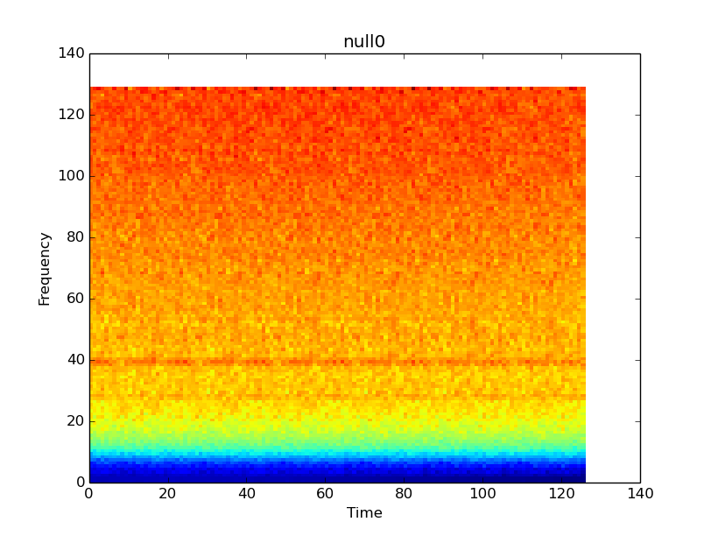Figure 36
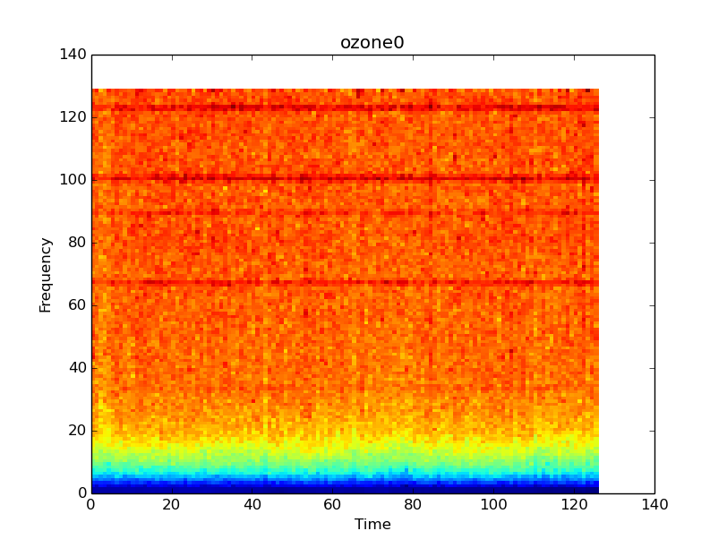Figure 37

2014-09-02

Initial ozone stimuli
Separating null and ozone reliably is still a significant problem. It was suggested that the cause might be that the plant is closing its pores upon ozone stimulus, halting (or reducing) the response. In this case, it would be expected that the first ozone stimulus would be significant and more recognizable than later stimuli. Separation using the wavelet histogram (38) showed the usual poor separation between null and ozone, a better (but not great) separation between null and ozone_initial and poor separation between ozone and ozone_initial. This somewhat supports the theory that the plants are less responsive to later ozone applications.
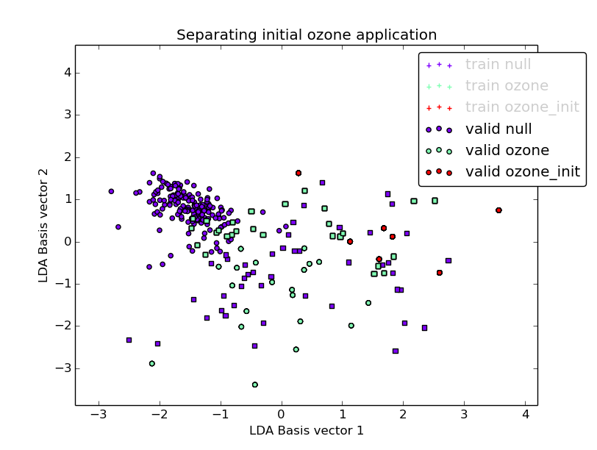Figure 38

Propagation of response
I measured the time delay between the two electrode channels using the cross-correlation on various transformations of the data, such as the original data, the moving averaged-subtracted data and the first derivative. Across all classes, the delay was zero the majority of the time, otherwise it was seemingly randomly distributed.

To-do
- Eliminate experiment bias
  - Subtract null from data
    - Might require serious restructure/clever use of pipelines
    - Very careful not to introduce bias!
- Feature extraction
  - Investigate low-level features in noise
  - Windowed features
  - Pyramid scale-space windows
  - Difference between electrodes
- Quantify quality of LDA via distance between means
- Perform LDA (PCA?) on transposed dataset separated by class
  - Will yield values indicating variance of each feature within each class
- Consider classification on smaller windows across length of stimulus application
- Look at feature values in online learning + switching behaviour between classes

