1. Yes, there are 3 houses with sale prices more than 3 standard deviations from the mean. Houses 40, 60, and 94 are 3.11, 3.11, and 5.52 standards deviations from the mean respectively, making them outliers.
2. Looking at the frequency data visually, it does not appear that the data is normally distributed.   
   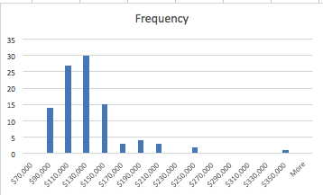
3. According to the single variable regression analysis UFFI has a direct correlation, assuming you remove outliers, with a P-value of 0.039.  
   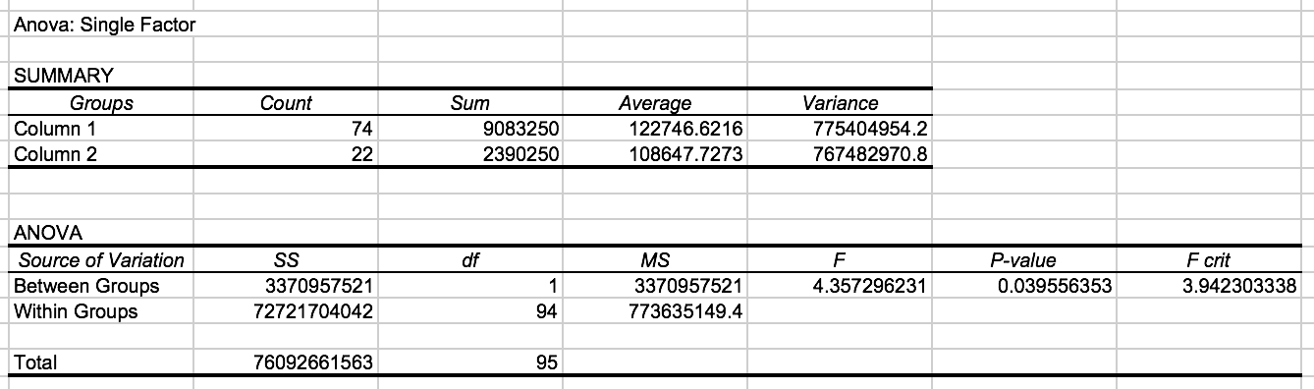
4. When taken into account with the rest of the variables present, UFFI is a significant predictor of home price, with a p-value of 0.003. However, with an R-square of 0.644 there isn’t a terribly strong correlation, indicating this might not be as good of a predictor as the P-value indicates:  
   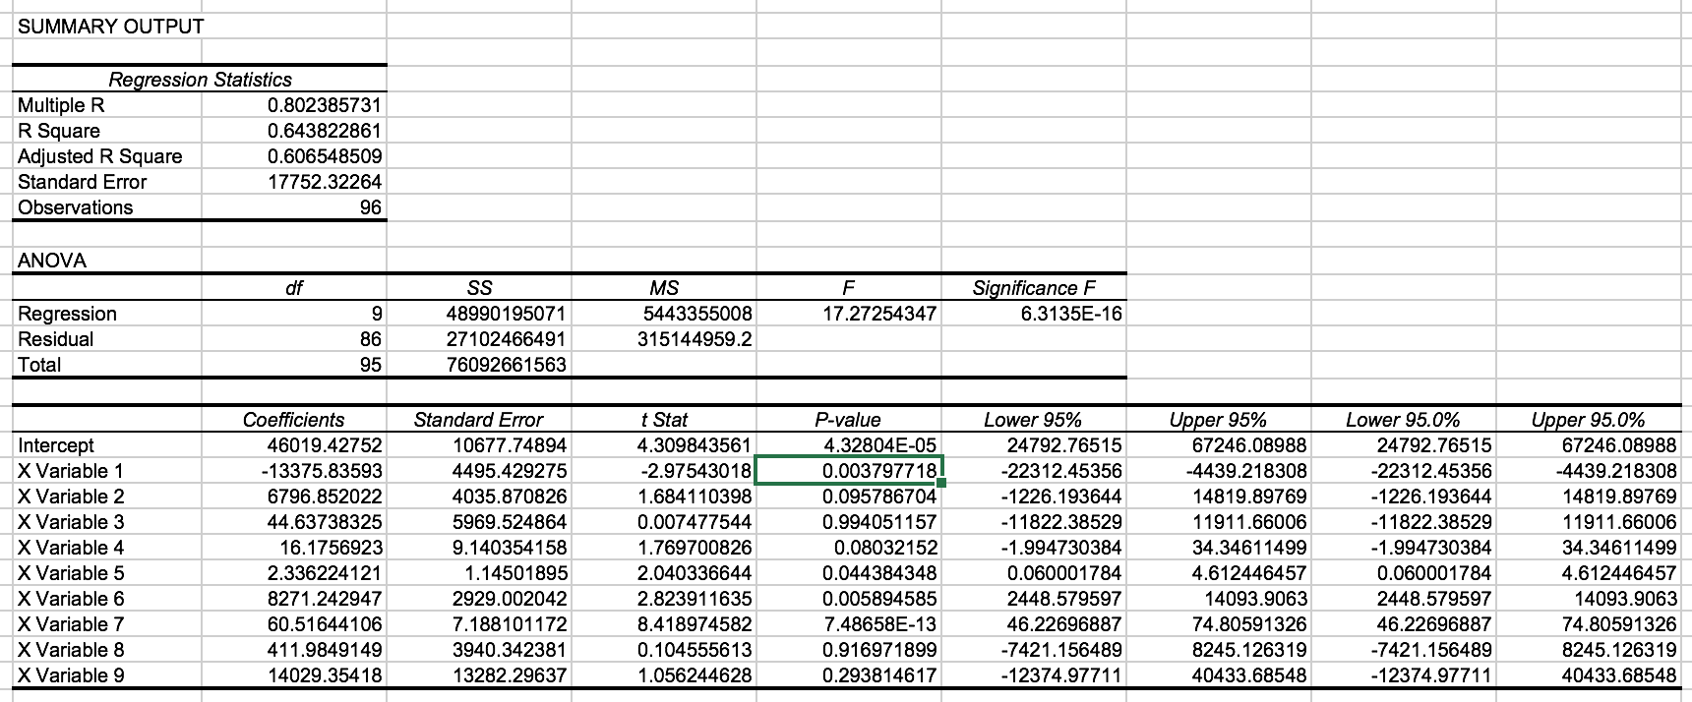
5. The ideal model includes just 5 variables, UFFI, basement, lot area, enclosed parking spaces, and living area. Providing the below model. All P-values are below 0.05, which indicates that we’re only taking into account variables that are statistically significant, but an adjusted R square of 0.607 indicates that the model is still not an excellent predictor of housing prices.  
   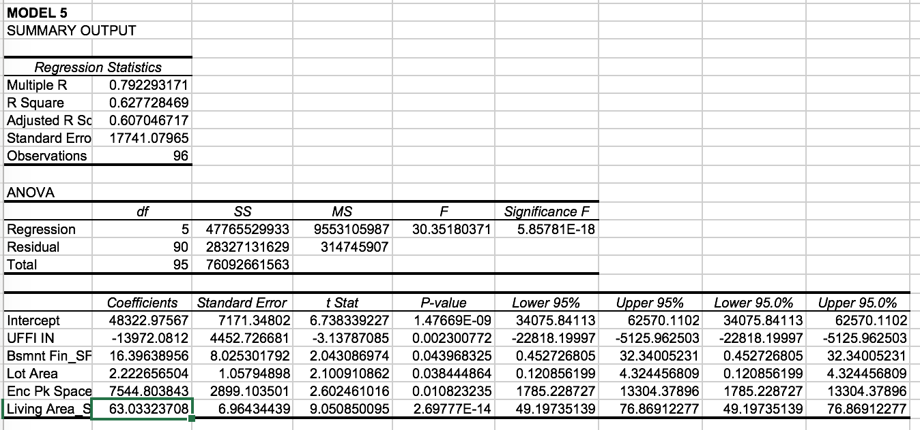
6. We expect the presence of UFFI to decrease the house price by about $14,000.
7. The following cells show the predicted price of the house.   
   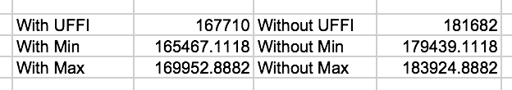
8. Based on the information given, the client potentially overpaid by up to $80,000 according to our confidence interval models. In terms of the client’s reimbursement, it should come in the amount of $14,000. There’s no way to value the market’s speculation or perceptions so the client should only be reimbursed for the calculated effect of UFFI, approximately $14,000.