Naming Convention

All of the points in figures 1, 3, 4, and 5 will remain in the naming convention. For the points in figure 3, 4, and 5, the side of the bat will need to be specified in a similar manner to figure 1. Most of the points in figure 2 are already account for in figure 1. Of the seven points in figure 2, three of them will remain the same: Sj18, Sj19, and Sj20. Sj13 will be named hip. Sj14 will be named knee. Sj11 will be named ip5. Sj08 will be named ip4. The side of the bat that these points are on will also need to be specified.

As for the naming the coordinates of the points, the naming has to be as follows: for the z-coordinate of the point called “hipR”, the coordinate will be called “hipR_Z”. The naming convention is the same with the appropriate changes for the x and y coordinates of the points.

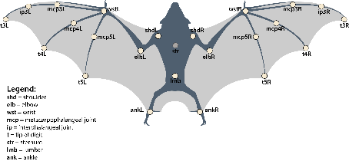

Figure 1

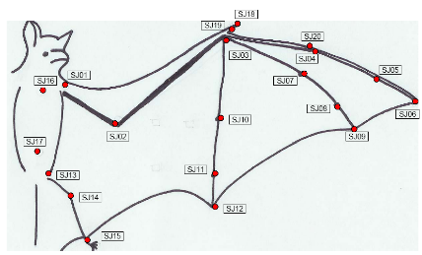

**Sj01-Sj20 (20)**

Figure 2

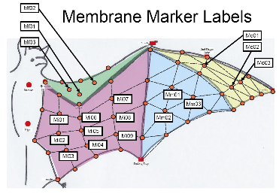

**Mf01-Mf03**

**Mi01-Mi09**

**Mm01-Mm03**

**Mo01-Mo03**

**(18)**

Figure 3

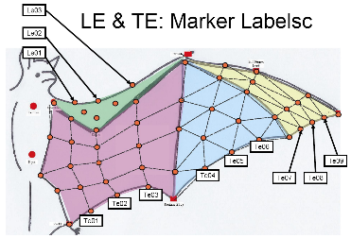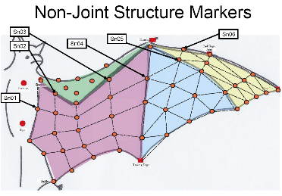

**Sn01-Sn06 (6)**

Figure 5

**TE01-TE09**

**LE01-LE03**

**(12)**

Figure 4