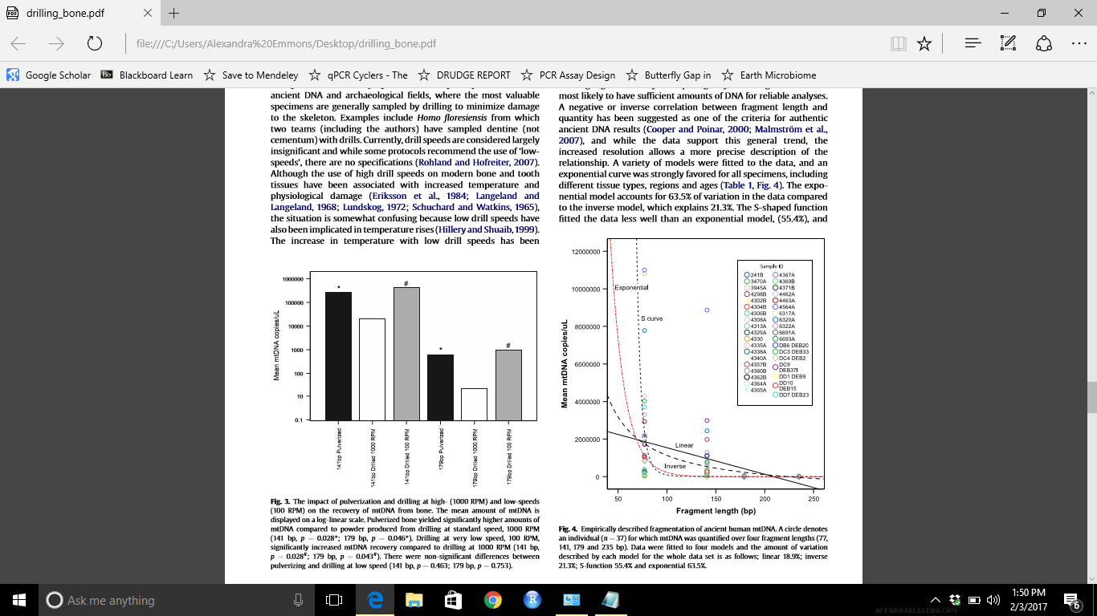

From Adler et al. (2011).

According to Tufte, the background or other extraneous information should not take away from the graph. This graph does not include futile gridlines that would normally distract the reader. However, some simple grid lines could make the data easier to read. Therefore, it most of the ink is contributed to the data, with the exclusion of the legend, which is fairly meaningless and could be presented in a table. The legend and colors for each individual are not necessary.

The x-axis is misleading given that this is not continuous data, but that there were only 4 fragment sizes.