**Logical Modelling**

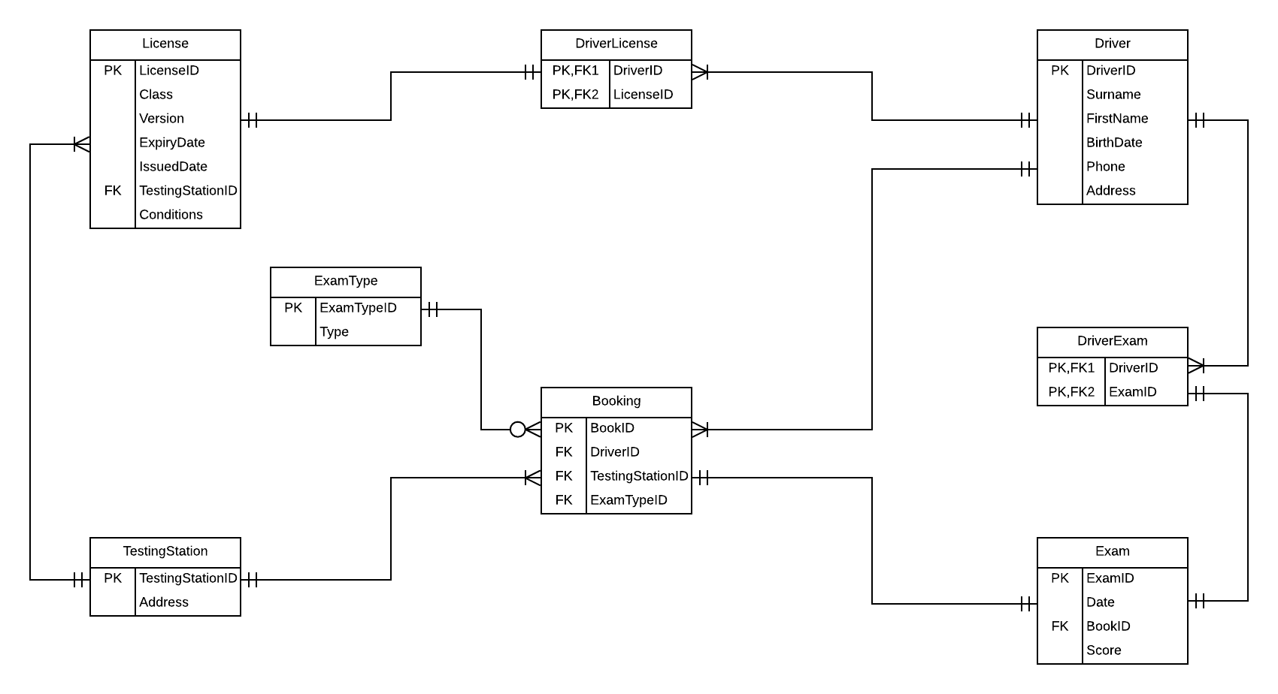

|  |  |  |  |
| --- | --- | --- | --- |
| **Table Name** | Driver | | |
| **Field Name** | **Key Field** | **Data Type** | **Constraint** |
| DriverID | PK | int | Not null |
| Surname |  | varchar | Not null |
| FirstName |  | varchar | Not null |
| BirthDate |  | date | Not null |
| Phone |  | varchar | null |
| Address |  | nvarchar | Not null |

|  |  |  |  |
| --- | --- | --- | --- |
| **Table Name** | DriverExam | | |
| **Field Name** | **Key Field** | **Data Type** | **Constraint** |
| DriverID | PK, FK | int | Not null |
| ExamID | PK, FK | int | Not null |

|  |  |  |  |
| --- | --- | --- | --- |
| **Table Name** | Exam | | |
| **Field Name** | **Key Field** | **Data Type** | **Constraint** |
| ExamID | PK | int | Not null |
| Date |  | date | Not null |
| BookID | FK | int | Not null |
| Score |  | numeric | Default value: 0.0 |

|  |  |  |  |
| --- | --- | --- | --- |
| **Table Name** | Booking | | |
| **Field Name** | **Key Field** | **Data Type** | **Constraint** |
| BookID | PK | int | Not null |
| DriverID | FK | int | Not null |
| TestingStationID | FK | int | Not null |
| ExamTypeID | FK | int | Not null |

|  |  |  |  |
| --- | --- | --- | --- |
| **Table Name** | DriverLicense | | |
| **Field Name** | **Key Field** | **Data Type** | **Constraint** |
| DriverID | PK, FK | int | Not null |
| LicenseID | PK, FK | varchar | Not null |

|  |  |  |  |
| --- | --- | --- | --- |
| **Table Name** | License | | |
| **Field Name** | **Key Field** | **Data Type** | **Constraint** |
| LicenseID | PK | varchar | Not null |
| Class |  | varchar | Not null |
| Version |  | int | Not null |
| ExpiryDate |  | date | Not null |
| IssuedDate |  | date | Not null |
| TestingStationID | FK | int | Not null |
| Conditions |  | nvarchar | null |

|  |  |  |  |
| --- | --- | --- | --- |
| **Table Name** | ExamType | | |
| **Field Name** | **Key Field** | **Data Type** | **Constraint** |
| ExamTypeID | PK | int | Not null |
| Type |  | varchar | Not null |

|  |  |  |  |
| --- | --- | --- | --- |
| **Table Name** | TestingStation | | |
| **Field Name** | **Key Field** | **Data Type** | **Constraint** |
| TestingStationID | PK | int | Not null |
| Address |  | nvarchar | Not null |

# Normalization

## UNF

|  |  |  |  |  |  |  |
| --- | --- | --- | --- | --- | --- | --- |
| Theate Name | Location | Seats | Year | Manager | Manager phone | playing |
| Rialto | 11 Moray street | 600 | 2015 | MR W | 021-888888 | Name: xxx,  genre: xxx,  author: xxx,  author address: xxx |
| Rialto | 11 Moray st | 600 | 2015 | MR W | 021-888888 | Name: yyy,  genre: yyy,  author: yyy,  author address: yyy |
| Rialto | 11 Moray st | 600 | 2015 | MR W | 021-888888 | Name: zzz,  genre: zzz,  author: zzz,  author address: zzz |

## 1NF

## 

## 2NF

## 

## 3NF

