Årsoppgave Documentation

Contents

Uke 9 3

Spotify API Code Example 4

Conclusion 5

Uke 13 6

SMTP Code Example 7

Conclusion 8

Uke 14 9

Abstract & Hcaptcha Code Example 9

Conclusion 10

Uke 15 11

Submit Form Function Code Example 12

Conclusion 13

Uke 19 14

Conclusion 14

Uke 20 15

# Uke 9

* Started researching the Spotify API
* Watching some tutorials to understand the API and how it works

Et bilde som inneholder tekst, skjermbilde, Menneskeansikt, Multimedieprogramvare

KI-generert innhold kan være feil.

* My plan is to create a website that integrates the Spotify API, a login system, and databases using HTML, CSS, and JavaScript for the front end, and Python for the backend as the API. I will connect the databases and use Flask for the login systems.

## Spotify API Code Example

* This week, my main goal is to test the different functions available in the Spotify API.
* Added a **get_token** function that connects to Spotify to obtain an access token, acting as a temporary pass to access Spotify's data.
* Added a **/get-artist-image** route that retrieves and displays an artist’s image from Spotify based on the user’s search.
* Added a **search_artist** function that displays the artist’s name from Spotify when a user searches for an artist.

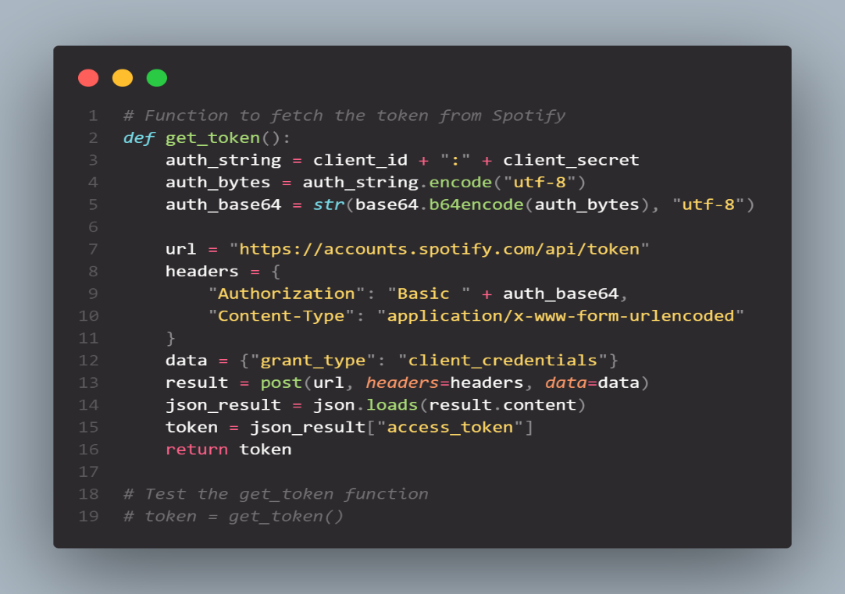

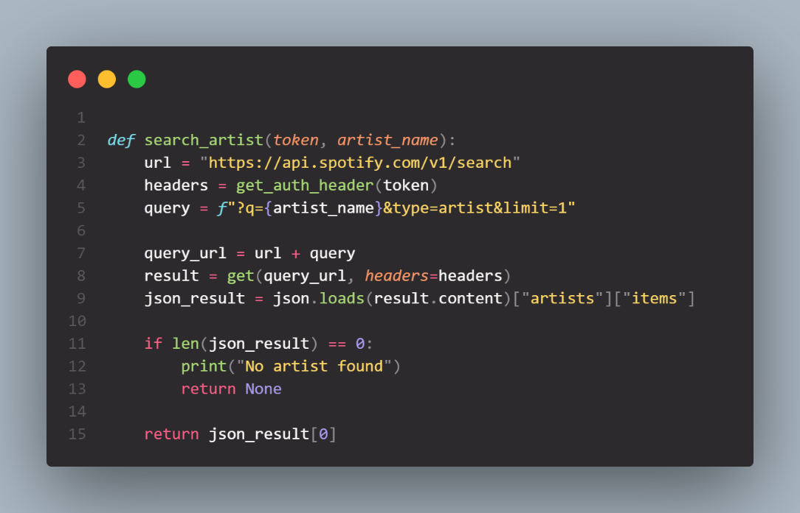

### Conclusion

* After working with the Spotify API, I realized that there were parts of the code I didn’t fully understand, especially on JavaScript. My initial plan was to create a Tinder-style music app using Spotify, where users could like or dislike songs to generate a playlist. However, I discovered that Spotify doesn’t allow full song playback, which is a key feature for my project. Because of this limitation, I decided to shift my focus on working my portfolio instead.

# Uke 13

* Began planning using GitHub Projects.
* My objective is to combine two APIs, **Abstract** and **hCaptcha**, to create a contact form. Abstract will validate whether the user's email address is valid, and hCaptcha will prevent spam. Additionally, once the user is validated, the form will send an email to both the user and myself using **SMTP**.
* I started developing the front end of the website using Bootstrap for responsiveness.

## SMTP Code Example

* Added an **SMTP** function that automatically sends an email via Gmail to both me and the user when the contact form is filled out and submitted.
* The **os.gatenv** function is linked to **.env** where all the important information is stored.
* My goal for next week is to create a submit function that generates a receipt for both the user who sends the email and for myself. This information will then be saved to the database using **MariaDB.**

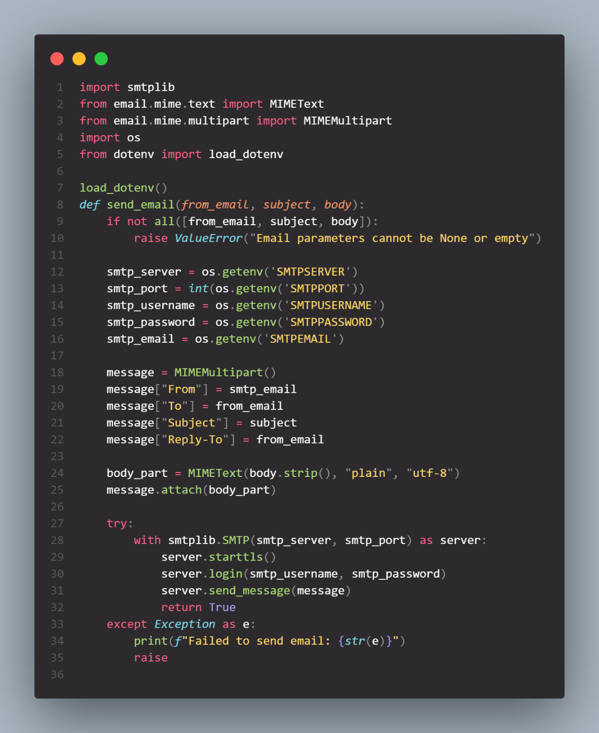

### Conclusion

* After switching projects, I feel that the code is easier for me to understand, and it aligns better with my goal of focusing more on Python rather than JavaScript. Creating the GitHub plan also made me feel more in control of the project. I received advice from my friends and teachers, which was very helpful.

# Uke 14

* This week, my focus was to create the submit function in my **Python** backend. However, I realized it would be more effective to first focus on integrating the two APIs **hCaptcha** and abstract for email validation. The contact form should first go through hCaptcha and validation when the user clicks the submit button, so it makes sense to implement these checks before developing the submit function.
* Started linking the two APIs in my **.env** to secure the keys and manage to create a function to verify if both API works.

## Abstract & Hcaptcha Code Example

**Abstract Verification Code**

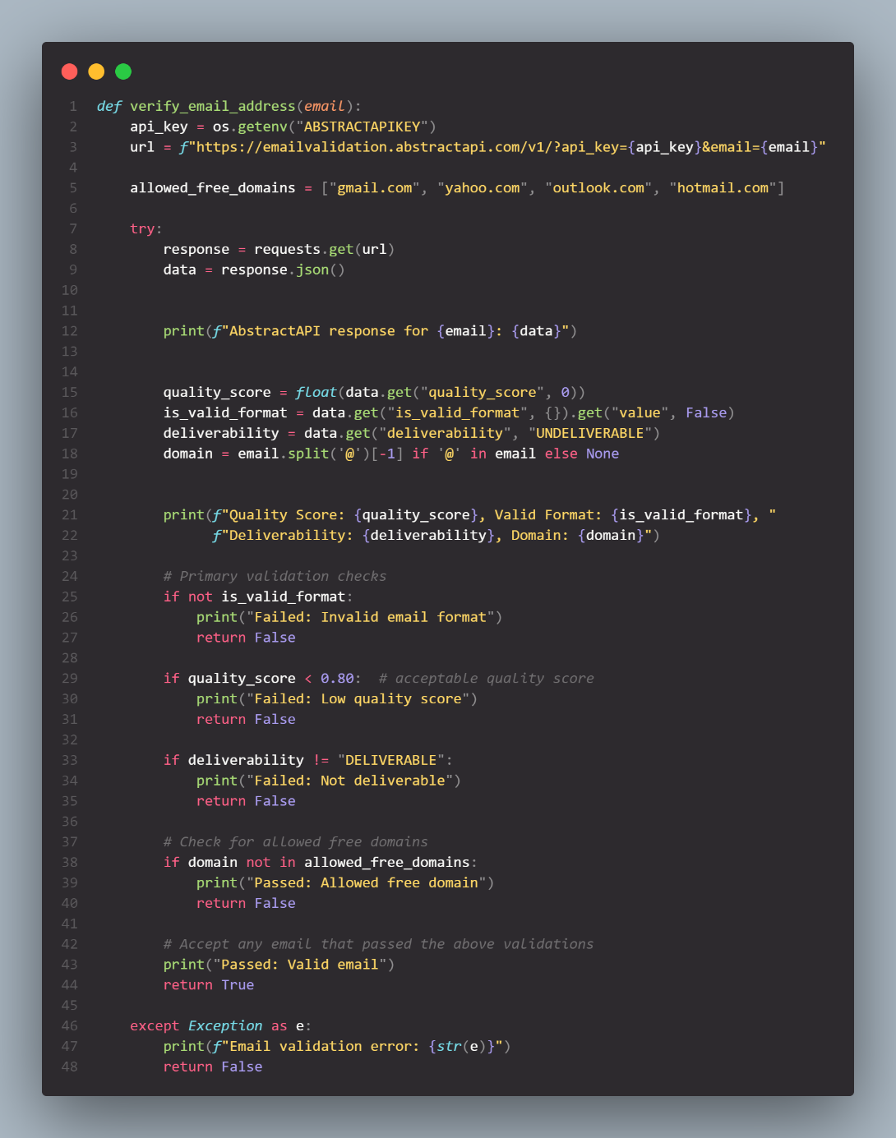

**Hcaptcha Verification Code**

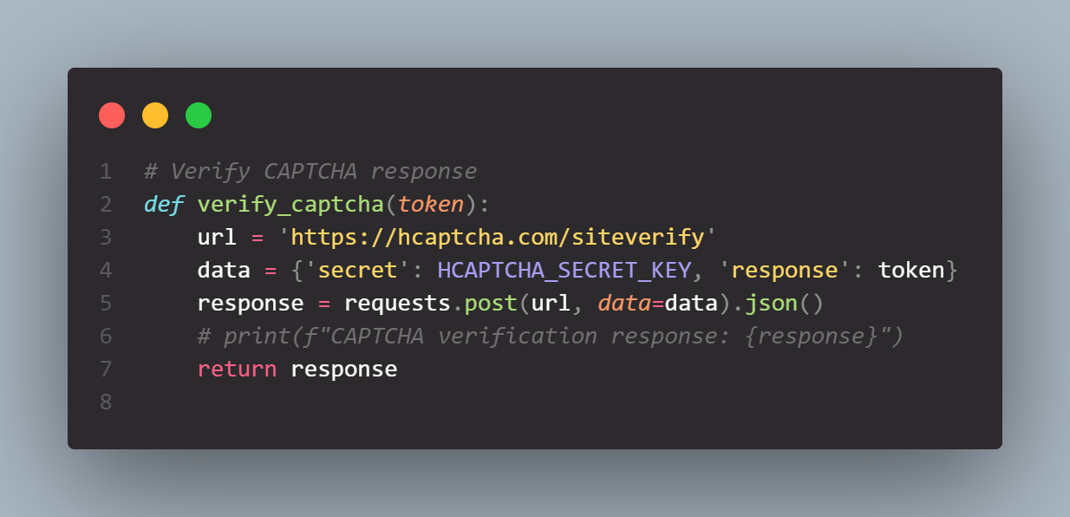

### Conclusion

* This week was challenging because it was my first time integrating an API into my project. Fortunately, I found some helpful videos that guided me through establishing the connection.
* My plan for next week is to create the submit function. After the user completes verification using hCaptcha and Abstract, the function will check if the email domain is valid, such as Gmail, Hotmail, Yahoo, or Outlook. Additionally, Abstract will assess whether the email is a dummy based on its score and format before approving it.

# Uke 15

* My plan for this week is to finally create the submit function
* Create Database via MariaDB and connect it to my python script
* Create a Flowchart on how my Whole website works

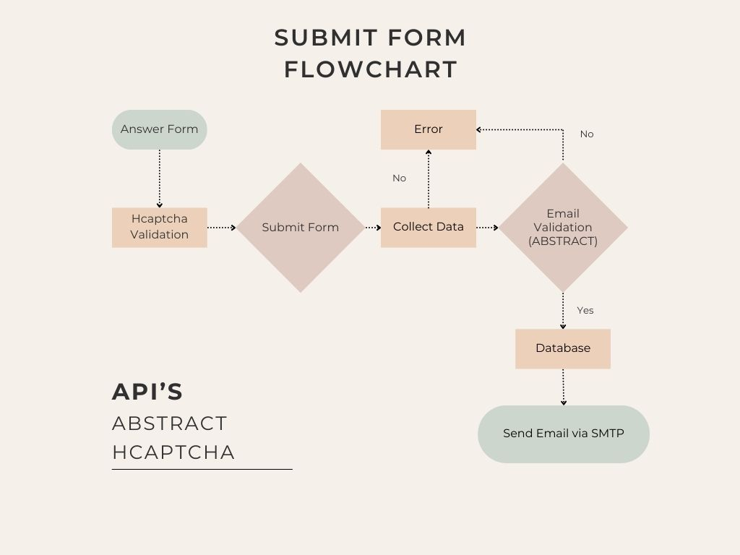

## Submit Form Function Code Example

Submit Function with the database connection

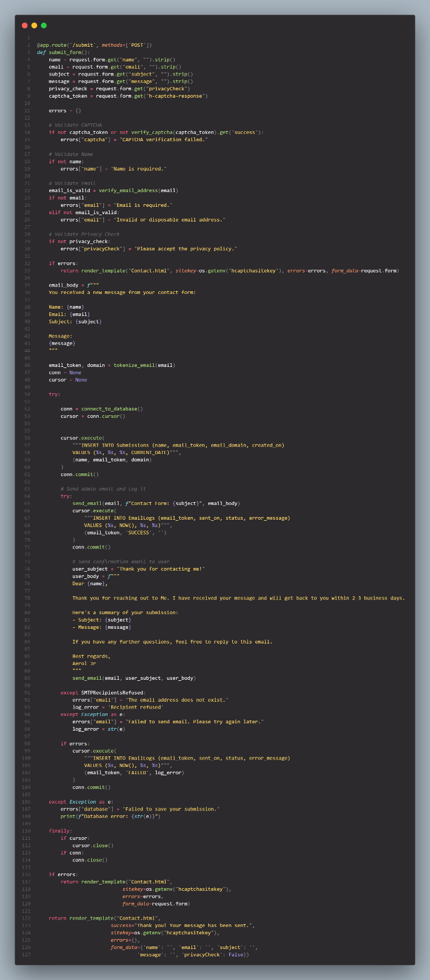

Added Tokenize Email

* This Code will make the database table look something like “User123” instead of the user real email. The reason for that is to make sure the user security and privacy.

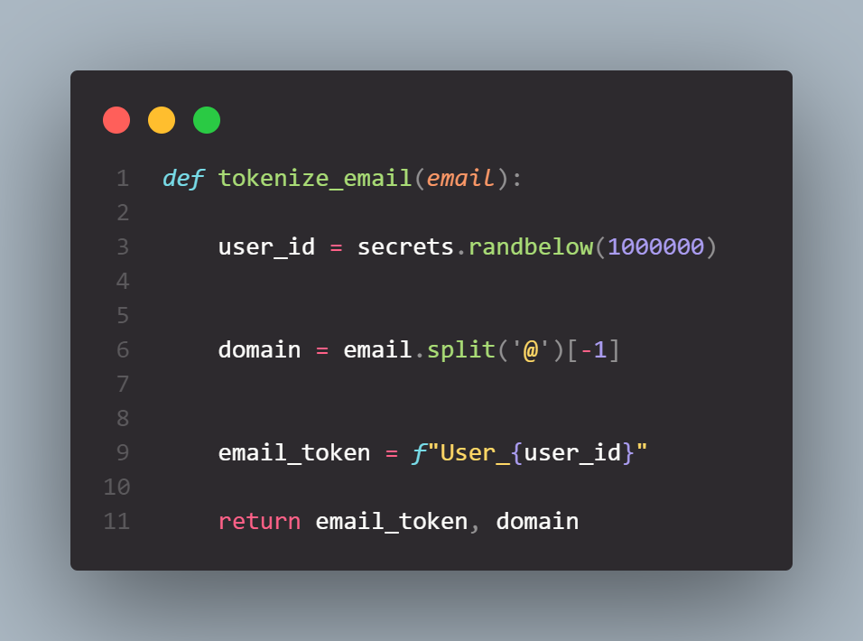

### Conclusion

* This week was more challenging because I had to fix not only the code as well as if the database worked or not. In Addition to that I added a Tokenize function for the my table database so I can
* Next week i will try to deploy my website by using Azure and a Web App as a Resource Group.

# Uke 19

* This week my plan is to deploy my Project into Azure by connecting my GitHub repository to it.

### Conclusion

* The process was difficult but luckily I got help from Alf, the only problem that I got is managing my .env because I forgot to put all the secret information in Environment Variable inside of my web app.

# Uke 20

* Plan for this week is to double all my works from the start to make sure I got all of my Projects ready for the incoming discussion.