Alex McLaurian
590
9-11-2013
Lab 3

For lab 3, we needed to create a mashup application. I decided to use the following services:
- custom google search engine
- last.fm rss feed
- twitter profile feed
These services all focused on a musical artist named Drake, and gives you the ability to quickly find information on him.

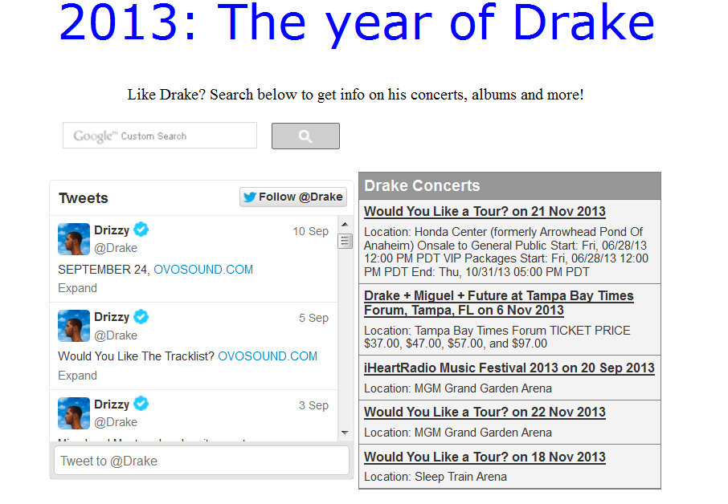

We also needed to install glassfish on our cloud instance, and deploy a web service to it as well.

Here is a view of the glassfish console after it has been installed.
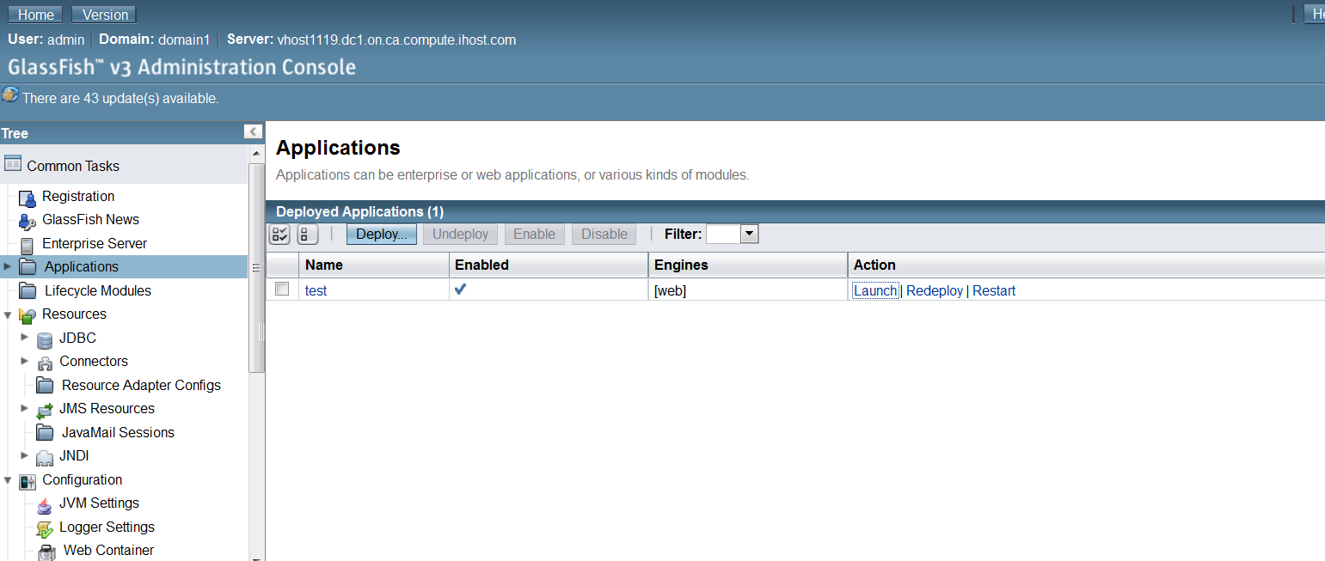

Here is a view of the web service on the cloud instance being run.
