CS551 Advanced Software Engineering

Second Increment Report
Due Date: October 18 (F) 2013, 11:59PM

The class project is to be based on Agile development techniques. In the first stage, each group has proposed a rough idea of the project they will work on this semester. This will be refined throughout the semester. For each increment hereafter, each group will deliver a set of outcomes related to their project.

The tentative schedule for project development is as follows:
- Sep. 6 (F): Project Proposal
- Sep. 20 (F): Project Plan
- Oc. 4 (F): 1st Increment Report
- Oct. 18 (F): 2nd Increment Report ⬅ This Deadline
- Nov. 1 (F): 3rd Increment Report
- Nov. 15 (F): 4th Increment Report
- Dec. 2 (M) & 4 (W): Final Project Presentations.
- Dec. 6 (F): Final Project Report

Each group prepares the proposal narrative following this guideline. Note that plagiarism is strongly prohibited.

Submission:
- Submit your report to Blackboard SecondIncrement Asssingment Site
- Submit your report and source codes to your project GitHub SecondIncrement site.
- Share the GitHub SecondIncrement link to https://docs.google.com/spreadsheet/ccc?key=0AhbU4L_hb-TvdC1QUTJWNWtXLS13allLbWVCZFowSlE#gid=1

For the selected features of your proposed system,
- Import Existing Services/API
  - Google API, LightBox Libraries, HTML5-Geo location services.
  - Sign-up form with Javascript and jquery check for password and email address and send email notification.
  - Sign-in form, validation, redirection to home page.
- Detail Design of Services
  - Write User Stories /Use Case (Using ScrumDo)
  - We do not have any WSDL services yet.
  - Sequence diagram (using Visio)
  - Class diagram (using Visio)
  - Design of Mobile Client Interface
  - Design of Unit test cases (using NUnit tool)
Refer to http://aspnet.4guysfromrolla.com/articles/011905-1.aspx
- Implementation
  - We designed sign-up form and google API. We deployed all of the services in the cloud and debugged.
  - We have tested in PC bowsers (Safari, GoogleChrome, Firefox, IE) and iPhone browser (Safari).
  - We implemented test case by installing NUnit Test adapter, which excute NUnit within visual studio. The test we run is to insure the encrypted passwords are being stored correctly. We have tested encryption and decryption functionality password that have been stored in the database.
- Testing: The NUnit test we run, it calls encryption test.
- Deployment:
  - (Sign-Up) http://vhost0221.dc1.on.ca.compute.ihost.com/new-registration.html
  - (Sign-In) http://vhost0221.dc1.on.ca.compute.ihost.com/login.html
  - (Home Page) http://vhost0221.dc1.on.ca.compute.ihost.com/Project/GP-homepage.html
  - (Github) https://github.com/rkurdi/Increment-2
  - (Scrumdo) http://www.scrumdo.com/projects/project/project155/iteration/78649/board#

- Report: screenshots and explanation on the design, implementation and testing.
- Project Management: update your project ScrumDo site with the progress and plan of your project and include the URL
  - Implementation status report
    - Work completed: Please Check ScrumDo!
      - Description
      - Responsibility (Task, Person)
      - Time taken (#hours)
      - Contributions (members/percentage)
    - Work to be completed: Please Check ScrumDo!
      - Description
      - Responsibility (Task, Person)
      - Time to be taken (estimated #hours)
    - Issues/Concerns

Screenshots Report

NUnit tool
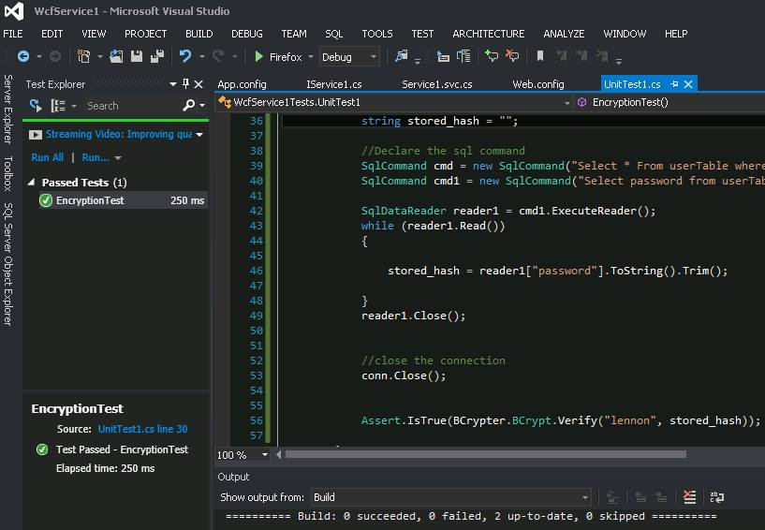

Password Encryption (DB):
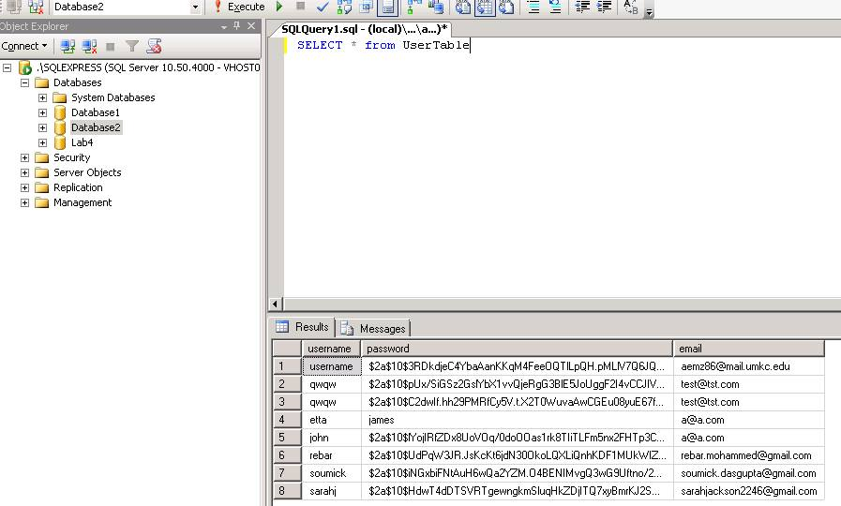

Email-Notification:

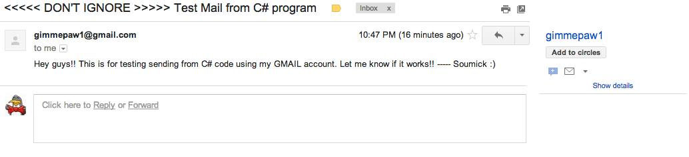

Google Map API
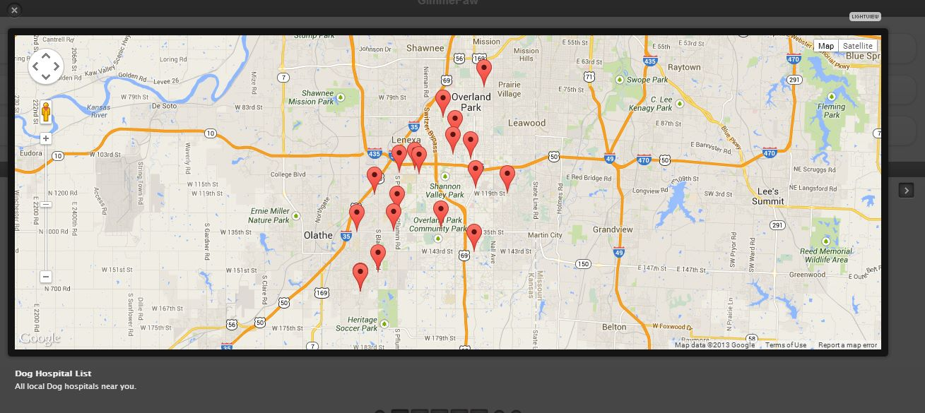

User Registration:

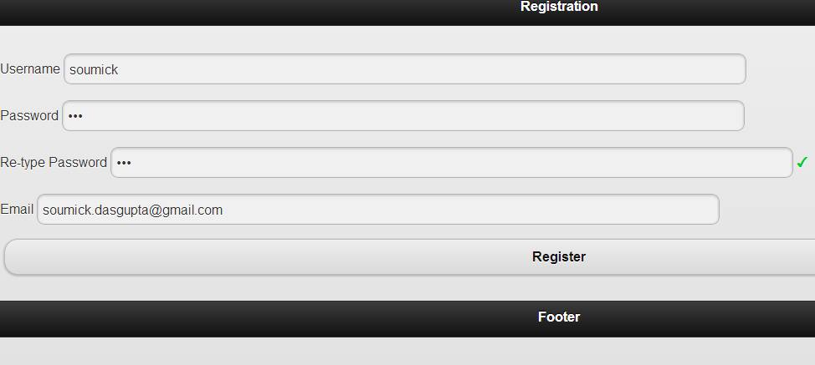

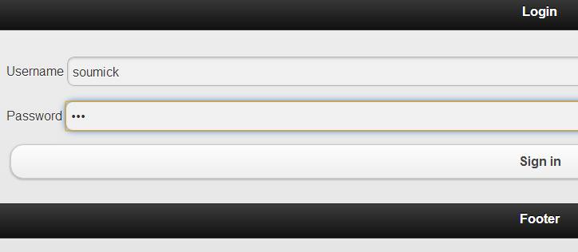
User Login

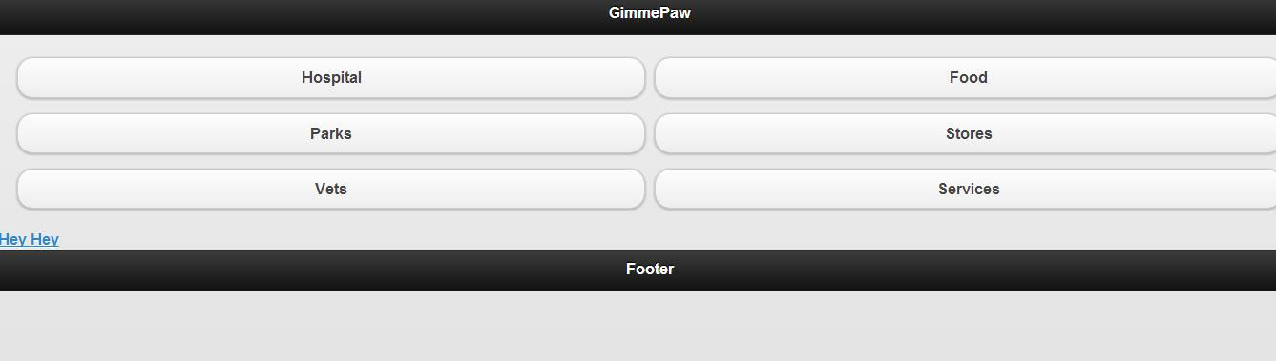
User Homepage:

