Rayan Katib
Alex McLaurian
Avinash Reddy
Koushik Tammineedi

CS590VC Mobile Cloud Computing

- Import Existing Services/API
  - We will be using Google Maps API for the client-side implementation of our JAX-RS web service
  - Our crime dataset comes from KC's open data project: https://data.kcmo.org/

- Detail Design of Services
  - Restful Service: Multiway Coordination Service
    - This is our main service for this phase. It is developed as a JAX-RS implementation, and is responsible for communicating to multiple users each person's current geolocation.
  - Class Diagram:
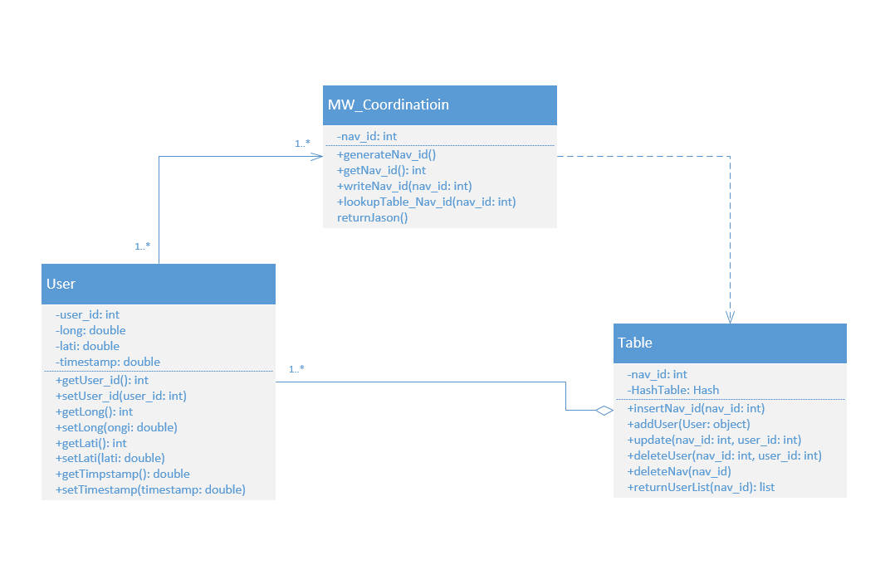

  - Design of MapReduce Algorithm or usage of any other Hadoop Ecosystem
  - Design of Data

- Implementation
  - Multiway Coordination Web Service
To implement our multiway coordination web service, we needed to create three classes. They are the User, Table and MW_Coordination class. The user represents the mobile user calling on the service, and stores all relevant data (geolocation, user id). A new User instance is created upon calling the service. The user will be input into the HashTable located inside the Table class. The HashTable will consist of a number of keys referred to as Navigation IDs, and a User will be a value associated with that Navigation ID key.

Upon first calling the web service, one user will be paired with a uniquely generated Navigation ID. The Table class will periodically return a JSON object consisting of user data (geolocation, user id) to the MW_Coordination class, which acts as an intermediary for the User and the Table classes. The JSON is then returned to the mobile client's interface, where it will be used to display the current user position. The Navigation ID represents a group of users, and while initially there is only one user in the group, the first user can invite other users to their Nav ID group. As other users join the group, they are added to the HashTable under the same Navigation ID key, so the JSON object that is returned to them and subsequently displayed in their mobile interface will contain not only their data, but also any other user's data associated with the Navigation ID.
The Multiway Coordination service is designed so a large number of concurrent Navigation ID groups can exist, as well as a large number of users connected to each group. Navigation ID groups are deleted from the HashTable when all associated users have disconnected from the group.

- Deployment:
  - http://www.scrumdo.com/organization/umkc32/dashboard
  - http://vhost0316.dc1.on.ca.compute.ihost.com/mcc_codebase/
  - Post your report and source code to your GitHub site and include the URL to the report

- Project Management: update your project ScrumDo site with the progress and plan of your project and include the URL
  - Implementation status report
    - Tracking of assignment/status of tasks with relevant details is done on our ScrumDo project site: http://www.scrumdo.com/organization/umkc32/dashboard

