Avinash Reddy, Desireddy
Rayan Katib
Alex McLaurian
Koushik Tammineedi

Safety-Aware GPS Navigation and Police Assistance
Second Increment Report

- Import Existing Services/API
  - Implementation of Google Maps/Places API was done by referencing Google's developer site https://developers.google.com/maps/documentation/javascript/places?csw=1, as well as stack overflow http://stackoverflow.com/questions/10314741/fetching-nearby-locations-from-google-places-and-adding-markers-on-google-map-fr
  - Our crime statistics data set was drawn from Kansas City's open data website, https://data.kcmo.org/Crime/crime-data-kc/f6v5-vekn and then modified for our specific use
  - Twitter Bootstrap was used to make interface design easier http://getbootstrap.com/2.3.2/
- Detail Design of Services
  - User Stories: http://www.scrumdo.com/projects/project/project160/
  - Service description:
    - User registration: provides users with an easy way to register (data stored in MySQL database)
    - Sign-in: lets users access the application features, keeping any relevant data stored and associated with their corresponding registration information
    - Finding police stations: take a user's current location and give him a map display of the nearest police stations within a set radius
  - System Architecture
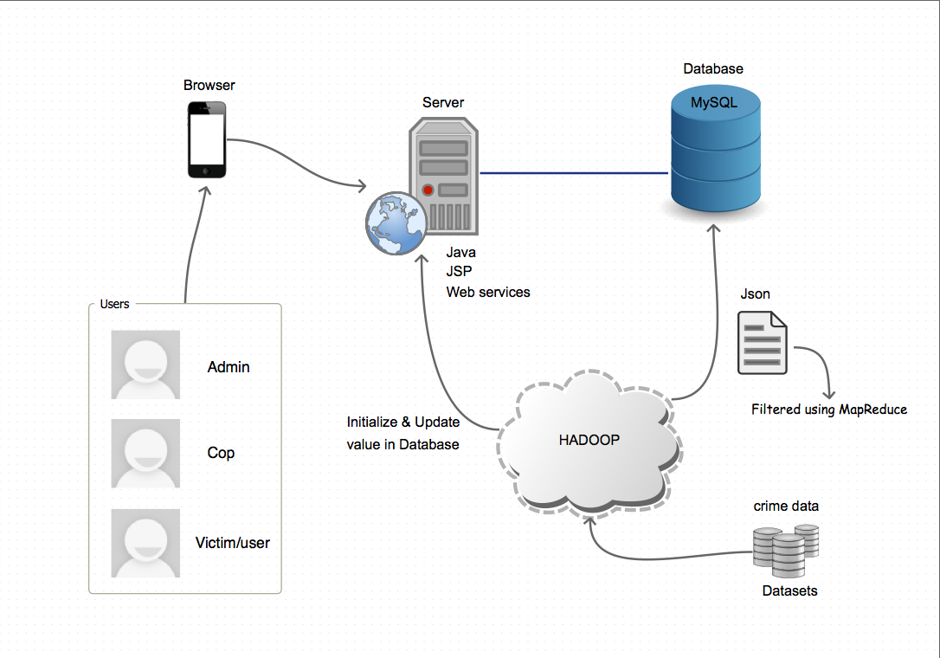
Our system consists of three types of users: standard users (victim), cops, and administrators. Each usertype will have access to a different functionality. They all access the application via a mobile interface. The mobile interface utilizes Java to connect to the SQL database and Hadoop, storing and retrieving data from the SQL database and sending queries to Hadoop. Hadoop has the main crime data set stored on it, and provides all crime event information, ready to be parsed into a more presentable format.

  - Design of Mobile Client Interface
    - We decided to use Twitter Bootstrap for our frontend framework, due to its ease of use and features which let our interface code adapt to whatever display it shows up in (fullscreen, halfscreen, mobile, tablet)
    - We also utilized JavaServer Pages in order to maintain sessions for our users, leading to a better user experience
  - Design of MapReduce Algorithm or usage of any other Hadoop Ecosystem
    - We will use MapReduce in the following manner:
      - Set our main JSON data set as the input
      - Parse the data set, grouping crime events by zipcode and presenting this as a JSON output
      - The parsed data set will then be stored as a long string representation of the zip code sorted JSON crime information, which will then be inserted into the SQL database.
  - Design of Data
    - Our database schema includes two tables:
      - User table (to keep track of users registration and signing in)
        - username
        - password
        - email
        - usertype (user, cop, admin)
      - Crime table
        - zip code (primary key)
        - JSON string (will include all crime events related zipcode)
          - Zip code (primary key)
          - crime type
          - reported time
          - reported date
          - address
          - city
          - longitude
          - latitude
        - zip code population
        - total crimes committed (integer)
Refer to http://aspnet.4guysfromrolla.com/articles/011905-1.aspx
- Implementation
  - Implementation of services
    - User registration and Sign-in: Done using JSP, AJAX and MySQL
    - Finding police stations: Implemented with Google Maps/Places API, AJAX and JSP
  - Generate your datasets
    - Our main data set is taken from KC's open data website, and is stored in Hadoop. We are then grouping all crime event data by zipcode from Hadoop, and storing the grouped information into SQL DB as a string.
  - Implementation of user interface (Mobile Apps)
    - All of our JSP pages were designed with Twitter Bootstrap and AJAX (Javascript, Jquery, HTML5, CSS3).

- Deployment:
  - http://www.scrumdo.com/projects/project/project160/
  - Registration: http://vhost0316.dc1.on.ca.compute.ihost.com/mcc_codebase/
  - Signin: http://vhost0316.dc1.on.ca.compute.ihost.com/mcc_codebase/signin.jsp
  - Nearest police stations: http://vhost0316.dc1.on.ca.compute.ihost.com/mcc_codebase/Navigation.jsp
  - Post your report and source code to your GitHub site and include the URL to the report

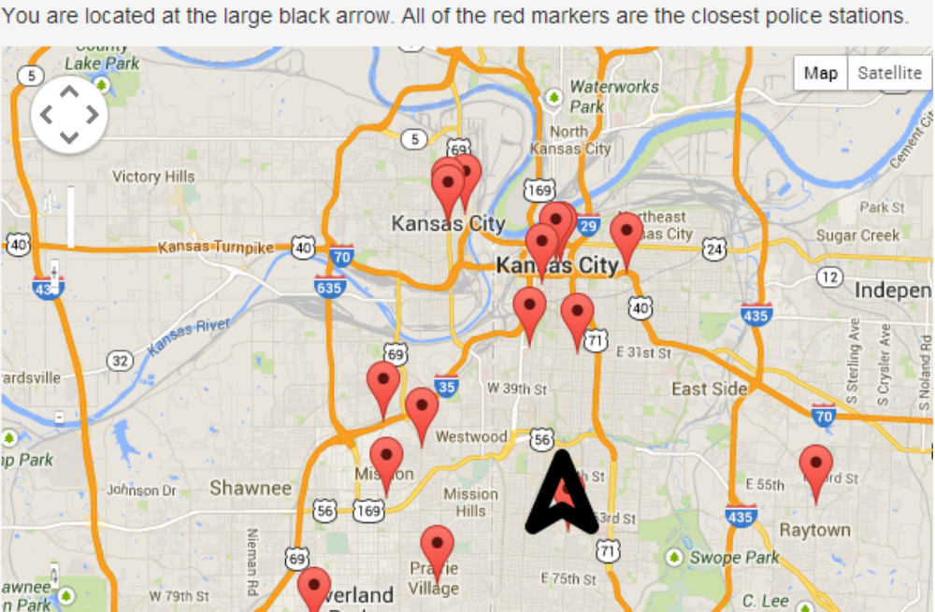
View of our implementation of geolocation and Maps/Places API

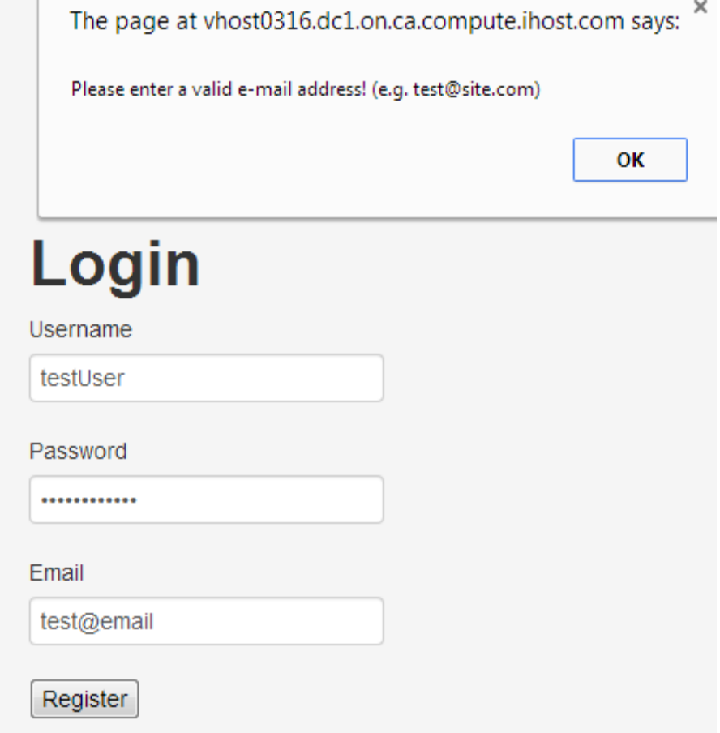
Registration page with validation feature
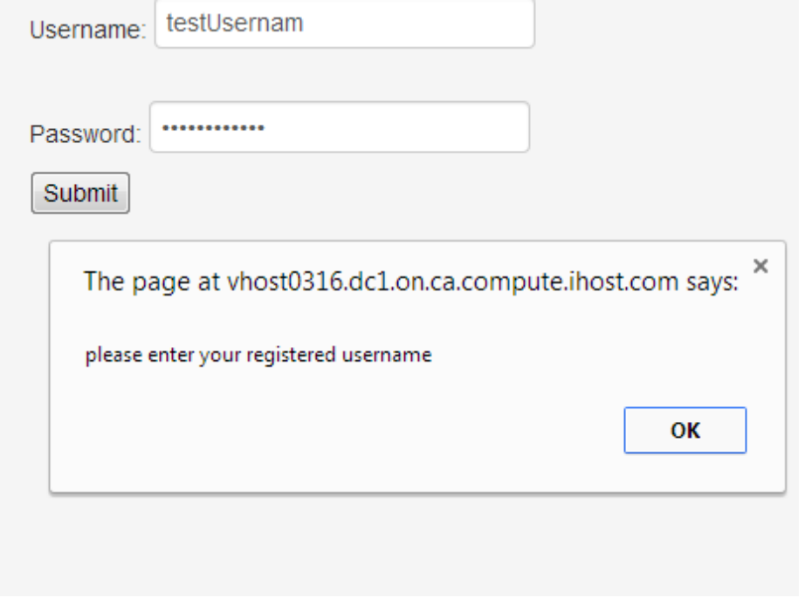
Signin page with validation feature

- Project Management: update your project ScrumDo site with the progress and plan of your project and include the URL
  - Implementation status report
    - Work completed:
      - The configuration to support the application was completed by Avinash. We decided to configure our applicaion to use Java Server Pages, so we utilize Eclipse for Java EE to design and develop the majority of our pages. This process took 3 hours.
      - A user interface with multiple pages was completed. This included implementation of various web technologies, with Alex working on HTML, AJAX and Google API implementation on the JSP pages, Avinash working on the mobile interface's database connectivity, and Rayan contributing additional HTML. In total, this took over 16 hours, with the majority of time dedicated to troubleshooting and understanding how to use the required technologies and APIs.
      - Database schema was implemented. The data set was discovered by Alex, the schema was implemented by Koushik and designed by Avinash. This took 3 hours.

    - Work to be completed
      - We need to connect Hadoop to our MySQL server in order to fully utilize our crime data set. This will involve developing a MapReduce program to parse our JSON data set by zip code, and return each parsed crime data grouping into its corresponding row entry in the SQL DB as a string. This will be a group effort, and we estimate this to take 15+ hours, as we gain a better understanding of the use and parsing of JSON in MapReduce.
      - We want to be able to share geolocation between two mobile devices. This will involve continuous updating of each mobile client, with a presentation of the other mobile user's geolocation. We estimate this to take 10+ hours, due to a degree of the uncertainty involved with continuous geolocation sharing. This will be a group effort.
      - APIs will need to take in all the JSON information from the SQL DB, and display it in a correct manner. We will additionally need to list all crime types in graphical format and on a google Map, and create an interface that will filter the various parameters in the crime data, giving users a customized view of crime events in their specified region. This will be handled by Alex and Rayan, and will take 15+ hours as Google Maps API details and usage in combination with custom JSON files are better understood.
    - Issues/Concerns
      - The ability to parse real-time data is an issue we have run into, as most relevant data we have found is static.

