Lab 4 5551
Alex McLaurian
10/6/13

Both the restful client/service and the Soap client/service implement basic math functions, storing each calculation in a database table. There is also one call to the database, where users can determine if certain number pairs have already been entered or not.

Restful Client:

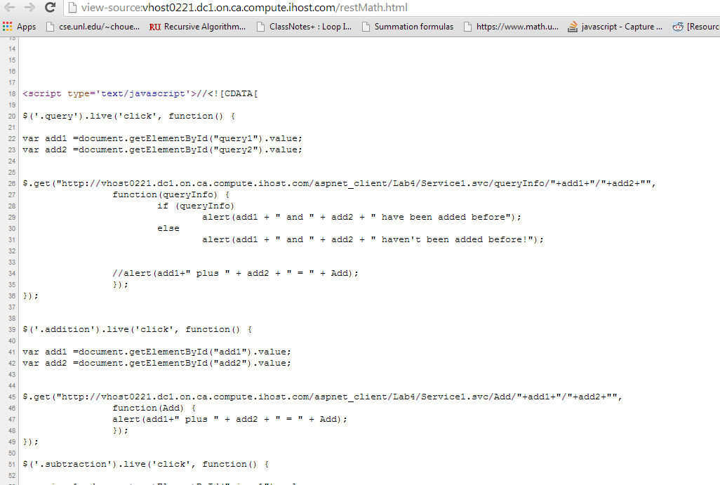

Restful Service:
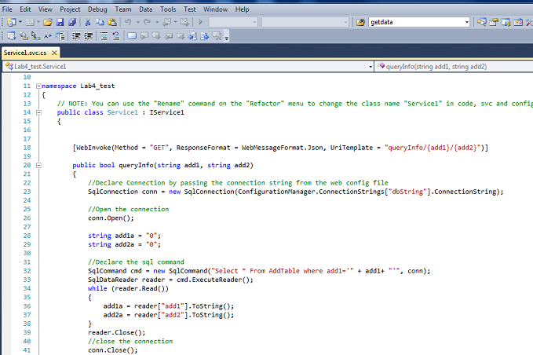

Soap client:
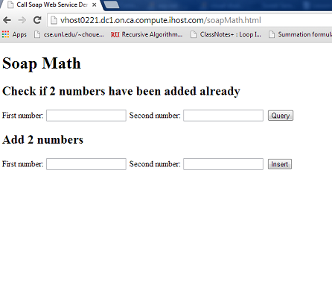
Soap service:
