Alex McLaurian
551
9-11-2013

Lab 3

For lab 3, we needed to create a mashup application. I decided to use the following services:
- custom google search engine
- last.fm rss feed
- twitter profile feed
These services all focused on a musical artist named Drake, and gives you the ability to quickly find information on him.

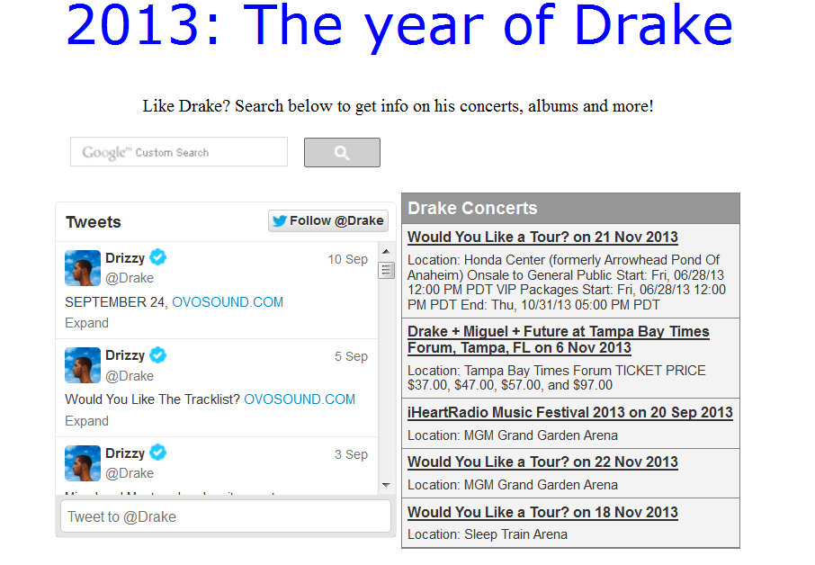

Additionally, we needed to install an IIS server on our Cloud instance, and add/use a web service from the instance.

Here is a screenshot of the IIS server on the cloud
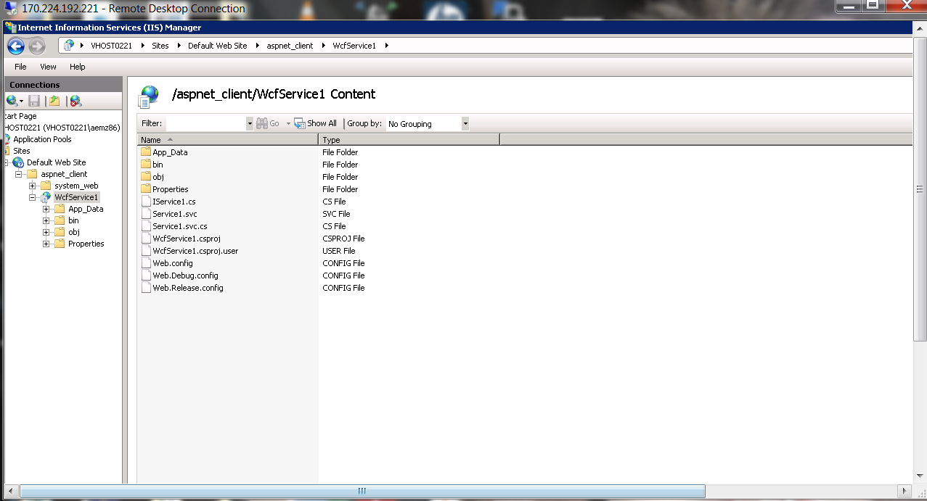

And the web service being successfully run on the cloud instance.

