Alex McLaurian
8-28-13
CS 551

Lab 1

1. Below are scrumdo screenshots, showing the dashboard, scrumboard and iteration planning:

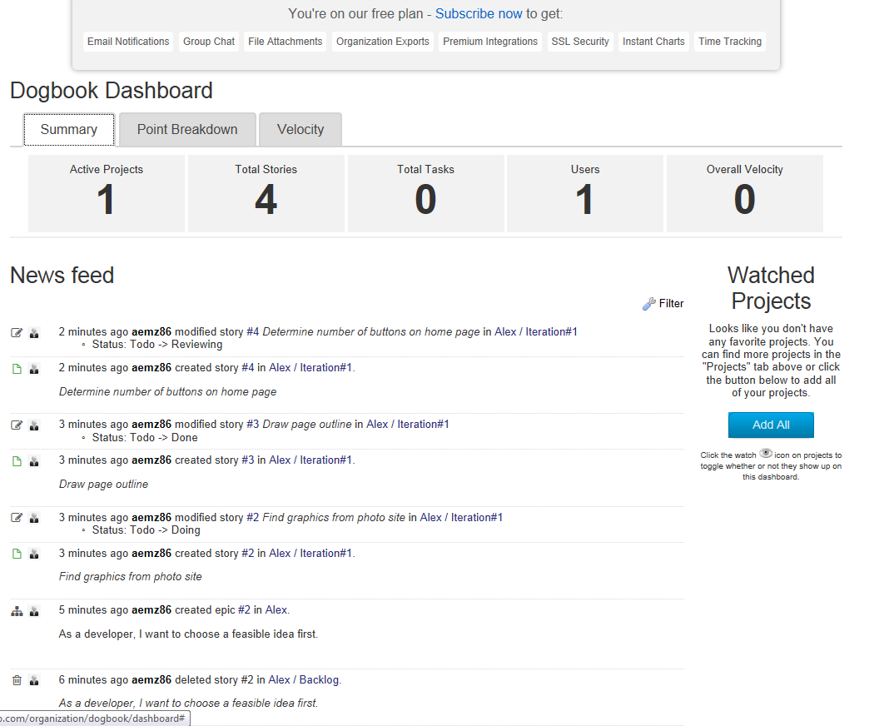
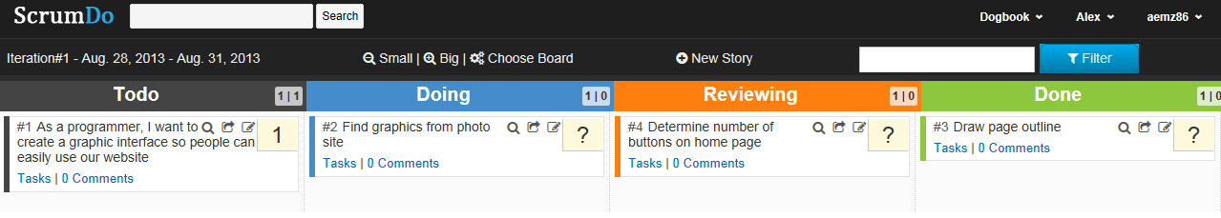

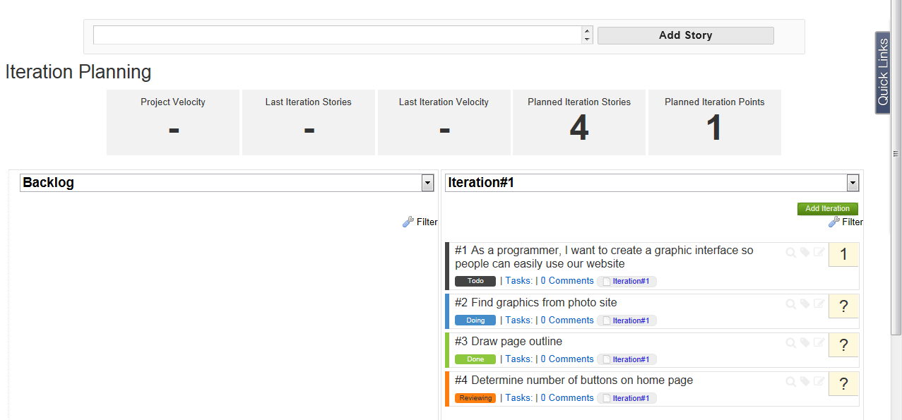

2. Github views from the browser page and the Windows application are shown below:

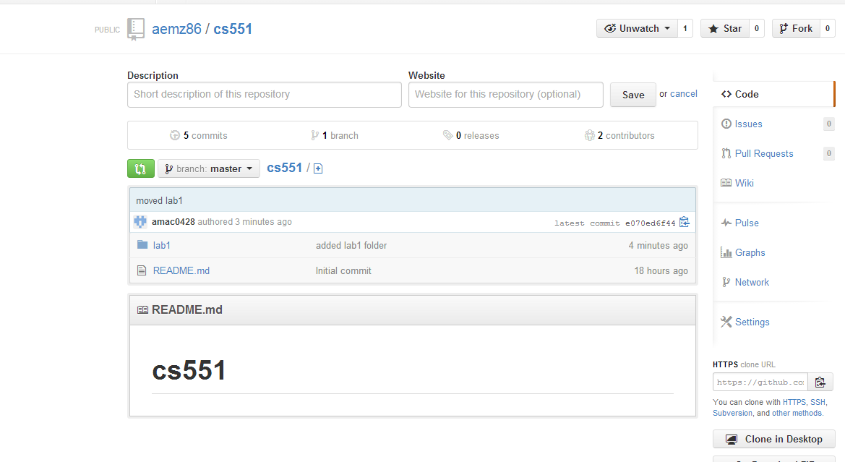

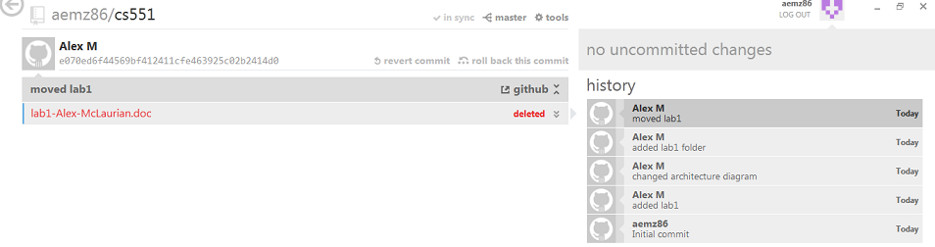
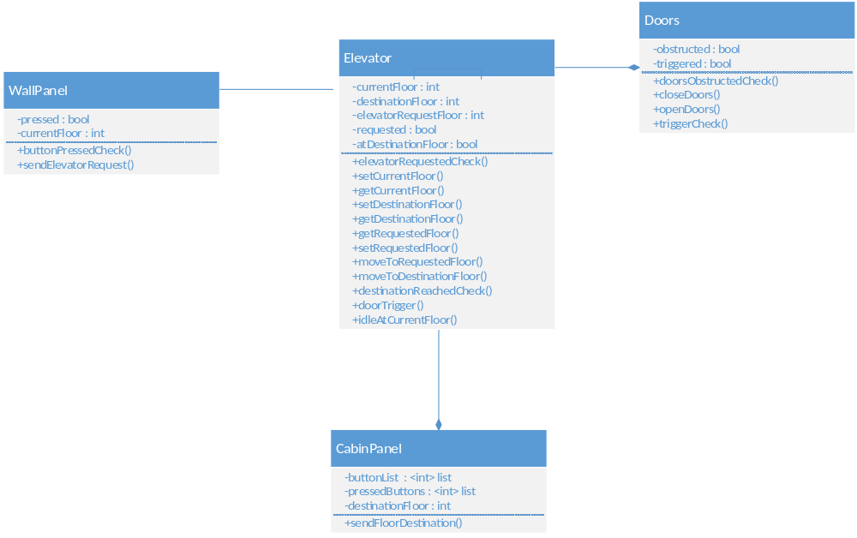
3. For the class diagram, I decided to create 4 classes: WallPanel, Elevator, Doors, and CabinPanel. Elevator is the class that utilizes the three other classes. WallPanel is responsible for sending all user requests to Elevator from users outside of the elevator. CabinPanel handles to all floor requests to Elevator from users inside the elevator. Doors handles all door-related events, which would occur once a desired floor is reached.

The required sequence diagram is shown below. WallPanel is called first, triggering a response from elevator to move to the specified floor. Once the floor is reached, the doors open and only close once the doors are not obstructed. The elevator then responds to any user-inputted floors entered on the cabin panel. Once the destination is reached, the door open/close process is triggered once again.

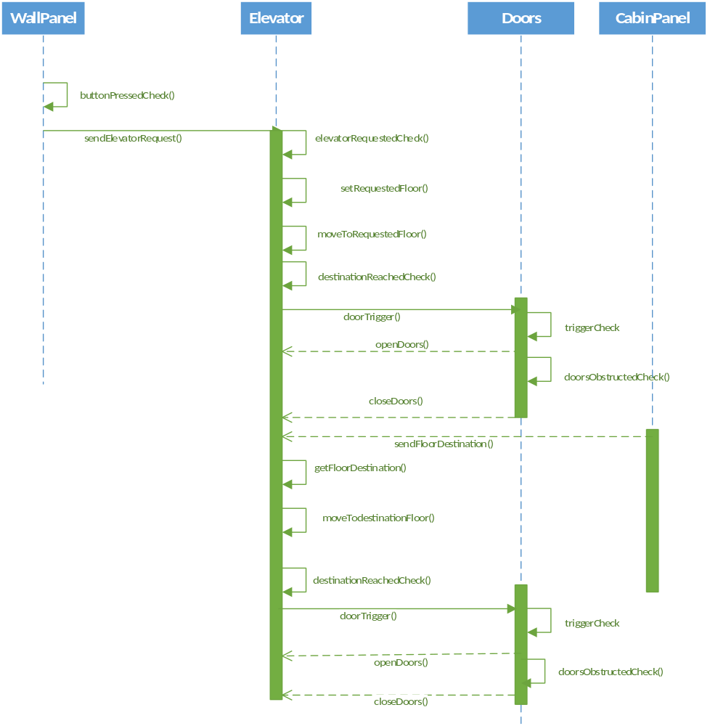

The architecture diagram is shown below. The passenger interacts with the elevator via either an external or internal panel. The external wall panel sends requests for the elevator to come to the floor, whereas the internal cabin panel specifies various floors for the elevator to visit.
