Alex McLaurian
8-28-13
CS 551

Lab 1

For our lab, we needed to create a class diagram, sequence diagram, and architecture diagram.

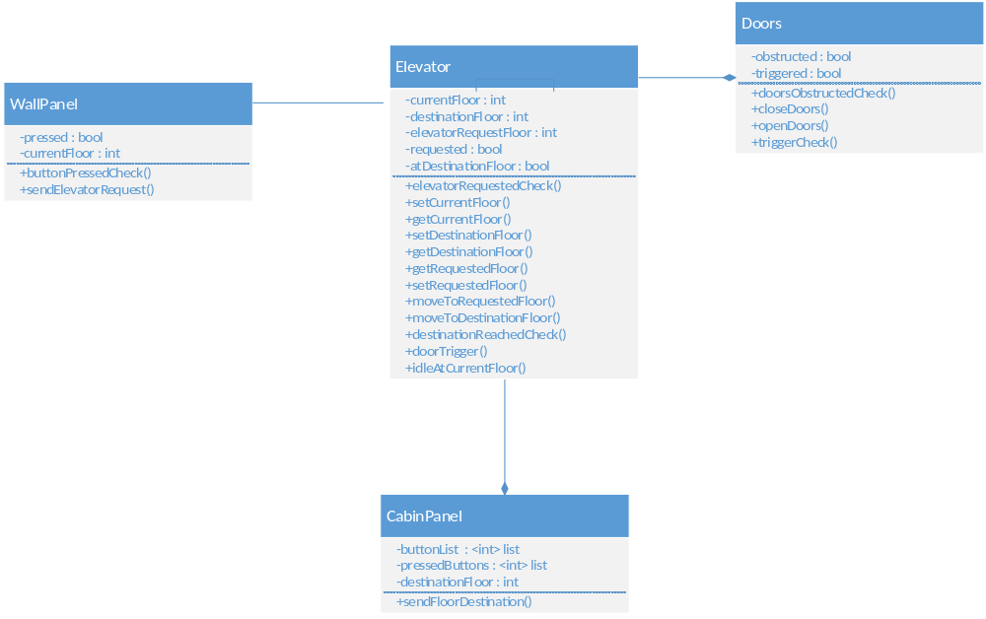
For the class diagram, I decided to create 4 classes: WallPanel, Elevator, Doors, and CabinPanel. Elevator is the class that utilizes the three other classes. WallPanel is responsible for sending all user requests to Elevator from users outside of the elevator. CabinPanel handles to all floor requests to Elevator from users inside the elevator. Doors handles all door-related events, which would occur once a desired floor is reached.

The required sequence diagram is shown below. WallPanel is called first, triggering a response from elevator to move to the specified floor. Once the floor is reached, the doors open and only close once the doors are not obstructed. The elevator then responds to any user-inputted floors entered on the cabin panel. Once the destination is reached, the door open/close process is triggered once again.

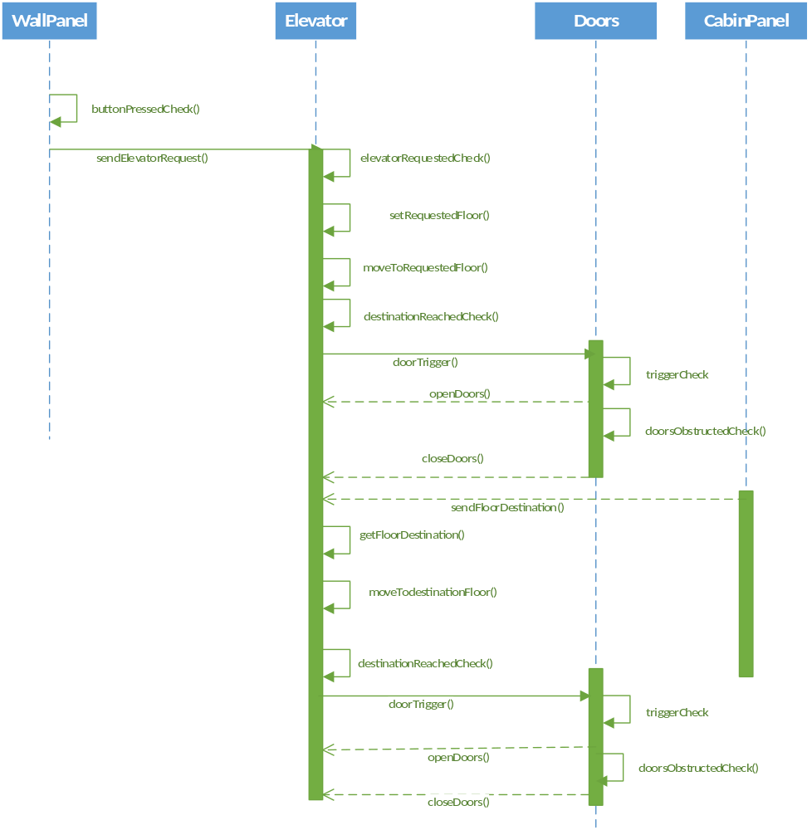

The architecture diagram is shown below. External and internal user requests to the elevator are handled in similar manners, and are both detected and trigger motion-responses from the elevator. All successful elevator movements result in the elevator reaching a specific floor, which will in turn lead to the doors opening and closing. If there are no requests, no movement will occur as the elevator has no target floor to go to, and the doors will not be triggered.
