CS551 Advanced Software Engineering
Alex McLaurian
Submission:
- Source code submission to CS551 blackboard/exam/MidtermSourceCode. Submit a word document file including all source codes (IMPORTANT: just in case you use someone’s code and include the reference – URL)
- Report submission to CS551 blackboard/exam/MidtermReport. Submit your report (word document). Check out the report guideline below.
- GitHub submission: Submit your report and source package (source code, library, date, etc) to your GitHub site and email the GitHub link to the instructor leeyu@umkc.edu

Report Guideline
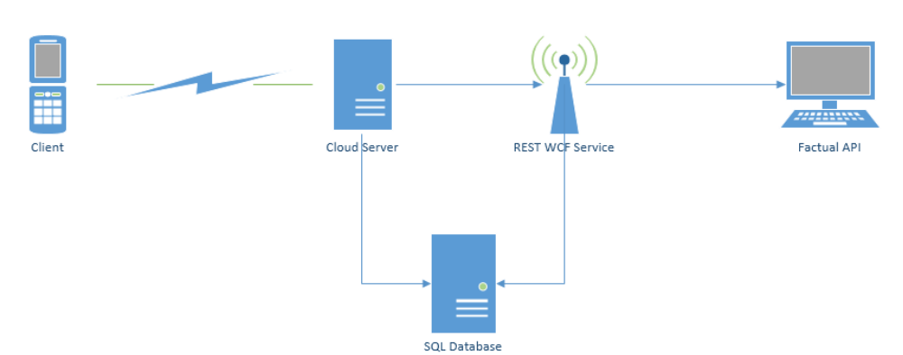
- Design

- Features Implemented
  - Web Services
    - User registration/sign-in (aspx sessions were utilized)
    - Add products to database (sql calls through aspx webforms were used)
    - Display/update products in database (sql calls through aspx webforms were used)
    - API Used
      - Factual for product lookup based on UPC number
  - Database Tables
    - Created tables
      - UserTable
        - Username, password, usertype
      - ProductTable
        - product name, price, bought status, username of gift registry creator, registry type
  - Mobile User Interface
    - I utilized HTML, AJAX and ASPX web forms to implement the client interface.
- Include Screenshots of the Features
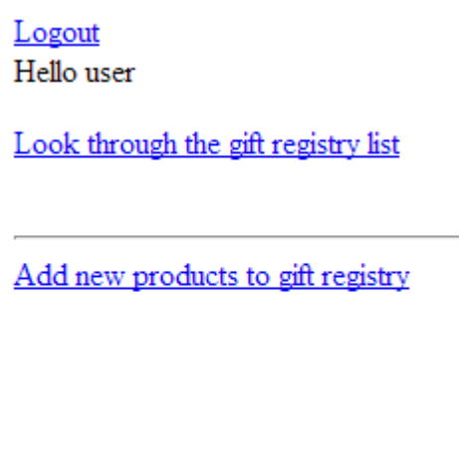
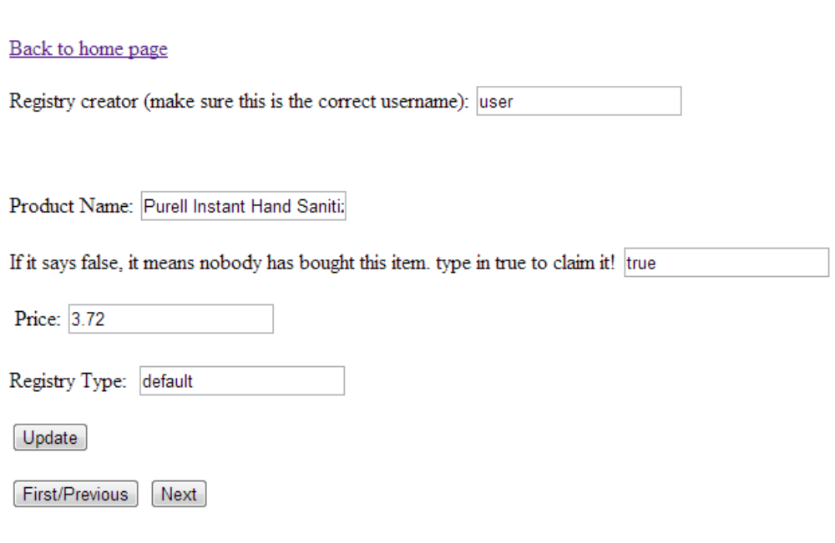

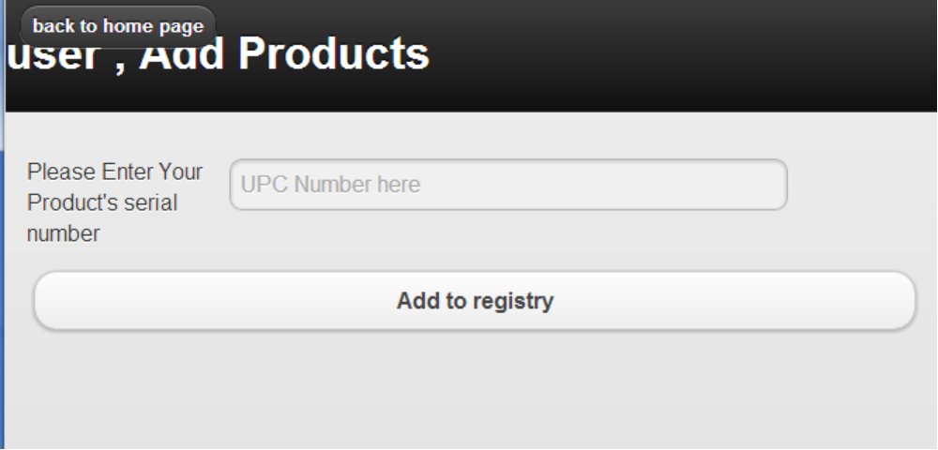

- Webpages:
  - registration: http://vhost0221.dc1.on.ca.compute.ihost.com/aspnet_client/WcfService2/WcfService2/account/register.html
  - login: http://vhost0221.dc1.on.ca.compute.ihost.com/aspnet_client/WcfService2/WcfService2/account/login.aspx
  - home page: http://vhost0221.dc1.on.ca.compute.ihost.com/aspnet_client/WcfService2/WcfService2/account/main.aspx (logout functionality seems to only work on firefox)
  - add products: http://vhost0221.dc1.on.ca.compute.ihost.com/aspnet_client/WcfService2/WcfService2/account/newProducts.aspx
  - view/update products: http://vhost0221.dc1.on.ca.compute.ihost.com/aspnet_client/WcfService2/WcfService2/account/WebForm2.aspx
- Limitations
  - There seems to be issues with displaying/updating all columns for each product in the database, but the product name displays correctly.
  - Factual's API results seem to be hit or miss when it comes to full product details (images, prices). Manufacturer and product name are generally available if the upc number can be found via the API.
  - While I successfully created a web service to take in an mobile captured image of a upc number, uploading it to the server proved to be a larger issue then expected, so I had to stick with manual UPC input.
- References
  - SQL Reader information: http://www.youtube.com/watch?v=RKXVeKQ6ghs
  - Factual information: http://developer.factual.com/working-with-factual-products/
  - Session information: http://www.aspdotnet-suresh.com/2012/11/aspnet-session-state-example-in-c-vbnet.html

