**Queuing System with Admin Module for Student Affairs Office of Saint Louis University**

System Documentation and User Manual  
Presented to the   
Staff of the Office of Student Affairs  
Saint Louis University

**By  
Aeneid Anthony M. Adversalo**

**Submitted to:  
Andrew S. Macalma, MBA, MS Psych, RPm, RP**

**Dean of Student Affairs**

**Laurence F. Balmeo**

**Project Adviser**

Table of Contents

Chapter 1: General Information 3

1.1 System Overview 3

1.2 Organization of the Manual 3

Chapter 2: System Summary 4

2.1 System Configuration 4

2.2 User Access Levels 4

Chapter 3: Getting Started 5

3.1 Prerequisites 5

3.2 Installing the System 5

3.2.1 Server Module 5

3.2.2 Client Module 5

3.3 System Interfaces 5

3.3.1 Login 5

3.3.2 Service Cubicle Module 6

3.3.3 Admin Module 8

3.3.4 Server Module 9

3.4 Changing Username and Password 10

3.5 Exiting the System 11

Chapter 4: Using the System 12

4.1 Login 12

4.2 Client Module 13

4.2.1 Service Cubicle Module 13

4.2.2 Admin Module 13

# Chapter 1: General Information

## System Overview

The OSA Queuing System is a simple queuing system, which operates on Windows operating systems. It is similar to those seen in banks and government agencies. This application supports up to 4 clients, which have respective accounts and are saved in the database. Whenever a number is called by a client (herein referred to as a service cubicle), such information, along with the date of its calling, is saved in the database.

## 1.2 Organization of the Manual

The user’s manual consists of five sections, namely General Information, System Summary, Getting Started, Using the System and Troubleshooting.

The General Information section explains in general terms the system and its purpose intended.

System Summary provides a general overview of the system that of which details the hardware and software requirements, system configuration and user access levels.

The Getting Started section provides steps on how to install the software on the device, as well as the prerequisite components before installing the software. It also presents the sections of the system, which covers both the Server and Client (Admin and Service Cubicle) module.

Using the System section provides a detailed description of system functions.

And lastly, the Troubleshooting Section will describe the steps that should be undertaken in such event that contingencies happen.

# Chapter 2: System Summary

## 2.1 System Configuration

Both the client and server modules of the OSA Queuing System operate on Microsoft Windows. This server module of the application requires a MySQL server to operate, as most of the functions of the system are database-dependent. The data saved in the database can be seen in any major internet browser through the use of PHPMyAdmin (which is accessed via <http://localhost/phpmyadmin>). After its installation, this application can be used without any further configuration.

## 2.2 User Access Levels

Both the Dean, the Associate Dean as well as the service cubicle staff of the Office of Student Affairs, both situated in the Main and Maryheights Campus are the only ones who can use the system, so as long as their accounts are saved in the database.

# Chapter 3: Getting Started

## 3.1 Prerequisites

## 3.2 Installing the System

### 3.2.1 Server Module

### 3.2.2 Client Module

## 3.3 System Interfaces

### 3.3.1 Login

/* The Client Module consists of two sub modules, namely Service Cubicle and Admin. */ Shown in Figure 1 is the interface in which Student Affairs staff can log into the system with their account credentials. It is the responsibility of the staff to keep their credentials safe. Refer to the troubleshooting section of this manual if in the case any of the staff forget their account credentials.

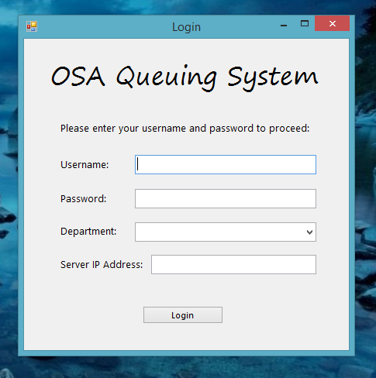

Figure 1: Login Interface

Depending on their department, staff would either be lead to the admin module or service cubicle module – provided that they have supplied the right credentials.

### 3.3.2 Service Cubicle Module

The Service Cubicle Module is the first sub module of the client-side of the system. Figure 2 shows the main menu of the service cubicle module after the user logs in as service cubicle staff. In order to call a student, the user would have to click on the “Call Student” button – the user should take note of his cubicle number. The next number would be displayed on the server interface, as well as in the box where their cubicle number is. That number would also be displayed on the lower right corner of the interface.

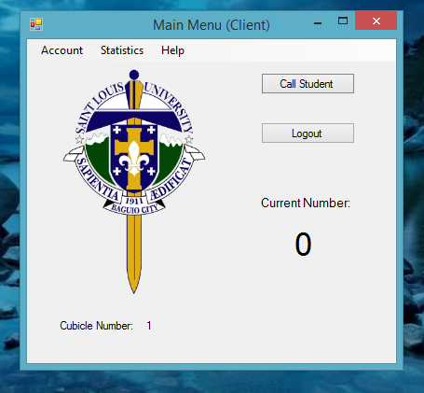

Figure 2: The Service Cubicle Interface

Also shown is a menu bar containing three menus – Accounts, Statistics and Help. The Accounts Menu is where they could “personalize” their account by changing their account credentials. On the other hand, the Statistics Menu is where they could see the number of records they have done for the day. Unlike in the Admin Module, users can access their number of students served at anytime of the day. Users can go back to the login interface by clicking on the logout button. Lastly, the Help Menu is where users can open the user manual as well as view information about the program and its authors.

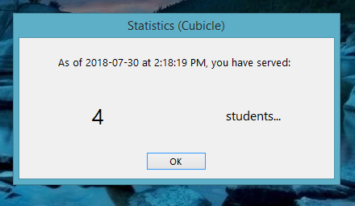

Figure : Statistics for each Service Cubicle. Such can be accessed at any time.

### 3.3.3 Admin Module

The Admin Module is the second sub module of the client-side of the system. As the name implies, only the Dean and the Associate Dean can access the module. This is where they can see the statistics on the number of students served in a day that of which is not accessible until the end of the day, which is at 5:00 pm. Figure 3 shows the interface of the Admin Module.

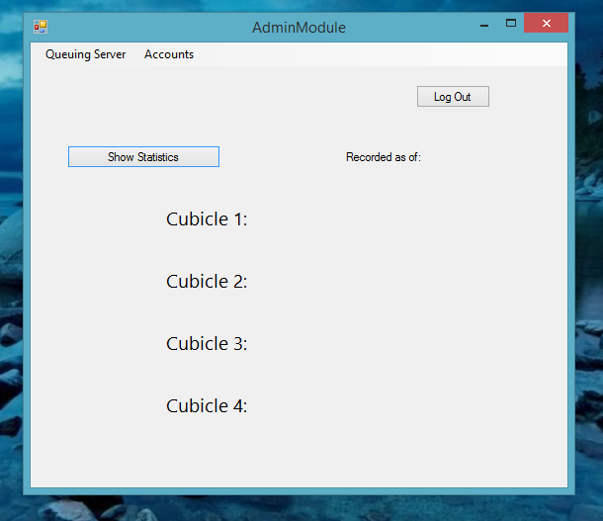

Figure 4: Admin Module Interface. Note that the statistics are not available until 5:00 pm.

The menu bar contains three menus, namely Queuing Server, Accounts and About. The Queuing Server is where the admin will view a miniature version of the Server Module interface (to be discussed in the next section). It should be noted that initially, all other numbers except for the latest one called will be at zero. And like in the Service Cubicle Module, the Accounts Section is where they can “personalize” their accounts. Such will be shown in the preceding chapter (3.4).

### 3.3.4 Server Module

The Server module of the system is what the students would be seeing on the big screen. This is where the current number of each cubicle is displayed, as well as the latest number. As this module is (supposedly) responsive, it could fit to any screen – such that the text is still visible from afar. At the upper right corner is where the current date and time is displayed. The leftmost side of the server interface will show the latest number called per cubicle, while the last number called is shown in the rightmost side of the interface. The aforementioned are as shown in Figure 5.

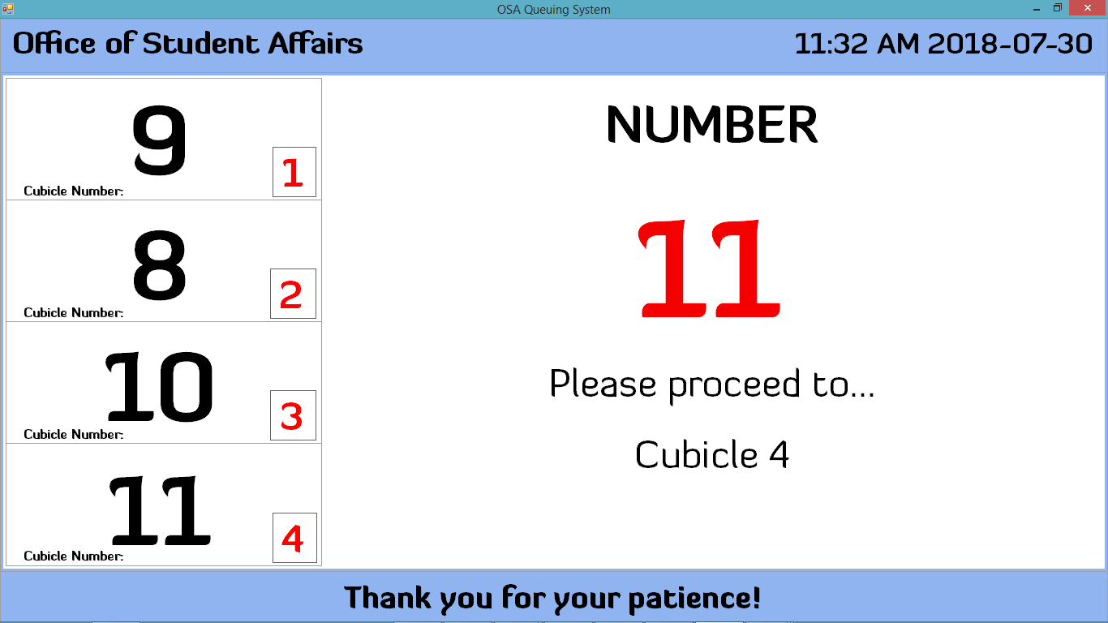

Figure : Server Module of the Queuing System. Note that the large number on the right blinks red, this is to show emphasis.

## 3.4 Changing Username and Password

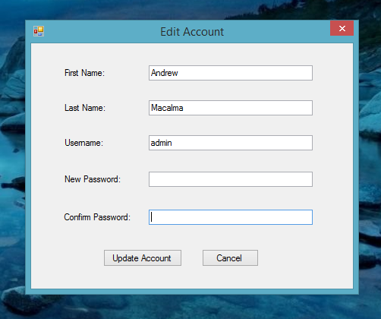 Accounts in both the service cubicle and admin sub-modules can be edited/updated though new accounts can only be added in the admin module, as accounts for the service module is only limited to 4, which comprise of the maximum number of cubicles in the office. As stated beforehand, accounts can be personalized, up to the first and last names. Figure 6 shows the update account window which is accessible in both the Service Cubicle and Admin Module while Figure 7 shows the new account window which is only accessible in the Admin Module.

Figure 6: Edit Accounts. Filled-in details will vary based on who is logged in.

## 

Figure 7: Creation of Accounts, exclusive to the Admin Module.

## 3.5 Exiting the System

To close the “Statistics for each Service Cubicle” window (as shown in Figure 3), click on OK. For all other windows, simply click the close button.

# Chapter 4: Using the System

## 4.1 Login

Upon opening the system, you will be taken to a login screen (as shown in Figure 1). Enter your username and password, along with your corresponding department. Provided that you just opened the application, you would have to enter the server’s IP Address in order to gain access, along with your credentials. To get your server’s IP Address, you would have to get the IP Address of the computer where you have installed the Server Module of the system, as seen in Figure 8. Otherwise, whenever you logout, you do not need to enter it again, as the IP address is saved in memory.

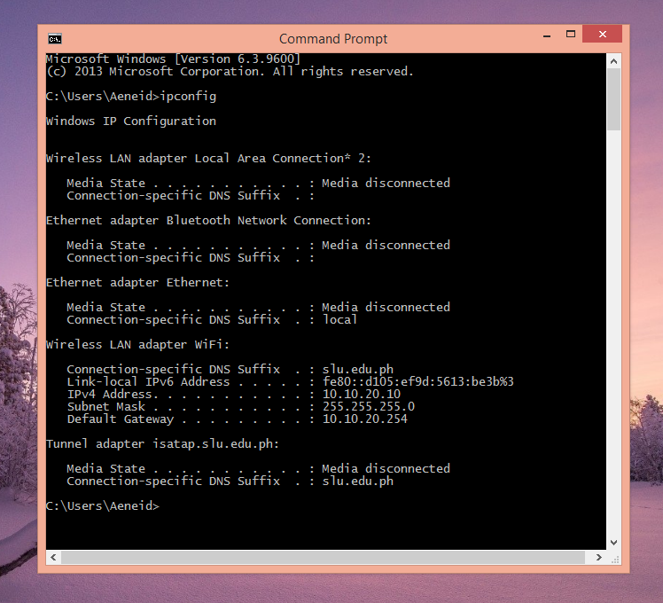

Figure 8: Obtaining the IP Address of the Server. Note that according to the photo, 10.10.20.10 is the IP Address of the PC.

## 4.2 Client Module

### 4.2.1 Service Cubicle Module

Provided that you have entered your account credentials correctly, you will be seeing a welcome message which should contain your full name as well as your corresponding cubicle number (Figure 9).

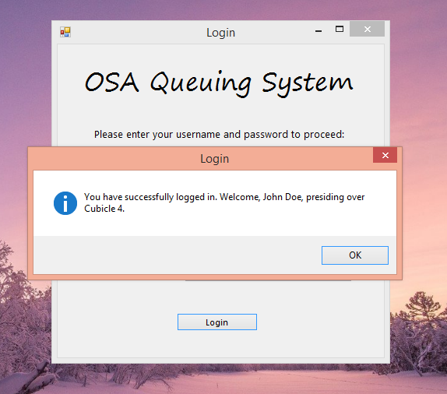

Figure 9: Welcome Message (for the Service Cubicle Module. The content of the message may vary on the user logged in.

### 4.2.2 Admin Module