Bon Voyage! Five Design Sheets Work

Andrew Enfield, Mike Browne, Todd Schultz

Group 8

August 7, 2018

# Introduction

Ideas. How does one come up with ideas to solve a problem? In the world of visualization, the Five Design Sheets Method is a contemporary method to lead groups through the process of creating and refining concepts to address a visualization design problem. The in-class exercise held on August 1, 2018 was an excellent opportunity to learn about the method while creating ideas for our project to help business travelers find the most on-time fights. Although, the exercise was handicapped by the unfortunate absence of one of the members. Nevertheless, the process did help to generate an original idea for one of the visualizations that is unique compared to previous projects and a refined idea for helping the traveler’s discovery alternative airports.

# Sheet 1

The purpose of Sheet 1 is to capture as many ideas as possible and then sort them. We struggled with this part of the exercise as we already had a general idea of concepts for the project. Also, we all have had significant exposure to similar visualizations through our personal and professional lives as we all have moderate to significant experience as air travelers. Overall, the areas we tended to focus on were finding the best time of day to fly and how to help travelers better understand the available airports around them. These are the two concepts that are refined in the following Sheets 2-4.

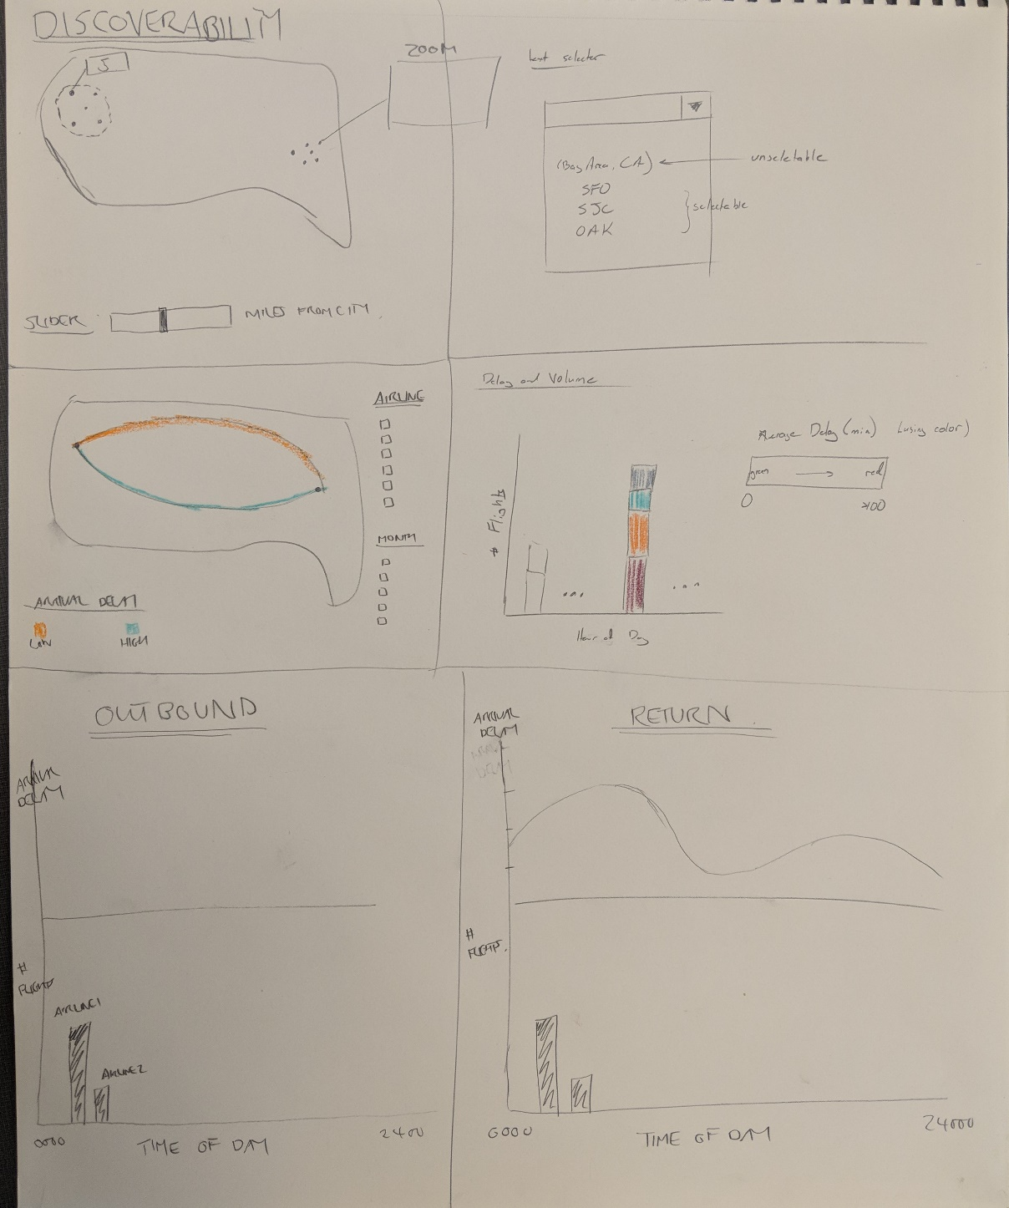

Figure 1: Sheet 1, the brainstorming sheet.

# Sheet 2

The first refinement we worked on was for the visualization to support the cognitive task of find the best time of day to fly given a desired travel date. Here we decided that the overall interface should display the outbound and return flight graphics separately and start initially with the average over all airlines that provide service for the desired route the traveler entered. Both graphics would should the average total delay including the departure delay and the arrival delay. For the focus detail, we focused on using the concept of detail on demands to provide the traveler with more granularity in the displayed data by providing a filter for the Traveler to select preferred airlines. The work on this sheet also lead us to develop the idea that the Traveler might also be concerned with the number of flights for each time of day. Thus, as we worked on the sheet we added a small multiple under the average total delay of a bar chart with the number of flights.

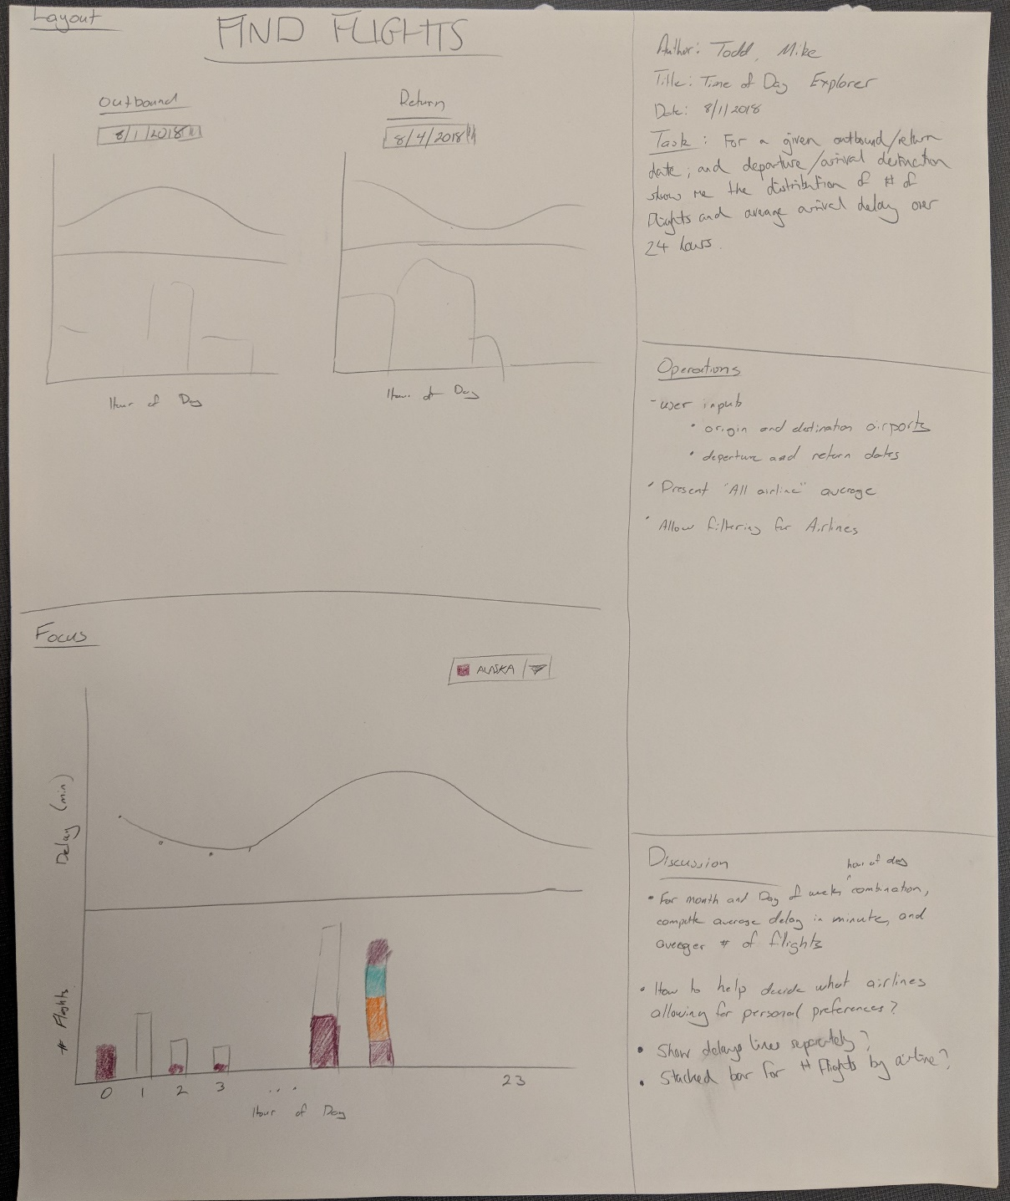

Figure 2: Sheet 2, first concept for the visualization to find the best time of day.

# Sheet 3

Sheet 3 shows our second idea for the same cognitive task in Sheet 2, to find the best time of day. Here we forced ourselves to develop an orthogonal visualization to the idea we captured in Sheet 2. The central theme here is that the hour of the day repeats and is cyclical. Thus we though of a compass rose style chart might be appropriate. Overall, the selection filters for origin airport, destination airport, and travel dates would be the same. Now the chart would be a compass rose type chart with the length of the rays would encode the average number of flights for that hour and the color would encode the category of the average total delay. The three delay categories would be on-time (average total delay less than 15 minutes), moderate delay of between 15 minutes and 30 minutes, and long delay of over 30 minutes. The focus would be again another details on demand scheme where the Travel could filter or view the data the airlines separately for a chosen hour of the day. We are intrigued by the novelty of this concept and plan to test it with user testing.

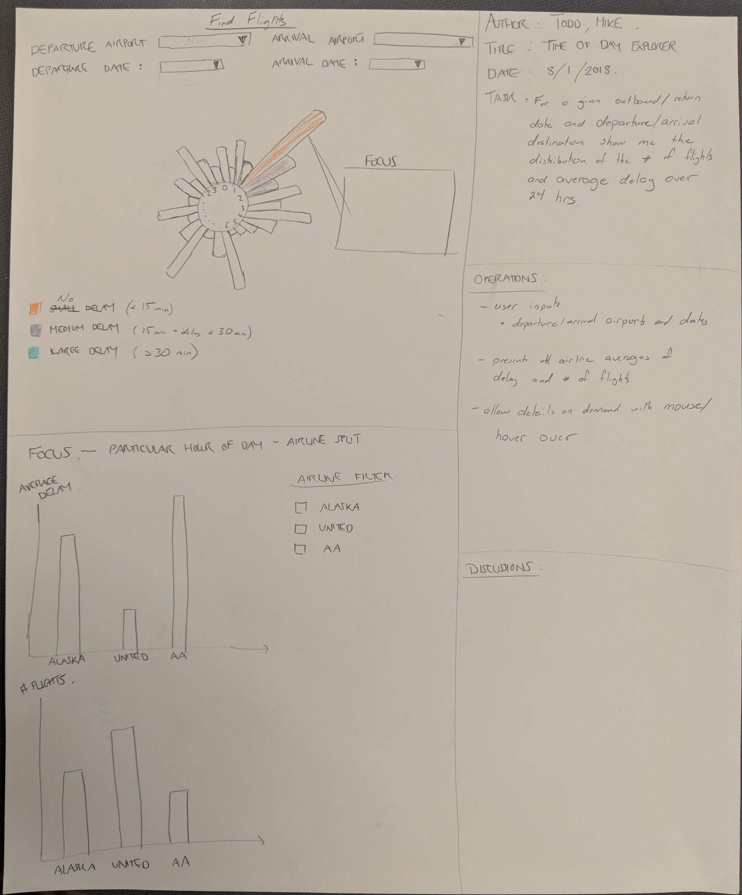

Figure 3: Sheet 3, second concept for the visualization to find the best time of day.

# Sheet 4

Sheet 4 was our idea to help the Traveler with the cognitive task of identifying alternative airports that may offer better on-time performance. This concept starts with a map display and only three inputs for the origin and destination market cities, and the search radius. Next, the map would present the airport in the search radius for both the origin market city and destination market city and provide a bar chart of the average delay time for each airport. Here, the average delay time for each market city would be unique to the situation as the origin market city airports would should the average departure delay and the destination market city airports would show the average arrival delays. We also hope that map display has intuitive zoom and pan controls to allow the Traveler to explore the results to their needs.

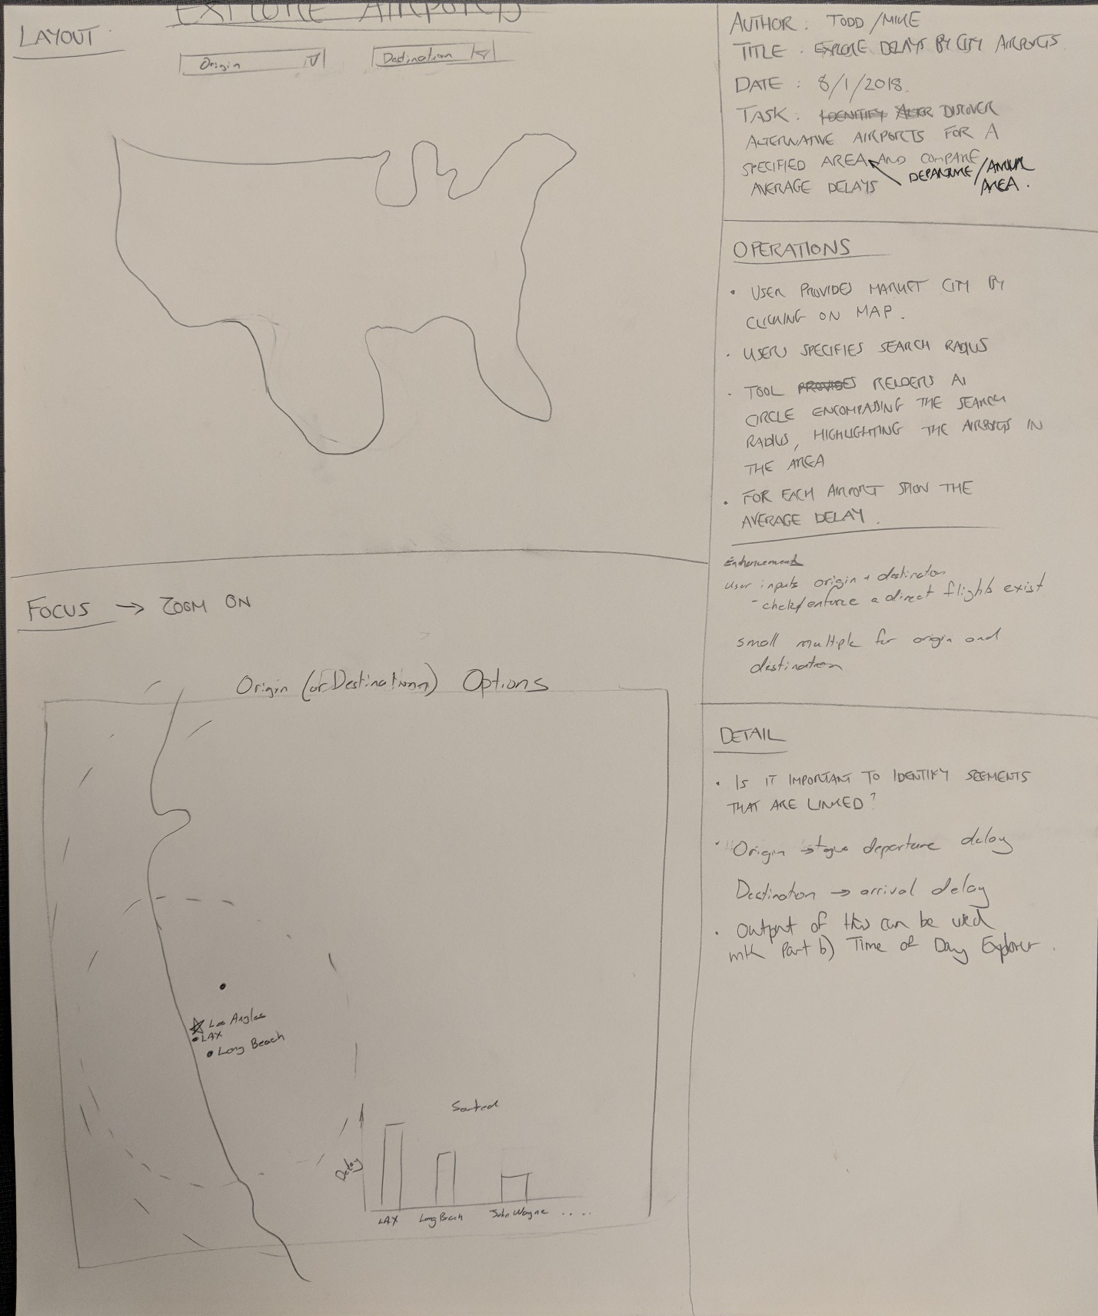

Figure : Sheet 4, first concept for finding the best airport.

# Sheet 5

The concept from Sheet 4 was refined into Sheet 5. The refinement process brought up a lot of additional ideas and items to discussion. Some of the items including where to assume a round trip itinerary and thus a need to display both the departure delay and arrival delays, if we should display and investigate both the origin and destination markets together in one visualization or generalize the visualization to a single market and let the Traveler chose to repeat for both cities if they desire.

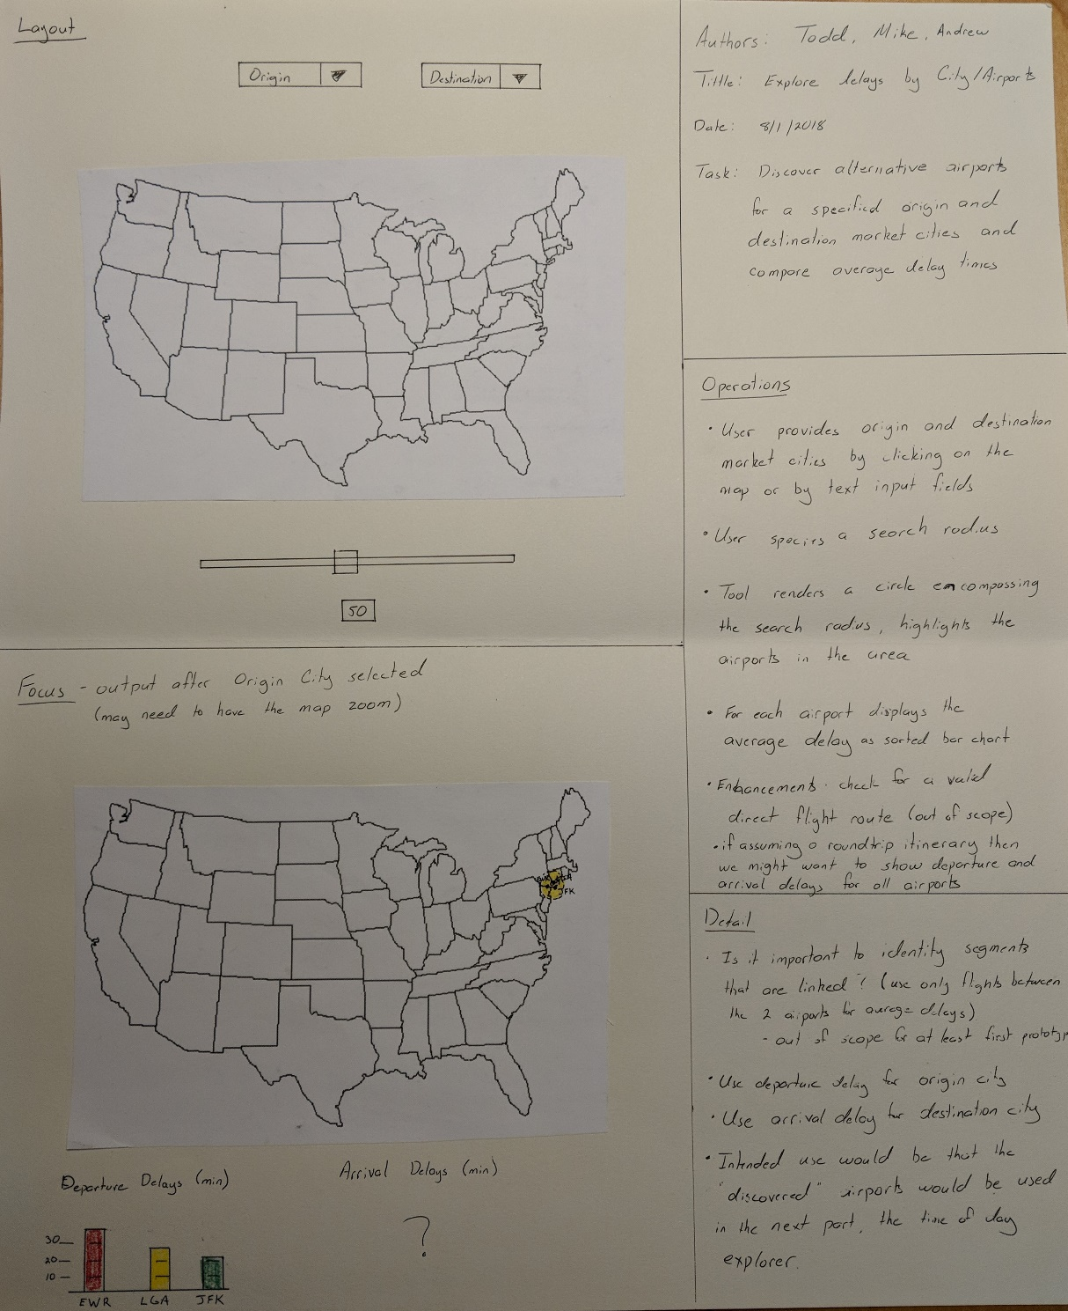

Figure : Sheet 5, refinement of the Sheet 4 for finding the best airport.

# Breakthroughs

The Five Design Sheets process help us generate more ideas quickly and systematically. In particular, we had the following breakthroughs.

1. Only need departure delay for the origin airport and arrival delay for the destination airport for the task of finding the best airport.
2. Only need the total delay for the flights for the task of finding the best hour of day to fly.
3. Hour of day is cyclical and thus, may be amendable to a compass rose or spider type chart.

# Conclusions

The Five Design Sheets process helped us quickly generate ideas, sort and filter them, and then work on refining two of the most promising ideas. The process also helps us uncover other features that we might have overlooked without a structured process such as only using the departure delays for the origin market city. The process also helped us stay on task for generating an orthogonal visualization that can be used to contrast our original idea for showing the best time of day to fly. We found that we easily locked into preconceived ideas from our own experiences search for flights, but the Five Design Sheets methodology provided guidance to overcome those biases and generate a novel concept. Ultimately, we may find that users prefer the original idea with more conventional bar charts, but now we have an option to present during usability testing that could provide for some interesting feedback that might lead to a hybrid concept.