**Foreword**

ISO (the International Organization for Standardization) is a worldwide federation of national standards bodies (ISO member bodies). The work of preparing International Standards is normally carried out through ISO technical committees. Each member body interested in a subject for which a technical committee has been established has the right to be represented on that committee. International organizations, governmental and non-governmental, in liaison with ISO, also take part in the work. ISO collaborates closely with the International Electrotechnical Commission (IEC) on all matters of electrotechnical standardization.

The procedures used to develop this document and those intended for its further maintenance are described in the ISO/IEC Directives, Part 1. In particular, the different approval criteria needed for the different types of ISO documents should be noted. This document was drafted in accordance with the editorial rules of the ISO/IEC Directives, Part 2 (see [www.iso.org/directives](https://www.iso.org/directives-and-policies.html)).

Attention is drawn to the possibility that some of the elements of this document may be the subject of patent rights. ISO shall not be held responsible for identifying any or all such patent rights. Details of any patent rights identified during the development of the document will be in the Introduction and/or on the ISO list of patent declarations received (see [www.iso.org/patents](https://www.iso.org/iso-standards-and-patents.html)).

Any trade name used in this document is information given for the convenience of users and does not constitute an endorsement.

For an explanation of the voluntary nature of standards, the meaning of ISO specific terms and expressions related to conformity assessment, as well as information about ISO's adherence to the World Trade Organization (WTO) principles in the Technical Barriers to Trade (TBT), see [www.iso.org/iso/foreword.html](https://www.iso.org/foreword-supplementary-information.html).

This document was prepared by Technical Committee ISO/TC 108, *Mechanical vibration, shock and condition monitoring*, Subcommittee SC 5, *Condition monitoring and diagnostics of machine systems*.

A list of all parts in the ISO 16079 series can be found on the ISO website.

Any feedback or questions on this document should be directed to the user’s national standards body. A complete listing of these bodies can be found at [www.iso.org/members.html](https://www.iso.org/members.html).

**Introduction**

This document is the second step of the procedure for carrying out the CM and D application design phase according to the V-model of [ISO 13379-1](https://www.iso.org/obp/ui/en/#iso:std:iso:13379:-1:en). In this step, the monitoring strategy for the drivetrain is defined, based upon the prioritized failure modes which were the outcome of the failure modes, effect and criticality analysis (FMECA) procedure performed according to [ISO 16079-1](https://www.iso.org/obp/ui/en/#iso:std:iso:16079:-1:en) (see [Figure 1](https://www.iso.org/obp/ui/en/#iso:std:iso:16079:-2:ed-1:v1:en:fig:1)).

According to the V-Model of [ISO 13379-1](https://www.iso.org/obp/ui/en/#iso:std:iso:13379:-1:en) and [ISO 16079-1](https://www.iso.org/obp/ui/en/#iso:std:iso:16079:-1:en), the steps described in this document are as follows:

* a) decide under which operating conditions the different faults can be best observed and specify the conditions under which the symptom is most likely to be observed;
* b) identify the symptoms that can serve in assessing the condition of the machine, and that are used for diagnostics;
* c) list the descriptors that are used to evaluate (recognize) the different symptoms;
* d) identify the necessary measurements and transducers from which the descriptors are derived or computed.

**Figure 1 — The relationship between this document and**[**ISO 16079-1**](https://www.iso.org/obp/ui/en/#iso:std:iso:16079:-1:en)

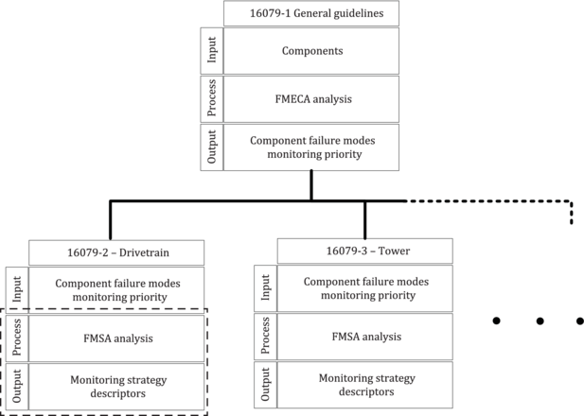

**Key**

|  |  |
| --- | --- |
| dotted line | scope of this document |

In relation to the V-model, this document describes the two last steps of the application design phase of the condition monitoring system. This process shall ensure that data are available to support an efficient process in the use phase of the condition monitoring system. The end goal of the “Use phase process” is minimizing wind turbine downtime through a risk assessment of a detected fault by means of remaining useful life (RUL) evaluation, and successive determination of maintenance timing. The criticality and risk assessment uses information from the FMECA analysis, but may also feed information back into an adjustment of the initial FMECA analysis (see [Figure 2](https://www.iso.org/obp/ui/en/#iso:std:iso:16079:-2:ed-1:v1:en:fig:2)).

**Figure 2 — Condition monitoring and diagnostics (CM and D) cycle: Design phase and use phase of the application on a machine**

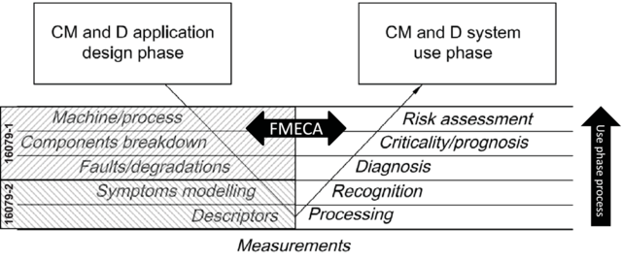

This document shows how to apply the results of an FMECA analysis made according to [ISO 16079-1](https://www.iso.org/obp/ui/en/#iso:std:iso:16079:-1:en) by prescribing a methodology for making a failure mode symptoms analysis (FMSA) with the purpose of defining symptoms and related descriptors to detect a particular failure mode.

In order to implement the results of the FMSA, sections with guidelines for condition monitoring of wind turbines are provided, covering:

* 1) guidelines for descriptor measurements;
* 2) adapting to changes in operating conditions;
* 3) selection of transducers and transducer technology;
* 4) selection of transducer locations;
* 5) naming convention for identifying transducer locations and related descriptors;
* 6) evaluation criteria for descriptor measurements;
* 7) requirements to data for diagnosis;
* 8) prognosis and/or criticality assessment; and
* 9) review of the CM & D design:
  + a) assessment of effectiveness of the diagnostics system, and
  + b) cost benefit analysis.

[Figure 3](https://www.iso.org/obp/ui/en/#iso:std:iso:16079:-2:ed-1:v1:en:fig:3) shows the relationship between the monitoring strategy, diagnostic strategy and maintenance strategy and how these important elements support the steps in the condition monitoring process. If the monitoring strategy, the diagnostic strategy, or both are based upon weak or missing data, it compromises the prognosis and the whole purpose of the condition monitoring process.

**Figure 3 — Relationship between monitoring methods, diagnostic methods and prognosis methods**

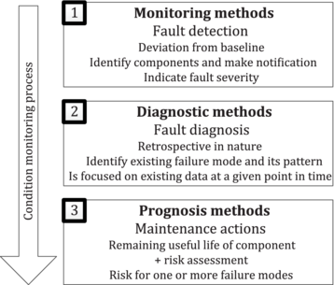

The selection of the monitoring method is to define where you measure, what you measure and how often you measure in order to provide data for:

* — detecting the failure modes designated to be revealed by the condition monitoring system;
* — assessing the severity of the present state of the fault;
* — assessing the remaining useful lifetime of a certain component.

A weak point in the condition monitoring system setup (e.g. lack of transducers or bad transducer location, limitations in what can be measured, or too sparse data) affects the end goal of the condition monitoring process – the prognosis.

The choice of the diagnostic method is to provide enough data for:

* — detailed analysis of a failure mode and identification of the root-cause;
* — assessing the severity of the present state of the fault;
* — assessing the remaining useful lifetime of a certain component.

The purpose of the prognosis is to make a prediction of remaining useful lifetime (RUL) of a component and assess the risk for related failure modes (secondary failure).

The maintenance action is based upon the data provided by the monitoring methods, the diagnostic methods and the prognosis methods, and on knowledge of maintenance history and alarm history. Therefore, it is very important that not only measured data are stored, but also information about earlier alarms, maintenance actions and identification of persons which have been involved with earlier alarm handling on the machine.

**1   Scope**

This document specifies the implementation of a condition monitoring system for wind turbines, with particular focus on monitoring of the drivetrain. Guidance for a practical implementation of the FMSA is provided, as well as guidance for specifying best practices and minimum recommendations regarding the condition monitoring system used for failure mode detection, diagnostics and prognostics of the direct drive and geared wind turbine drivetrain, including:

* a) main bearing(s);
* b) gearbox, if applicable; and
* c) generator (mechanical aspects).

This also includes subcomponents such as coupling and the lubrication system.

This document provides an overview of the important aspects of condition monitoring of wind turbines and makes references to other standards where in-depth information on the subjects is available.

**2   Normative references**

The following documents are referred to in the text in such a way that some or all of their content constitutes requirements of this document. For dated references, only the edition cited applies. For undated references, the latest edition of the referenced document (including any amendments) applies.

* [ISO 2041](https://www.iso.org/obp/ui/en/#iso:std:iso:2041:en), *Mechanical vibration, shock and condition monitoring — Vocabulary*
* [ISO 13372](https://www.iso.org/obp/ui/en/#iso:std:iso:13372:en), *Condition monitoring and diagnostics of machines — Vocabulary*

**3   Terms and definitions**

For the purposes of this document, the terms and definitions given in [ISO 2041](https://www.iso.org/obp/ui/en/#iso:std:iso:2041:en) and [ISO 13372](https://www.iso.org/obp/ui/en/#iso:std:iso:13372:en) and the following apply.

ISO and IEC maintain terminological databases for use in standardization at the following addresses:

* — ISO Online browsing platform: available at [https://www.iso.org/obp](https://www.iso.org/obp/ui)
* — IEC Electropedia: available at <http://www.electropedia.org/>

**3.1**

**time waveform**

sampled vibration signal recorded from the transducer

Note 1 to entry: Time waveform recordings have a certain length in time and represent a parameter value at every instance during the recording of the time waveform.

**Only informative sections of standards are publicly available. To view the full content, you will need to purchase the standard by clicking on the "Buy" button.**