**FOREWORD**

* 1) The International Electrotechnical Commission (IEC) is a worldwide organization for standardization comprising all national electrotechnical committees (IEC National Committees). The object of IEC is to promote international co-operation on all questions concerning standardization in the electrical and electronic fields. To this end and in addition to other activities, IEC publishes International Standards, Technical Specifications, Technical Reports, Publicly Available Specifications (PAS) and Guides (hereafter referred to as "IEC Publication(s)"). Their preparation is entrusted to technical committees; any IEC National Committee interested in the subject dealt with may participate in this preparatory work. International, governmental and nongovernmental organizations liaising with the IEC also participate in this preparation. IEC collaborates closely with the International Organization for Standardization (ISO) in accordance with conditions determined by agreement between the two organizations.
* 2) The formal decisions or agreements of IEC on technical matters express, as nearly as possible, an international consensus of opinion on the relevant subjects since each technical committee has representation from all interested IEC National Committees.
* 3) IEC Publications have the form of recommendations for international use and are accepted by IEC National Committees in that sense. While all reasonable efforts are made to ensure that the technical content of IEC Publications is accurate, IEC cannot be held responsible for the way in which they are used or for any misinterpretation by any end user.
* 4) In order to promote international uniformity, IEC National Committees undertake to apply IEC Publications transparently to the maximum extent possible in their national and regional publications. Any divergence between any IEC Publication and the corresponding national or regional publication shall be clearly indicated in the latter.
* 5) IEC itself does not provide any attestation of conformity. Independent certification bodies provide conformity assessment services and, in some areas, access to IEC marks of conformity. IEC is not responsible for any services carried out by independent certification bodies.
* 6) All users should ensure that they have the latest edition of this publication.
* 7) No liability shall attach to IEC or its directors, employees, servants or agents including individual experts and members of its technical committees and IEC National Committees for any personal injury, property damage or other damage of any nature whatsoever, whether direct or indirect, or for costs (including legal fees) and expenses arising out of the publication, use of, or reliance upon, this IEC Publication or any other IEC Publications.
* 8) Attention is drawn to the Normative references cited in this publication. Use of the referenced publications is indispensable for the correct application of this publication.
* 9) Attention is drawn to the possibility that some of the elements of this IEC Publication may be the subject of patent rights. IEC shall not be held responsible for identifying any or all such patent rights.

International Standard [IEC 61400-4](https://www.iso.org/obp/ui/en/#iso:std:iec:61400:-4:en) has been prepared by IEC technical committee 88: Wind turbines, in co-operation with ISO technical committee 60: Gears.

It is published as a double logo standard.

This first edition cancels and replaces [ISO 81400-4](https://www.iso.org/obp/ui/en/#iso:std:iso:81400:-4:en) published in 2005. It constitutes a technical revision of [ISO 81400-4](https://www.iso.org/obp/ui/en/#iso:std:iso:81400:-4:en) with extended content and changes in all pertinent sections.

This edition includes the following significant technical changes with respect to the previous edition:

* a) extension of the scope to wind turbines above 2 MW rated power;
* b) considerations for converging differing approaches to reliability in gear, bearing and wind turbine standards;
* c) a new clause on wind turbine loads specific to drivetrains;
* d) new clause on testing and validation of new gearbox designs;
* e) updated bearing selection tables for different locations in a wind turbine gearbox;
* f) expanded design considerations on the use of bearings based on avoiding standard failures;
* g) a new clause on considerations and requirements in the design and analysis of gearbox structural elements;
* h) updated considerations and requirements on lubricants and lubrication systems.

The text of this standard is based on the following documents of IEC:

| FDIS | Report on voting |
| --- | --- |
| 88/438/FDIS | 88/441/RVD |

Full information on the voting for the approval of this standard can be found in the report on voting indicated in the above table. In ISO, the standard has been approved by 11 P-members out of 12 having cast a vote.

This publication has been drafted in accordance with the ISO/IEC Directives, Part 2.

A list of all parts in the [IEC 61400](https://www.iso.org/obp/ui/en/#iso:std:iec:61400:en) series, published under the general title *Wind turbines,* can be found on the IEC website.

The committee has decided that the contents of this publication will remain unchanged until the stability date indicated on the IEC web site under "http://webstore.iec.ch" in the data related to the specific publication. At this date, the publication will be

* • reconfirmed,
* • withdrawn,
* • replaced by a revised edition, or
* • amended.

A bilingual edition of this document may be issued at a later date.

**INTRODUCTION**

[IEC 61400-4](https://www.iso.org/obp/ui/en/#iso:std:iec:61400:-4:en) outlines minimum requirements for specification, design and verification of gearboxes in wind turbines. It is not intended for use as a complete design specification or instruction manual, and it is not intended to assure performance of assembled drive systems. It is intended for use by experienced gear designers capable of selecting reasonable values for the factors, based on knowledge of similar designs and the effects of such items as lubrication, deflection, manufacturing tolerances, metallurgy, residual stress and system dynamics. It is not intended for use by the engineering public at large.

Any of the requirements of this standard may be altered if it can be suitably demonstrated that the safety and reliability of the system is not compromised. Compliance with this standard does not relieve any person, organization, or corporation from the responsibility of observing other applicable regulations.

**1   Scope**

This part of the [IEC 61400](https://www.iso.org/obp/ui/en/#iso:std:iec:61400:en) series is applicable to enclosed speed increasing gearboxes for horizontal axis wind turbine drivetrains with a power rating in excess of 500 kW. This standard applies to wind turbines installed onshore or offshore.

This International Standard provides guidance on the analysis of the wind turbine loads in relation to the design of the gear and gearbox elements.

The gearing elements covered by this standard include such gears as spur, helical or double helical and their combinations in parallel and epicyclic arrangements in the main power path. This standard does not apply to power take off gears (PTO).

The standard is based on gearbox designs using rolling element bearings. Use of plain bearings is permissible under this standard, but the use and rating of them is not covered.

Also included is guidance on the engineering of shafts, shaft hub interfaces, bearings and the gear case structure in the development of a fully integrated design that meets the rigours of the operating conditions.

Lubrication of the transmission is covered along with prototype and production testing. Finally, guidance is provided on the operation and maintenance of the gearbox.

**2   Normative references**

The following documents, in whole or in part, are normatively referenced in this document and are indispensable for its application. For dated references, only the edition cited applies. For undated references, the latest edition of the referenced document (including any amendments) applies.

* IEC 60050 (all parts), *International Electrotechnical Vocabulary Available at <*[*http://www.electropedia.org*](http://www.electropedia.org/)*>*
* IEC 61400-1:2005, *Wind turbines — Part 1: Design requirements*
* IEC 61400-3, *Wind turbines — Part 3: Design requirements for offshore wind turbines*
* IEC/TS 61400-13:2001, *Wind turbine generator systems — Part 13: Measurement of mechanical loads*
* IEC 61400-22:2010, *Wind turbines — Part 22: Conformity testing and certification*
* [ISO 76](https://www.iso.org/obp/ui/en/#iso:std:iso:76:en), *Rolling bearings — Static load ratings*
* [ISO 281:2007](https://www.iso.org/obp/ui/en/#iso:std:iso:281:ed-2:en), *Rolling bearings — Dynamic load ratings and rating life*
* [ISO 683 (all parts)](https://www.iso.org/obp/ui/en/#iso:std:iso:683:en), *Heat-treatable steels, alloy steels and free-cutting steels*
* [ISO 1328-1](https://www.iso.org/obp/ui/en/#iso:std:iso:1328:-1:en), *Cylindrical gears — ISO system of accuracy — Part 1: Definitions and allowable values of deviations relevant to corresponding flanks of gear teeth*
* [ISO 4287](https://www.iso.org/obp/ui/en/#iso:std:iso:4287:en), *Geometrical Product Specifications (GPS) — Surface texture: Profile method — terms, definitions and surface texture parameters*
* [ISO 4288](https://www.iso.org/obp/ui/en/#iso:std:iso:4288:en), *Geometrical Product Specifications (GPS) — Surface texture: Profile method — rules and procedures for the assessment of surface texture*
* [ISO 4406](https://www.iso.org/obp/ui/en/#iso:std:iso:4406:en), *Hydraulic fluid power — Fluids- Method for coding the level of contamination by solid particles*
* [ISO 5725-2](https://www.iso.org/obp/ui/en/#iso:std:iso:5725:-2:en), *Accuracy (trueness and precision) of measurement methods and results — Part 2: Basic methods for the determination of repeatability and reproducibility of a standard measurement method*
* [ISO 6336 (all parts)](https://www.iso.org/obp/ui/en/#iso:std:iso:6336:en), *Calculation of load capacity of spur and helical gears*
* [ISO 6336-1:2006](https://www.iso.org/obp/ui/en/#iso:std:iso:6336:-1:ed-2:en), *Calculation of load capacity of spur and helical gears — Part 1: Basic principles, introduction and general influence factors*
* [ISO 6336-2:2006](https://www.iso.org/obp/ui/en/#iso:std:iso:6336:-2:ed-2:en), *Calculation of load capacity of spur and helical gears — Part 2: Calculation of surface durability (pitting)*
* [ISO 6336-3:2006](https://www.iso.org/obp/ui/en/#iso:std:iso:6336:-3:ed-2:en), *Calculation of load capacity of spur and helical gears — Part 3: Calculation of tooth bending strength*
* [ISO 6336-5:2003](https://www.iso.org/obp/ui/en/#iso:std:iso:6336:-5:ed-2:en), *Calculation of load capacity of spur and helical gears — Part 5: Strength and quality of materials*
* [ISO 6336-6:2006](https://www.iso.org/obp/ui/en/#iso:std:iso:6336:-6:ed-1:en), *Calculation of load capacity of spur and helical gears — Part 6: Calculation of service life under variable load*
* [ISO/TR 10064-3](https://www.iso.org/obp/ui/en/#iso:std:iso:tr:10064:-3:en), *Cylindrical gears — Code of inspection practice — Part 3: Recommendations relative to gear blanks, shaft centre distance and parallelism of axes*
* [ISO 12925-1](https://www.iso.org/obp/ui/en/#iso:std:iso:12925:-1:en), *Lubricants, industrial oils and related products (class L). Family C (Gears) — Part 1: Specifications for lubricants for enclosed gear systems*
* [ISO/TR 13593](https://www.iso.org/obp/ui/en/#iso:std:iso:tr:13593:en), *Enclosed gear drives for industrial applications*
* [ISO/TR 13989-1](https://www.iso.org/obp/ui/en/#iso:std:iso:tr:13989:-1:en), *Calculation of scuffing load capacity of cylindrical, bevel and hypoid gears — Part 1: Flash temperature method*
* [ISO/TR 13989-2](https://www.iso.org/obp/ui/en/#iso:std:iso:tr:13989:-2:en), *Calculation of scuffing load capacity of cylindrical, bevel and hypoid gears — Part 2: Integral temperature method*
* [ISO 14104](https://www.iso.org/obp/ui/en/#iso:std:iso:14104:en), *Gears — Surface temper etch inspection after grinding*
* [ISO 14635-1:2000](https://www.iso.org/obp/ui/en/#iso:std:iso:14635:-1:ed-1:en), *Gears — FZG test procedures — Part 1: FZG test method A/8,3/90 for relative scuffing load-carrying capacity of oils*
* [ISO 15243:2004](https://www.iso.org/obp/ui/en/#iso:std:iso:15243:ed-1:en), *Rolling bearings — Damage and failures — Terms, characteristics and causes*
* [ISO/TS 16281:2008](https://www.iso.org/obp/ui/en/#iso:std:iso:ts:16281:ed-1:en), *Rolling bearings — Methods for calculating the modified reference rating life for universally loaded bearings*
* AGMA 9005, *Industrial Gear Lubrication*
* ANSI/AGMA 925-A02, *Effect of lubrication on gear surface distress*
* ANSI/AGMA 6001-E10, *Design and selection of components for enclosed gear drives*
* ANSI/AGMA 6123, *Design manual for enclosed epicyclic gear drives*
* ASTM E1049-85, *Standard practices for cycle counting in fatigue analysis*
* DIN 471, *Circlips (retaining rings) for shafts: Normal type and heavy type*
* DIN 472, *Circlips (retaining rings) for bores: Normal type and heavy type*
* DIN 743:2000, *Shafts and axles, calculations of load capacity, Parts 1,2, 3*
* DIN 3990-4, *Calculation of load capacity of cylindrical gears: calculation of scuffing load capacity*
* DIN 6885-2, *Parallel Key Geometries*
* DIN 6892, *Mitnehmerverbindungen ohne Anzug — Passfedern — Berechnung und Gestaltung (available in German only)*
* DIN 7190, *Interference fits — Calculation and design rules*
* DIN 51517-3, *Lubricants: Lubricating oils — Part 3: Lubricating oils CLP; Minimum requirements*
* EN 12680-3:2003, *Ultrasonic examination. Spheroidal graphite cast iron castings*

**3   Terms, definitions and conventions**

**3.1   Terms and definitions**

For the purposes of this document, the terms and definitions given in IEC 61400-1:2005 and IEC 60050-415 as well as the following apply.

NOTE The definitions in this standard take precedence.

**3.1.1**

**bearing manufacturer**

legal entity supplying bearings for the wind turbine gearbox, and who is responsible for the design and the application engineering of the bearing

Note 1 to entry: Typically, the bearing supplier will also manufacture the bearing.

**3.1.2**

**certification body**

entity that conducts certification of conformity of the wind turbine gearbox in accordance with IEC 61400-22

**3.1.3**

**characteristic load**

load value having a prescribed probability of not being exceeded

Note 1 to entry: See also [3.1.5](https://www.iso.org/obp/ui/en/#iso:std:iec:61400:-4:ed-1:v1:en:sec:3.1.5), design load.

**3.1.4**

**design lifetime**

specified duration for which strength verification shall be performed

Note 1 to entry: Some serviceable components and wear parts may have a lower design lifetime than the one specified for the entire gearbox.

**3.1.5**

**design load**

load for which the strength of any component has to be documented

Note 1 to entry: It consists of the characteristic load multiplied by the appropriate partial safety factor for load.

Note 2 to entry: See also IEC 61400-1 and [Clause 6](https://www.iso.org/obp/ui/en/#iso:std:iec:61400:-4:ed-1:v1:en:sec:6).

**3.1.6**

**double-row bearings**

rolling bearings with two rows of rolling elements

**3.1.7**

**equivalent load**

load which when repeated for a specified number of cycles causes the same damage as the actual load variation if a specified life exponent applies

Note 1 to entry: When applied to load ranges, the equivalent load does not take the mean-stress level of the load cycles into account.

**3.1.8**

**extreme load**

that design load from any source, either operating or non-operating, that is the largest absolute value of the respective load component

Note 1 to entry: This component can be a force, a moment, a torque or a combination of these.

**3.1.9**

**gearbox manufacturer**

the entity responsible for designing the gearbox, and specifying manufacturing requirements for the gearbox and its components

Note 1 to entry: In reality, several legal entities may be involved in this process, which is not further reflected in this standard.

**3.1.10**

**interface**

defined boundary of the gearbox that is either a physical mount to another wind turbine subcomponent or a path of exchange such as control signals, hydraulic fluid, or lubricant

**3.1.11**

**load reserve factor**

*LRF*

ratio of the design load to the maximum allowable load on a specific component

Note 1 to entry: *LRF* can be determined separately for both the ultimate and fatigue strength calculation.

**3.1.12**

**local failure**

failure which occurs when at a critical location, the maximum allowable strain is exceeded

**3.1.13**

**locating bearing**

fixed bearing

bearing supporting axial forces in both directions

**3.1.14**

**lubricant supplier**

legal entity supplying lubricants for the wind turbine gearbox through either the wind turbine manufacturer, the gearbox manufacturer, or the wind turbine owner

Note 1 to entry: The lubricant supplier is responsible for the performance of the lubricant and the blending specifications, but will not necessarily produce any of the components, or blend the final product.

**3.1.15**

**maximum operating load**

highest load determined by the design load cases used in fatigue analysis as defined in IEC 61400-1, including partial load safety factor as applicable in accordance with IEC 61400-1

**3.1.16**

**nacelle**

turbine structure above the tower that holds the drivetrain, generator, other subcomponents, and parts of the controls and actuation systems

**3.1.17**

**non-locating bearing**

floating bearing

bearing supporting only radial load

**3.1.18**

**paired bearings**

two bearings of the same type at the same location

Note 1 to entry: These can be arranged so that their radial capacities complement and their axial capacities are opposite (e.g., two TRB or two ACBB in face-to-face or back-to-back arrangement), or they can be two bearings in tandem to increase both radial and axial load carrying capacities (see [C.7](https://www.iso.org/obp/ui/en/#iso:std:iec:61400:-4:ed-1:v1:en:sec:C.7)).

**3.1.19**

**rainflow matrices**

representation of fatigue loads using a two dimensional matrix containing counts of cycle occurrence within sub-ranges of cyclic means and amplitudes

SEE:

**3.1.20**

**time series**

set of time sequences of loads, describing different operational regimes of the wind turbine

Note 1 to entry: These time series together with their corresponding occurrences specify the load history during the entire design lifetime.

**3.1.21**

**wind turbine manufacturer**

entity responsible for specifying the requirements for the gearbox designed in accordance with this standard

Note 1 to entry: Typically, the wind turbine manufacturer will design, manufacture and market the wind turbine.

**3.1.22**

**wind turbine owner**

entity who purchases and is responsible for operating the wind turbine

Note 1 to entry: In reality, the owner may contract different legal entities to operate, service and maintain the wind turbine. This distinction is not further reflected in this standard.

**3.2   Conventions**

**3.2.1**

**bearing position designations**

the following abbreviations can be used to define bearing positions (shaft designations are defined in [3.2.2](https://www.iso.org/obp/ui/en/#iso:std:iec:61400:-4:ed-1:v1:en:sec:3.2.2)):

* • RS: rotor side (normally upwind)
* • GS: generator side (normally downwind)

In case of paired bearings the following can be used:

* • IB: inboard (pointing inwards related to the shaft)
* • OB: outboard (pointing outwards related to the shaft)

**3.2.2**

**shaft designations — examples for typical wind turbine gearbox architecture**

[Figure 1](https://www.iso.org/obp/ui/en/#iso:std:iec:61400:-4:ed-1:v1:en:fig:1) shows the designations of shafts in 3-stage parallel shaft gearboxes. In 4-stage gearboxes, the intermediate shafts are called "low speed intermediate shaft", "medium speed intermediate shaft", and "high speed intermediate shaft".

**Figure 1 — Shaft designation in 3-stage parallel shaft gearboxes**

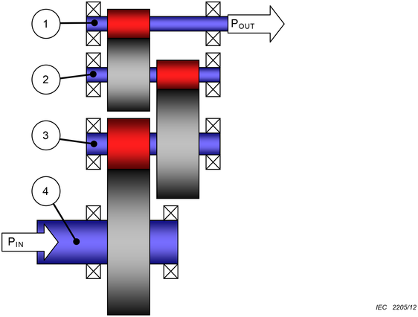

**Key**

|  |  |  |
| --- | --- | --- |
| 1 | HSS | High-speed shaft |
| 2 | HS-IS | High-speed intermediate shaft |
| 3 | LS-IS | Low-speed intermediate shaft |
| 4 | LSS | Low-speed shaft |
| Pin |  | Power input |
| Pout |  | Power output |

[Figure 2](https://www.iso.org/obp/ui/en/#iso:std:iec:61400:-4:ed-1:v1:en:fig:2) shows the designations of shafts in 3-stage planet/helical hybrid gearboxes with one planet stage.

**Figure 2 — Shaft designation in 3-stage gearboxes with one planet stage**

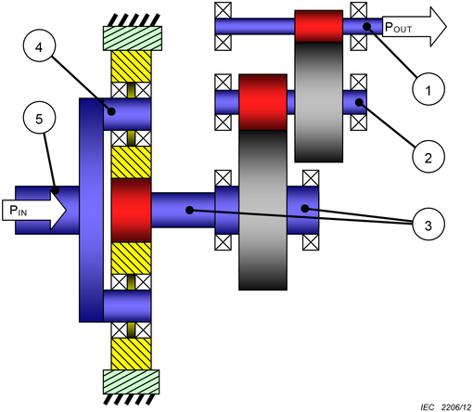

**Key**

|  |  |  |
| --- | --- | --- |
| 1 | HSS | High-speed shaft |
| 2 | HS-IS | High-speed intermediate shaft |
| 3 | LS-IS | Low-speed intermediate shaft |
| 4 | PS | Planet shaft |
| 5 | LSS | Low-speed shaft |
| PIN |  | Power input |
| POUT |  | Power output |

[Figure 3](https://www.iso.org/obp/ui/en/#iso:std:iec:61400:-4:ed-1:v1:en:fig:3) shows the designations of shafts in 3-stage planet/helical hybrid gearboxes with two planet stages.

**Figure 3 — Shaft designation in 3-stage gearboxes with two planet stages**

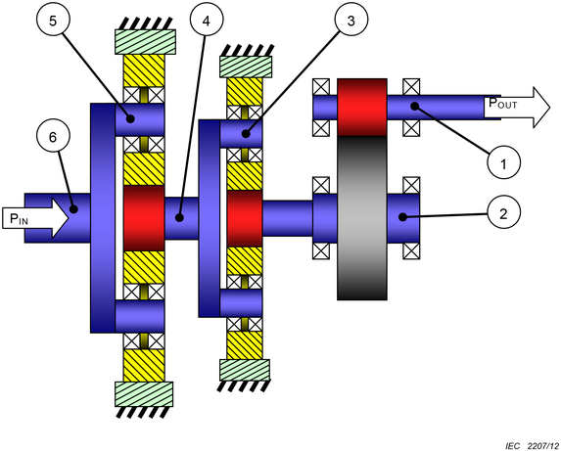

**Key**

|  |  |  |
| --- | --- | --- |
| 1 | HSS | High-speed shaft |
| 2 | HS-IS | High-speed intermediate shaft |
| 3 | IS-PS | Intermediate-speed planet shaft |
| 4 | ISS | Intermediate-speed shaft |
| 5 | LS-PS | Low-speed planet shaft |
| 6 | LSS | Low-speed shaft |
| PIN |  | Power input |
| POUT |  | Power output |

**Only informative sections of standards are publicly available. To view the full content, you will need to purchase the standard by clicking on the "Buy" button.**