Azures, Jan Aeron
201912723

PROJECT PROPOSAL
I. Project Details
- Application Title: Klasmeyt: Adamson Community Bulletin & Student Feed
- Target Users:
  - Adamson University undergraduate and graduate students tracking daily campus discourse.
  - Student leaders and recognized campus organizations disseminating activity updates and announcements.
  - Classmates coordinating study circles, project groups, and department-specific concerns.
  - Campus community members posting or browsing lost-and-found items and event bulletins.
II. Problem Statement
Mainstream social networking platforms like Facebook and public forums host an overwhelming amount of general clutter, algorithmic noise, commercial advertisements, and external traffic. As a consequence, Adamson University students struggle to locate urgent campus announcements, college-specific academic discussions, student organization notices, and lost-and-found reports.
Campus-specific interactions frequently become buried underneath unrelated public content, forcing students to navigate multiple disjointed groups or rely on unorganized message threads. There is a lack of a streamlined, localized mobile environment dedicated strictly to Adamsonians where students can publish, browse, and curate campus discourse without commercial clutter.
III. Proposed Solution
Klasmeyt is an Android mobile bulletin and micro-community application built specifically for Adamson University students. Developed using modern declarative UI principles with Jetpack Compose, the application establishes a focused campus feed where students can compose academic or extracurricular posts, assign relevant category tags (such as Announcements, CS/IT, Lost & Found, or Campus Life), and interact with active student entries.
The application employs an architectural ViewModel paired with Compose observable state to maintain post records during runtime, delivering full Create, Read, Update, and Delete (CRUD) capabilities across a seamless three-screen navigation structure.
IV. Main Features
- Campus Feed Stream (Read): Displays an organized, chronological collection of student posts in a clean card layout powered by LazyColumn, featuring author labels, timestamps, and department/category tags.
- Post Authoring Studio (Create): Enables students to compose new updates by inputting a post title, category tag, and detailed body text before committing the record to the campus board.
- Detailed Bulletin Inspector (Read): A dedicated inspection screen presenting the complete post content, category metadata, and author details.
- Post Content Modifier (Update): Allows the author to modify an existing post's title, category classification, or content body through an edit form with synchronized state updates.
- Direct Entry Deletion (Delete): Provides an immediate removal option from the detail view to purge outdated bulletins, resolved lost-and-found items, or erroneous posts.
V. Data or Information to be Managed
The core data structure managed by the application is the CampusPost model:
Attribute | Data Type | Description
id | String | Unique identifier generated per post record via UUID.
author | String | Full name or display name of the student author.
studentNumber | String | Student ID tag or department identifier for university context.
title | String | Headline or subject summary of the post.
category | String | Departmental or thematic tag (e.g., Announcements, CS/IT, Events, Lost & Found).
content | String | Complete body text of the bulletin or student message.
timestamp | String | Formatted relative time or creation timestamp.
CRUD Operations Breakdown
- Create: Instantiates a new CampusPost from the composition screen and prepends it to the ViewModel state collection, instantly making it visible on the feed.
- Read: Queries the observable state to populate the scrollable feed via LazyColumn and retrieves specific post records by their unique id when navigating to the detail screen.
- Update: Identifies an existing post record by its id and modifies its title, category, and content attributes, updating the UI state reactively.
- Delete: Removes a post record matching the target id from the collection, immediately returning the user to the refreshed feed.
VI. Screen Architecture & Navigation Flow
- Feed Screen (FeedScreen): Main entry point presenting university branding, a category-tagged scrollable LazyColumn of community posts, a Floating Action Button (+) to compose a post, and card tap actions linking to detailed post views.
- Post Detail Screen (PostDetailScreen): Inspector view displaying the complete post body, author information, and action buttons to trigger Edit or Delete operations.
- Create / Edit Post Screen (CreateEditPostScreen): Dual-purpose input form containing text fields for title, category, and body content, handling both new post creation and existing post modifications before saving back to the feed.

ERD:
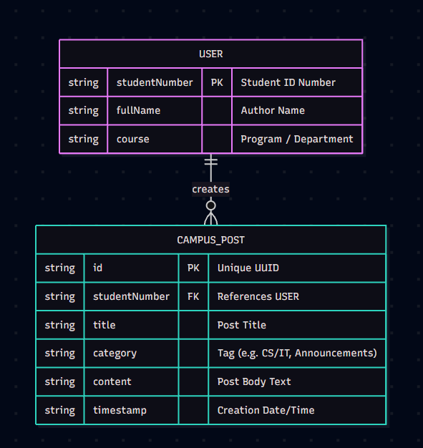

My application follows a One-to-Many (1:M) relational schema between the USER and CAMPUS_POST entities. A student is uniquely identified by their studentNumber, which serves as the Primary Key for the User entity. Each post is uniquely identified by an id using a UUID and references the author through studentNumber as a Foreign Key. This ensures that every post in the feed and user profile traces back to its author while allowing any single student to publish multiple posts across various campus categories.
UPDATED ERD:
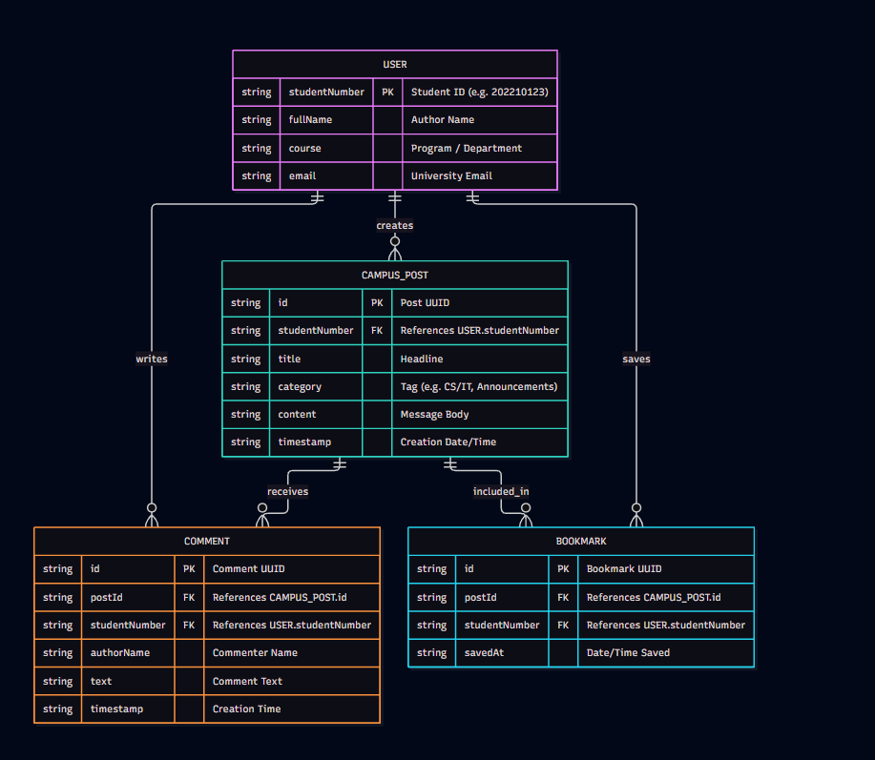

This ERD illustrates a One-to-Many ($1:M$) relational architecture where a central USER entity authors CAMPUS_POST entries, posts comments (COMMENT), and curates personal saved items (BOOKMARK), maintaining relational integrity through Primary and Foreign Key references.

UPDATED FIREBASE ERD
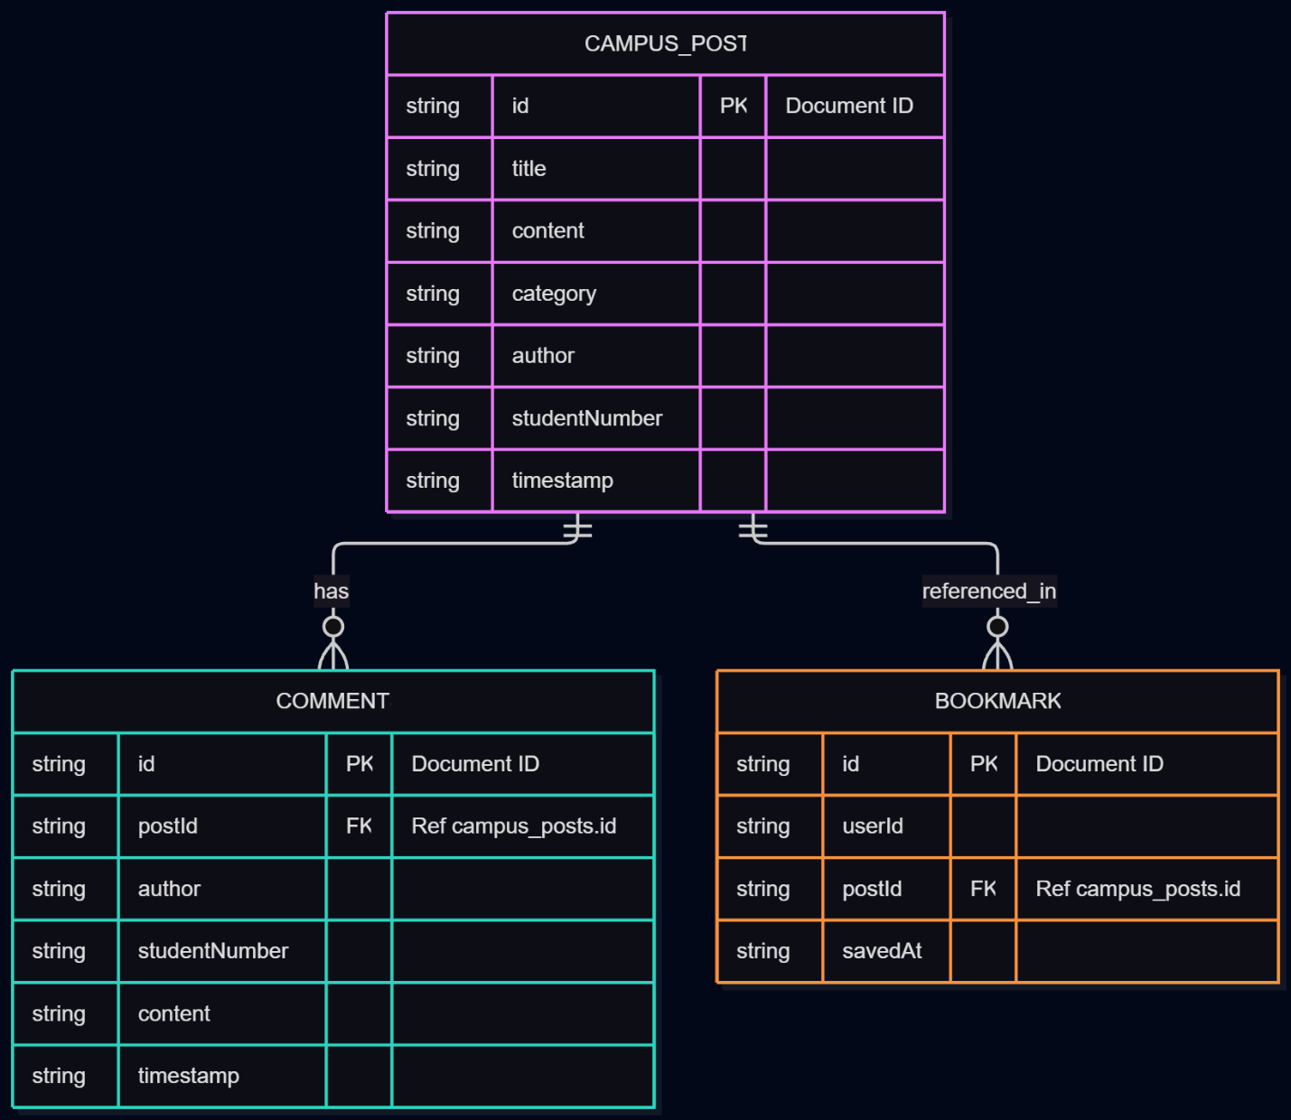

This diagram models our app’s Cloud Firestore NoSQL data structure using three main collections centered around campus posts:
- CAMPUS_POST (Main Collection): Stores the post details—title, content, category, author info, and timestamp, each identified by a unique Firestore document ID (PK).
- COMMENT (One-to-Many): One post can have multiple comments. Each comment references its parent post through the postId (FK).
- BOOKMARK (One-to-Many): One post can be saved by multiple users. It links a userId to the specific post via postId (FK) along with the timestamp it was saved.

