GSoC 2026 Midterm Report
Flow matching track of the PINNDE project (ML4SCI / GENIE)
Contributor: Tina Period: June to July 2026 Date: July 23, 2026

Summary
During the first half of the program I built two Python packages, both in the Tina folder of the project repository. The first, pinnde_eval, is a quantitative evaluation module that compares any two sets of samples (real against generated) with a suite of standard metrics. It is meant to serve as the common yardstick for both tracks of the project. The second, flow_matching, is a conditional flow matching generator that learns a velocity field and produces samples by integrating an ODE from noise to data.
Both packages are covered by 45 automated tests, all passing as of July 23. Every random step is seeded, so all numbers in this report are reproducible, and every figure can be regenerated with a single script. The two study items agreed in the June 26 meeting (metric stability against sample size, and metrics that localize where a generator fails) are both complete and are described in sections 2 and 3.

1. The evaluation module (pinnde_eval)
One entry point, evaluate(real, gen), accepts numpy arrays or torch tensors of shape (N, d) and returns a flat dictionary of metrics, organized in three tiers:
Tier | Question it answers | Metrics
Live monitors | Is training converging? Cheap enough to run inside the loop. | MMD, sliced Wasserstein distance (SWD)
Distribution distances | How far apart are the distributions, with error bars? | FPD, KPD, Wasserstein distance per feature
Standard tests | Can real and generated samples be told apart at all? | Classifier two sample test (AUC), histogram chi squared

The reading convention is simple: AUC near 0.5, chi squared near 1, and the distances near their floor all mean the generator is good. Beyond the global score, evaluate_by_condition splits the evaluation by a per sample label (for example an energy bin), so one bad slice cannot hide inside a good average. A features hook (features_fn) maps raw samples to physics observables before any metric runs, which means the module can be pointed at calorimeter shower observables later without any change to its interface.
The module is validated on seeded Gaussian mixture toys with three asserted checks: a null check (two independent draws from the same distribution must look identical: AUC 0.505 with error 0.002, mean chi squared 1.01, MMD below 0.00001 at 8000 samples), a sensitivity check (every metric must grow as the toy distribution is perturbed in three different ways), and a speed check (the live monitors run in under 0.2 seconds on 5000 samples). Each threshold was calibrated against a measured noise floor rather than picked by preference, and the full calibration record is kept in pinnde_eval/DEVLOG.md so future changes can be checked for regressions.
FPD and KPD wrap the jetnet package, which is used by the CaloChallenge community. jetnet is optional: when it is not installed the two metrics return None and everything else still runs. I verified my wrappers against the jetnet source and validated both numerically on the null case.

2. Metric stability against sample size
This was the first item from the June 26 meeting. For every metric and a grid of sample sizes N from 250 to 8000, the study in pinnde_eval/stability.py measures three things: the null floor (the value a perfect generator shows at that N), its spread over repeated independent draws, and the separation z between the null and a fixed perturbation. A perturbation counts as resolvable at N only if z stays above 2 at that N and every larger N.
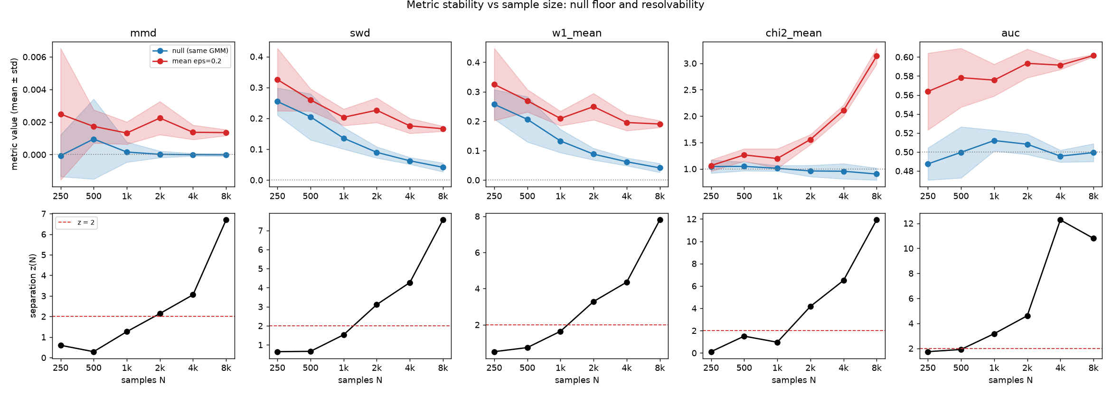
Figure 1. Top row: null floor (blue) and perturbed value (red) for each metric as N grows. Bottom row: separation z(N) with the z = 2 line marked. AUC resolves the test shift from N = 1000; the other metrics need N of at least 2000.
The main findings: the SWD and Wasserstein null floors are pure finite sample artifacts and fall roughly as one over the square root of N (from 0.25 at N = 250 to 0.04 at N = 8000), while MMD stays near zero, chi squared near 1, and AUC near 0.5 at every N. For the test shift, the classifier AUC is the most sample efficient detector, resolving from N = 1000, and every other metric needs N of at least 2000. Below roughly 1000 samples nothing separates at two sigma.
This buys a concrete practical rule for the rest of the project: never compare a metric value against zero; compare it against the null floor at your sample size. An SWD of 0.05 is perfect at 8000 samples and terrible at 500. It also tells us that per condition bins need on the order of 1000 events or more before their numbers can be trusted.

3. Local discrepancy maps
This was the second item from the June 26 meeting: a global score can say that something is off, but not where. The module pinnde_eval/local.py adds three complementary maps that point at the failing region, all sharing one sign convention (positive means the real data is over dense there, so the generator missed something; negative means the generator is over dense, so it hallucinated something):
- The MMD witness function, which decomposes the global MMD monitor in space using the same kernel.
- A classifier probability P(real | x) for every sample, where each sample is scored by a model that never trained on it. Sorting generated samples by this probability lists the worst fakes first.
- A binned residual map, which decomposes the histogram chi squared per bin into a z score that is standard normal under the null, so any bin with |z| above 3 is a genuine local disagreement.
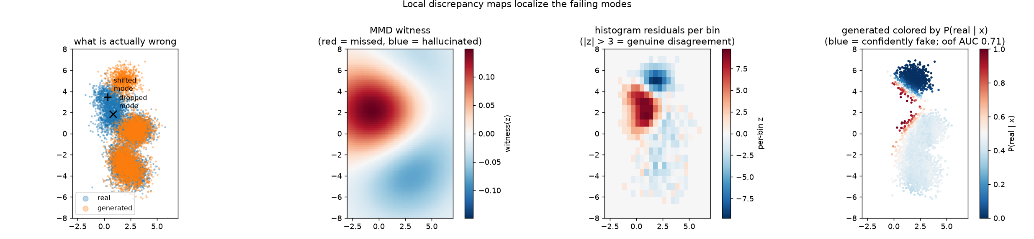
Figure 2. A deliberately broken generator (one mode dropped, one mode shifted). The global numbers only say that something is wrong; all three maps point exactly at the two broken modes.
The demo in Figure 2 uses a generator that drops one mixture component and shifts another. The global score reports AUC 0.71 and an elevated SWD, which says only that the generator is imperfect. The witness map peaks exactly on the dropped mode, the residual map shows |z| around 8 at the broken locations and behaves like standard normal noise everywhere else, and the shifted mode's samples receive P(real | x) near zero. All three maps run in feature space, so for showers they apply to any pair of observables through the same features hook. Null calibration for each map is asserted in the test suite.

4. The conditional flow matching generator
The flow_matching package learns a velocity field v(x, t) by regressing it onto a straight line target between noise and data, then generates by integrating an ODE from t = 0 (noise) to t = 1 (data). This is a simulation free alternative to the score based track: training never integrates the ODE, so there is no O(N times M) Monte Carlo estimate inside the loss. Passing a per sample condition c turns the field into v(x, t, c), which is the shape of the actual calorimeter target, p(shower | incident energy).
I benchmarked the conditional model on a calorimeter flavored toy: three correlated and skewed observables (sampling fraction, depth, width) whose distributions all depend on a normalized log energy c. Training on 40000 events takes about two minutes on a CPU. The model is scored three ways, strictest last:
- Pooled over all energies: SWD 0.006 and Wasserstein 0.006, both at the null floor for this sample size; FPD consistent with zero.
- Per energy bin, so a bad bin cannot hide: SWD between 0.008 and 0.011 in all four bins; AUC rises from 0.512 in the lowest bin to 0.617 in the highest, which identifies the high energy bin as the weakest slice.
- At fixed conditions the model never saw, against fresh truth draws at exactly those conditions: per feature means agree to about half a percent.
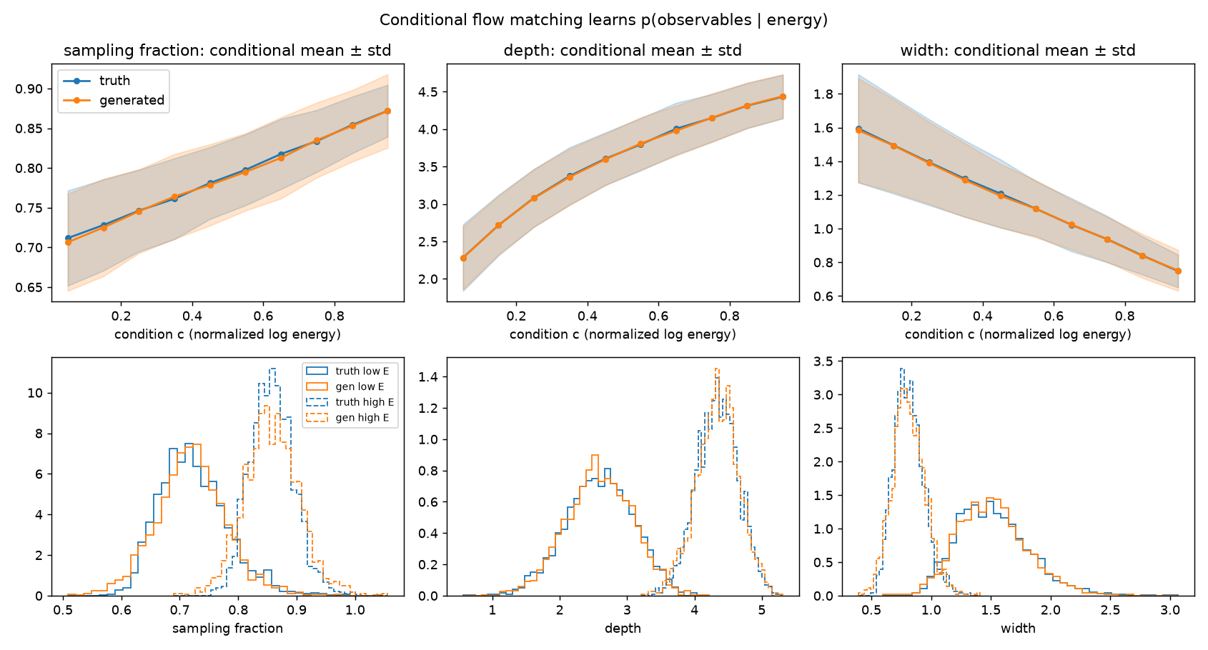
Figure 3. The conditional model tracks p(observables | energy). Top: conditional mean and spread of each observable against the condition, truth against generated. Bottom: per bin histograms at low and high energy.
One honest caveat is that the pooled classifier still reaches AUC 0.565, driven by the most skewed feature: the flow slightly under models the tail of the sampling fraction distribution. The transport distances sit at their floor while the classifier still finds this, which is exactly why the classifier test stays in the suite.

5. Practical problems solved along the way
- jetnet does not install cleanly on macOS because a transitive dependency tries to compile against OpenMP. I worked out a recipe that installs it without any compiler, documented it in the README, and made the module degrade gracefully when jetnet is absent.
- With the numpy wheels on this machine, threaded OpenBLAS turned a 9 second evaluation into more than 30 minutes of busy waiting that looked like a hang. I diagnosed it, measured both cases, and documented the one line fix (OPENBLAS_NUM_THREADS=1).
- Several thresholds needed real calibration rather than guesses: for example the unbiased MMD estimator is legitimately slightly negative on identical inputs, and the smallest perturbations sit below the finite sample noise floor, so the sensitivity check uses a rank correlation over the whole perturbation grid instead of demanding step by step growth. All of these decisions are recorded with their measured numbers in the DEVLOG.

6. Plan for the second half
- Point the evaluation module at real shower data through the features hook (layer energies, shower widths, and the other CaloChallenge style observables) and use it as the shared yardstick for both tracks of the project.
- Apply the stability results in practice: choose per energy bin sizes so that every reported number is above its resolvable threshold, and report metrics against their null floor.
- Use the local discrepancy maps to diagnose where the shower models fail, per pair of observables.
- Scale the conditional flow matching generator from the three observable toy toward the real target, p(shower | incident energy).

