GSoC 2026 Final Report
Flow matching track of the PINNDE project (ML4SCI / GENIE)
Contributor: Tina Period: June to September 2026 Date: September 22, 2026

Summary
The first half of the program produced two Python packages in the Tina folder of the project repository: pinnde_eval, a quantitative evaluation module meant as the common yardstick for both tracks, and flow_matching, a conditional flow matching generator. The second half moved both onto real data. The generator now trains on CaloChallenge dataset 2 and is scored in the challenge's own 362 high level features, computed with the challenge's own code, against a floor measured by comparing two independent sets of real Geant4 showers.
The two packages now hold 31 modules, 5,178 lines of code and 2,238 lines of tests, with 171 automated tests passing. Every random step is seeded and every figure in this report can be regenerated with a single script.
The main result of the second half is that the generator's largest failure was not a question of model capacity but of how the data was written down. An empty calorimeter layer is recorded as an exact value, and a continuous model can never produce an exact value, so it reproduced empty layers zero percent of the time. Fixing the representation moved the chi squared statistic from 50.7 to 11.7 times the Geant4 floor, at no computational cost, where a thirty fold increase in model size had previously bought almost nothing. The classifier two sample test did not move, and section 6 explains what we learned about why.

1. Scoring against a measured floor
The single most useful discipline in this project is that no number is compared against zero. Two independent sets of 8,000 real Geant4 showers, scored against each other, give chi squared 0.95 and a classifier AUC of 0.5003 rather than 1 and 0.5 exactly, because 8,000 samples carry sampling noise. That is what a perfect generator scores, and every figure in this report is quoted as a multiple of it.
The floor also has to be matched in incident energy. Our model generates each shower at the energy of a specific real shower, so it never pays the energy draw variance that two independent Geant4 samples pay. Matched and unmatched floors differ by three to five standard errors on chi squared, the transport distances and separation power. Scored against the unmatched floor, an early model appeared to be better than Geant4, which is what prompted the correction.
The harness itself is checked by replacing the model with real showers and pushing them through the identical path. Everything must then land on the floor. It did not at first, and the discrepancy found three bugs: a transform that moved exact zeros by 7e-18, a range test that flagged 59 percent of real values as impossible, and a quantizer that returned a lattice value one bit away from the one stored in the data, which made a statistical test reject a perfect generator at p = 5e-25.

2. The 362 official features
Comparing our numbers with published CaloChallenge submissions requires their feature space, not ours. pinnde_eval/calochallenge.py downloads their feature code, pinned by commit hash and checksum, and assembles the 362 columns exactly as their classifier receives them: the incident energy, the total energy, and eight summaries of each of the 45 layers. A test checks our assembly against their own function to a relative tolerance of 1e-12.
Each layer is described by eight numbers, computed from its 144 voxels: the layer's total energy, the centre of energy in eta, phi and radius, the spread in each of those three, and the sparsity, which is the fraction of the 144 voxels that recorded nothing. Our generator produces these 362 summaries directly. A full CaloChallenge submission generates the 6,480 voxels and computes the summaries from them, which is a harder problem; section 5 describes our first attempt at it.

3. The empty layer, and why representation mattered more than capacity
A shower does not light every layer. Low energy showers stop early, so the layers behind them receive nothing at all, and in dataset 2 that is 17.8 percent of every layer and shower pair, rising to 51 percent for the last layer. The official features record this as exact numbers: the layer's log energy is exactly -8, its centres and widths are exactly 0, and its sparsity is exactly 1.
A flow matching model produces a continuous probability density, and a continuous density assigns zero probability to any single exact value. Measured on 8,000 generated showers, an exactly empty layer appeared 0.0 percent of the time, and no amount of extra capacity would change that. The model was not wrong about how often layers are empty: 18.5 percent of its output sat in the no energy region, against 17.8 percent in the real data. It had no way to express that as an exact value, so it spread that mass out and put a third of it below -8, which means less energy than nothing.
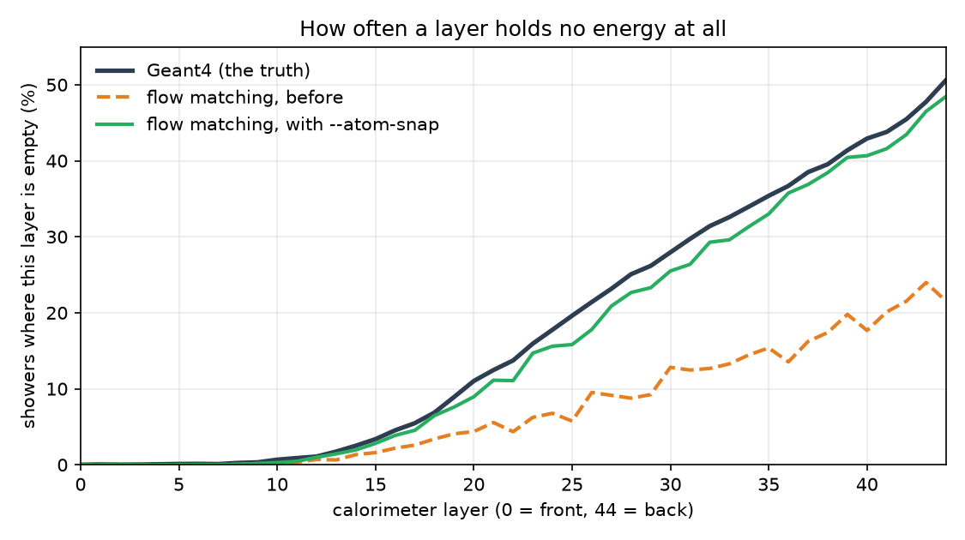
Figure 1. How often each layer holds no energy at all, over 8,000 showers. Horizontal axis: the 45 layers, front to back. Vertical axis: the percentage of showers in which that layer is empty. Dark blue is Geant4, which reaches 50.6 percent at the back. Orange dashed is the model before the fix, reaching only 21.6 percent, and that count is generous because it includes values below the empty value, which are impossible. Green is the same model after the fix.
The fix is to stop asking the model to hit an exact value. Between the empty value and the smallest real non empty energy there is a band that no shower occupies: checked across all 200,000 showers in both files, nine million layer instances, not one deposits between zero and 15.16 keV. During training the point mass is spread uniformly across that band, so the model aims at a region and only has to learn how much probability belongs there. When generating, anything landing in the band is snapped back to the exact value. Real showers pushed through the round trip return bit for bit identical, which the test suite asserts.
One detail turned out to matter more than the trick itself. Applying the snap to each of the 362 columns independently made the model worse, taking the classifier AUC from 0.892 to 0.968, because it produced layers with no energy but a non zero centre of energy, which no real shower contains. Emptiness is a property of the layer, not of a single number, so the decision is made once per layer, using the energy, and applied to all eight of that layer's columns together. It also has to run in both directions: a layer the energy calls lit must have at least one lit voxel. Adding that second direction took layers holding energy in zero voxels from 58.6 percent of showers to 5.9 percent, and also removed six sevenths of a separate defect, sparsity values outside their physical range.
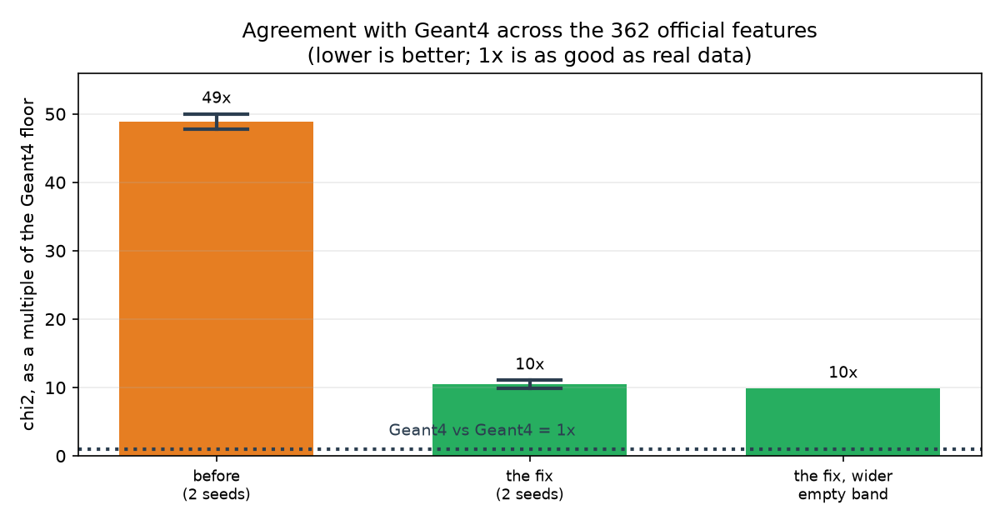
Figure 2. Agreement with Geant4 across the 362 official features. Height is the chi squared statistic divided by the Geant4 against Geant4 floor, so the dotted line at 1 is agreement as good as real data and lower is better. Orange is the model before this work, green after. The whisker spans two runs differing only in random seed.
Over five seeds of each configuration, the measured effect is:
 | before | after
chi squared, as a multiple of the floor | 50.7 ± 3.4 | 11.7 ± 2.3
separation power, as a multiple of the floor | 52.8 ± 3.5 | 11.1 ± 2.3
classifier AUC | 0.909 ± 0.017 | 0.894 ± 0.020
showers containing a negative width | 72.6 % | 4.8 %
showers with an inconsistent empty layer | 49.9 % | 0.03 %

For comparison, increasing the network from 384 by 5 to 1024 by 8 cost thirty times the compute and gained 0.09 in AUC. The representation change cost nothing at all.

4. Physical validity: a different kind of check
Every metric in the project compares distributions: it takes two sets of showers and asks whether the sets look alike. None of them looks at a single shower and asks whether it could exist. pinnde_eval/validate_physical.py asks exactly that, with nine rules, and runs real Geant4 showers through the identical code as a control. Real showers score zero percent on every rule, which is the point: a rule that real data fails is a broken rule, not a discovery.
It found two defects that no distribution metric had seen. The first is that every generated shower had a total energy that was not the sum of its 45 layer energies. In real showers that relation holds to one part in ten to the fifteenth; it is not an approximation but the definition of the total. Nothing in the model tied the 46 numbers together, and each of them looked reasonable on its own, so no per feature test noticed. Computing the total from the generated layers instead of modelling it fixes this exactly, from 100 percent of showers to zero.
The second was found by explaining the method rather than by running anything. Asked how we decide a layer is empty when eight numbers describe it, the answer is that the energy decides, and saying that out loud exposed that the rule only ran one way. A layer the energy called lit could still report that all 144 of its voxels were dark, which is energy sitting in no voxel at all. Sixty three percent of baseline showers contained at least one such layer.
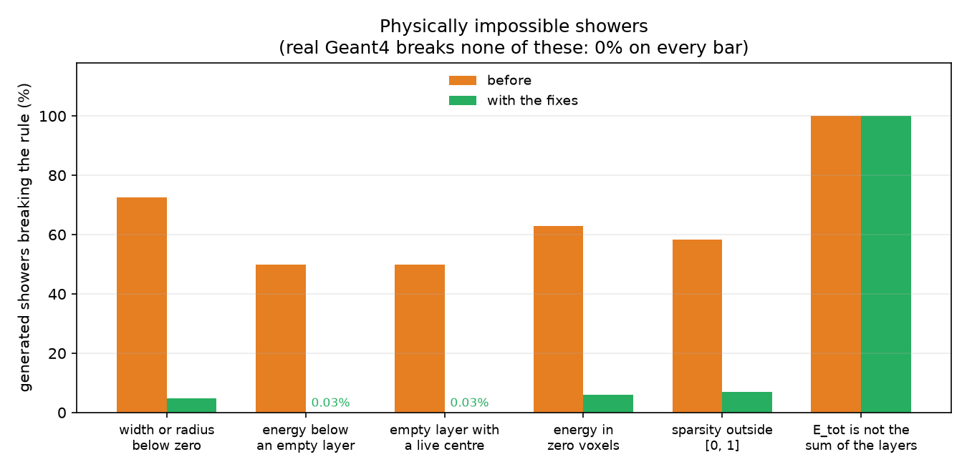
Figure 3. Percentage of 8,000 generated showers breaking each physical rule, so lower is better and zero is correct. Orange is the model before this work, green with the fixes of section 3 in place. Real Geant4 showers break none of these rules and so have no bars. The last rule needs the total energy to be computed from the layers rather than modelled, which takes it to zero.

5. Generating raw showers
An analysis never uses a shower directly; it uses quantities derived from one. So the reason to generate showers accurately is that a generator which gets the 6,480 voxels right is then known to be right for anything computed from them. flow_matching/demo_voxels.py does this: it generates the voxels and then computes the 362 features from them with the challenge's own code, so the result is scored in the same space against the same floors.
It does not work yet, and the reason is specific. Every generated shower deposits more than ten times the energy it received. The log representation has no upper bound, 22.4 percent of generated layers hold more energy than any layer in the real data, and those few layers carry essentially all of the model's energy. Five times more data and five times more training changed the score by less than one percent, so this is not undertraining. The fix that matches the physics is to generate the layer energies first and then the normalized pattern within each layer, which is bounded by construction, so that the total is set deliberately rather than emerging from 6,480 unbounded numbers.
The attempt was still worth making, for two reasons. Generating voxels makes every consistency rule hold automatically, because the features are computed from a real grid rather than predicted as separate numbers. And it exposed a hole in our own checks: all nine physical rules passed on showers depositing ten to the thirteenth times the beam energy, because every rule tested internal consistency and none tested energy conservation. That rule now exists and fires on 100 percent of those showers.

6. Checking our own claims
Three claims in earlier drafts of this work did not survive being measured properly, and correcting them is as much a result as the fix itself.
Run to run noise had been estimated from two runs, which gives a range rather than a spread. Five seeds of a single configuration give AUC plus or minus 0.020 and chi squared plus or minus 20 percent. Several numbers quoted to three significant figures from one run were therefore too precise, and one earlier conclusion, that a family of features was getting steadily worse with each change, turned out to be noise.
The headline number itself was a fortunate seed. The fix was first reported at 9.8 times the floor; the five seed mean is 11.7. The improvement is a factor of 4.3 rather than 5, which is still far outside the spread, but the precise figure had to be corrected.
The most important correction is the interpretation. Because chi squared improved fourfold while the classifier did not move, it was natural to conclude that what remained was cross layer correlation, which per feature tests cannot see. We tested that directly by building a sample carrying this model's marginal distributions inside Geant4's exact correlation structure. It is still detectable at 0.916, against 0.929 for the model itself, so the marginals account for nearly all of the detectability and correlations for very little. Per feature accuracy, not correlation, is what the classifier reads, and that changes which improvement is worth attempting next.

7. Practical problems solved along the way
The cluster has no job scheduler and its GPU machine is shared, so long runs go in a tmux session on the machine itself. The home directory is served over Kerberos protected NFS, which expires after ten hours, and an expired ticket looks like a code failure rather than an authentication one. Setting up the GPU machine brought a full run from hours down to about three minutes, which is what made it possible to measure twenty one configurations in a week rather than argue about two.
A deep velocity field could be knocked into a region it never recovered from by a single unusually large gradient step; at 361 dimensions the training loss jumped from 1.19 to 1.46 mid run and two generated showers later diverged to not a number. Clipping the gradient norm fixed it, and the scoring path now reports and drops non finite showers loudly rather than silently stalling.
One honest caveat about the snapping itself: it makes out of range values legal by construction, so the percentage of impossible values can no longer be read as a quality measure for the columns it touches. That is recorded alongside the result rather than left for a reader to discover.

8. What does not work yet, and what comes next
The classifier AUC has never moved: 0.909 plus or minus 0.017 before this work and 0.894 plus or minus 0.020 after. Every gain is in the per feature metrics and in physical validity. A shower generated by this model is now almost always physically possible and its individual distributions are four times closer to Geant4, but a classifier with access to all 362 numbers at once still separates real from generated with high confidence.
One measurement is unexplained. A rank Gaussian feature transform, which maps every feature onto a standard normal through its own empirical distribution, makes every marginal exactly right by construction. It halves chi squared, from 11.7 to 5.9 times the floor, collapses the seed to seed spread from 2.3 to 0.1, and removes every impossible value, giving the best physical validity measured. It also makes the classifier worse, from 0.894 to 0.956. The obvious explanation, noise introduced by dithering tied values, was tested and ruled out at one to seven percent of variance. The cause is not identified.
Work continues past the program's technical end date. In order of expected value: explain the rank Gaussian result, since it is the only measurement here whose cause is unknown and it decides which metric the project should be optimising; bound the voxel model's output so that raw shower generation becomes usable, which is the path to numbers directly comparable with published submissions; and then make that comparison against the CaloChallenge submissions on Zenodo, which is now possible because our numbers are in their feature space, computed with their code, and quoted against measured floors.
The full record, including the measurements that contradicted things believed earlier, is in pinnde_eval/DEVLOG.md, which now runs to thirty sections.

