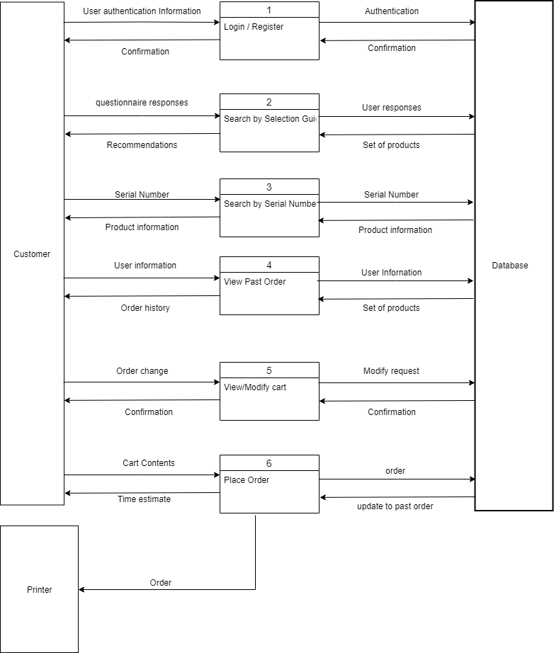

Login / Register

Search by Selection Gui

Search by Serial Numbe

Customer

**Database**

View Past Order

View/Modify cart

Place Order

Printer