Fissura

Substrate: Polyimide (PI)

Composite system geometry:

Substrate thickness t_{s} (μm): 80
Composite plate width w (mm): 11
Film thickness t_{f} (nm): see table 1.
Composite plate length under tension L₀ (mm): 14 mm

Neutral plane
Coating
Interface
t_{f}
t_{s}
Compression residual stress
x
z
y
Substrate stresses
Composite plate width
w

Tables

Table 1
Data of the measured curvature, k, of the Si/PI composite system, the calculated mismatch strain, Δε, in the Si film relative to the PI substrate and the calculated residual strain of the deposited Si film.

Code sample | S97 | S96 | S95
Film thickness t_{f} (nm) | 100 | 250 | 500
Curvature k (mm⁻¹) | −0.0021 | −0.0094 | −0.015
Mismatch strain Δε (%) | 0.03498 | 0.08985 | 0.1122
Film residual strain ε_{f}^{r} (%) | −0.02977 | −0.06842 | −0.06837
Film residual stress σ_{f}^{r} (MPa) | −33.430 | −76.830 | −76.782
Film first - fracture strain ε_{ff} (%) | 1.77 | 1.38 | 1.02
Film first - fracture stress σ_{ff} (MPa) | 1954.28 | 1472.90 | 1068.7

Estimated Substrate Young’s modulus (GPa): E_{s} = 1.11

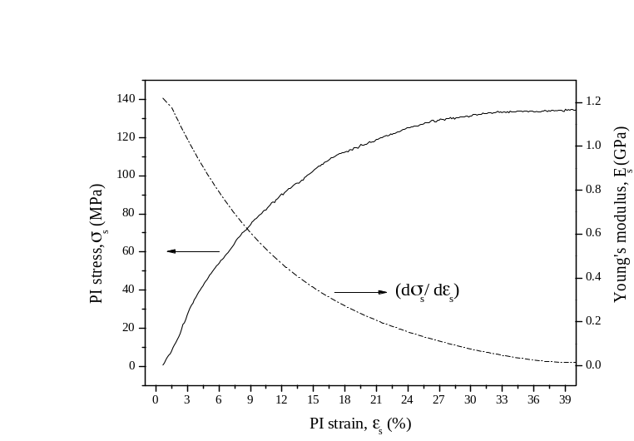
Fig.1 Experimental stress-strain curve (solid curve) and Young’s modulus (dotted line) for a PI substrate without a film of Si. Stretching speed of the specimen was 3.3 μm s⁻¹.

Estimated Film Young’s modulus (GPa): E_{f} = 112.3 [mean value]

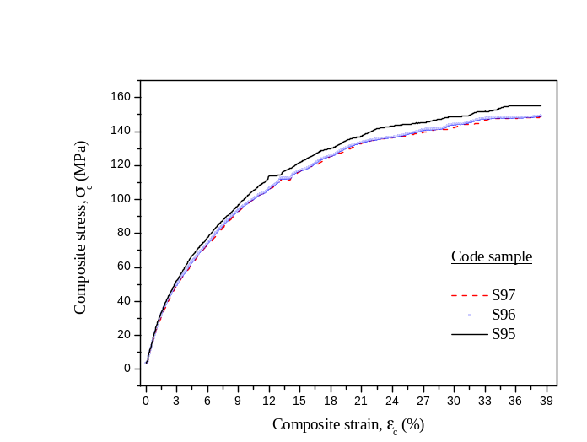
Fig.2 Experimental composite stress-strain curve for PI substrate with Si films with different thicknesses.

Table 2
Estimated Young’s moduli in Si films deposited on PI substrates

Si film thickness (nm) | Estimated Young’s modulus (GPa)
100 | 122.6
250 | 103.5
500 | 110.8

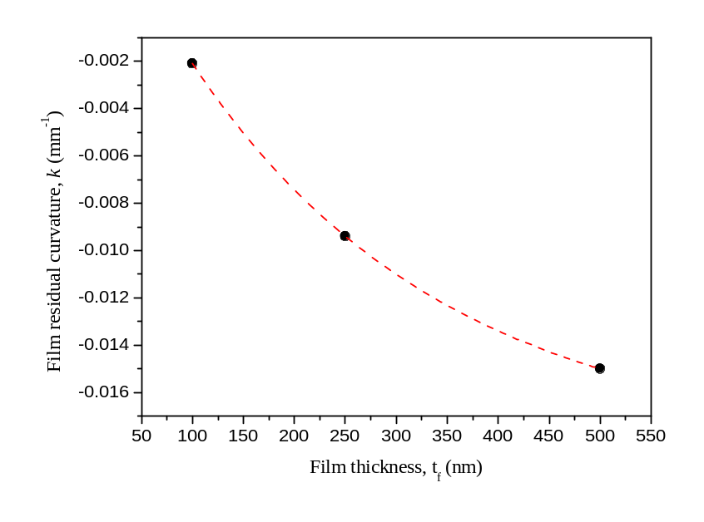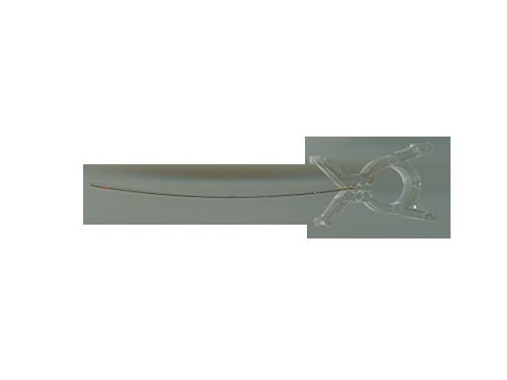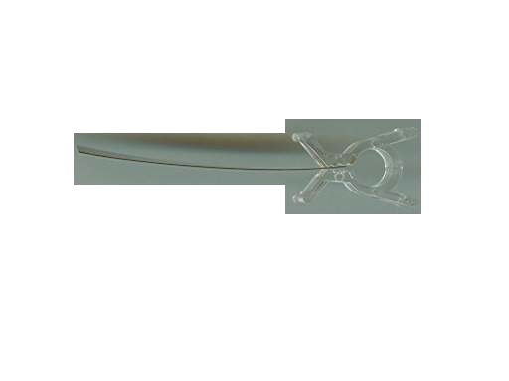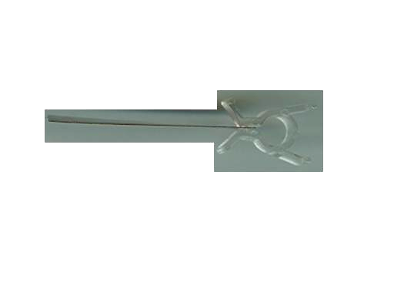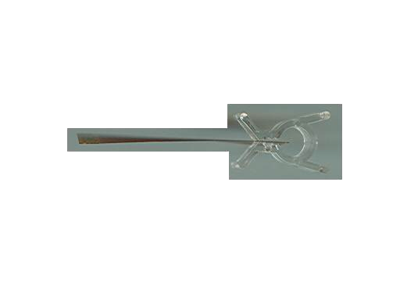
Bare
S-97
S-96
S-95
Fig.3

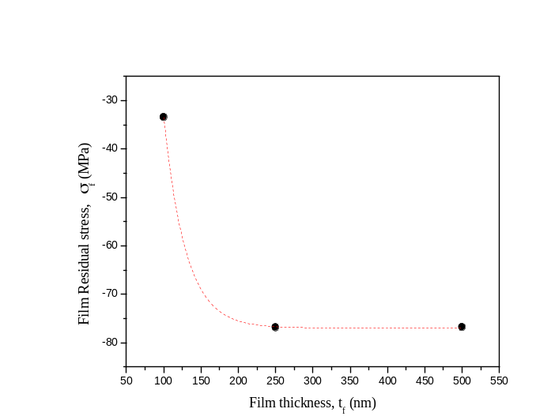
Fig.4

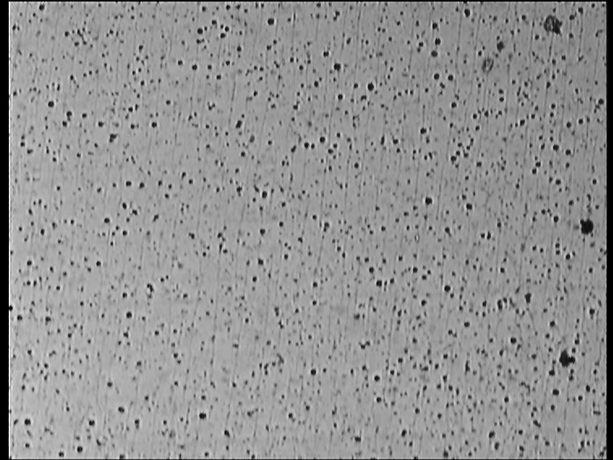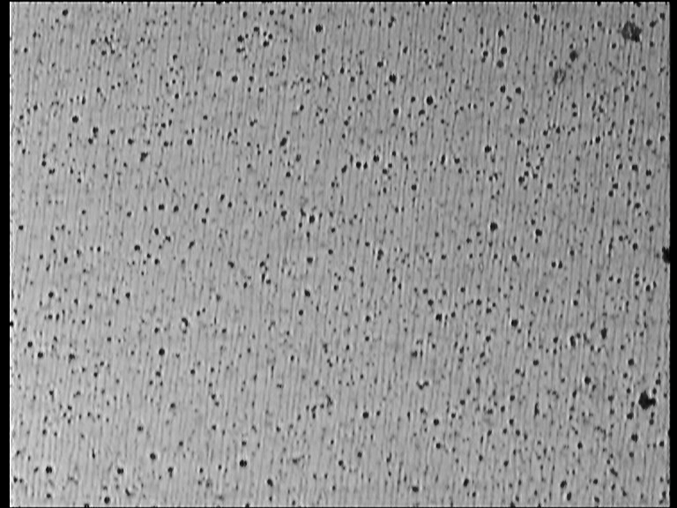
60 μm

Fig. 5 Micrographs of multiple cracking of 500 nm thick Si film on a PI substrate at two different applied strains: upper 1.2 % and lower 1.8 %

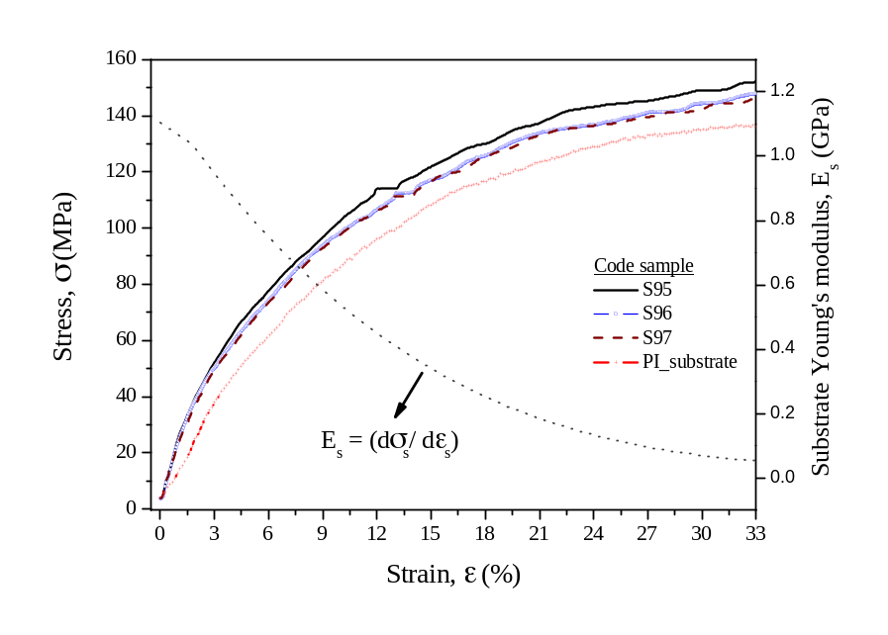

Fig 6 Experimental stress-strain curves for PI substrate without a film and with Si films with different thicknesses. It is also plotted the PI substrate Young’s modulus (dotted line). The stretching speed was 3.3 μm s⁻¹ for all tested specimens.

Mathematic Equations

1. Experiments

Nanocrystalline Silicon thin films were deposited on flexible Polyimide (PI) substrates by HW-CVD technique. The thickness of the PI substrate was about 80 μm. Three kinds of specimens with Si film thicknesses of 100, 250 and 500 nm were prepared. Specimens with rectangular shape, (length of 14 mm and width of 11mm) were subjected to a set of tensile tests in order to obtain their fracture mechanical properties.
Firstly, a specimen of PI substrate was subjected to a tensile test to record a stress-strain curve, and the Young’s modulus of the substrate, E_{s} and its strain dependence was obtained. Fig. 6 shows the stress and E_{s} as a function of the applied strain in room temperature. It is also shown the composite stress of the specimens as a function strain. The stretching speed during the tests was 3.3 μm s⁻¹ for all tested specimens.
Because of the residual compression strains upon cooling to the room temperature the Si/PI composite specimens curled as can be seen in Fig. 3. The difference of the residual strains (i.e. the mismatch strain, Δε) existing in the film and substrate were calculated from the specimens curvature k [Ref.1]
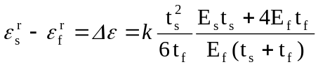 (1)

Fig. 7 shows schematically a one – dimensional model of a composite plate consisting of a polymer substrate with a thin film under residual strains. In fact, if the film in an initial compressive state (see Fig. 7a) was removed from the substrate and placed on a free surface then it should expand in length (see Fig.7 b) because in the previous state the film was constrained. On the other hand, if the substrate was released from the film then it should contract in length if it was initially under tension (see Fig.7 c).

(a)
(b)
(c)
Coating
t_{f}
t_{s}
Substrate
coating
substrate
Coating
Residual strain
Substrate
residual strain
Fig.7

Stresses σ and strains ε in the layers in this situation are residual components and can be expressed as follows:

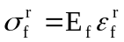 (2)
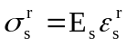 (3)

In this way, a total force in the composite must be zero in this situation because it is not stretched yet. Thus,

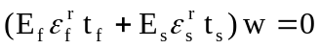 (4)

where w is the composite plate width. As it was shown, at the beginning of the tensile test, the film and substrate already have residual strains. However, until the generation of initial cracks in the film, the tensile load is transferred from the test machine to the film and substrate and no interfacial shear stress exists between the substrate and film. Thus, a composite tensile load T_{c} applied to the composite system is the sum of loads T_{f} and T_{s} transferred to the film and the substrate, respectively

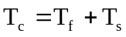 (5)

Each load is related to the corresponding stress (residual plus applied) according with

(6)

In the elastic regime, then

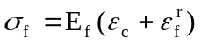 (7)
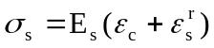 (8)

With these expressions, Eq. (5) is written in terms of the stress and strains

(9)

Finally, the film Young’s modulus can be easily estimated by differentiating Eq. (9) with respect to ε_{c},

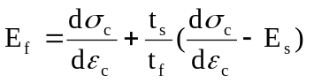 (10)

where E_{s} can be easily estimated by differentiating with respect to ε_{s} the experimental stress-strain curve of the substrate and adopting a value which corresponds to the linear elastic region and (dσ_{c}/dε_{c}) is also calculated through the same procedure, however using the experimental stress-strain curve of the composite system.
It is also important to note that the residual strains in the film and substrate can be calculated by combining Equation (1) and Equation (4), resulting in the following expressions:

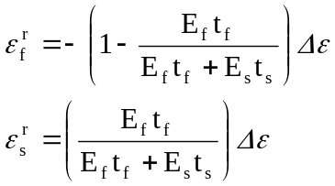 (11)

