**CHRISTOPHE THIEBAUD**



Christophe Thiebaud

### HEBELSTRASSE 2, HOCKENHEIM, 68766, GERMANY +49 176 81 20 33 24 [CHRISTOPHE.THIEBAUD@AEQUOLOGICA.NET](mailto:christophe.thiebaud@sap.com)

I have been developing software since 1987, filling a number of different roles including Architect, People Manager, Project Manager, Lead Developer and Outside Advisor. What energizes me ? A challenging position where I am able to build on decades of experience in the **creativity** + **technical expertise** + **people ecology** magical bundle to deliver truly beautiful software.

I am actively looking for a position in either **France**, or **Italy**, or ... both 

[↑](https://www.linkedin.com/in/cthiebaud)

[](https://github.com/cthiebaud)

[](https://twitter.com/cthiebaud)

[](https://www.facebook.com/christophe.thiebaud)

[](https://www.instagram.com/cthiebaud/)

# EXPERIENCE

## ARCHITECT

### [SAP](https://www.sap.com/index.html), WALLDORF, GERMANY

Hard skills: SAP Cloud Platform (CloudFoundry & Neo) ; Microservices ; Git & Github ; Jenkins & Travis ; Docker ; Continuous Deployment.

Soft skills: Internal Instructor ("Continuous Integration & DevOps" course) ; DevOps ; Agile Processes & Scrum.

Product Owner for a team of ten that was providing tools and service for non-abap / non-java internal development teams, i.e. C/C++ builds. As product Owner, my main duty was to define and prioritize the work items, à la scrum: Epics, User Stories, Tasks. Eventually, the responsibility was moved to our colleagues in India.

I moved then to an Architect role, having been frustrated by the lack of hands-on activities in my Product Owner role. As Architect, my duties were:

Develop new tools, chiefly around the maven ecosystem.

Contribute to the management team on-going thinking process about the evolution of our technical environment. Evaluation of new 3rd party products, as well as migration of existing tools to new architectures.

Consulting to external teams, especially when projects were so complex that our standard tooling was stretched to its limits; development and delivery of custom solutions/integrations for these projects.

During all these years, I have been an early champion of cloud-based services, effectively and progressively moving functionalities of our legacy tools to REST apis and web interfaces.

I ended up begin again Product Owner (as role, not title) for such a cloud based/rest api/web-ui product, code-named 'arcoiris', aimed to enable teams to take control of their software dependencies (internal and external).

Finally, these last two years, I took a trainer part-time job for another department, training hundreds of developers on a course titled "Continuous Integration and DevOps".

November 2010 - Present

## MANAGER

### [BUSINESS OBJECTS](https://en.wikipedia.org/wiki/BusinessObjects), PARIS, FRANCE

Hard skills: REST API design ; System Performance Management.

Soft skills: Managing People ; Managing Customer Escalation ; Rolling out Engineering Processes and Tools, Worldwide. February 2005 - November 2010

## TEAM LEAD

### [UNIMATICA](https://www.unimaticaspa.it/), BOLOGNA, ITALY

Hard skills: Linux & shell programming ; Java ; Javascript ; HTTP & HTML & CSS ; Web Servers (Tomcat & Websphere) ; Maven ; XML ; [Digital Signature](https://en.wikipedia.org/wiki/Digital_signature).

Soft skills: Web UI Design ; Using and contributing to open source software. January 2000 - February 2005

## CONSULTANT

### [SELF-EMPLOYED](https://aequologica.net/), BOLOGNA, ITALY

Hard skills: Graph Algorithms ; Game Programming ; Macintosh Programming.

Soft skills: Selling myself ; Selling one same software component to multiple customers. September 1995 - January 2000

## PROJECT MANAGER

### [EUROLOG](https://www.eurolog.com/), MUNICH, GERMANY

Hard skills: n/a.

Soft skills: Juggling with external contractors ; Juggling with internal politics. July 1993 - July 1995

## CODER

### DATAID & COMELOG (SOFTWARE HOUSES), PARIS, FRANCE

Hard skills: Windows & OS/2 SDKs ; C & C++ ; Relational Databases & SQL ;[System Integration](https://en.wikipedia.org/wiki/System_integration). Soft skills: Humility (being sold to customers as [OOP](https://en.wikipedia.org/wiki/Object-oriented_programming) guru) ; Team Lead.

July 1987 - July 1993

## SUPPORT TECHNICIAN

### ISI (HARDWARE RESELLER), PARIS, FRANCE

Hard skills: Everything (answering a wild variety of questions at the hot-line). Soft skills: The Customer Is Always Right.

June 1986 - July 1987

# EDUCATION

## [INSEAD](https://www.insead.edu/), FONTAINEBLEAU, FRANCE

### MBA

Finance

January 1992 - December 1992

## CENTRE DE FORMATION [BULL](https://en.wikipedia.org/wiki/Groupe_Bull), MARNE LA VALLEE, FRANCE

### PROGRAMMER ANALYST

[Warnier Structured Programmin](https://en.wikipedia.org/wiki/Warnier/Orr_diagram)g August 1985 - May 1986

## [ÉCOLE NORMALE DE MUSIQUE DE PARIS](http://www.ecolenormalecortot.com/en/)

### [DIPLÔME D'EXÉCUTION](https://aequologica.net/cv/img/diplome_CT_ENMP.jpg)

Guitar

September 1978 - June 1982

## [LYCÉE POINCARÉ](http://www.h-poincare.fr/c-p-g-e/filieres-scientifiques/), NANCY, FRANCE

### CLASSES PRÉPARATOIRES AUX GRANDES ECOLES

[Mathématiques supérieure](https://fr.wikipedia.org/wiki/Math%C3%A9matiques_sup%C3%A9rieures)s September 1977 - June 1978

# SKILLS

### PROGRAMMING LANGUAGES & TOOLS

[](https://en.wikipedia.org/wiki/Java_(programming_language)) [](https://en.wikipedia.org/wiki/JavaScript) [](https://en.wikipedia.org/wiki/Python_(programming_language)) [](https://en.wikipedia.org/wiki/Jenkins_(software)) [](https://en.wikipedia.org/wiki/Docker_(software)) [](https://en.wikipedia.org/wiki/Git)



### PROCESSES

 Multi-cultural environment

 Agile Development & Scrum

### LANGUAGES

 French, mother tongue

 English, fluent

 Italian, fluent

 German, basic

# INTERESTS

 **MUSIC**

In addition to being a geek, I am a fine guitar player, with a strong focus on JS Bach music (google for [Thiebaud+Bach](https://www.google.com/search?q=thiebaud%2Bbach&amp;tbm=vid)).

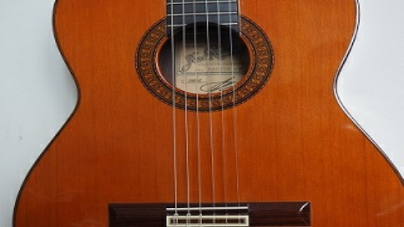

 **BIKE**

~ 4000 kms per year, mostly commuting.

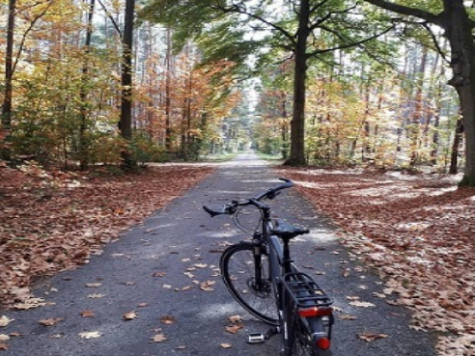

− **FAVOURITE QUOTES**

« *Why program by hand in 5 days what you can spend 5 years of your life automating ?* » Terence Parr

« *So convenient a thing it is to be a reasonable creature, since it enables one to find or make a reason for everything one has a mind to do.* »

Benjamin Franklin

« *Triple-double-quoted strings behave like double-quoted strings, with the addition that they are multiline, like the triple-single-quoted strings.* »

Groovy programming language documentation

« *Without the ball, you can't win.* » Johan Cruyff

# AWARDS & CERTIFICATIONS

 Business Objects Leadership Award

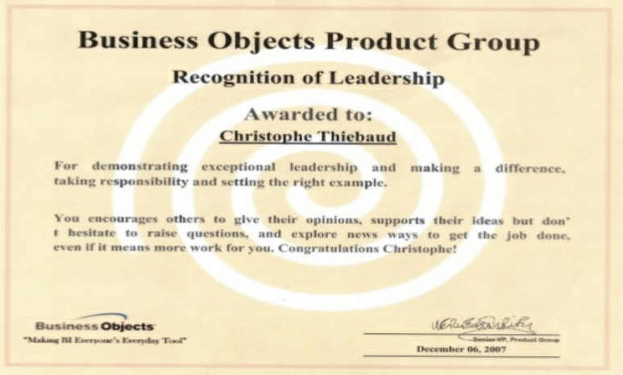

 Proud to be a [jgrapht](https://jgrapht.org/guide/UserOverview) contributor (google for [thiebaud+jgrapht](https://www.google.com/search?q=thiebaud%2Bjgrapht)).

