# Your Library, Your Private Cloud Storage!

Welcome to AeroFS! Anything you place within an AeroFS library will be synchronized between your devices and anyone you invite, but will *not* be stored in the cloud unless you choose to remotely backup your library through our service. If you would like to create another library, simply go to **AeroFS Tray Menu 🡪 Add Library…**

**­**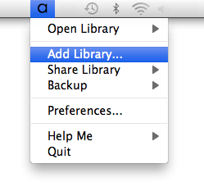

# Share Your Library

Sharing your libraries with friends and colleagues is easy: Select **AeroFS Tray Menu 🡪 Share Library 🡪** (a library), input the email of the person you want to share with, and you’re done!

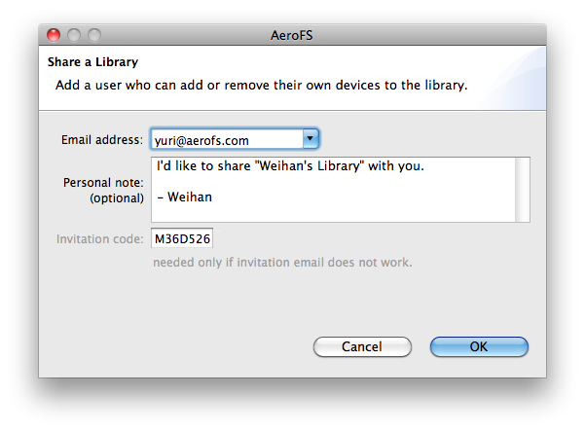

# Backup Your Library to the Cloud

Enabling real-time cloud backup is even easier: When creating a library, simply click on the **Backup** **button** and select the desired plan. Alternatively, you may also add backup at any later point by selecting **AeroFS Tray Menu 🡪 Backup 🡪** (a library).

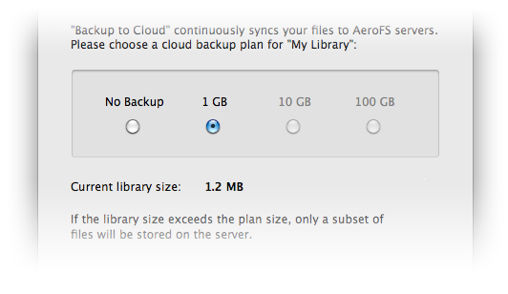

# We Are With You!

Run into problems? Go to **AeroFS Tray Menu 🡪Help Me**, and we are here to help!

