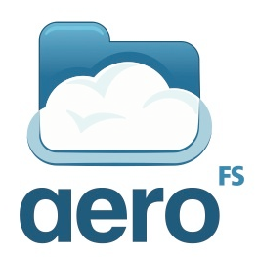

What AeroFS can do for your team

A white paper for IT administrators

# Intended audience

If you are an IT administrator or CIO in a small to medium sized business, this white paper will help you evaluate how AeroFS fulfills your team’s need for private file syncing and collaboration. The best evaluation however, is to try AeroFS for free at [www.aerofs.com](https://www.aerofs.com).

# Contents

What AeroFS is great at 3

What AeroFS includes 3

Data ownership, privacy and security 4

Team Server: file servers revolutionized 4

Team Server saves you time and money 5

Team dashboard: take control and prevent data leakage 5

Desktop application: consumer-grade user experience 6

Mobile app: browse files on the go 7

On the road map 7

Next step 7

# What AeroFS is great at

AeroFS is a perfect solution for you if:

* Your team needs a user-friendly file syncing solution like Dropbox.
* You can’t use the public cloud due to privacy, compliance, or cost concerns.
* Managing a private cloud is a painful experience.

With AeroFS, your team can enjoy a Dropbox-like file syncing experience while your files are hosted privately. Even a non-technical admin can manage the AeroFS private cloud easily with minimal effort and hardware cost.

There are two key technologies that make this possible:

1. While all the files are stored locally and encrypted in transit, the management interface is hosted in the cloud. This guarantees data privacy with no need to deploy expensive management infrastructures locally.
2. AeroFS synchronize peer-to-peer through your private devices. This means that end users will not be affected even if the file servers are down or overloaded. This greatly reduces IT costs in server hardware and maintenance.

# What AeroFS includes

As a team admin, you will have access to the following AeroFS components:

* **Team server**: A lightweight software package to be installed on one or more computers that will act as a central file server for your team.
* **Team dashboard**: A Web interface hosted on aerofs.com to manage team servers, team members, the team’s shared folders, and so on.

Your team members have access to:

* **Desktop application**: A lightweight program that syncs files with other desktop applications and team servers. It is integrated with native file managers like Finder and Windows Explorer.
* **Mobile application**: View and download files from desktop applications and team servers.
* **Personal dashboard**: A Web interface hosted on aerofs.com for end users to manage personal devices, shared folders, and more.

# Data ownership, privacy and security

You own your data. We have no possession or even access to it. With AeroFS, you no longer need to worry about data ownership, privacy, or compliance issues. In particular:

**We do not possess your files**: All the files are stored only on your team servers, desktop and mobile applications. No servers that are hosted by us, including Web services at aerofs.com, store your files.

**We do not access your data**: AeroFS’s unique syncing algorithms allow us to be *completely* blind about your file content and even metadata such as file names and modification dates. No servers hosted by us access such information[1].

**We cannot access your data**: When file content or metadata are transferred among your devices over the network, AeroFS uses end-to-end encryption to make sure no third party, not even us, can tap into the transferred data.

For more information about AeroFS privacy and security, please visit:

* AeroFS Security: [www.aerofs.com/terms#security](http://www.aerofs.com/terms#security)
* AeroFS Privacy Policy: [www.aerofs.com/terms#privacy](http://www.aerofs.com/terms#privacy)

# Team Server: file servers revolutionized

AeroFS Team Server is a software package to be installed on regular computers running Linux, Windows, or Mac OS X. It is a central repository for your team’s files. All files and subfolders under each team member’s AeroFS folder are synced to the server. While AeroFS client application syncs files peer-to-peer independently from Team Servers, computers running Team Server can:

1. Act as a central file relay, so that two client applications do not have to be online at the same time to sync files.
2. Back up your team’s files in case of device loss or other disasters.
3. Save version history in a central location for recovery or auditing.
4. Provide a central access point for AeroFS files, through a traditional protocol like Windows File Share, FTP, and NFS.

## Team Server saves you time and money

**High availability with cheap hardware**: Unlike traditional file servers, Team Server is inexpensive to maintain. Since client applications do not rely on the server, you can run a Team Server on low-cost computers and networks with little impact on overall sync performance. Your team members will observe little to zero downtime even if the server is down!

**Cost stays low as your team grows**: As more members (and thus more devices) share the same dataset, the likelihood of a file being available online from devices other than the team server increases dramatically. As a result, as your team's collaboration demands grow, the requirements on the team server's availability and performance remain low. This behavior is in sharp contrast with traditional models where servers are often a bottleneck for the system.

**Easy setup and provisioning**: Non-technical admins can install Team Servers in under a minute. No public IPs, port forwarding, or bash scripting is needed. After installation, admins can manage Team Servers centrally at aerofs.com.

**Easy data replication and recovery**: You can install multiple Team Servers for mutual backup and disaster recovery. New servers will synchronize data with other servers and client applications in the same team. Each server replicates the full data set. Therefore, you can take down any one of the Team Servers and when back online again, it will automatically sync up.

**Reduce storage costs**: Choose Amazon S3 as the Team Server’s backend storage to save you money spent on hard drives. The server encrypts data before sending it to S3. In addition, since your team members will share the same files, the Team Server deduplicates data at the block level to save only one copy of the same data. Deduplication is applicable to both local and S3 storage.

# Team dashboard: take control and prevent data leakage

Your team admins can manage the team’s account any time at aerofs.com. Admin functions are independent from Team Servers, available whether the Team Server is running or not. These functions include:

* Manage team members
* Manage permissions of folders shared by team members
* View, rename, unlink, and erase team members’ devices
* Manage Team Servers

To prevent company data from being leaked to the wrong hand, if a device is lost or an employee leaves the company, admins can remotely unlink the devices and erase AeroFS files from these devices.

# Desktop application: consumer-grade user experience

We strive to deliver a Dropbox-like user experience for your team members and external collaborators. The application supports Windows, Mac OSX, and Linux operating systems, offering features such as:

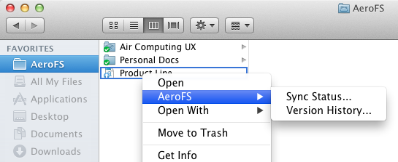

Figure AeroFS desktop app

**The AeroFS folder**: A folder called “AeroFS” is created under the user’s home directory. Any file placed in that folder will be synced to the user’s other devices as well as team owned Team Servers.

**Tight operating system integration**: Users can access AeroFS functions through right clicks in Finder and Windows Explorer. AeroFS displays icons on files and folders to indicate sync status and progress.

**Fast LAN sync**: If two computers are in the same LAN, data is directly transferred via the local network, which is much faster than public cloud solutions that involve Internet traffic.

**Simple sharing**: To share a folder with collaborators, all you need is to click on the folder, select “Share This Folder”, and input their email address.

**Easy conflict management**: When you work on files with multiple collaborators, two people may edit a file at the same time. AeroFS notifies you about the conflict with file icons and pop up messages. You can choose to continue working on your version, or compare and merge conflict versions through a few mouse clicks.

**Version history**: AeroFS saves old copies when receiving new versions from other computers. You can browse and restore old versions saved on the local computer, even if the file has been deleted from other computers.

**Auto updates for constant improvements and security**: Desktop applications as well as Team Servers automatically update themselves in the background. This ensures that all your team’s computers are up to date for features, bug fixes, and more importantly, security patches.

# Mobile app: browse files on the go

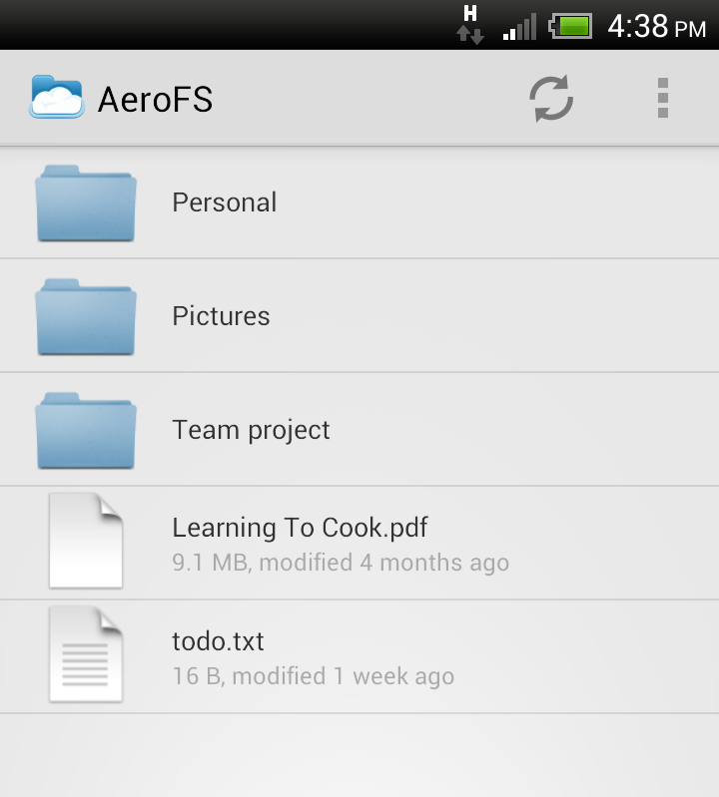

Figure AeroFS Android app

We recently released the Android app, which allows you to view and download files from Team Servers or your own computers. If there are multiple computers available, the app automatically selects and requests files from one of them.

# On the road map

New versions of AeroFS are released several times every week. Stay tuned for exciting new features to come up in the near future:

* Web-based file access and sharing support
* iPhone app, and new features on the Android app
* Better control and access to version history on Team Servers
* More management features for the team and personal dashboards

If the features you are looking for are not on the list, email [business@aerofs.com](mailto:business@aerofs.com) or vote for them at [vote.aerofs.com](http://vote.aerofs.com).

# Next step

Sign up a free AeroFS account at [www.aerofs.com](https://www.aerofs.com), or browse our knowledge base for more information at [support.aerofs.com/knowledgebase](http://support.aerofs.com/knowledgebase). If you have any question or comment, do not hesitate to email us at [business@aerofs.com](mailto:business@aerofs.com).

Air Computing Inc.

635 High St., Palo Alto, California 94301

[business@aerofs.com](mailto:business@aerofs.com)

1. The only exception is that our Web services need to know your shared folder names to send invitation emails and display them on the Web pages.