Ahmet Erdem Çağatay – 49826 20.02.2019

ELEC404 –HW2

Engin Erzin

1) The waveforms are matched with their word equivalents as below:

a) AND b) THAT

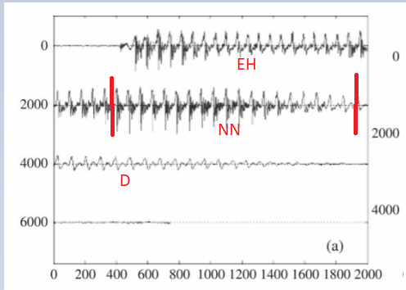 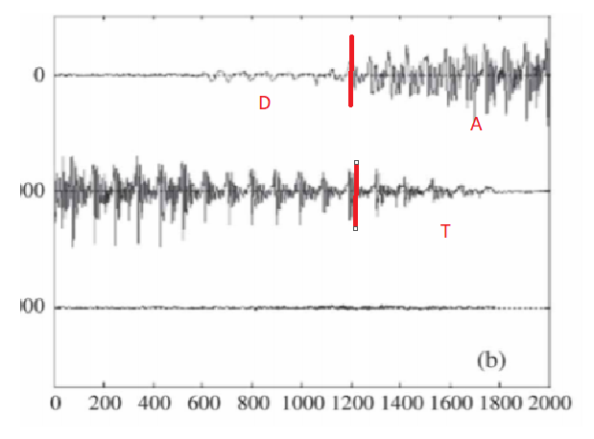

c) WAS d) BY

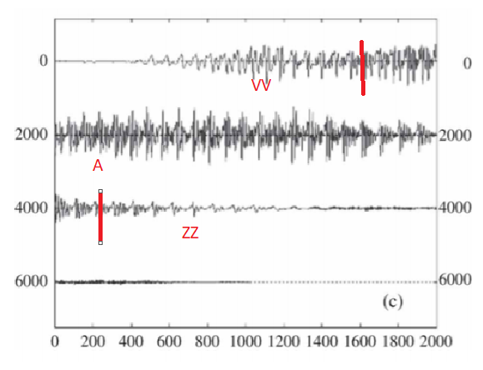 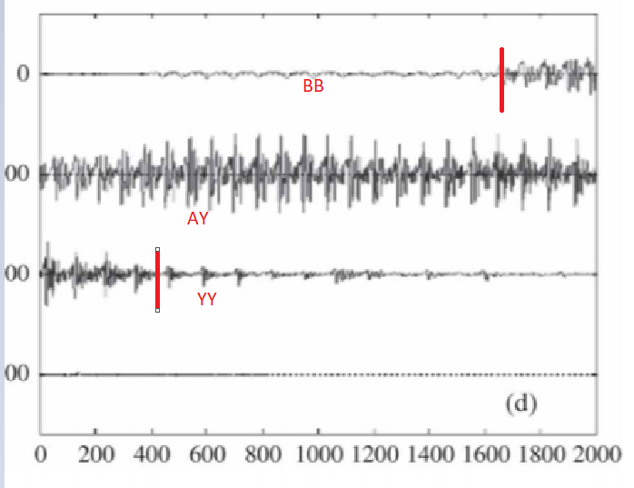

e) ENJOY f) COMPANY

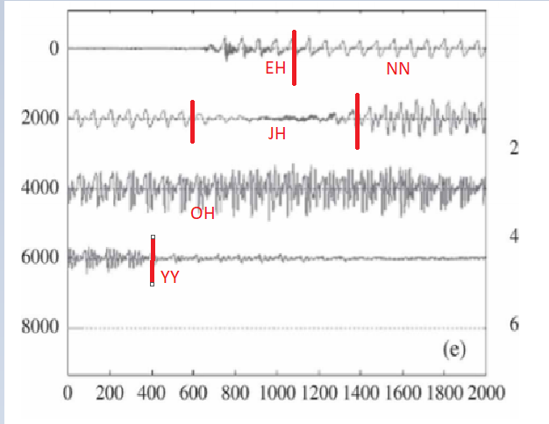 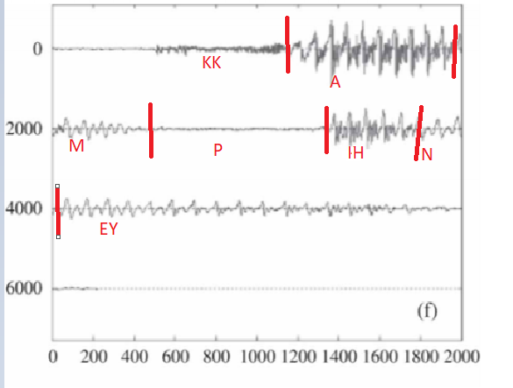

g) SIMPLE

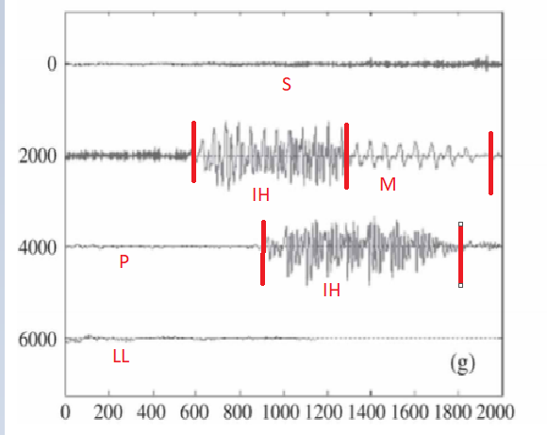

2) The spectrograms are matched with their equivalent words as below:

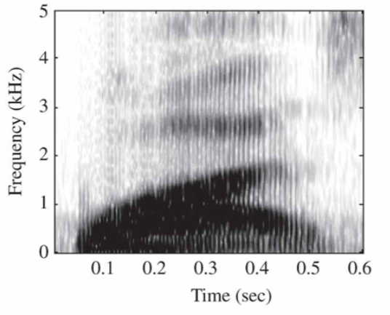

This spectrogram belongs to WAS because it has one vowel and

its first sound is a voiced fricative.

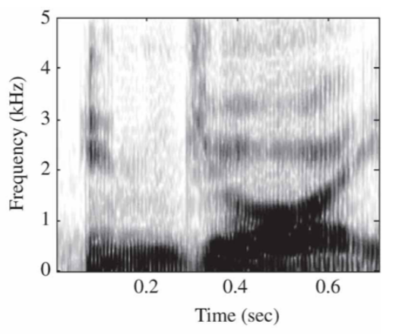 This spectrogram belongs to ENJOY because it has 2 vowels and

the first vowel has a higher pitch than the second one.

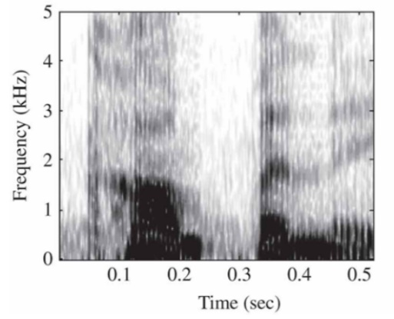 This spectrogram belongs to COMPANY because it has 3 vowels,

and a stop consonant at the middle.

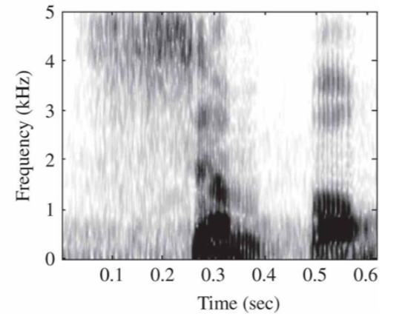

This spectrogram belongs to SIMPLE because it has 2 vowels, a

stop consonant in the middle, and unvoiced fricative at the

beginning.

3) Each frequency has a different loudness relativeness with DBs and this relativity is laid out on the Sound Pressure Level vs Frequency diagram. This diagram below is taken from course slides.

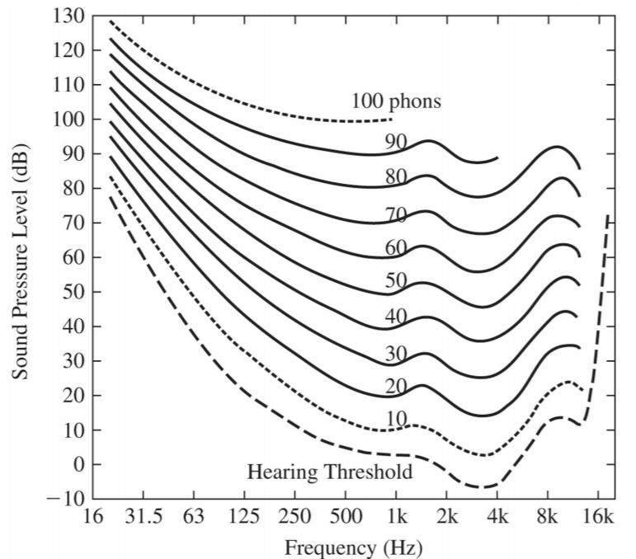

By looking at the graph to compare given sounds

(a) 20 dB IL at 1000 Hz has 20 phons while 20 dB IL at 500 Hz has 10-15 phons. Thus, predecessor is louder by around 5 phons

(b) 40 dB IL at 200 Hz has 20 phons while 30 dB IL at 2000 Hz has 30 phons. Thus, successor is louder by 10 phons.

(c) 50 dB IL at 100 Hz has 20 phons while 50 dB IL at 1000 Hz has 50 phons. Thus, successor is louder by 30 phons.

4) Perceived pitch is the perceptual quantity that is related to the fundamental frequency. Its formula in mels is the following:

or

To find critical bandwidths for certain frequencies, we can use the diagram from http://digitalsoundandmusic.com/4-1-6-sound-perception/ .

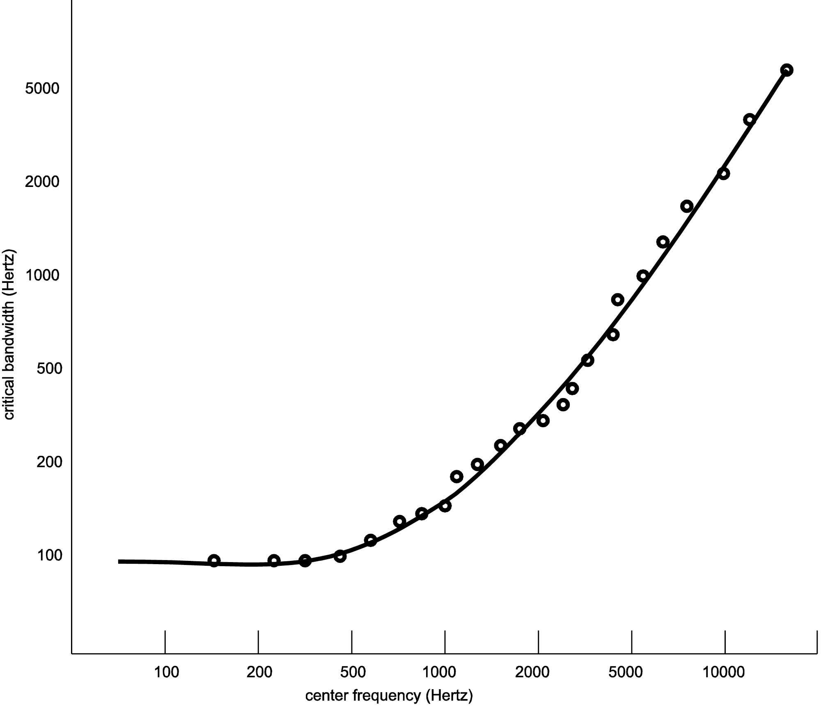

1. For 100 Hz, pitch is 137.5 mels, critical bandwidth for that tone is 100 Hz
2. For 400 Hz, pitch is 485.4 mels, critical bandwidth for that tone is 100 Hz
3. For 2000 Hz, pitch is 1585 mels, critical bandwidth for that tone is 350 Hz
4. For 10000 Hz, pitch is 3460 mels, critical bandwidth for that tone is 2000 Hz

5)

a) Here is the confusion matrix for 12 dB

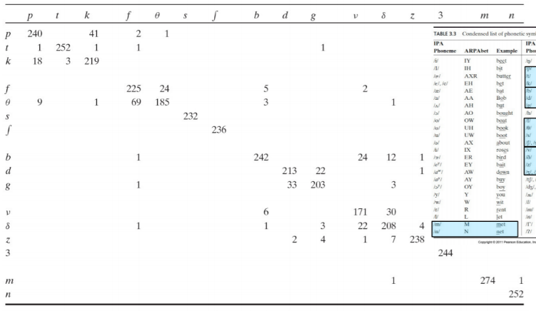 Here, it is seen that among the options p-t, p-s,

g-d, g-n; the most likely one to be confused is

g-d. Thus, go-doe is the answer for this option.

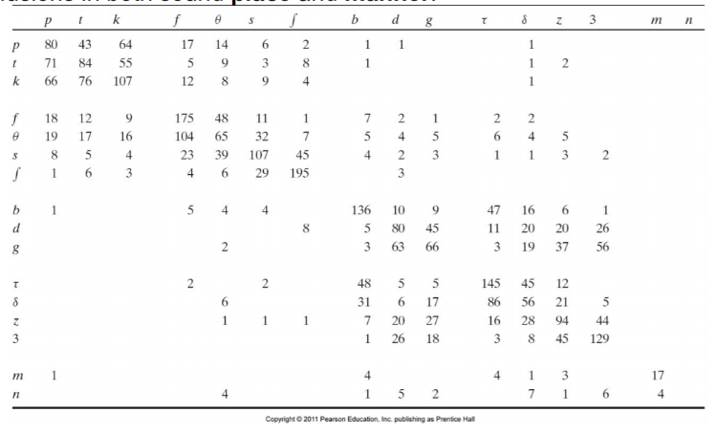b) Here is the confusion matrix for -6 dB

Here, it is seen that among the options p-t, p-s,

g-d, g-n; the most likely one to be confused are

g-d and p-t. Thus, both go-doe and pick-tick are

strong candidates. On the other hand, for -6 dB,

manner is also another confusion reason.

Go-doe and pick-tick are different in terms of

having voiced/unvoiced consonants. Since unvoiced consonants are easier to be confused, probably pick-tick is more likely to be confused.