Ahmet Erdem Çağatay – 49826 20.03.2019

ELEC404 – Assignment #5

Engin Erzin

1. 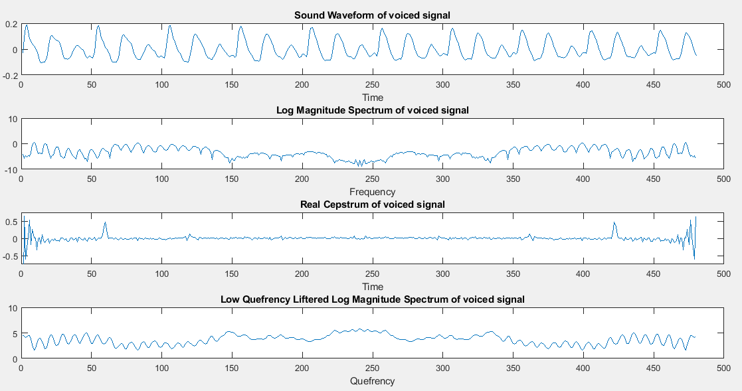

Figure 1: Plots of the voiced signal

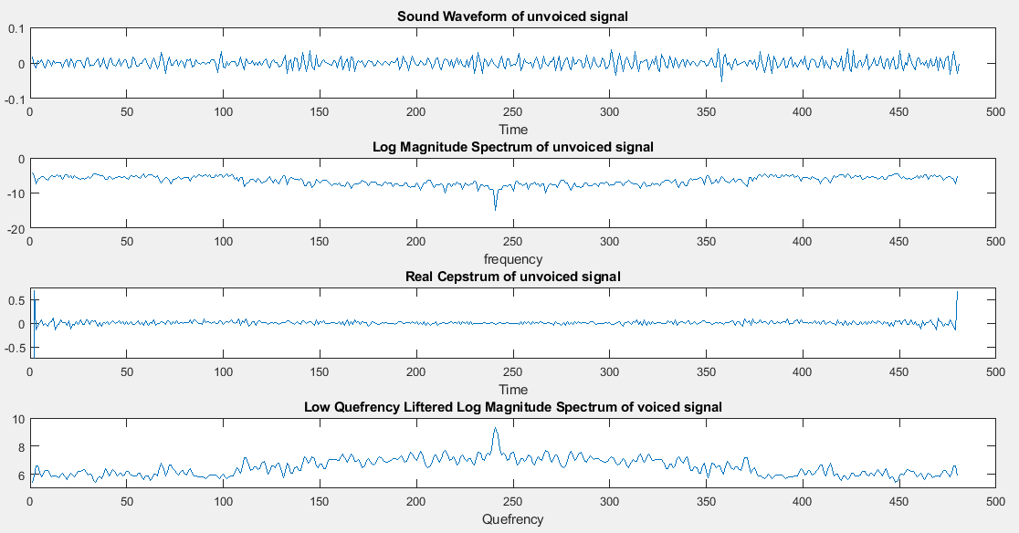

Figure 2: Plots of the invoiced signal

Sound waveform of the voiced signal has a higher amplitude than unvoiced signal and it is quasi-periodic as it is expected. There is no periodicity on the unvoiced signal’s plot.

Log magnitude spectrum of the voiced signal is more observable than unvoiced signal’s in terms of determining formants, but still signal needs low quefrency liftering for healthy results.

As it is seen from the plots, real cepstrum of the voiced signal includes local maximum points. On the other hand, there is no peak on the real cepstrum plot of the unvoiced signal.

For voiced signal, low quefrency liftered log magnitude spectrum smooths the plot and it gets easier to determine the formants.

2.

a) $x_{mean}\left[n\right]=w\left[n\right]+βw\left[n-1\right]=0$

$$V\left[x\right]= x^{2}\left[n\right]={\left(w\left[n\right]+βw\left[n-2\right]\right)}^{2}=w^{2}\left[n\right]+2βw\left[n\right]w\left[n-1\right]+β^{2}w^{2}[n-1]$$

$$x^{2}\left[n\right]= ϖ_{w}^{2}+β^{2}ϖ_{w}^{2}=(1+β^{2}{)ϖ}_{w}^{2}= 1+β^{2}$$

b) Transfer function of x[n] from w[n] 🡪

c)

=

then,

3. For linear prediction, coefficients need to be found. After they are calculated by either autocorrelation or covariance method, next samples’ values can be estimated by observing previous samples.

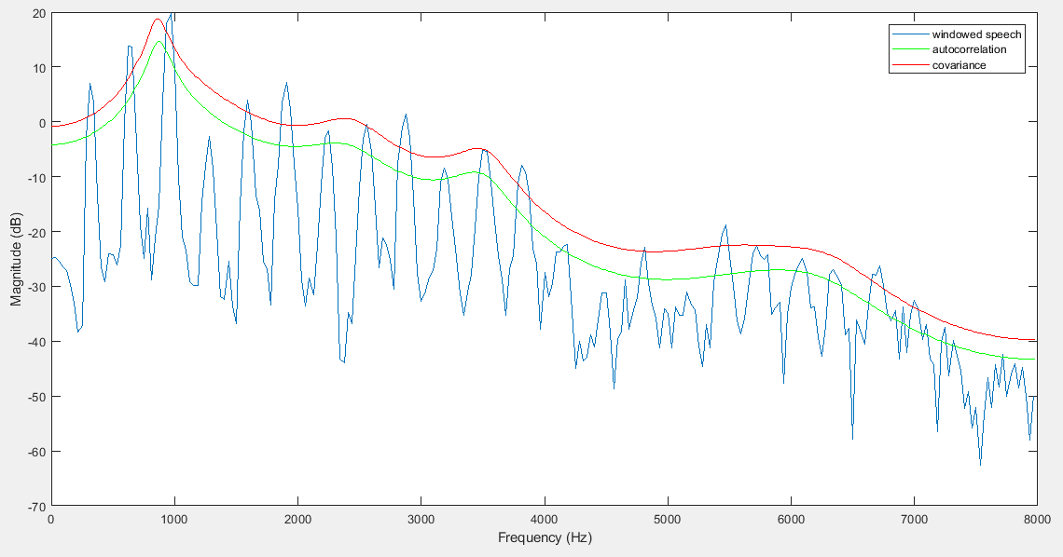

Figure 3: LPC spectra of voiced signal

Autocorrelation and covariance methods give very similar results. We can differentiate the formant frequencies from the spectra because this is a voiced signal. There is a slight difference between them because they have different gains. There is a larger difference between the signal itself and the LPC spectra in the beginning part of the plot, but that difference gets smaller at the end.

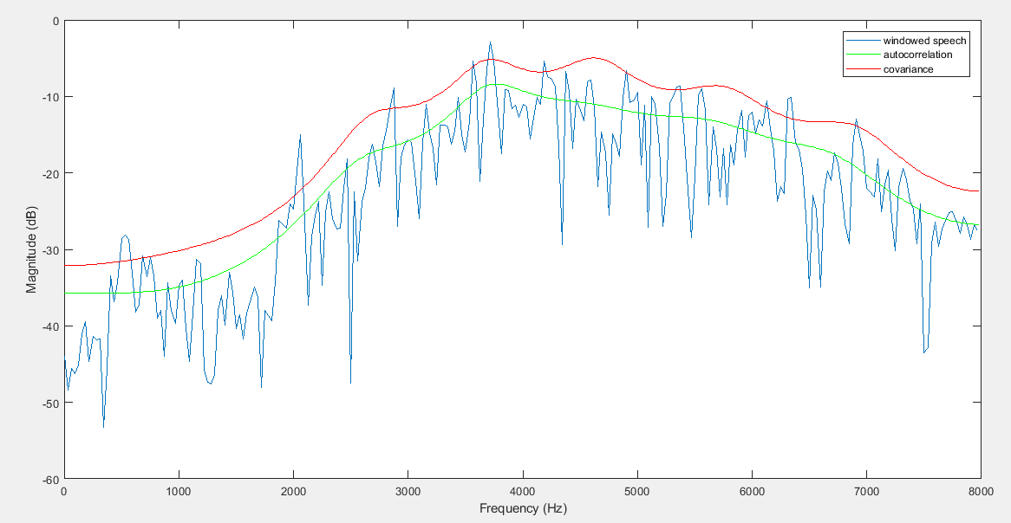

Figure 4: LPC spectra of unvoiced signal

These spectra doesn’t give formant frequencies because this is an unvoiced signal. Autocorrelation and covariance methods give similar results again. Similarly, the difference between LPC spectra and the signal is higher in the beginning, but it get smaller in the end.