ISTANBUL TECHNICAL UNIVERSITY FACULTY OF SCIENCE AND LETTER

INVESTIGATION OF STRUCTURAL DIFFERENCES BETWEEN WILD-TYPE AND MUTANT FORMS OF CHK2 HOMODIMER BY MOLECULAR DYNAMICS SIMULATIONS.

B.Sc. THESIS

Ayten Dilara GÜRSEL

Department of Molecular Biology and Genetics

JUNE 2022

ISTANBUL TECHNICAL UNIVERSITY FACULTY OF SCIENCE AND LETTER

Thesis Advisor: Prof. Dr. Gizem DİNLER DOĞANAY

Ayten Dilara GÜRSEL
(090160035)

B.Sc. THESIS

INVESTIGATION OF STRUCTURAL DIFFERENCES BETWEEN WILD-TYPE AND MUTANT FORMS OF CHK2 HOMODIMER BY MOLECULAR DYNAMICS SIMULATIONS.

Department of Molecular Biology and Genetics

JUNE 2022

ISTANBUL TEKNİK ÜNİVERSİTESİ FEN VE EDEBİYAT FAKÜLTESİ

Tez Danışmanı: Prof. Dr. Gizem DİNLER DOĞANAY
Ayten Dilara Gürsel
(090160035)
LİSANS TEZİ

CHK2 HOMODİMERİNİN YABANIL TİP VE MUTANT FORMLARI ARASINDAKİ YAPISAL FARKLILIKLARININ MOLEKÜLER DİNAMİK SİMÜLASYONLARI İLE İNCELENMESİ

Moleküler Biyoloji ve Genetik Bölümü

HAZİRAN 2022

Ayten Dilara GÜRSEL, a B.Sc. student of ITU Undergraduate School student ID 090160035 successfully defended the thesis entitled “INVESTIGATION OF STRUCTURAL DIFFERENCES BETWEEN WILD-TYPE AND MUTANT FORMS OF CHK2 HOMODIMER BY MOLECULAR DYNAMICS SIMULATIONS.”, which he prepared after fulfilling the requirements specified in the associated legislations, before the jury whose signatures are below.
.

Thesis Advisor : Prof. Dr. Gizem DİNLER DOĞANAY ..............................
İstanbul Technical University

Jury Members :
Assoc. Prof. Dr. Gizem DİNLER DOĞANAY .............................
İstanbul Technical University

Assoc. Prof. Mert GÜR ..............................
Istanbul Technical University
Dr. Bülent BALTA ..............................
Istanbul Technical University

Date of Submission : 17 June 2022
Date of Defense : 20 - 24 June 2022

To my family and my grandmother,

FOREWORD
First of all, I would like to express my appreciation and thank my advisor, Assoc. Prof. Mert Gür, for his support and understanding. I would like to thank my GURLAB colleagues Mert Gölcük, Clara Xazal Buran, Elhan Taka, Sema Zeynep Yılmaz, Derman Baştürk and Yaren Barutçu for always helping me.
I would especially like to thank my family and friends who are like my family, for always being there for me, supporting me and making me feel their love no matter what.

June 2022 | Ayten Dilara GÜRSEL

TABLE OF CONTENTS
Page
FOREWORD ix
TABLE OF CONTENTS xi
ABBREVIATIONS xiii
SYMBOLS xv
LIST OF FIGURES xvii
SUMMARY xix
ÖZET xxi
1. INTRODUCTION 1
1.1 Purpose of Thesis 1
1.2 Cell cycle checkpoint kinase 2 (CHEK2) gene 1
1.3 Chk2 protein structure 2
1.3.1 FHA Domain 3
1.3.2 SCD Domain 4
1.3.3 Kinase Domain 5
1.4 Chk2 dimerization and downstream pathways 8
1.5 Molecular Dynamics Simulation 11
2. METHODS 13
2.1 Molecular Dynamics Simulations System Preparation 13
2.2 Molecular Dynamics Simulations 14
2.3 RMSD Analysis 15
2.4 RMSF Analysis 16
2.5 Heat Capacity Analysis 16
3. RESULTS 17
3.1 RMSD Analysis 17
3.2 RMSF Analysis 18
3.3 Heat Capacity Analysis 21
4. CONCLUSION 22
REFERENCES 25
CURRICULUM VITAE 28

ABBREVIATIONS
ATM : Ataxia telangiectasia mutated
BRCA1 : Breast cancer gene 1
BRCA2 : Breast cancer gene 2
C_{α} : Alpha carbon
CHEK2 : Cell cycle checkpoint kinase 2
Chk2 : Checkpoint kinase 2
C-lobe : C-terminal lobe
C Spine : Catalytic spine
FHA : Fork-head-associated
KD : Kinase Domain
LSP : Local spatial pattern
MD : Molecular dynamics
N-lobe : N-terminal lobe
pThr : Phosphorylated threonine
RMSD : Root Mean Square Deviation
RMSF : Root Mean Square Fluctuation
R spine : Regulatory spine
SCD : SQ/TQ cluster domain
TP53 : Tumor protein p53

SYMBOLS
C_{p} : Heat Capacity
H : Enthalpy
k_{B} : Boltzmann coefficient
N : Total number of atoms
P : Pressure
$R$ : Universal gas constant
$R$ : Coordinate
T : Temperature
$V$ : Volume

LIST OF FIGURES
Page
Figure 1.3.1 : Structure of FHA domain of human Chk2. 4
Figure 1.3.2 : SCD domain location on different protein sequence 8
Figure 1.4.1 :FHA-KD interface with hydrophobic patches. 9
Figure 1.4.2 :FHA-FHA dimerization inteface. 10
Figure 1.4.3 :Structural parts of Kinase domain of monomeric Chk2 10
Figure 2.1.1 :Chk2 protein in water box 14
Figure 3.1.1 :RMSD results 17
Figure 3.2.1 :RMSF results 18
Figure 3.2.2 :Structure of WT and mutant Chk2 protein for specific region 20
Figure 3.3.1 :Heat capacity results 22

INVESTIGATION OF STRUCTURAL DIFFERENCES BETWEEN WILD-TYPE AND MUTANT FORMS OF CHK2 HOMODIMER BY MOLECULAR DYNAMICS SIMULATIONS.
SUMMARY
Cancer is a common and fatal disease seen all over the world. Breast cancer is one of the most common causes of death in women. Chk2 protein, which is involved in the DNA repair mechanism, is thought to play a role in breast cancer. The Chk2 protein is expressed from the CHEK2 gene and consists of three important domains, the fork-head-associated domain (FHA), the SQ/TQ cluster domain (SCD) and the kinase domain (KD). The FHA region, also known as the protein-protein interaction region, is involved in the recognition of pThr residues located on extended epitopes. The Chk2 protein is stable in the monomer state but is induced to dimer by phosphorylation of Thr68 in the SCD region. Phosphorylation of Thr68 is the first response to DNA damage. While the kinase domain is important for signal transduction, there is a domain of interaction with the FHA domain. The FHA-KD interface has a hydrophobic patch.
Molecular dynamics simulations are important for observing biomolecular ligand binding, protein folding processes, and conformational changes with capturing the positions of atoms at femtosecond temporal resolution. The system preparation process is important in molecular dynamics simulations. For the molecular dynamic simulation of the Chk2 protein, structures with the numbers PDB ID: 3I6U, PDB ID: 3I6W, whose crystal structure was obtained in 2009 from Cai et al, were used. Since Chk2 protein is located in the cell nucleus, ion concentrations in the simulation system were determined as 20 mM sodium chloride (NaCl) and 210 mM potassium chloride (KCl).
In MD simulations for the Chk2 protein, the NAMD 2.13 program and the CHARMM36 force field were used. The VMD mutator extension is used for mutations. A minimum cut-off distance of 12 Å was chosen for the calculation of the van der Waals interactions. The particle mesh Ewald method was used for long-range electrostatic interactions. Protein fixed on C_{α} for equilibration with 1fs time step and 2 fs used for other steps. The simulations were carried out under constant NPT conditions, and the temperature was kept constant at 310 K and the pressure at 1 atm. Langevin dynamics is used at a damping coefficient of 1 ps to maintain isothermal conditions. In order to maintain the pressure constant, the Langevin Nosé-Hoover method was used with an oscillation time of 100 fs and a damping time of 50 fs. Two-step minimization and equilibration are used in MD simulations. First of all, minimization was made for 10000 steps without any fixation, then the system energy was equilibrated by keeping the C_{α} of the protein constant for 2 ns. In addition, the entire system was minimized at 10000 steps without any fixation, and then harmonic restriction was applied to the C_{α} of the protein for 20 ns. Finally, the system was equilibrated for 10 ns without any fixation. Molecular dynamics simulations of 100 ns were applied for two sets. A total of 600 ns molecular dynamics simulations were performed for WT, mutant Leu183Phe and Pro283Ser. RMSD, RMSF and heat capacity calculations were used for examine the effects of mutations on the structure.
Mutant Leu183Phe was observed at a lower value than WT and mutant Pro283Ser in RMSD results. Likewise, in the heat capacity results, mutant Leu183Phe was observed at a lower value than WT and mutant Pro283Ser. In the RMSF results, fluctuations were observed in the regions between 274 to 286 residues and between 392 to 412 residues in the kinase region. The presence of protein loops in these regions and the fact that protein loops are more flexible structures, the high RMSF values are expected. The decrease in heat capacity also means more compact form in proteins. This difference in RMSD and heat capacity of the mutant Leu183Phe, Chk2 protein may became more compact form.

CHK2 HOMODİMERİNİN YABANIL TİP VE MUTANT FORMLARI ARASINDAKİ YAPISAL FARKLILIKLARININ MOLEKÜLER DİNAMİK SİMÜLASYONLARI İLE İNCELENMESİ

ÖZET
Kanser tüm dünyada görülen yaygın ve ölümcül bir hastalıktır. Meme kanseri, kadınlarda en çok görünen ölüm sebeplerinden biridir. DNA onarım mekanizmasında görev alan Chk2 proteininin meme kanserinde rol aldığı düşünülmektedir. Chk2 proteini CHEK2 geninden eksprese edilir ve üç önemli bölgeden oluşur, bunlar çatalbaşı ile ilişkili bölge (FHA), serin-glutamin (SQ) ve treonin-glutamin (TQ) küme bölgesi ve kinaz bölgesi (KD)'dır. FHA bölgesi protein-protein etkileşim bölgesi olarak da bilinir ve uzatılmış epitoplar üzerinde yer alan pThr kalıntılarının tanınmasında görev almaktadır. Chk2 proteini monomer durumunda stabil halde bulunur fakat SCD bölgesindeki Thr68'in fosforilasyonuyla dimer hale geçmek için indüklenir. Thr68'in fosforilasyonu DNA hasarına verilen ilk tepkidir. Kinaz alanı, sinyal iletimi için önemli olmakla birlikte FHA alanı ile etkileşimi alanı bulunmaktadır. FHA-KD arayüzü hidrofobik yamaya sahiptir.
Moleküler dinamik simülasyonları, biyomoleküler ligand bağlanması, protein katlanma süreçleri ve konformasyonel değişikleri femtosaniye zamansal çözünürlükte atomların pozisyonlarını yakalayarak süreçleri gözlemlemede önemlidir. Moleküler dinamik simülasyonlarında ortam hazırlama süreci önemlidir. Chk2 proteininin moleküler dinamik simülasyonu için Cai vd. 2009 yılında kristal yapısını elde ettikleri PDB ID: 3I6U, PDB ID: 3I6W numaralı yapılar kullanılmıştır. Chk2 proteini hücre çekirdeğinde bulunduğu için, simülasyon ortamındaki iyon konsantrasyonları 20 mM sodyum klorür (NaCl) ve 210 mM potasyum klorür (KCl) olarak belirlenmiştir.
Chk2 proteini için MD simülasyonlarında, NAMD 2.13 (Phillips, 2005) programı ve CHARMM36 (Best vd., 2012) kuvvet alanı kullanılmıştır. Mutasyonlar için VMDmutator uzantısı kullanılmıştır. Van der Waals etkileşimlerinin hesaplanmasında minimum 12 Å kesme mesafesi seçilmiştir. Parçacık ağ Ewald metodu, uzak mesafeli elektrostatil etkileşimler için kullanılmıştır. Sabitlenmiş ve geri kalan simülasyonlar için 1 ve 2fs adım aralığı belirlenmiştir. Simülasyonlar sabit NPT koşullarında gerçekleştirilmiş olup sıcaklık 310 K, basınç ise 1 atm'de sabit tutulmuştur. Langevin dinamiği izotermal koşulları korumak için 1ps'lik sönümleme katsayısında kullanılmıştır. Basınç sabitini korumak adına ise Langevin Nosé-Hoover yöntemi, 100 fs'lik bir salınım süresi ve 50 fs'lik bir sönümleme süresinde kullanılmıştır. MD simülasyonlarında iki adımlı minimizasyon ve dengeleme döngüsü kullanılmıştır. Öncelikle sistemin enerjisinde sabitleme yapılmadan 10000 adım için minimizasyon yapılmış daha sonra proteinin alfa karbonlarını 2 ns boyunca sabit tutarak sistem enerjisi dengelenmiştir. İlave olarak tüm sistem 10000 adımda hiçbir sabitleme olmadan minimize edilip sonrasında 20 ns boyunca proteinin alfa karbonuna harmonik kısıtlama uygulanmıştır. Son olarak sistem 10 ns boyunca hiçbir sabitleme olmadan dengelenmiştir. İki set için 100 ns moleküler dinamik simülasyonları uygulanmıştır. Yabanıl tip, mutant Leu183Phe ve Pro283Ser için toplam 600 ns moleküler dinamik simülasyonları uygulanmıştır. Mutasyonların yapıya olan etkilerini incelemek için RMSD, RMSF ve ısı kapasitesi hesaplamaları yapılmıştır.
RMSD sonuçlarında mutant Leu183Phe, yabanıl tip ve mutant Pro283Ser'ye göre daha düşük bir değerde gözlemlenmiştir. Aynı şekilde ısı kapasitesi sonuçlarında da mutant Leu183Phe, yabanıl tip ve mutant Pro283Ser'ye göre daha düşük bir değerde gözlemlenmiştir. RMSF sonuçlarında ise kinaz bölgesindeki 274. amino asit ile 286. amino asit arasındaki ve 392. amino asit ve 412. amino asit arasındaki bölgelerinde dalgalanma fazla görülmüştür. Bu bölgelerde protein döngülerinin bulunması ve protein döngülerinin daha esnek yapılar olması RMSF değerlerinin yüksek çıkmasını anlamlı hale getirmektedir. Isı kapasitesinin düşmesi proteinlerde daha kompakt form anlamına da gelmektedir. Mutant Leu183Phe Chk2 proteininin RMSD ve ısı kapasitesindeki bu farklılık mutasyonun proteini daha kompakt hale getirmiş anlamına gelebilir.

- INTRODUCTION
  - Purpose of Thesis
The main aim of the thesis is to investigate structural differences between mutant and WT Checkpoint kinase 2 (Chk2) homodimer with help of the molecular dynamic simulations. Chk2 is an important multifunctional enzyme to intricate pathways as cell cycle checkpoint, apoptosis and DNA repair system. Under normal conditions, the Chk2 protein exist as a monomer, DNA damage cause dimerization of the Chk2 protein. Investigation of mutant and wild-type (WT) homodimer Chk2 protein structure may help to understand effect of mutations on dimerization and or on protein function. Kinase domain is important for catalytic activity and has FHA-KD interface on Chk2 homodimer. One of mutant Chk2 protein has Leu183Phe mutation on FHA domain and other mutant Chk2 protein has Pro283Ser mutation on kinase domain which means this mutation can affect the dimerization of Chk2. FHA domain is important for dimerization of Chk2 protein, mutation of leucine to phenylalanine can effect of hydrophobic interface of FHA-KD because of the hydrophobicity of phenylalanine more than leucine. (Wimley ve White, 1996) Proline is known to be a helix breaker. Thus, because of the mutation proline to serine, the disappearance of the helix breaking feature of proline may affect the structure of Chk2. (Imai ve Mitaku, 2005) Molecular dynamics is a computational simulation technique, which has an important role in investigating the structural, energetical and dynamical properties of proteins at the atomic level. The effects of this mutations will be investigated by molecular dynamics simulations. In this thesis, structure of the Chk2 homodimer in its WT and mutant forms has been examined using molecular dynamic simulations.
  - Cell cycle checkpoint kinase 2 (CHEK2) gene
Cancer is a common health problem all over the world, it is one of the diseases that cause death worldwide. Cancer can occur as a result of abnormal proliferation of any type of cell in the body. According to studies conducted in the United States and Turkey, breast cancer is the most common cancer and important causes of death among women. (Siegel et al., 2016; Özmen et al., 2019) Various factors can affect the formation of breast cancer, which is a multifactorial disease. (Lountos et al., 2009) CHEK2 gene’s 1100delC, R117G, I160M, G167A and I157T mutations can be example of these factors which is in sight to increased risk for breast cancer. (Apostolou ve Papasotiriou, 2017) 1100delC mutation on CHEK2 encodes truncated C-terminal protein in their kinase domain and increases the risk of breast cancer. (Ahn et al., 2004)
CHEK2 is a tumor suppressor gene that is located in the 22q12.1 region of human chromosome. (Nevanlinna ve Bartek, 2006) The product of CHEK2 gene is a serine-threonine kinase, serve as a tumor suppressor and cell cycle checkpoint regulator. Phosphorylation of Thr68 by ataxia telangiectasia mutated (ATM) lead to dimerization of Chk2 protein, thus dimerization activates Chk2 and causes it to acquire kinase activity. (Apostolou ve Papasotiriou, 2017) DNA damage provide activation of CHEK2 and its lead to downstream interactions with tumor protein p53 (TP53), breast cancer gene 1 (BRCA1) and breast cancer gene 2 (BRCA2) which are more frequent in cancer patients. (Apostolou et al., 2018)
  - Chk2 protein structure
Chk2 protein kinase which is expressed on CHEK2 gene, and p53 protein’s ATM-dependent activation occurs after DNA damage. The Chk2 protein can phosphorylate p53 at Ser20 so it has intermediate kinase functions which means has an important role in p53 connection to the response of double-stranded DNA breaks. (Wu et al., 2001) Releasing of BRCA1 from Chk2 requires phosphorylation of BRCA1 at Ser988 which means Chk2 also regulates BRCA1. According to the literature, by acting as a scaffolding protein, BRCA1 can be involved in the organization of different DNA damage sensors that BRCA1 recruits as an effector in DNA repair coordination. (Allinen et al., 2001) The functional effect of the mutation on CHEK2 depends on the mutation location. The location of CHEK2 mutations is important for Chk2 function, for example, mutation in the FHA domain can cause disruption of protein-protein interaction or provide structural changes that can accelerate Chk2 degradation. (Wu et al., 2001) Chk2 protein consist of 543 amino acids, have three different protein as central fork-head-associated domain (FHA), SQ/TQ cluster domain (SCD) and C-terminal serine/threonine kinase domain (KD). (Nevanlinna ve Bartek, 2006)
    - FHA Domain
FHA domain is a small phosphopeptide which have conserved five amino acids important in binding phosphorylated epitopes. FHA is the protein-protein interaction domain that binds to phosphothreonine sites which includes SCD phosphorylated Thr68 segment. (Durocher et al., 2000; Bartek et al., 2001; Ahn ve Prives, 2002) This modular domain consists of 100-120 residues which are folded and became 11-stranded β-sandwich as two lateral and two apical surfaces. Apical surface has phosphopeptide-binding pocket and opposite this surface has N- and C- termini. This architecture provides FHA domains and other functional domains to assemble modularly. Multi-domain arrangements are created when modular domains combine to achieve separate specific function, which causes them to be called super domains. (Chehab et al., 2000; Durocher ve Jackson, 2002) FHA domains recognize specifically phosphorylated threonine (pThr) residues on extended epitopes. The β3–β4 and β4–β5 loops on FHA are the pThr binding site where two conserved residues provide critical contacts with the phosphoepitope. Conserved arginine residue in the β3–β4 loops are critical for binding to the phosphorylated residue. Interactions further regulated by oligomerization are generally those mediated by Chk2 and Rad53 kinases. (Durocher et al., 2000; Cai et al., 2009; Liu et al., 2012; Almawi et al., 2017) Normally Chk2 is functional and stable in monomer form but threonine damage-induced phosphorylation on SCD domain triggers to dimerization of Chk2 and also with help of the trans-autophosphorylation kinase activation promoted. Association of dimers as head to head configuration, promotes activation loops swapping in trans phosphorylation. FHA β1-β2-β11 strands on pThr binding site’s lateral surface mediates to this configuration. Dimerization of Chk2 can occur even in absence of p-epitope which shows that distal surface on FHA importance for dimerization. Because of the activation promotes Chk2 monomerization, dimerization could not affect other interaction on distal surface. In Figure1.3.1, FHA domain structure is shown as blue and pink color which are specify chain A and chain B, and eleven-stranded β sandwich of FHA domain is seem clearly. (Durocher ve Jackson, 2002; Cai et al., 2009; Liu et al., 2012; Almawi et al., 2017)
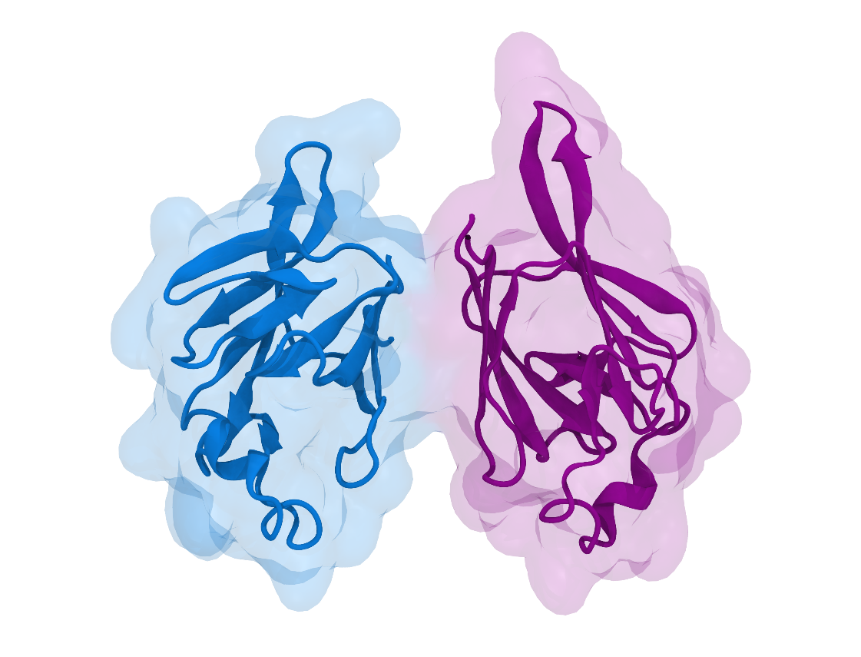
Figure1.3.1: FHA domain of homodimer Chk2 is modelled based on PDB ID 3I6U crystal structure and shown as blue and pink color for each chain of homodimer Chk2 protein. FHA domain has eleven-stranded β sandwich. FHA domain consist of between 92 to 205 residues. (Cai et al., 2009)
    - SCD Domain
Some agents, such as ionizing radiation, can cause DNA damage, in which cases Chk2 proteins phosphorylate Thr68 at ATM sites in order to immediately arrest DNA separation or replication of the cell. In other words, activation of Chk2 protein is dependent on ATM in the SCD domain (SQ/TQ motifs). (Ahn et al., 2004; Buscemi ve Zannini, 2016) ATM/ATR-like kinases are favorably phosphorylating threonine or serine residues which are predate glutamine residues. Human Chk2 contain seven SQ-TQ motifs in 51 residues. SCDs show a remarkable diversity in different proteins as SCD can exist anywhere in N-terminal, C-terminal or central region. Characterization of Chk2 kinases make with identification of N-terminal FHA domain and most of the kinases have N-terminal SCD domain. SCD length and SQ/TQ motifs density shows diversity and little similar sequence on different organisms. (Kim et al., 1999; Ahn et al., 2000; Cai et al., 2009) According to Schwartz et al, small ratio of all yeast or mammalian protein have SCD that shows respond to DNA-damage response. (Schwartz et al., 2002) In mammalian Chk2 SCD can be phosphorylate several sites when DNA damage occurs. Mostly Thr68 residue phosphorylation occurs on SCD in DNA damage and also it is important for downstream functions. Phosphorylated SCD can also facilitates other Chk2 protein’s threonine trans-autophosphorylation on activation loop of the catalytic domain with bind their FHA domain. (Kim et al., 1999; Durocher ve Jackson, 2002; Traven ve Heierhorst, 2005) Additional site of SCD and FHA domain in Chk2 oligomers also can be trans-phosphorylated. The reason for SCD autophosphorylation was thought to amplify checkpoint signals by recruitment allow and activate more Chk2 molecules. However, it was later found that the reason for promoting the release of activated Chk2 monomers may be to gain access to their downstream targets. Because it has been noticed that phosphorylation at the FHA domain decreases its affinity for phosphorylated SCD. (Bartek et al., 2001; Ahn ve Prives, 2002; Kobe ve Kemp, 2010) The intramolecular SCD-FHA interaction is an interaction that overrides conformation-dependent kinase auto-inhibition by other parts of the protein. SCD phosphorylation facilitates this interaction and plays a role in the regulation of kinase activity. On the other hand, SCD phosphorylation have not role only Chk2 activation, also can have downstream mechanism with activated Chk2 as pThr68 binds to mediator protein MDC1’s FHA domain which is phosphorylated by Chk2 and ATM after DNA damage. (Ahn et al., 2000; Traven ve Heierhorst, 2005) SCD region contain proteins of human Chk2, BRCA1, UPF1, Mdt1 and Mrc1 amino acids. SCD found different length and location on sequence in different protein. (Traven ve Heierhorst, 2005)
    - Kinase Domain
In eukaryotic cells, protein kinases serve as a major signal transmitters. Src protein phosphorylate tyrosine without serine or threonine is an important discovery for revealed protein kinase family tremendous diversity. Src and PKA protein sequencing comparison shown that these proteins are came from common ancestors which means protein kinases have conserved motifs. (Reinhardt ve Yaffe, 2009; Kobe ve Kemp, 2010) Protein kinases have C-terminal lobe (C-lobe) and N-terminal lobe (N-lobe), and ATP adenin ring are buried between these two lobes cleft base. Architecture of active protein kinases assembly structure was revealed as conserved hydrophobic parts and enzyme distal parts can be linked. Also fully assembled active kinases acrhitecture is broken when this kinase most inactive form. (Guo et al., 2010) Local spatial pattern (LSP) is a method to compare two structures and identification of spatially conserved residue as protein kinase and active enzyme assemble explanation on conserved hydrophobic motifs (spines) and protein kinase core internal architecture. (Bartek et al., 2001; Ahn et al., 2004; Reinhardt ve Yaffe, 2009)
N-lobe of protein kinase have five-stranded B-sheet and this B-sheet coupled with helical subdomain. Two highly conserved region embeded on first three B-strands. Most flexible part on N-lobe is first motif which has gly-rich loop (GxGxxG) and fold over nucleotide. ATP γ-phosphate position found for catalysis. C-helix is an another important motifs of the N-lobe which is also couples with ATP phosphates. (Guo et al., 2010; Zannini et al., 2014)
The C-helix located between two lobes which means strategically important position and very dynamic and unique motif in protein kinase. C-helix is a signal integration motifs because their connection with different parts of the molecule. There are critical steps for efficient catalysis as the position of N- terminus of C-helix has to be achieved by kinase activation. Another critical step is open and closed conformation determination with distance between activation loop and N-terminus of C-helix. In active state, N-lobe moves open and closed state as rigid body which part of the catalytic cycle when C-helix and B-sheet are bound. In inactive kinases, C-helix’s N-terminus can be corrupted or changes its position in a non-optimal way. (Taylor ve Kornev, 2011; Zannini et al., 2014)
C-lobe is large lobe which have one B-sheet and mostly helices. Helical parts of the kinase serve as a peptide/protein tethering surface with their rigid helical structures. With one of exception as G-helix which is exposed to solvent, core helices backbone amides are shielded from solvent because of Hydrogen Deuterium exchange. (Ahn et al., 2004; Cai et al., 2009; Taylor ve Kornev, 2011) The B-subdomain anchored to helical core along to hydrophobic residue and contain association of phosphate transfers ATP to protein substrate catalytic machinery. One of the B-strands contain DFG motifs which serve critical recognition of ATP-bound Mg²⁺ ions. (Cai et al., 2009)
Regulatory spine (R spine) is highly conserved motif which was not found inactive kinase but found every active kinase. R spine consist of two non-consecutive hydrophobic region from N-lobe, two non-consecutive hydrophobic region from C-lobe, four non-consecutive hydrophobic region which can not identified alone and has regulatory spine design. (Kim et al., 1999; Kobe ve Kemp, 2010) Catalytic spine (C-spine) have residues from N and C lobe like R spine but there is one differences between R-spine and C-spine, ATP adenin ring completed to C-spine. Also C-spine sequence is not conserved but C-spine found all kinases. F-helix thought to be transmembrane because of their strong hydrophobicity but with other analysis show that this helix all kinase core’s organizing element. (Bartek et al., 2001; Taylor ve Kornev, 2011)
Kinase domain is the most conserved region of kinase family in eukaryotic proteins which consists of N-lobe and C-lobe. Regulatory spines and catalytic spines which are serve as a require elements anchorage, DGF which is provide Mg²⁺ bound to ATP, glycine-rich loop which regulates ATP binding and the activation loop which is phosphorylation site, are also conserved motifs of kinase domain. (Ahn et al., 2004; Oliver et al., 2006) Kinase domain and FHA domain connected each other with linker part and catalytic activity is provide with kinase domain. In order for the kinase domain to be activated, there must be DNA damage and Thr383 on the activation loop must be phosphorylated. In Figure1.3.2, kinase domain structure is show as chain A and chain B has different blue and pink color. Darker color shows N-lobe of the kinase domain and lighter color shows C-lobe of the kinase domain. (Ahn et al., 2004; Cai et al., 2009)

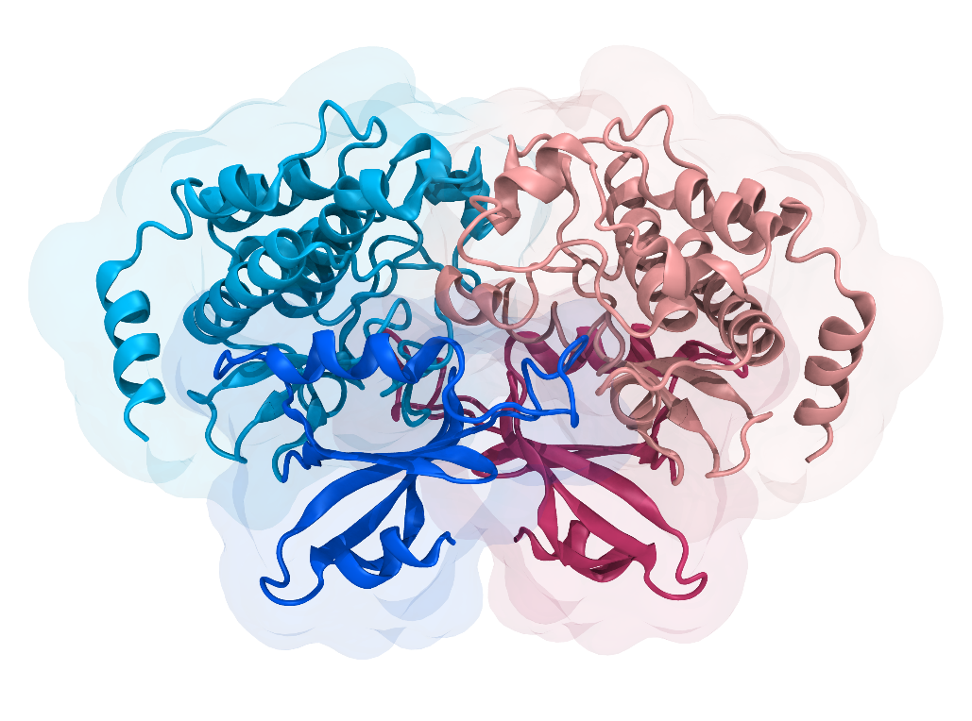
Figure1.3.2: Kinase Domain of human Chk2 which is modelled based on PDB ID 3I6U crystal structure. Dark blue and dark pink parts are N-lobe of kinase domain which are located between 213 to 305 residues on Chk2 sequence. Light blue and light pink parts are C-lobe of kinase domain which are located between 305 to 501 residues on Chk2 sequence. (Traven ve Heierhorst, 2005; Cai et al., 2009)
  - Chk2 dimerization and downstream pathways
Monomer Chk2 is found as inactive in unperturbed cells. When DNA damage occurs, the SCD region of Chk2 is phosphorylated and Chk2 dimerization occurs. The Chk2 dimer is domain-exchanged and intertwined. First, the FHA domains interact with each other, then the kinase domain of one Chk2 interacts with the FHA domain of the other, through the dyad axis crossing of the FHA-KD linker. (Durocher ve Jackson, 2002; Guo et al., 2010) With the interaction of the FHA-kinase domain, a symmetrical dimer is formed. In FHA-KD interface, FHA β sandwich which have β5′–β6′- β9′ end and N-lobe’s concave β5′–β6 hairpin portion packing formation found. This formation interface have hydrophobic patches between N lobe of KD and FHA (Gly151, Pro152, Ile157, Tyr159, and Pro182 on FHA- Ile221, Phe238, Leu226, Leu236, Cys243, Lys224 and Lys245 on KD). Some of residues ar as far apart as the H-bond. As shown in Figure1.4.1, FHA kinase domain interface have hydrophobic residues which are participate in hydrophobic interaction. (Cai et al., 2009; Liu et al., 2012)
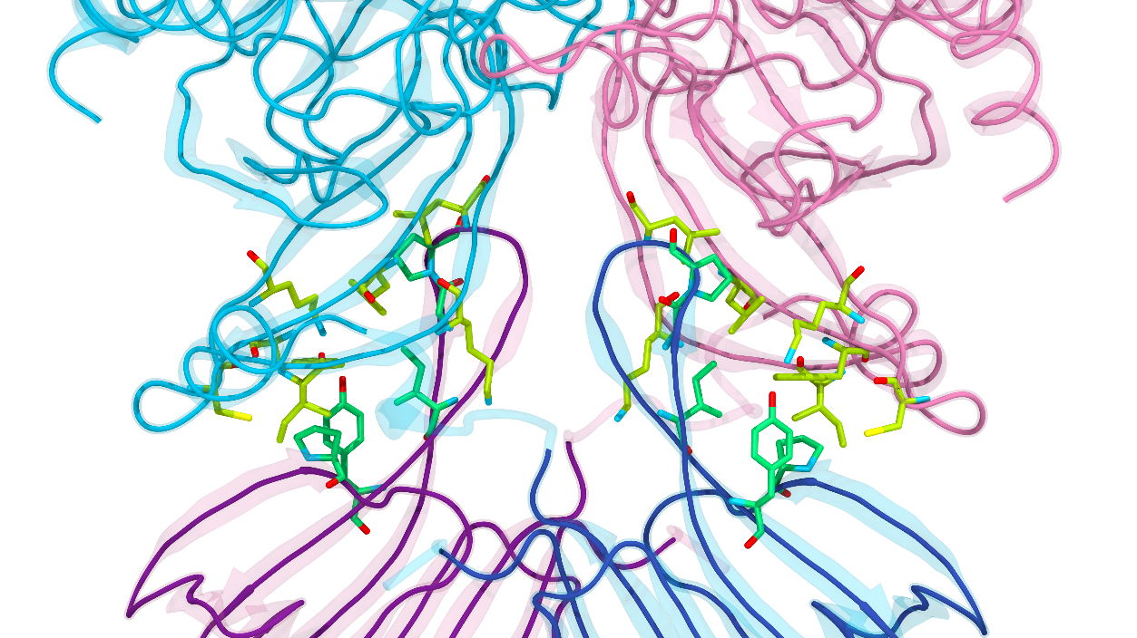
Figure1.4.1: The FHA-KD interface. Light pink and light blue parts are FHA domain and dark blue and dark pink parts are kinase domain. The green portion shown in the Figure is residues Ile221, Phe238, Leu226, Leu236, Cys243, Lys224 and Lys245 found in the kinase region, while the yellow portion is residues Gly151, Pro152, Ile157, Tyr159, and Pro182 found in the FHA region. These residues are hydrophobic patches that generate the van der Waals contacts at the interface. (Cai et al., 2009; Liu et al., 2012)
FHA-FHA interface interaction formed on three adjacent β1′, β2′, and β11′ strand which are make hydrogen and van der Waals bond. The interface center have aromatic residues such as Phe202 and Trp97, as well as the side chains of protomers include van der Walls interaction and hydrogen bonds. (Durocher et al., 2000; Almawi et al., 2017) SCD-FHA has intermolecular relationship and shows that 8 amino acids in SCD and FHA are bound with high affinity, the other FHA region of Tyr72 on SCD has a 34 A distance from the N-terminus of FHA, which is bound to the C terminus, that is, a second change in the dimer has area. After the activation of Chk2, the dissociation of the dimers may be due to the contact of the Ser140 side chain with the phosphate groups from autophosphorylation of the FHA domain residues. As shown in Figure1.4.2, FHA-FHA interface have hydrophobic residues which are participate in hydrophobic interaction. In Figure1.4.3, monomeric Chk2 structure is shown as their catalytic loop, R-spine, C-spine, DFG region which are participate in activation of Chk2 protein. (Cai et al., 2009; Zannini et al., 2014)
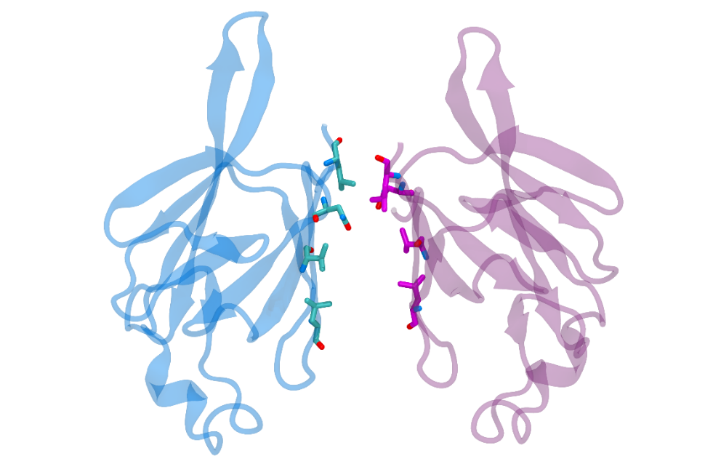
Figure1.4.2: FHA-FHA dimerization inteface shown in Figure. The residues Leu99, Val200, Asn186 and Leu204 in the purple and blue parts are responsible for the van der Walls interactions for homo chain of Chk2 protein. (Cai et al., 2009) (Liu et al., 2012)
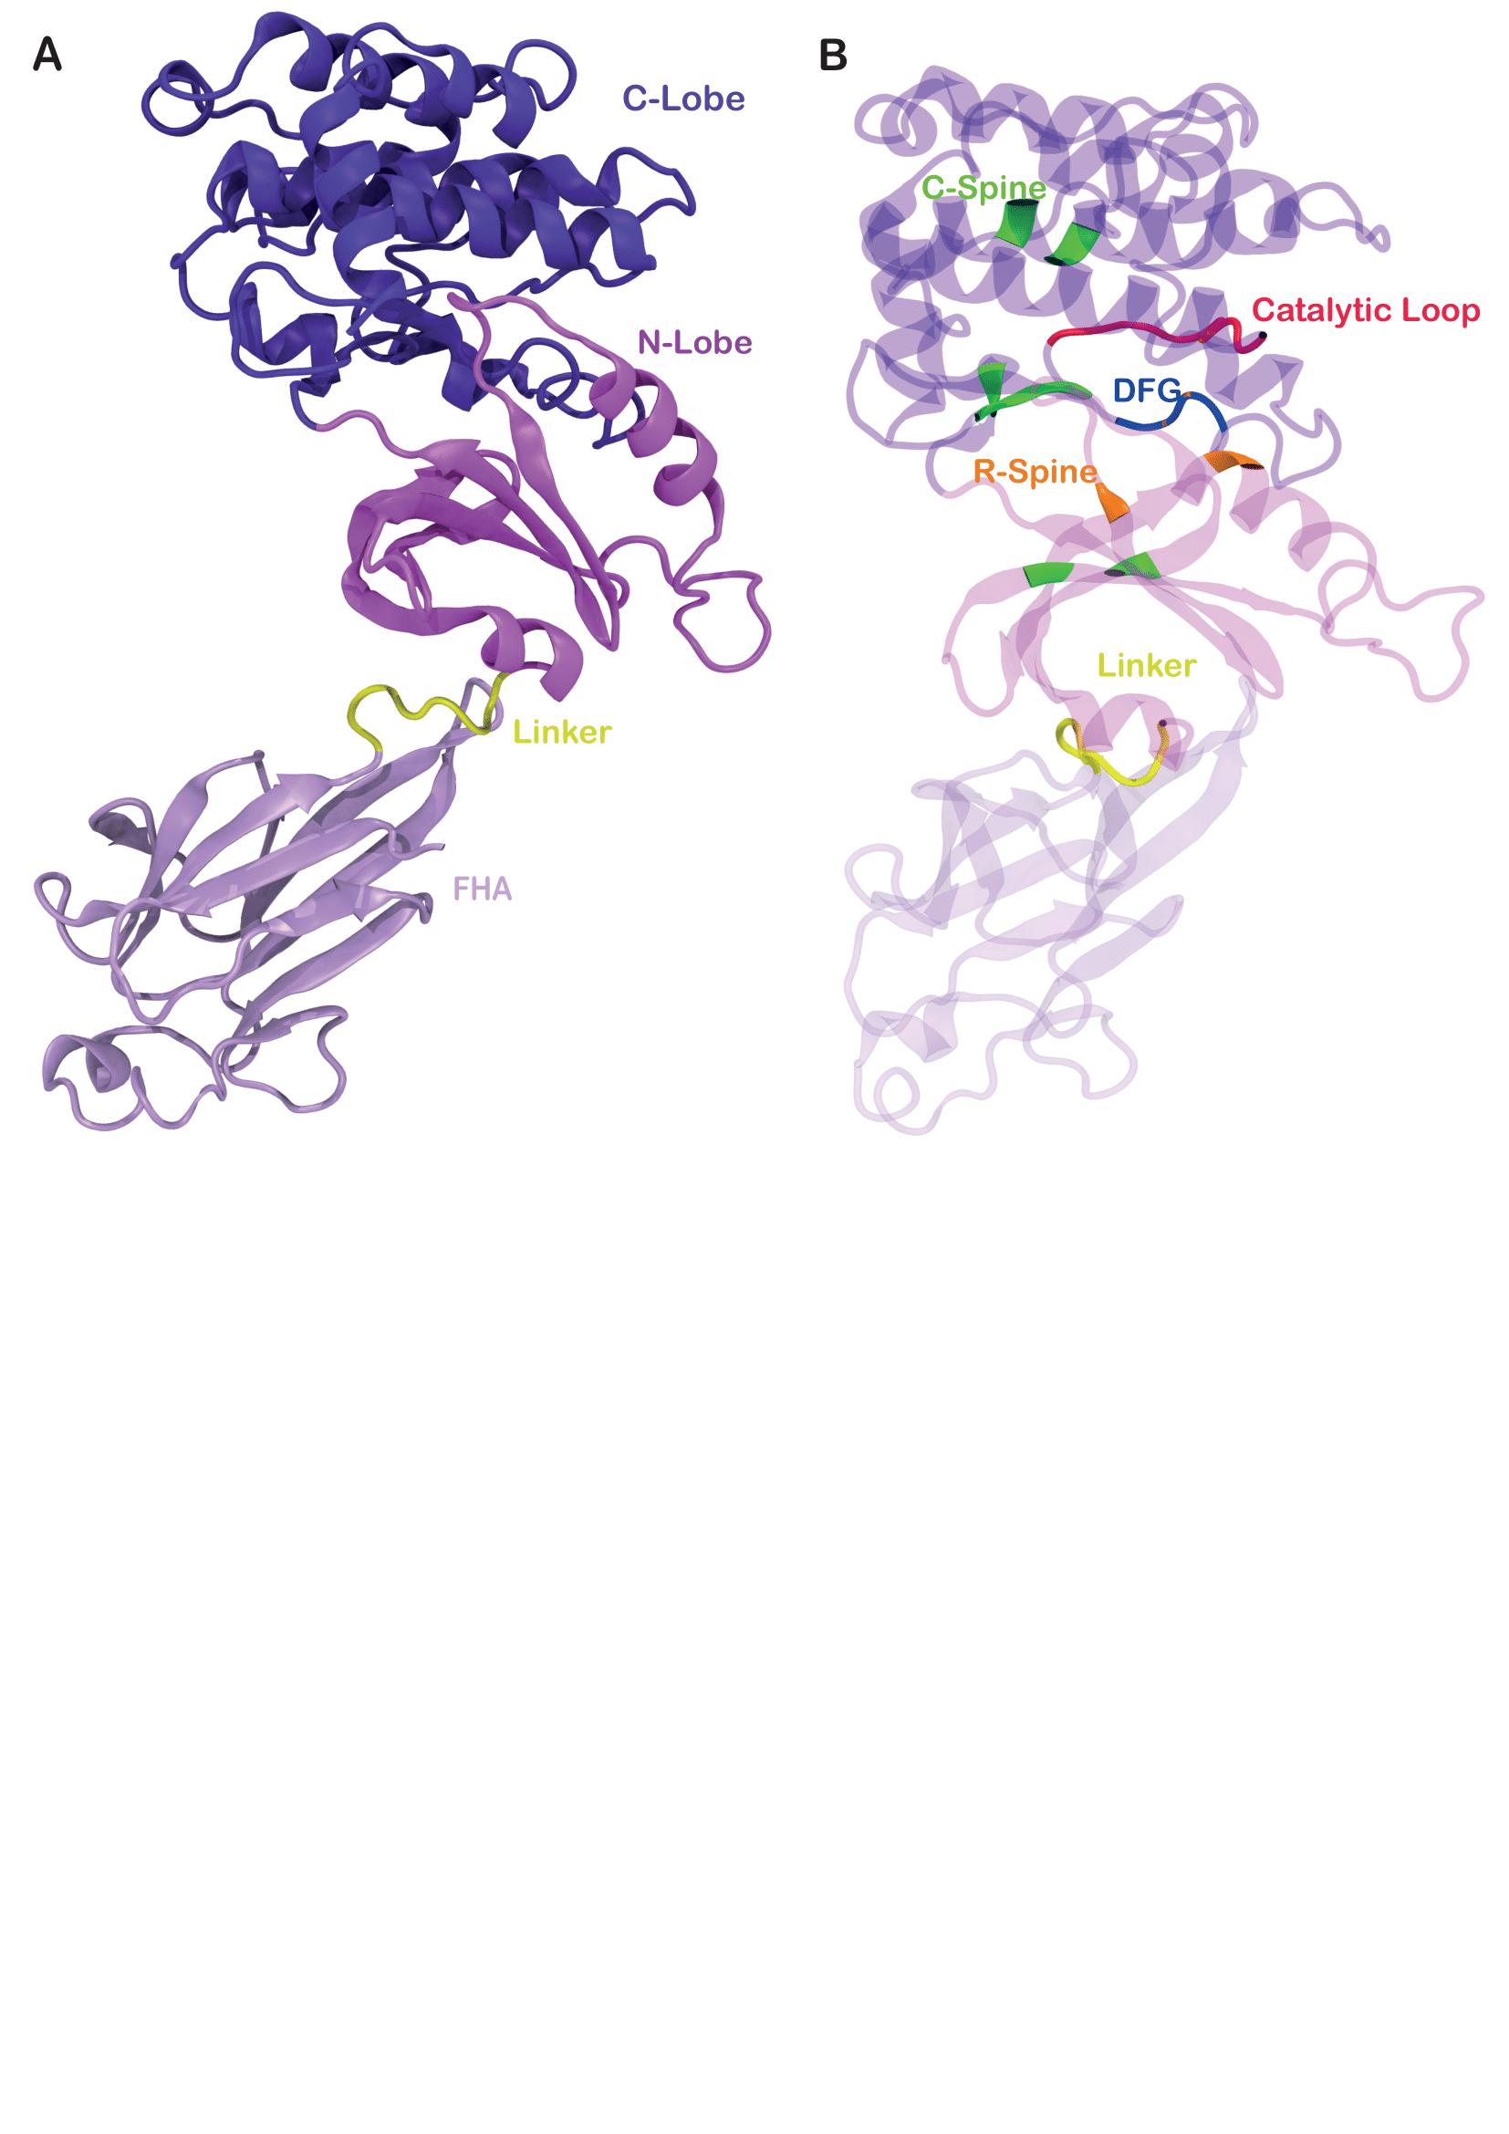
Figure 1.4.3: Chk2 monomer structure shown in Figure. A part of the Figure indicate that C-lobe and N-lobe of the kinase domain, linker and FHA domain of the Chk2 protein. B part of the Figure demonstrate that important part of the Chk2 protein for their activation as C-Spine(green), R-Spine (orange), Catalytic loop (Nagy et al.), DFG region (blue). (Cai et al., 2009)
Increased local ATM activity is important for efficient phosphorylation of the p53 protein which is prominent tumor suppressor and Chk2 the downstream effector kinase. As a result of the studies, it was found that the Thr68Ala mutation resulted in impaired Chk2 activation. This indicates that the Thr68 residue is involved in Chk2 activation. However, it was discovered that the phosphorylation of Thr68 in Chk2 activation is not a necessary phosphorylation by activation of the IR-induced mutant Chk2 in the WT background. But Thr68 actually activates Chk2 by triggering autophosphorylation events (Thr383 and Thr387). (Kim et al., 1999; Oliver et al., 2006; Reinhardt ve Yaffe, 2009)
Persistent inhibition of Cdk occurs with DNA damage, followed by activation of ATM and ATR kinases (I3-kinase-like kinases) signaling through the cell cycle checkpoint signaling cascade. Thr68 activates Chk2 by its phosphorylation, and ATM and ATR are important for activating the p38 MAPK/MK2 effector kinase complex which are downstream of TAO kinases in the DNA damage response. (Ahn et al., 2000; Cai et al., 2009; Reinhardt ve Yaffe, 2009)
  - Molecular Dynamics Simulation
Molecular dynamics (MD) simulations is a system that predicts how each atom acts and their interaction with each other in a molecular system, such as a protein, will change over time, based on a interatomic interactions general physics model. Molecular dynamics simulations are involved in capturing many important biomolecular processes such as ligand binding, conformational changes and protein folding, and capturing the positions of all atoms with femtosecond temporal resolution. (Zhao et al., 2013) Molecular dynamics simulations are carried out in a solution consisting of water molecules and ions that mimic the physiological conditions in the cell. These simulations are also involved in predicting how biomolecules will respond at the atomic level to disruptions such as phosphorylation, mutation, ligand binding and removal. X-ray crystal structures are less representative of the structures of proteins in the physiological environment than MD structures simulated under physiological conditions, since crystallization solution conditions can lead to higher ion concentrations, low temperatures, and stronger crystal packing in protein-protein interactions. (Gur et al., 2018) While creating the system in which molecular dynamics simulations will be carried out, it is necessary to determine the ion concentration in the environment where the molecule to be simulated is active. Molecular dynamics simulations are used in combined with techniques such as cryo-electron microscopy (cryo-EM), X-ray crystallography, and nuclear magnetic resonance (NMR). (Hollingsworth ve Dror, 2018)
In the literature for the crystal structure of the human Chk2 homodimer, the complete crystal structure was not found. The first crystal structure of human Chk2 was reported by Li et al. was obtained in 2002. However, although there is only the FHA domain in this structure, its resolution is 2.70 Å (PDB ID:1GXC). (Liu et al., 2012) The crystal structures obtained between 2006 and 2009 also often contain kinase sites. The structure obtained by kinase contains the ADP binding region of the kinase domain, and this region is bound with various inhibitors (PDB ID: 2W0J). (Lountos et al., 2009) The closest human crystal structure of the Chk2 protein was found in 2009 obtained by Cai et al. This structure contains the FHA and kinase domain of the Chk2 dimer (PDB ID: 3I6U, PDB ID: 3I6W). (Cai et al., 2009) These two structures differ in that the secondary structure changes into α-helix and β-sheet depending on whether the protein in the activation loop is active or inactive. But both structures are missing amino acids containing the SCD domain. For kinase domain S260-A267 amino acids, for activation loop 370-387 and 398-404, for C-terminus 502-543 amino acids and lastly 1-88 index of amino acids are missing in these crystal structure. Except S260-A267 missing amino acids, missing amino acids are not important because these amino acids residues are not affect protein structure, function and dynamics. (Cai et al., 2009)
Understanding the functions of proteins at the molecular level is important for a detailed understanding of biological systems. To understand the protein's function and interactions at the molecular level, the 3D structure of the protein is needed. Applications have been developed for homology or comparative modeling of protein complexes in order to obtain the exact structures of protein complexes, with the structures of experimentally determined protein complexes becoming usable and accessible, as well as determining the structure of a protein more than once in different situations. SWISS-MODEL is an example of comparative modeling application in modeling protein complexes. (Waterhouse et al., 2018)
- METHODS
  - Molecular Dynamics Simulations System Preparation
The closest crystal structure to the human Chk2 homodimer is the structures PDB ID:3I6U and PDB ID:3I6W obtained by Cai et al. (Cai et al., 2009) The most important difference between the these structures is that PDB ID: 3I6U is in the active state, PDB ID: 3I6W is in the inactive state, and they contain the secondary structure difference that changes as α-helix and β-sheet when Chk2 is active and inactive. However, in these crystal structures, 1-88 indexed amino acid residues, namely SCD region, 502-543 indexed amino acid residues at the C-terminus, 370-387 and 398-404 indexed amino acid residues in the activation region, and S260-A267 indexed amino acid in the kinase region are missing. These missing structures in the Chk2 homodimer were completed without 1-88 residue, using the PDB ID: 3I6U coded structure SWISS-MODEL to perform molecular dynamics simulations.
Molecular dynamics simulations, which are performed by imitating the solution consisting of water molecules and ions in the cell, that is, physiological conditions, are used to examine protein structure and dynamics. While creating the system, determining the ion concentration in the environment of the molecule to be simulated is an important step for molecular dynamics simulations. In the literature, it was determined that the Chk2 protein is actively present in the cell nucleus under physiological conditions. Bischof et al. (2017) and Nagy et al. (1981) reported that there are ~210 mM potassium and 20 mM sodium in the cell nucleus. For this reason, ion concentrations of 20 mM sodium chloride (NaCl) and 210 mM potassium chloride (KCl) were used in the molecular dynamics simulation. In Figure 2.1.1, homodimer Chk2 protein shown in water box which have 210 mM KCl and 20 mM NaCl ion concentration as in cell nucleus. (Nagy et al., 1981; Bischof et al., 2017)
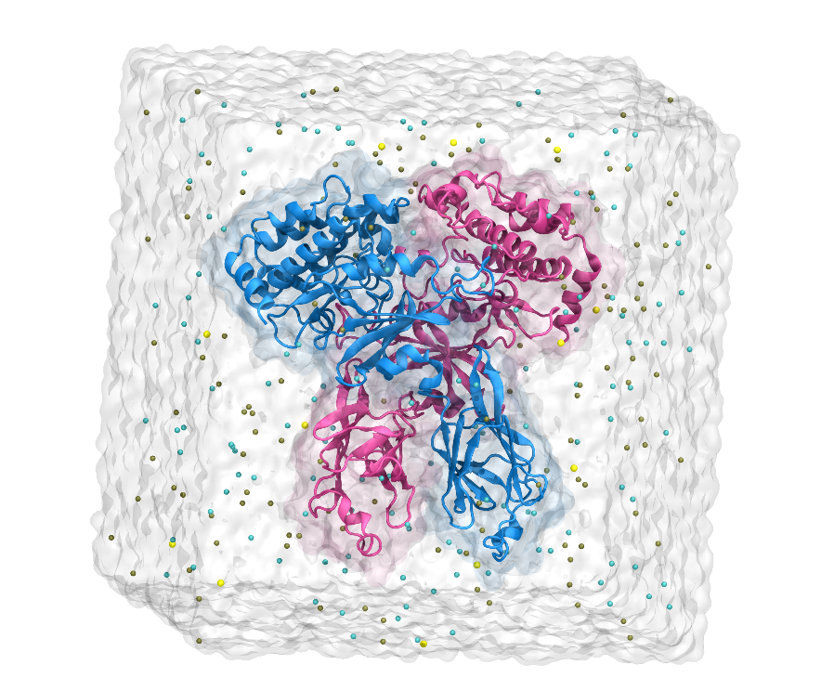
Figure 2.1.1: Homodimer Chk2 protein shown as blue and pink color for each homo chain in water box which have 210 mM KCl and 20mM NaCl ion concantration.
  - Molecular Dynamics Simulations
NAMD 2.13 (Phillips et al., 2005) software and CHARMM36 (Best et al., 2012) force field were used in molecular dynamics simulation, and the cut-off distance was calculated as 12 Å, taking into Van Der Waals (vdW) interactions. Mutation of Chk2 protein as Leu183Phe and Pro283Ser done with VMD Mutator extension. (Humphrey et al., 1996) Long-range electrostatic interactions were calculated using the particle-mesh Ewald method. The SHAKE algorithm using a 2 fs time step was used to restrict covalent bonds containing hydrogen bonds throughout the simulation. In the simulation, 1 fs time step used for the equilibration of water on fixed protein’s C_{α} and 2 fs time step used for the other steps, in the NTP condition, keeping the pressure 1 atm, particle number and temperature 310 K of the system constant. The damping coefficient of 1 ps in Langevin dynamics was used to maintain isothermal conditions. To maintain the pressure constant, Langevin was performed using the Nosé-Hoover method with an oscillation period of 100 fs and a damping time of 50 fs. The two-step minimization-equlibration method was used in the molecular dynamics simulation for the Chk2 protein. First, the system energy was minimized for 10000 steps, without any restriction and fixation, after minimization, the C_{α} of the protein were fixed for 2ns to equilibrate the energy of the system. In the second minimization, the system was minimized in 10000 steps without any restriction and fixation on the protein. A harmonic motion $2kcalmol^{-1}Å^{-2}$ applied to the C_{α} of the protein for 20 ns. Equilibration simulation was performed for 10 ns without any restriction and fixation on the protein. Molecular dynamics simulations were same for mutated Chk2 proteins and WT Chk2 protein. Two sets of 100 ns long molecular dynamics simulations were performed for each system, totalling 600 ns for all three systems
  - RMSD Analysis
Root Mean Square Deviation (RMSD) analysis is used for calculation of equilibration of the system. With RMSD analysis, the amount of deviation of a molecule according to a position in space is calculated, so it is used to understand that the system has reached equilibrium. (Phillips, 2003)
Numerical measure differences of two structure calculated with RMSD as;
$$RMSDα\left(tj\right)=\sqrt{\frac{\sum_{α=1}^{Nα}{{(\vec{r}α(tj)-(\vec{r}α))}^{2} }}{Nα}}$$
Nα means, comparison to number of atom’s position on the other hand Nt means comparison to atomic position over number of steps, $\vec{r}α(tj)$ means, $α$ atom’s position at time tj and lastly $〈\vec{r}α〉$ is the , $α$ atom positions average value which is compaired to $\vec{r}α(tj)$.
$$〈\vec{r}α〉= \frac{1}{Nt}\sum_{j=1}^{Nt}{\vec{r}α\left(tj\right)}$$
  - RMSF Analysis
Root Mean Square Fluctuation(RMSF) is similar to RMSD for numerical measurement but RMSF calculate flexibility of individual residue during a simulation other words a particular residue how much fluctuates during simulation on the other hand RMSD indicates positional differences of structure during simlation. (Phillips, 2003)
Calculations of RMSF values,
$${〈∆R_{i}^{2}〉}^{1/2}={〈{\left(R_{i}-〈R_{i}〉 \right)}^{2}〉}^{1/2}$$
i^{th} C_{α} atoms atomic coordinate means is $〈R_{i}〉$ and i^{th} C_{α} atoms instantaneous coordinate means is $R_{i}$.
  - Heat Capacity Analysis
Heat Capacity is important analiysis method for the protein folding-unfolding, protein association, protein interaction and ligand binding. (Prabhu ve Sharp, 2004) As mentioned above, the simulation was performed under constant pressure (P), temperature (T) and particle (N) conditions (NTP). Heat capacity under constant pressure calculated as,
$$C_{p}=({∂H}/{∂T)}$$
Heat capacity also known as Mean Squared Fluctuation which means the mean of the square of the fluctuation of the energy values. (Jorgensen, 1982; Prabhu ve Sharp, 2005)
$$C_{p}=\frac{〈H^{2}〉- {〈H〉}^{2}}{NkT^{2}}$$
Variance calculation of enthalpy values are exist in molecular dynamics simulations when assuming enthalpy to be the same as potential energy of applied force fields in MD simulations. With help of the NAMDEnergy in NAMD software, potential energy was calculated.
- RESULTS AND DISCUSSION
  - RMSD Analysis
The RMSD was calculated by aligning the protein in all structures in the MD trajectory. Aligning the protein along the RMSD trajectory allows focusing on the protein's internal motions by excluding translational and rotational motions. According to Figure3.1.1 WT Chk2 two replicas RMSD results demonstrated close values. Mutant Leu183Phe Chk2 two replicas RMSD results also showed close values, but there was a slight difference in mutant Pro283Ser two replicas RMSD results. Considering the average RMSD results, mutant Leu183Phe showed less internal motions than the others.
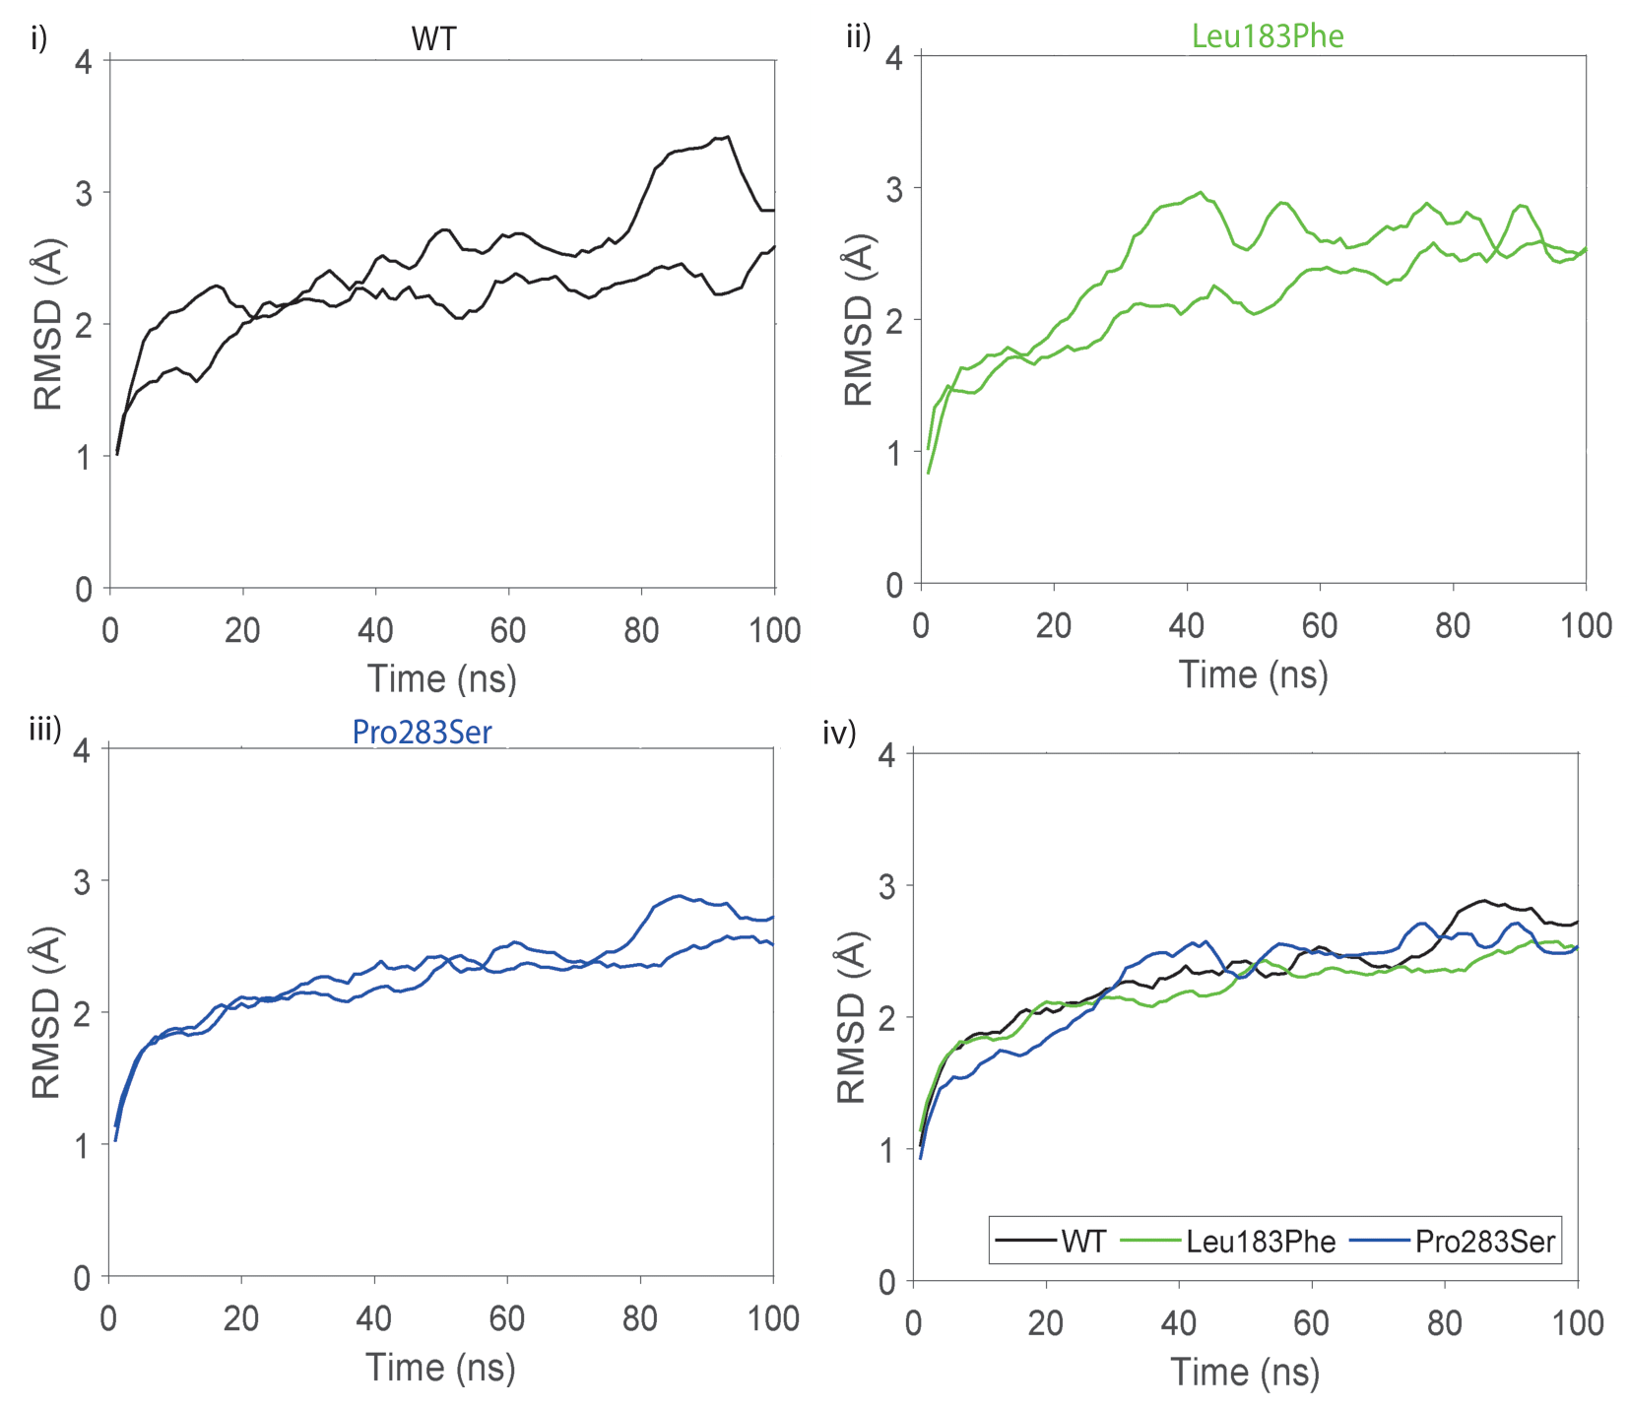
Figure3.1.1 Chk2 homodimer’s RMSD results for two replicas shown as i) WT, ii) Leu183Phe mutant, iii) Pro283Ser mutant and iv) average RMSD values of the systems.
  - RMSF Analysis
RMSF was calculated by using C_{α} atoms of amino acids in the structure of CHK2 protein. According to Figure3.2.1 RMSF data, mutant Leu183Phe shows highest fluctuation and mutant Pro283Ser shows lowest fluctuation between residue 128 to 154. WT Chk2 shows highest fluctuation and mutant Leu183Phe shows lowest between residue 274 to 286. Between residue 371 to 389, WT fluctuate more than mutant Chk2 proteins but mutants show similar fluctuations. On the other hand, between residue 392 to 412, WT show highest fluctuation than mutant Chk2 but mutant Leu183Phe more fluctuate than mutant Pro283Ser. When the RMSF results were analyzed as a whole, no certain fluctuation difference was observed.
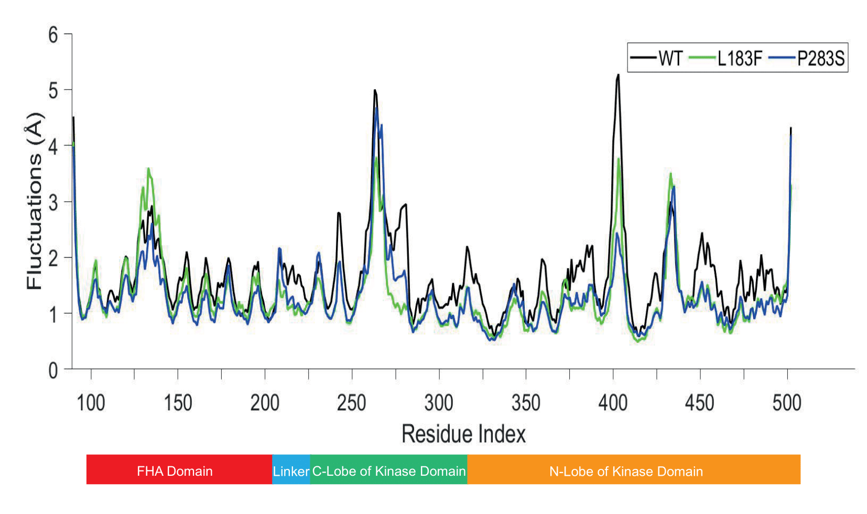
Figure3.2.1 Homodimer Chk2 protein’s WT, mutant Leu183Phe and mutant Pro283Ser RMSF values shown in Figure3.2.1 with average values of their two replicas. Down side of the Figure3.2.1 contain Chk2 homodimers region index as FHA domain locates in residue 92 to 205 which is shown red, linker domain locates in residue 206 to 212 which is shown light blue, C-lobe of kinase domain locates in residue 213 to 305 which is shown green and lastly N-lobe of kinase domain locates in residue 306 to 501 which is shown orange.
According to Figure3.2.1, fluctuation is shown higher between residue 125 to 145 for WT and mutant Chk2. As seen in Figure3.2.2, the RMSF value may be high because there is a loop in that area. WT proteins RMSF value between 206 and 227 residues was observed higher than mutants. As seen in Figure 3.2.2, it was noticed that there were loops in WT and mutants at this point. The higher value of the RMSF result in residues 248 to 271 may be due to the loops in this region. Considering the RMSF values ​​between 271 and 282 residues, it is seen that WT has a higher value. It is shown in Figure3.2.2 that the alpha helix structure is found in WT and mutants in this region. Likewise, the RMSF value of the region between 372 and 389 residues in WT is higher than in mutants. However, there is similar the structure of mutant and WT proteins in that region. Between 394 to 414 residue, WT and mutant proteins have loop structure in the region with the highest RMSF value. Finally, in the region between 445 to 497 residues, the WT protein RMSF value is higher than the mutants, but when their structures are examined, similar structures are observed.
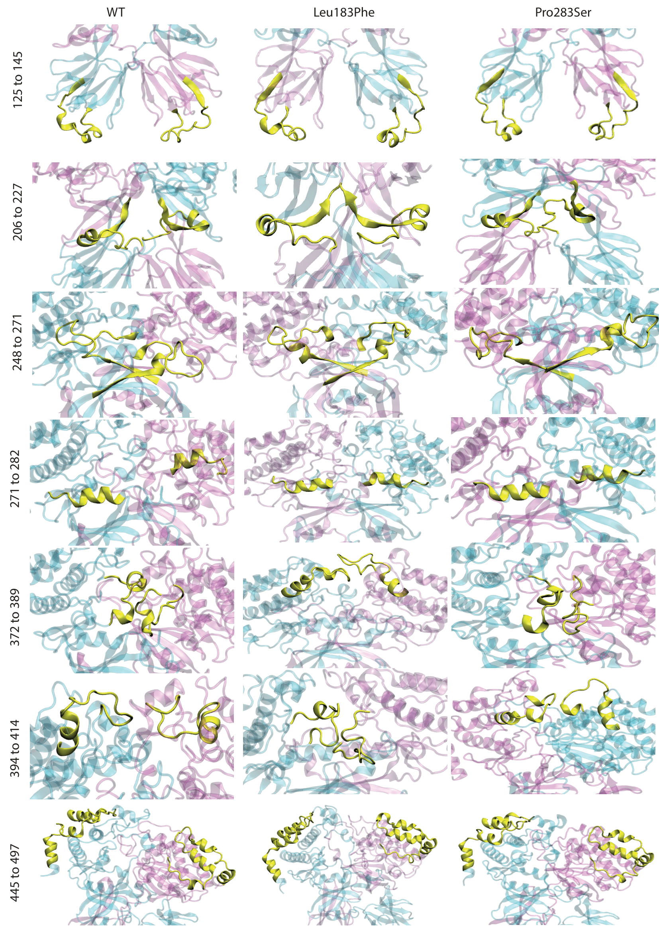
Figure3.2.2 Homodimer Chk2 protein’s WT, mutant Leu183Phe and Pro283Ser specific residue interval structures according to RMSF differences.

  - Heat Capacity Analysis
In the numerator of the heat capacity formula, there are two terms with the mean of the square of the enthalpies of the structures sampled in conformational space$〈H^{2}〉$ and the square of the mean${〈H〉}^{2}$. In other words, these two terms are directly related to the conformational space. The mean values ​​will converge when a sufficiently large space is conformation. Considering the heat capacity of the WT Chk2 protein, a slight difference was observed between the sets. When looking at mutant Leu183Phe and mutant Pro283Ser, there was no significant difference between the sets. Considering the average heat capacities, WT and mutant Pro283Ser showed close values, while mutant Leu183Phe showed a lower C_{p} value than the others. Unfolding of samples shows C_{p} values increasing which means unfolded polypeptide C_{p} value higher than the native state form. (Cooper, 2005) So mutations of Leu183Phe may cause more compact form than the others. Since the initial structures of the three different simulations examined in the separate minimization and equilibration simulations are different from each other, they do not sample exactly the same regions in the structural space during the simulation periods and they differ depending on time. However, as the simulations get longer, they are expected to converge to the same samples. As seen in Figure 3.3.1, although the heat capacity values ​​approached each other after 80 ns, there was a difference between mutant Leu183Phe and WT and mutant Pro283Ser. As can be seen in Figure 3.3.1, different curves that the simulations can converge are seen. This is a normal situation due to the differences in the structures sampled over time due to the differences in the initial structures in the simulations.
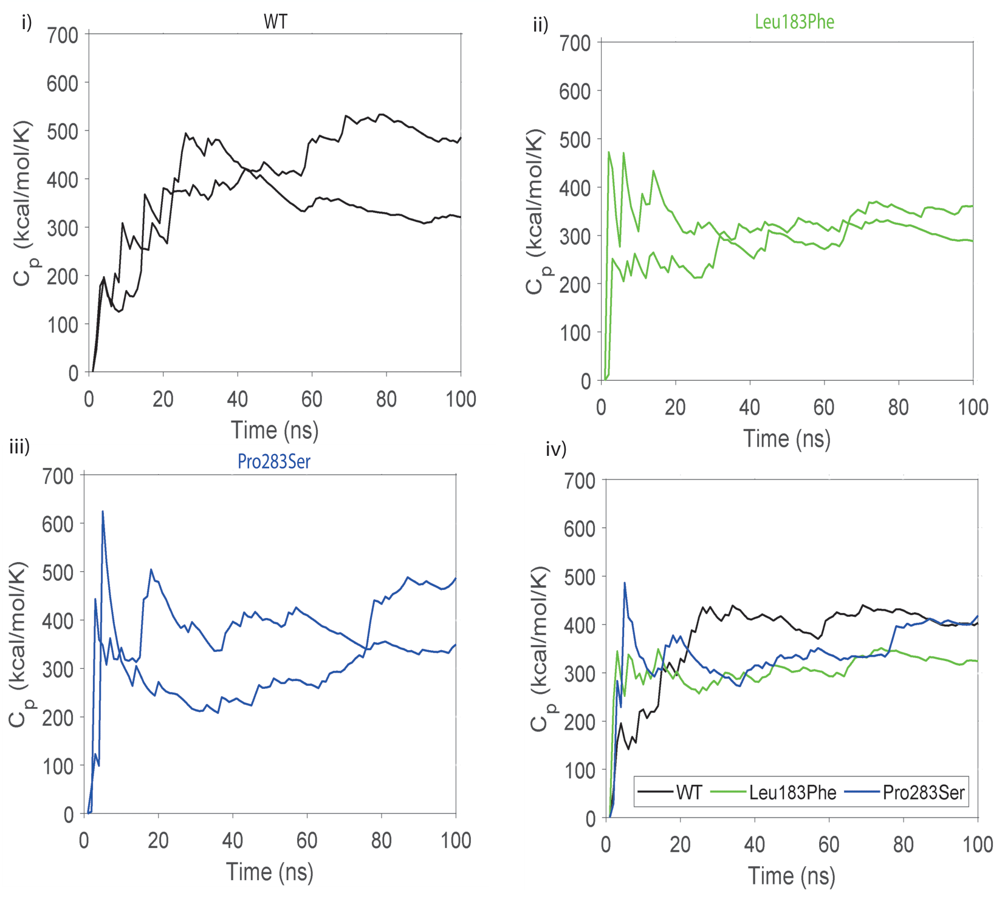
Figure3.3.1 Homodimer Chk2 protein’s heat results for two replicas shown as i) WT, ii) Leu183Phe mutant, iii) Pro283Ser mutant and iv) average heat capacity values of the systems.
- CONCLUSION
Cancer, which is a common and fatal disease all over the world, is caused by abnormal proliferation of cells. Breast cancer, which is one of the most common cancer types, is among the most important causes of death for women. It is known that the Chk2 protein expressed from the CHEK2 gene, which contains the 1100delC mutation, plays a role in breast cancer. Activation of Chk2 protein occurs due to DNA damage. The Chk2 protein consists of three distinct domains and 543 amino acid residues as central fork-head-associated domain (FHA), SQ/TQ cluster domain (SCD) and kinase domain (KD). The FHA domain is also known as the protein-protein interaction site. Although this region consists of a sequence containing 100-120 amino acids, this sequence is folded to form an 11-stranded β-sandwich as two lateral and two apical surfaces. The structure of the FHA allows the modular assemble of the other functional structures and the FHA structure. The FHA structure is specifically involved in the recognition of pThr residues on extended epitopes. Chk2, which is normally stable in monomer state, will be induced to dimerize by phosphorylation of Thr68 in the SCD domain. The β1-β2-β11 strands of FHA are involved in this dimerization. It has a primary role in the activation of Chk2. Chk2 have seven SQ/TQ motifs which has 51 amino acid residues on their sequences. Phosphorylation of Thr68, the residue of ATM found on SCD (SQ/TQ), is the first response to DNA damage. In eukaryotic proteins kinase family, kinase domain is most conserved region. Kinases consist of N-lobe, C-lobe, Regulator (R) spine and catalytic (C) spine. Kinase domain is important for signal transduction. Dimer Chk2 contain FHA domain and kinase domain interaction and FHA-FHA interaction. FHA-KD interface have hydrophobic patch. FHA-FHA interface’s three β strand make H-bond and van der Walls interactions.
Molecular dynamics simulation done each atoms and atom-atom interactions prediction in molecular system based on interatomic interactions general physics model. Molecular dynamics simulations are important for biomolecular ligand binding, conformational changes and protein folding processes capturing positions of all atoms with femtosecond temporal resolution. In the literature Cai et al. obtain closest human Chk2 homodimers crystal in 2009 (PDB ID: 3I6U, PDB ID: 3I6W). (Cai et al., 2009) In WT and mutant Chk2 homodimers structural differences investigation with molecular dynamics simulation, PDB ID: 3I6U structure will be used.
According to Figure3.1.1 iv) average RMSD values, mutant Leu183Phe shows slightly lower RMSD values than WT and mutant Pro283Ser and also as can be seen in Figure3.3.1, mutant Leu183Phe shows slightly lower C_{p} value than WT and mutant Pro283Ser. Although these differences in value are very small, the Leu183Phe mutation may have given the Chk2 homodimer a more compact form.
According to Figure3.2.1, there is no higher fluctuation differences observed between mutant and WT Chk2 protein. Highest fluctuation observed between 392 to 412 residues. This area locates on flexible part of the kinase domain’s N-lobe as loop so this fluctuation is expected. Also, between 274 to 286 residue locates on flexible part of C-lobe as loop of kinase domain and its show high RMSF value. In conclusions, there is slightly different C_{p} and RMSD values of mutant Leu183Phe Chk2 protein, it may cause more compact form for Leu183Phe Chk2 protein than WT and mutant Pro283Ser Chk2 protein.

REFERENCES
- Ahn, J. Prives, C. 2002. "Checkpoint kinase 2 (Chk2) monomers or dimers phosphorylate Cdc25C after DNA damage regardless of threonine 68 phosphorylation", J Biol Chem, 277(50), 48418-48426.
- Ahn, J., Urist, M. Prives, C. 2004. "The Chk2 protein kinase", DNA repair, 3(8-9), 1039-1047.
- Ahn, J. Y., Schwarz, J. K., Piwnica-Worms, H. Canman, C. E. 2000. "Threonine 68 phosphorylation by ataxia telangiectasia mutated is required for efficient activation of Chk2 in response to ionizing radiation", Cancer Res, 60(21), 5934-5936.
- Allinen, M., Huusko, P., Mäntyniemi, S., Launonen, V. Winqvist, R. 2001. "Mutation analysis of the CHK2 gene in families with hereditary breast cancer", British journal of cancer, 85(2), 209-212.
- Almawi, A. W., Matthews, L. A. Guarné, A. 2017. "FHA domains: Phosphopeptide binding and beyond", Prog Biophys Mol Biol, 127, 105-110.
- Apostolou, P., Fostira, F., Mollaki, V., Delimitsou, A., Vlassi, M., Pentheroudakis, G., Faliakou, E., Kollia, P., Fountzilas, G., Yannoukakos, D. Konstantopoulou, I. 2018. "Characterization and prevalence of two novel CHEK2 large deletions in Greek breast cancer patients", J Hum Genet, 63(8), 877-886.
- Apostolou, P. Papasotiriou, I. 2017. "Current perspectives on CHEK2 mutations in breast cancer", Breast Cancer (Dove Med Press), 9, 331-335.
- Bartek, J., Falck, J. Lukas, J. 2001. "CHK2 kinase--a busy messenger", Nat Rev Mol Cell Biol, 2(12), 877-886.
- Best, R. B., Zhu, X., Shim, J., Lopes, P. E. M., Mittal, J., Feig, M. MacKerell, A. D. 2012. "Optimization of the Additive CHARMM All-Atom Protein Force Field Targeting Improved Sampling of the Backbone ϕ, ψ and Side-Chain χ1 and χ2 Dihedral Angles", Journal of Chemical Theory and Computation, 8(9), 3257-3273.
- Bischof, H., Rehberg, M., Stryeck, S., Artinger, K., Eroglu, E., Waldeck-Weiermair, M., Gottschalk, B., Rost, R., Deak, A. T., Niedrist, T., Vujic, N., Lindermuth, H., Prassl, R., Pelzmann, B., Groschner, K., Kratky, D., Eller, K., Rosenkranz, A. R., Madl, T., Plesnila, N., Graier, W. F. Malli, R. 2017. "Novel genetically encoded fluorescent probes enable real-time detection of potassium in vitro and in vivo", Nature Communications, 8(1), 1422.
- Buscemi, G. Zannini, L. 2016. "CHEK2". Encyclopedia of Signaling Molecules. Choi, S.: New York, NY: Springer New York.
- Cai, Z., Chehab, N. H. Pavletich, N. P. 2009. "Structure and activation mechanism of the CHK2 DNA damage checkpoint kinase", Mol Cell, 35(6), 818-829.
- Chehab, N. H., Malikzay, A., Appel, M. Halazonetis, T. D. 2000. "Chk2/hCds1 functions as a DNA damage checkpoint in G(1) by stabilizing p53", Genes Dev, 14(3), 278-288.
- Cooper, A. 2005. "Heat capacity effects in protein folding and ligand binding: a re-evaluation of the role of water in biomolecular thermodynamics", Biophysical Chemistry, 115(2), 89-97.
- Durocher, D. Jackson, S. P. 2002. "The FHA domain", FEBS Lett, 513(1), 58-66.
- Durocher, D., Taylor, I. A., Sarbassova, D., Haire, L. F., Westcott, S. L., Jackson, S. P., Smerdon, S. J. Yaffe, M. B. 2000. "The molecular basis of FHA domain:phosphopeptide binding specificity and implications for phospho-dependent signaling mechanisms", Mol Cell, 6(5), 1169-1182.
- Guo, X., Ward, M. D., Tiedebohl, J. B., Oden, Y. M., Nyalwidhe, J. O. Semmes, O. J. 2010. "Interdependent phosphorylation within the kinase domain T-loop Regulates CHK2 activity", The Journal of biological chemistry, 285(43), 33348-33357.
- Gur, M., Blackburn, E. A., Ning, J., Narayan, V., Ball, K. L., Walkinshaw, M. D. Erman, B. 2018. "Molecular dynamics simulations of site point mutations in the TPR domain of cyclophilin 40 identify conformational states with distinct dynamic and enzymatic properties", The Journal of Chemical Physics, 148(14), 145101.
- Hollingsworth, S. A. Dror, R. O. 2018. "Molecular Dynamics Simulation for All", Neuron, 99(6), 1129-1143.
- Humphrey, W., Dalke, A. Schulten, K. 1996. "VMD: Visual molecular dynamics", Journal of Molecular Graphics, 14(1), 33-38.
- Imai, K. Mitaku, S. 2005. "Mechanisms of secondary structure breakers in soluble proteins", Biophysics (Nagoya-shi, Japan), 1, 55-65.
- Kim, S. T., Lim, D. S., Canman, C. E. Kastan, M. B. 1999. "Substrate specificities and identification of putative substrates of ATM kinase family members", J Biol Chem, 274(53), 37538-37543.
- Kobe, B. Kemp, B. E. 2010. "Chapter 74 - Principles of Kinase Regulation". Handbook of Cell Signaling (Second Edition). Bradshaw, R. A.Dennis, E. A.: San Diego: Academic Press.
- Liu, J., Luo, S., Zhao, H., Liao, J., Li, J., Yang, C., Xu, B., Stern, D. F., Xu, X. Ye, K. 2012. "Structural mechanism of the phosphorylation-dependent dimerization of the MDC1 forkhead-associated domain", Nucleic acids research, 40(9), 3898-3912.
- Lountos, G. T., Tropea, J. E., Zhang, D., Jobson, A. G., Pommier, Y., Shoemaker, R. H. Waugh, D. S. 2009. "Crystal structure of checkpoint kinase 2 in complex with NSC 109555, a potent and selective inhibitor", Protein science : a publication of the Protein Society, 18(1), 92-100.
- Nagy, I. Z., Lustyik, G., Nagy, V. Z., Zarándi, B. Bertoni-Freddari, C. 1981. "Intracellular Na+:K+ ratios in human cancer cells as revealed by energy dispersive x-ray microanalysis", J Cell Biol, 90(3), 769-777.
- Nevanlinna, H. Bartek, J. 2006. "The CHEK2 gene and inherited breast cancer susceptibility", Oncogene, 25(43), 5912-5919.
- Oliver, A. W., Paul, A., Boxall, K. J., Barrie, S. E., Aherne, G. W., Garrett, M. D., Mittnacht, S. Pearl, L. H. 2006. "Trans-activation of the DNA-damage signalling protein kinase Chk2 by T-loop exchange", The EMBO journal, 25(13), 3179-3190.
- Özmen, V., Özmen, T. Doğru, V. 2019. "Breast Cancer in Turkey; An Analysis of 20.000 Patients with Breast Cancer", European journal of breast health, 15(3), 141-146.
- Phillips, J. C., Braun, R., Wang, W., Gumbart, J., Tajkhorshid, E., Villa, E., Chipot, C., Skeel, R. D., Kalé, L. Schulten, K. 2005. "Scalable molecular dynamics with NAMD", J Comput Chem, 26(16), 1781-1802.
- Prabhu, N. V. Sharp, K. A. 2004. "HEAT CAPACITY IN PROTEINS", Annual Review of Physical Chemistry, 56(1), 521-548.
- Reinhardt, H. C. Yaffe, M. B. 2009. "Kinases that control the cell cycle in response to DNA damage: Chk1, Chk2, and MK2", Curr Opin Cell Biol, 21(2), 245-255.
- Schwartz, M. F., Duong, J. K., Sun, Z., Morrow, J. S., Pradhan, D. Stern, D. F. 2002. "Rad9 phosphorylation sites couple Rad53 to the Saccharomyces cerevisiae DNA damage checkpoint", Mol Cell, 9(5), 1055-1065.
- Siegel, R. L., Miller, K. D. Jemal, A. 2016. "Cancer statistics, 2016", CA Cancer J Clin, 66(1), 7-30.
- Taylor, S. S. Kornev, A. P. 2011. "Protein kinases: evolution of dynamic regulatory proteins", Trends Biochem Sci, 36(2), 65-77.
- Traven, A. Heierhorst, J. 2005. "SQ/TQ cluster domains: concentrated ATM/ATR kinase phosphorylation site regions in DNA-damage-response proteins", Bioessays, 27(4), 397-407.
- Waterhouse, A., Bertoni, M., Bienert, S., Studer, G., Tauriello, G., Gumienny, R., Heer, F. T., de Beer, T. A. P., Rempfer, C., Bordoli, L., Lepore, R. Schwede, T. 2018. "SWISS-MODEL: homology modelling of protein structures and complexes", Nucleic Acids Res, 46(W1), W296-w303.
- Wimley, W. C. White, S. H. 1996. "Experimentally determined hydrophobicity scale for proteins at membrane interfaces", Nat Struct Biol, 3(10), 842-848.
- Wu, X., Webster, S. R. Chen, J. 2001. "Characterization of tumor-associated Chk2 mutations", J Biol Chem, 276(4), 2971-2974.
- Zannini, L., Delia, D. Buscemi, G. 2014. "CHK2 kinase in the DNA damage response and beyond", J Mol Cell Biol, 6(6), 442-457.
- Zhao, G., Perilla, J. R., Yufenyuy, E. L., Meng, X., Chen, B., Ning, J., Ahn, J., Gronenborn, A. M., Schulten, K., Aiken, C. Zhang, P. 2013. "Mature HIV-1 capsid structure by cryo-electron microscopy and all-atom molecular dynamics", Nature, 497(7451), 643-646.

CURRICULUM VITAE


Name Surname : Ayten Dilara GÜRSEL
Place and Date of Birth : Isparta, 08.06.1997
E-Mail : aytendilara@gmail.com

