Aim
Cancer remains a significant global cause of mortality, highlighting the importance of understanding the complex molecular mechanisms that drive its development. The Checkpoint kinase 2 (CHEK2) gene is a critical target in cancer prevention, as it plays a pivotal role in maintaining genomic stability by regulating DNA repair processes and cell cycle checkpoints. Although mutations in CHK2 protein have been linked to a variety of cancers, many details of its catalytic cycle are still unclear and require further investigation. Understanding the molecular details of CHK2's function and dysregulation could lead to novel targeted therapeutic interventions and enhanced cancer management strategies.
As a key tumor-suppressing gene, CHEK2 encodes the vital serine/threonine kinase protein CHK2, essential for cell cycle checkpoint control and DNA repair pathways. Its role is crucial in preserving genomic stability and protecting against DNA damage. Key structural components of CHK2 include the N-terminal SQ/TQ cluster domain (SCD), a central forkhead-associated (FHA) domain, and the C-terminal serine/threonine kinase domain (KD). The SCD contains phosphorylation sites important for CHK2's substrate recognition. The FHA domain enables CHK2 to sense and respond to DNA damage signals, while the KD is responsible for phosphorylating target proteins (Ung, 2018).
Mutations in CHK2 have been linked to various cancers, such as breast cancer, underscoring its significant role across multiple cancer types. Such mutations or losses can impair CHK2's normal function, diminishing the cell’s capacity to respond effectively to DNA damage, which can lead to uncontrolled cell growth and cancer development (Zhou, 2000). Understanding how CHK2 dysfunction contributes to cancer is important for developing targeted therapies and strategies to fight tumorigenesis.
This study investigates a set of CHEK2 gene variants in the KD to assess their potential mutational impact on CHK2 protein structure and dynamics through all-atom molecular dynamics simulations. Five mutations, namely G306A (Boonen, 2022), E351D (Richards, 2015), S356L (Lim, 2023), D409V (Branco, 2018), and V415I (White, 2022), were selected for in silico analysis. The primary aim was to determine how these mutations influence CHK2 dynamics and structural integrity, as disruptions in CHK2 function could impair DNA repair and cell cycle control, ultimately increasing breast cancer susceptibility. By investigating these mutations, this work seeks to deepen our understanding of CHK2’s role in tumor suppression and provide insights into potential targeted therapies for individuals carrying CHEK2 mutations.
Material and Methods
To obtain active wild type (WT) CHK2, starting structural model was constructed by combining structural information derived from the crystal structures with PDB IDs 3I6U (Cai Z. C., 2009) and 2CN5 (Oliver, 2006). Residues S379, T383, T387, and T389 within the CHK2 activation loop were phosphorylated. Additionally, the ADP molecule, two Mg²⁺ ions, and crystal water molecules derived from the 2CN5 structure were included in the system. Mutant structures containing G306A, E351D, S356L, D409V, and V415I were prepared using the Mutator plugin in VMD. All structures were subsequently solvated in a TIP3P water box, applying padding dimensions of 28 Å along the x-axis, 20 Å along the y-axis, and 28 Å along the z-axis. Systems were neutralized, and ion concentrations were adjusted to 210 mM KCl and 20 mM NaCl. All system preparation steps were performed using VMD (Humphrey W, 1996 ).

To evaluate the structural dynamics of CHK2 and the effects of the selected mutations, MD simulations were performed using NAMD 3.0 (Phillips JC, 2020 )and the CHARMM36 all-atom force fields (Best, 2012). Two femtosecond time step was employed, and the SHAKE algorithm was applied to constrain bonds involving hydrogen atoms. Long-range electrostatic interactions were treated using the Particle Mesh Ewald (PME) method. All simulations were conducted under NPT ensemble conditions, with temperature and pressure held constant using a Langevin Nosé-Hoover approach.
Prior to production runs, systems were minimized and equilibrated in multiple steps. Initially, harmonic restraints were applied to the C_{α}, ADP, and Mg²⁺ atoms, allowing only water molecules to move freely. Following an initial unconstrained minimization, the heavy atoms of the protein, ADP, and Mg²⁺ were fixed, and the water molecules were equilibrated for 2 ns. Subsequent equilibration involved gradually releasing harmonic restraints on the C_{α}, ADP, and Mg²⁺ atoms. A final equilibration with no restraints was carried out before initiating production runs of 300 ns for each system.

To assess protein structural deformations throughout MD simulations, Root Mean Square Deviation (RMSD) (Phillips J. C., 2005) analysis was performed. RMSD quantitatively measures the average displacement of atoms between the structure at a given simulation time point and a reference structure. The starting structural model was used as reference structure. It is calculated as:

$$RMSD(t)=\sqrt{\frac{1}{N}\sum_{i=1}^{N}{{\left(r_{i}\left(t\right)-r_{i}\left(0\right)\right)}^{2}}}$$

where N is the total number of atoms, rᵢ(t) is the position of atom i at time t, and rᵢ^{ref} is the position of atom i in the reference structure.

The flexibility of individual residues was probed via Root Mean Square Fluctuation (RMSF) (Karplus, 2002) analysis. RMSF provides a measure of residue-wise flexibility by quantifying fluctuations of atomic positions around their average positions throughout the simulation. It is calculated using the following formula:

$$RMSF= \sqrt{\frac{1}{T}\sum_{t=1}^{T}{{\left\|r_{i}\left(t\right)- 〈r_{i}〉\right\|}^{2}}}$$

where T is the total number of trajectory frames, rᵢ(t) represents the position of residue i at time t, and ⟨rᵢ⟩ is the average position of residue i across the entire trajectory.

In RMSD and RMSF calculations, only the coordinates of alpha carbon (C_{α}) atoms were used.

Findings

For each mutant, two 300 ns long MD simulation runs were carried out. Each simulation trajectory was independently analyzed for RMSD and RMSF values. RMSD analysis indicated that three mutants, G306A, D409V, and V415I, exhibited higher RMSD values relative to the WT, as shown in Figure 1. In these trajectories, the mutants remained above the WT RMSD curve, suggesting increased conformational mobility and structural instability.

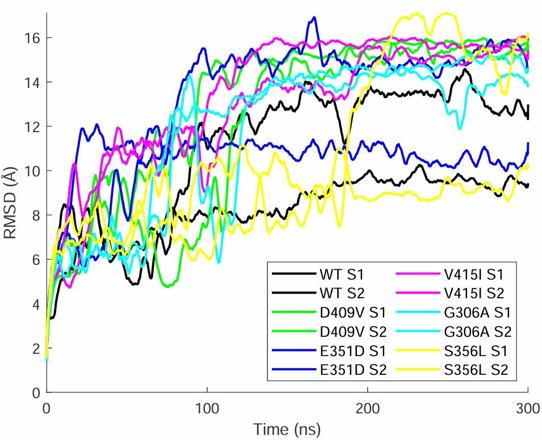
Figure 1. RMSD Comparison of Wild-Type and Mutant CHK2 Proteins

In the 205-270 amino acid range, all mutations exhibit lower RMSF values compared to the WT (Figure 2). This region includes the Gly-rich region (residues 227–232), which is considered structurally significant. Additionally, in the 370-405 amino acid range, our analysis shows that the RMSF values of all mutations are noticeably higher than those of the WT. This region contains the A-loop (residues 368–394), which plays a crucial role in the protein's. Visual representations generated with VMD were added to the figure to highlight these critical regions.
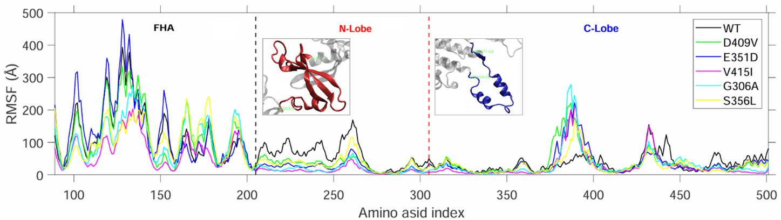
Figure 2. RMSF Values for Mutants and Wild Type by Amino Acid Index

Conclusion

In summary, MD simulations of CHK2 revealed noteworthy structural and dynamic alterations resulting from five specific mutations within the kinase domain. RMSD analysis demonstrated that mutations G306A, D409V, and V415I induce notable conformational changes, potentially leading to structural deviations compared to the WT protein. These structural changes could compromise the stability required for CHK2’s tumor suppressor functions. In addition to those structural changes shown by RMSD analysis, RMSF analysis further showed that these mutations affect protein dynamics, highlighting distinct fluctuations in the residues 205–270 and residues 370–405, both critical areas for CHK2’s catalytic activity and regulatory role.

Collectively, these findings predict that the studied mutations could impact both the structural integrity and dynamic behavior of CHK2, potentially impairing its ability to regulate cell cycle checkpoints and respond effectively to DNA damage. Consequently, these mutations may increase susceptibility to cancer. This study provides valuable insights into the functional consequences of CHEK2 variants and lays groundwork for future research into targeted therapies aimed at restoring CHK2’s tumor-suppressive activities in affected individuals.

References

Best, R. B. (2012). Optimization of the Additive CHARMM All-Atom Protein Force Field Targeting Improved Sampling of the Backbone ϕ, ψ and Side-Chain χ1 and χ2 Dihedral Angles. Journal of Chemical Theory and Computation, 8(9), 3257-3273.
Boonen, R. A.-J. (2022). Functional analysis identifies damaging CHEK2 missense variants associated with increased cancer risk. Cancer Research, 82(4), 615-631.
Branco, P. R.-K. (2018). Uncovering association networks through an eQTL analysis involving human miRNAs and lincRNAs. . Scientific Reports, 8(1), 15050.
Cai, Z. C. (2009). Structure and activation mechanism of the CHK2 DNA damage checkpoint kinase. Molecular cell, 35(6), 818–829. https://doi.org/10.1016/j.molcel.2009.09.007.
Humphrey W, D. A. (1996 ). VMD: visual molecular dynamics. J Mol Graph, 33-8, 27-8. doi: 10.1016/0263-7855(96)00018-5. PMID: 8744570.
Karplus, M. &. (2002). Molecular dynamics simulations of biomolecules. Nature Structural Biology, 9(9), 646-652.
Kim, S. O. (2020). CHARMM-GUI Free Energy Calculator for Absolute and Relative Ligand Solvation and Binding Free Energy Simulations . J Chem Theory Comput, 16(11), 7207-7218.
Lim, B. W. (2023). Somatic inactivation of breast cancer predisposition genes in tumors associated with pathogenic germline variants. JNCI: Journal of the National Cancer 115(2), 181-189.
Oliver, A. W. (2006). Trans-activation of the DNA-damage signalling protein kinase Chk2 by T-loop exchange. . The EMBO journal, 25(13), 3179–3190 https://doi.org/10.1038/sj.emboj.7601209.
Phillips JC, H. D.-S. (2020 ). Scalable molecular dynamics on CPU and GPU architectures with NAMD. The Journal of chemical physics, 153(4), 044130. https://doi.org/10.1063/5.0014475.
Phillips, J. C. (2005). Scalable molecular dynamics with NAMD. J Comput Chem, 26(16), 1781-1802.
Richards, S. A.-F. (2015). Standards and guidelines for the interpretation of sequence variants: a joint consensus recommendation of the American College of Medical Genetics and Genomics and the Association for Molecular Pathology. . Genetics in medicine : official journal of the American College of Medical Genetics 17(5), 405–424. https://doi.org/10.1038/gim.2015.30.
Taylor, S. S. (2011). Protein kinases: evolution of dynamic regulatory proteins. Trends in biochemical sciences 36, 65-77.
Taylor, W. R. (2009). The checkpoint kinase Chk2 in cancer. . Cell Cycle, 8(5), 680-686.
Tibbetts, R. S. (2000). Functional interactions between the ATM protein and the CHK2 protein in the DNA damage response. . Nature, 404(6779), 570-574.
Ung, P. M. (2018). Redefining the Protein Kinase Conformational Space with Machine Learning. . Cell Chem Biol 25, 916-924.e912.
White, J. A. (2022). Whole-exome sequencing of Nigerian prostate tumors from the prostate cancer transatlantic consortium (CaPTC) reveals DNA repair genes associated with african ancestry. Cancer research communications, 2(9) , 1005-1016.
Zhou, B. B. (2000). The DNA damage response: putting checkpoints in perspective. Nature, 408(6811), 433–439. .

