| **SEDOO-AERIS** | |  |
| --- | --- | --- |
| **ACTRIS Footprints** | | |
|  | **Technical Document**  **& User Manual** | |

|  | **Name** | **Organisation** | **Date** | **Visa** |
| --- | --- | --- | --- | --- |
| **Written by:** | Daria Malik | Magellium |  |  |
|
| **Checked by:** | Vanessa Pedinotti | Magellium |  |  |
| **Approved by:** | Béatrice Berthelot | Magellium |  |  |
|  |  |  |  |  |

| **Document reference:** |  |
| --- | --- |
| **Edition.Revision:** | 1.0 |
| **Date Issued:** | 30/05/2024 |
| **Customer:** |  |
| **Ref. Market, consultation:** |  |

**Distribution List**

|  | **Name** | **Organisation** | **No. copies** |
| --- | --- | --- | --- |
| **Sent to :** | D.Boulanger  P. Henry | OMP  OMP | 1  1 |
| **Internal copy :** | V. Pedinotti  B.Berthelot | Magellium  Magellium | 1  1 |

**Document evolution sheet**

| **Ed.** | **Rev.** | **Date** | **Purpose evolution** | **Comments** |
| --- | --- | --- | --- | --- |
| 1 | 0 | 30/05/2024 | Creation of document |  |
|  |  |  |  |  |

**Dissemination level**

| U | Public | x |
| --- | --- | --- |
| P | Restricted to other programme participants |  |
| E | Restricted to a group specified by the consortium |  |
| O | Confidential, only for members of the consortium |  |

**Contents**

**1. ACTRIS Overview 3**

1.1 ACTRIS stations 3

1.2 Expected output 4

**2. Processing chain tools 5**

2.1 FLEXPART tool 5

2.1.1 FLEXPART input files 6

2.1.2 Run-defining settings 7

2.1.2.1 File COMMAND 7

2.1.2.2 File RELEASES 7

2.1.2.3 File OUTGRID 8

2.1.2.4 File RECEPTORS 8

2.1.3 Meteorological data 8

2.1.3.1 Installation of flex_extract 9

2.1.3.2 flex_extract data extraction 12

2.1.4 FLEXPART output 14

2.2 SOFT-io tool 15

**3. ACTRIS simulation for user 17**

3.1 ACTRIS Singularity container 17

3.2 FLEXPART Python interface 18

3.3 SOFT-IO user interface 21

3.3 Creation of footprints images 22

3.4 Bash User Interface 23

3.4.1 User paths configuration 26

3.4.2 Stations JSON configuration 27

3.4.3 Processing flags 28

3.5 ACTRIS batch production 28

**Bibliography 32**

**Annexe 34**

Annexe 1: ACTRIS stations configuration 34

# 1. ACTRIS Overview

ACTRIS-FR [1] is the French component of ACTRIS for the observation and exploration of aerosols, clouds and reactive gasses and their interactions. ACTRIS is a distributed European research infrastructure, supporting research on climate and air quality. It improves understanding of the evolution of atmospheric processes and composition. ACTRIS provides users with information on the 4-D variability of short-lived species with a high level of quality, from observation and exploration platforms.

ACTRIS operates central platforms (data and calibration centers) and provides services intended for a large community of users working on chemistry/climate models, on the validation of satellite data or on the analysis of weather forecasting or of air quality. Finally, ACTRIS offers physical or remote access to its platforms serving scientific communities and the private sector, thus promoting research, training and technological innovation.

For this project, the objective was to set up a chain of systematic application of FLEXPART and the SOFT-IO tools to the in-situ measurement stations of ACTRIS-France with the development of a subsequent visualization tool. FLEXPART [1] is a Lagrangian particle dispersion model which makes it possible to estimate the backward trajectories of plumes of aerosol or gas particles. SOFT-IO (“Source attribution using FLEXPART and carbon monoxide emission inventories”) [2] is a tool developed within SEDOO department of the Observatoire Midi-Pyrénées by Pawel WOLFF which allows the estimation of the geographical origin of pollutants and emission sources which are at origin of CO increases in the troposphere and lower stratosphere. Combined with the in-situ measurements of the stations, the products provided by these two tools will serve as a complement for the data analyzes and atmospheric monitoring that SEDOO-AERIS would like to set up and offer to its users.

## 1.1 ACTRIS stations

Six ACTRIS stations were selected for the processing chain (in parentheses are indicated the altitudes of the stations):

* SIRTA Atmospheric Research Obs (162m)
* Puy de Dôme (1465m)
* Pic du Midi (2877m)
* Observatoire Perenne de l'Environnement (392m)
* the Maïdo observatory (Reunion, 2160m)
* Lamto (Côte d' Ivory, 105m)

|  | |
| --- | --- |
|  |  |

*Figure 1 : Locations of the selected ACTRIS stations*

These stations present very diverse profiles due to their different altitudes and locations (urban, mountainous, coastal regions, etc.). This allows to study different scenarios and observe different phenomena.

## 1.2 Expected output

The expected outputs of the processing chain are :

1. output of FLEXPART model, which represents the backward trajectories estimated from meteorological data (Fig. 2)
2. estimated contribution of different geographical areas and emission sources to these calculated trajectories (Fig. 3).

|  |  |
| --- | --- |
| *Figure 2 : The output of FLEXPART is the estimated trace of particles arriving at the SIRTA station; the image is the particle position at a certain timestamp along the calculated trajectory* | *Figure 3 : The estimated contribution of CO from the different geographical regions to the measurement of the SIRTA station on 04/17/2024, calculated by SOFT-IO from the results of FLEXPART. CEDS is an inventory of anthropogenic emissions, GFAS - biomass burning emissions.* |

The backward trajectories of FLEXPART output allows to analyze what were the upstream influences of the measurements obtained at the stations. After that, as it was already mentioned before, the SOFT-IO tool makes it possible to estimate the contribution of different geographical areas and emission sources in the trajectories estimated by FLEXPART.

Once the processing chain is ready, a visualization tool is to be implemented in order to allow users and scientists to study and analyze chain production results.

# 2. Processing chain tools

Processing chain for this project contains three main steps :

1. FLEXPART backward simulation
2. CO contribution estimation by SOFT-IO
3. creation of the visualization algorithm

Two of these steps require external tools such as FLEXPART and SOFT-IO which will be detailed in this section.

## 2.1 FLEXPART tool

ACTRIS chain production is based on the FLEXPART simulation tool which is a Lagrangian transport and dispersion model suitable for the simulation of a large range of atmospheric transport processes [1]. Hence, the main executable that launches simulations is the FLEXPART executable.

The executable needs : 1) FLEXPART input configuration files which follow particular syntax and also 2) the access to the meteorological data in the GRIB format (Fig. 4). The syntax of the input files is detailed in the FLEXPART documentation [1].

[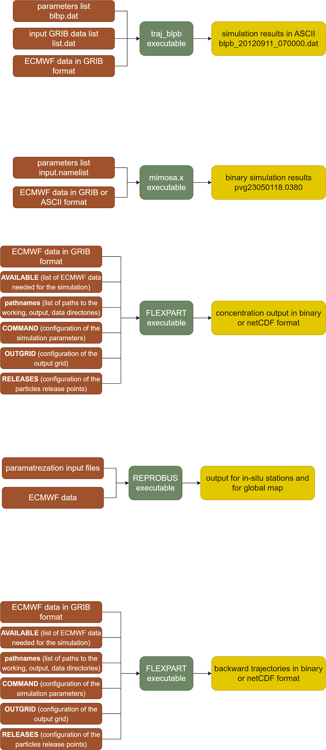](https://app.diagrams.net/?page-id=-bgibJA0lLBGlz3x-Dew&scale=auto#G1zTjAJhYo_0OS5C_VTIOaMg-ly95jQKHr)

*Figure 4: scheme of the FLEXPART simulation input/output which is the main element of the GIRAFE tool*

FLEXPART can be run either forward or backward in time. For forward simulations, particles are released from one or more sources, concentrations (or mixing ratios) are then determined on a regular latitude–longitude–altitude grid. In backward mode, the location where particles are released represents a receptor (e.g., a measurement site). And the output represents the mean estimated residence time of the particles in latitude-longitude-altitude grid cells. In this project, the backward trajectories were estimated via backward run mode of the FLEXPART tool.

### 2.1.1 FLEXPART input files

FLEXPART needs the following three types of input files [1] :

1. The text file pathnames which must be located in the directory from which FLEXPART is executed. It must contain exactly 4 lines:
   * the path to the working directory where the simulation will be executed and where run-defining input files are located (the so-called options directory, explained later in this section)
   * the path where output files will be created
   * the path to the directory with meteorological input GRIB files
   * the path to the so-called AVAILABLE file (see point 3)
2. Text files with the run-defining settings located in a subdirectory called options (given in line 1 of pathnames). The brief description of these files is given in Table 1.
3. The meteorological input data, one file for each input time, stored in GRIB format in a common directory (specified in line 3 of pathnames). To enable FLEXPART to find these files, a file named AVAILABLE (given in line 4 of pathnames) contains a list of all available meteorological input files and their corresponding time stamps (Fig 5).

*Table 1 : Alphabetical list of the run-defining input files (upper part) and static input files (lower parts).*

| **File name** | **Content** |
| --- | --- |
| AGECLASSES  COMMAND  OUTGRID  RECEPTORS  RELEASES  SPECIES/ | Age class definitions  Main control parameters  Output grid definition  Receptor locations for receptor kernel output  Specification of the sources (forward run) or receptors (backward run)  Directory containing files with definitions of physical and chemical parameters of species referenced in RELEASES |
| IGBP_int1.dat  surfdata.t  surfdepo.t | Land cover input data  Roughness length, leaf area index for different land cover types  Seasonal surface resistances for different land cover types |

| XXXXXX EMPTY LINES XXXXXXXXX  XXXXXX EMPTY LINES XXXXXXXXX  YYYYMMDD HHMMSS name of the file(up to 80 characters)  20240421 000000 EN24042100 ON DISK  20240421 030000 EN24042103 ON DISK  20240421 060000 EN24042106 ON DISK  20240421 090000 EN24042109 ON DISK  20240421 120000 EN24042112 ON DISK  ... |
| --- |

*Figure 5 : Example of the content of an AVAILABLE file*

### 2.1.2 Run-defining settings

This subsection, describes in more detail the run-defining setting files, their contents and their role. These settings control FLEXPART's physics and program flow.

#### 2.1.2.1 File COMMAND

The COMMAND file contains the user settings controlling the simulation and the behavior of the run. Parameters such as simulation begin and end datetime, output type and format, interval of model output and others are defined in this file. A complete listing of all settings with their meaning and preset default values can be found in the FLEXPART documentation [1].

#### 2.1.2.2 File RELEASES

The RELEASES file contains details regarding the introduction of particles in the simulation, including information on the timing, location, and characteristics of release points. The header of this file includes the total number of different species intended for release, accompanied by a corresponding list of FLEXPART species numbers (nnn). The SPECIES_nnn files further define the physical properties of these species. Following the header, an arbitrary number of namelists &RELEASE is entered, each defining a distinct release. For each release, the provided information includes the start and end times of the release, spatial coordinates and dimensions, released masses (with one value per species), the quantity of particles slated for release, and an accompanying comment string. For the ACTRIS project, the species that is used for backward FLEXPART runs is the air-tracer, which is configured precisely for the backward simulations.

#### 2.1.2.3 File OUTGRID

The OUTGRID file delineates the domain and grid spacing for the three-dimensional output grid. It is important to note that, in a Lagrangian model, the specifications for the domain and resolution of the gridded output are entirely distinct from those pertaining to the meteorological input. The only requirement is that the output domain must be contained within the computational domain.

#### 2.1.2.4 File RECEPTORS

In addition to gridded model output, it is also possible to define receptor points. This option allows to produce the output for certain points at the surface. The RECEPTORS file contains a list with the definitions of the receptor name, longitude and latitude.

### 2.1.3 Meteorological data

FLEXPART is capable of operating with meteorological input data tailored for global domains or more localized, limited-area domains. The computational domain in FLEXPART aligns with the domain established by the input data, while the output domain can be configured to be smaller.

The compilation of FLEXPART version 10.4 results in a single executable that automatically discerns whether the meteorological input data originate from ECMWF IFS or NCEP GFS, and whether they are formatted in GRIB-1 or GRIB-2. However, adjustments to certain parameters in the source par_mod.f90 file may be necessary to accommodate the size of meteorological input files, particularly in terms of array dimensions. Additionally, the input grid might require shifting relative to the output grid (nxshift parameter).

The meteorological data supported by FLEXPART can be extracted via flex_extract tool. Flex_extract is an open-source software which allows to retrieve meteorological fields from the MARS archive of the European Centre for Medium-Range Weather Forecasts (ECMWF) to serve as input for the FLEXTRA/FLEXPART atmospheric transport modeling system. The installation and the usage of the flex_extract tool are presented below.

#### 2.1.3.1 Installation of flex_extract

The following installation steps are destined for the member-state users of the ECMWF MARS server, and the installation is meant to be done on the MARS server. Other installation configurations are presented in the flex_extract official user guide [4]. Once you logged in onto the MARS server (ecs or hpc), you can follow the below steps.

First, download the dev branch of the flex_extract tool via git clone. This will create a flex_extract local git repository on your machine:

| $ git clone --single-branch --branch dev h[ttps://www.flexpart.eu/gitmob/flex_extract](https://www.flexpart.eu/gitmob/flex_extract)  $ ls flex_extract  Documentation/ For_developers/ Run/  Source/ Templates/ Testing/  CODE_OF_CONDUCT.md LICENSE.md README.md  setup.sh setup_bologna.sh setup_local.sh  setup_local_bologna.sh setup_local_reading.sh setup_reading.sh |
| --- |

The script setup_bologna.sh is intended to prepare installation files from the source of the git repository. The beginning of this script contains parameters that must be configured by the user.

| $ cat setup_bologna.sh  #!/bin/bash  #...  TARGET='ecs'  MAKEFILE='makefile_atosecs'  ECUID='<ecuid>'  ECGID='<ecgid>'  GATEWAY='<gatewayname>'  DESTINATION='<username>@genericSftp'  INSTALLDIR='<install_dir>'  JOB_TEMPLATE=''  CONTROLFILE='CONTROL_EA5'  #...  $ |
| --- |

The parameters ECUID and ECGID have to be replaced by your username of the MARS server account and your group. To find your username and group name, the ls -l command can be used:

| $ ls -l  -rwxr-xr-- 1 as2 fr 34902 20 déc. 2022 file1.txt  drwxr-x--- 4 as2 fr 4096 5 oct. 14:02 file2.txt  drwxr-x--- 14 as2 fr 4096 10 oct. 07:21 file3.txt  || ||  ECUID ECGID |
| --- |

The parameter INSTALLDIR has to be replaced by the directory path where you want to install the flex_extract; the tool will then be installed in ${INSTALLDIR}/flex_extract_[version_number]. The GATEWAY and DESTINATION variables can be set up by the user for a transfer to a local gateway server (read more about this configuration in the documentation [4]). For a default, they must be set as it is with '<gatewayname>' and '<username>@genericSftp'.

Then, in order for the script to be able to take into account the INSTALLDIR parameter, the following lines (highlighted in yellow) must be added at the end of the setup_bologna.sh (around lines 90-100):

| #!/bin/bash  #...  #...  TARGET='ecs  ...  ...  if [ -n "$CONTROLFILE" ]; then  parameterlist+=" --controlfile=$CONTROLFILE"  fi  if [ -n "$INSTALLDIR" ]; then  parameterlist+=" --installdir=$INSTALLDIR"  fi  # -----------------------------------------------------------------  # CALL INSTALLATION SCRIPT WITH DETERMINED COMMANDLINE ARGUMENTS |
| --- |

Lastly, some modifications have to be made to the install.py script of the flex_extract git repository. The file is located in flex_extract/Source/Python/install.py. In the function install_via_gateway the call of the submit_job_to_ecserver has to be commented, and the function submit_sbatch_job should be used instead (Fig. 6).

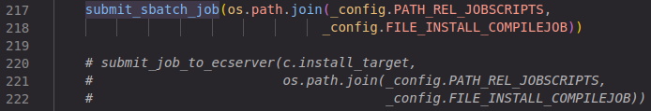

*Figure 6 : modification to be made in the install.py script*

After the setup_bologna.sh script has been updated, last step is to execute it :

| $  $ ./setup_bologna.sh  WARNING: Parameters GATEWAY and DESTINATION were not properly set for working on ECMWF server.  There will be no transfer of output files to the local gateway server possible!  Create tarball ...  SUBMITTED SBATCH JOB Run/Jobscripts/compilejob.sh  Job compilation script has been submitted to ecgate for installation in /home/as2/FLEX_EXTRACT/flex_extract_v7.1.3  You should get an email with subject "flexcompile" within the next few minutes!  SUCCESS: INSTALLATION FINISHED!  $ |
| --- |

If everything worked fine and modifications were made correctly, it should be possible to consult the installation job vie the squeue -u username command:



Once the job is complete, the flex_extract should be installed in the INSTALLDIR requested by you in the setup_bologna.sh script, and the job output should be found in /scratch/[your_username]/flex_compile.xxxxxxxx.out. If the job output seems correct, it is possible to test the installation with following instructions:

| $ cd directory_where_flex_extract_was_installed  $ cd Testing/Installation/Calc_etadot  $ ../../../Source/Fortran/calc_etadot  STATISTICS: 98842.4598 98709.7359 5120.5385  STOP SUCCESSFULLY FINISHED calc_etadot: CONGRATULATIONS |
| --- |

If everything worked fine, the flex_extract was successfully installed!

Last step, is to copy the script run_bologna.sh from the git repository, to your flex_extract installation folder :

| $ cp flex_extract/Run/run_bologna.sh [flex_install_dir]/flex_extract_[version_number]/Run/ |
| --- |

Verify if in the copy of the script the root of the flex_extract is correct; then, correct it if it is not (Fig. 7). Also, always in the same script, it is necessary to add the ecmwf-toolbox in the module load command (Fig. 8); after that the flex_etxract is ready for use.



*Figure 7 : flex_extract_path variable to check*

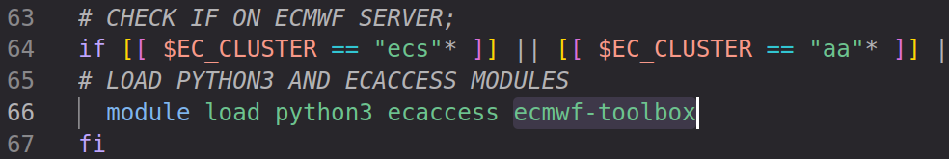

*Figure 8 : ecmwf-toolbox to add in module load command*

#### 2.1.3.2 flex_extract data extraction

To extract the meteorological data, the script run_bologna.sh should be used. The configuration of the data to be extracted is done either by modifying the parameters directly in the script (Fig. 9), or by using the CONTROL file (Fig. 10) which allows a more precise and complex configuration of the parameters.

For a simple analysis and/or forecast data, the script parameters can be set as shown on Fig. 9 and 10. The variables INPUTDIR, OUTPUTDIR and CONTROLFILE should still be adapted by the user. INPUTDIR and OUTPUTDIR should be set with paths where the data and eventual intermediate files will be stored The variable CONTROLFILE should follow this rule :

* if CONTROLFILE variable contains only the filename of the CONTROL file, then the file must be placed in the [flex_extract_root]/Run/Control directory
* if CONTROLFILE variable contains the full absolute path to the CONTROL file, then the file can be placed anywhere

The content of the CONTROL file can be as shown on Fig. 10.

|  | START_DATE 20240226  DTIME 3  TYPE AN FC AN FC AN FC AN FC  TIME 00 00 06 00 12 12 18 12  STEP 00 03 00 09 00 03 00 09  ACCTYPE FC  ACCTIME 00/12  ACCMAXSTEP 12  CLASS OD  STREAM OPER  GRID 1.  UPPER 90.  LOWER -90.  LEFT -180.  RIGHT 179.  LEVELIST 1/to/137  RESOL 255  ETA 1  FORMAT GRIB2  DEBUG 0  REQUEST 0  PREFIX EN |
| --- | --- |
| *Figure 9 : run_bologna.sh parameters set up in the script itself for a GIRAFE data extraction* | *Figure 10 : CONTROL file that can be used for the GIRAFE data extraction* |

In the CONTROL file, the parameters are as follows:

* START_DATE (and END_DATE) are set for a selection of time period for extraction
* DTIME, TYPE, TIME and STEP are set for the temporal resolution and data type (AN for analysis, or FC for forecast) of the extraction; here we extract AN data on the respective hour values indicated in TIME below AN, and FC data on hour values indicated in STEP below, with forecast basetime being indicated in TIME; DTIME should correspond to the hour timestep of the extraction, here we request the data every 3 hour so DTIME is 3
* ACCTYPE, ACCTIME and ACCMAXSTEP correspond to the type, forecast times and maximum forecast steps of the flux forecast fields
* CLASS and STREAM tell us that we want to extract operational deterministic data
* GRID is the spatial resolution of the extraction bounding box
* UPPER, LEFT, LOWER, RIGHT are coordinates of the limits of the extraction area
* LEVELIST is the list of the models levels to extract
* RESOL is the horizontal resolution of spectral grid
* ETA 1 means that horizontal wind fields etadot are retrieved on a regular lat-lon grid from ECMWF for a time-saving and computational ease
* FORMAT is the format of the data to extract
* DEBUG 0 means that temporary files are not saved
* REQUEST 0 means that a file with MARS requests is not created
* PREFIX is the prefix which precedes the YYMMDDHH datetime in the filename

Then the script can be launched via srun or sbatch command, in order to fasten up the process in comparison with the launch on the frontal nodes. Current version of the ACTRIS processing chain uses the ECMWF data already present on the NUWA server, but flex_extract tool can always be used to extract missing/new data or to update the processing chain with its own data extraction process.

### 2.1.4 FLEXPART output

At each output time, FLEXPART generates files containing gridded output, with separate files produced for each species. The file-naming convention follows the pattern grid_[type]_[date]_[nnn]. For backward runs, type can be time for the sensitivity of receptor concentrations to emission fluxes, drydep for the sensitivity of receptor dry deposition to emissions or wetdep for the sensitivity of receptor wet deposition to emissions. For backward runs, there can also be an output file grid_initial_nnn, which gives the receptor sensitivity to initial conditions; date denotes the date and time for which the output is valid, and nnn is the species number as specified in RELEASES. The list of the output times is progressively written to the text file dates.

The physical unit used for the output data in the files grid_conc_date_nnn and grid_time_date_nnn depends on the settings of the switches ind_source and ind_receptor (Table 2). It's important to note that the unit of mass mixing ratio can also be utilized in grid_conc_date_nnn. Source–receptor relationships (i.e., emission sensitivities) in backward mode for atmospheric receptors are written out in grid_time_date_nnn files; those for deposited mass are recorded in files grid_wetdep_date_nnn and grid_drydep_date_nnn. Additionally, it's noteworthy that all gridded output quantities in FLEXPART represent grid cell averages, not point values.

*Table 2 : Physical units of input/output data in forward runs for various settings of ind_source, ind_receptor*

| File name | ind_source | ind_receptor | Input unit | Output unit |
| --- | --- | --- | --- | --- |
| grid_time*  grid_time*  grid_time*  grid_time* | 1  1  2  2 | 1  2  1  2 | 1  1  1  1 | s  s.m3.kg-1  s.kg.m-3  s |

By default, FLEXPART output is written in the native binary format. However, FLEXPART v10.4 can also support output in NetCDF format if the NetCDF libraries are installed. To activate NetCDF support, the option ncf=yes must be appended to the compilation make command. Only one NetCDF file is written; this file contains all species and all time steps. Since the NetCDF output is specified in the climate and forecast (CF) format, any standard software can be used for displaying and processing the output (Fig. 11). NetCDF output data files are compressed. The NetCDF output file contains information on the run settings and the simulation grid from the COMMAND and OUTGRID files.

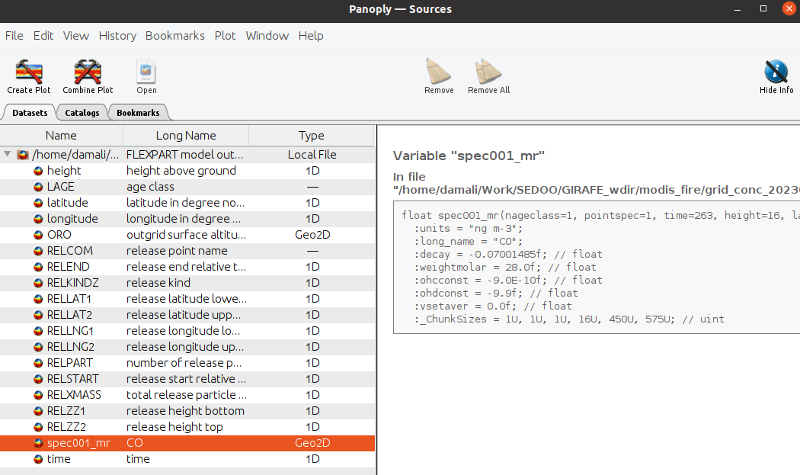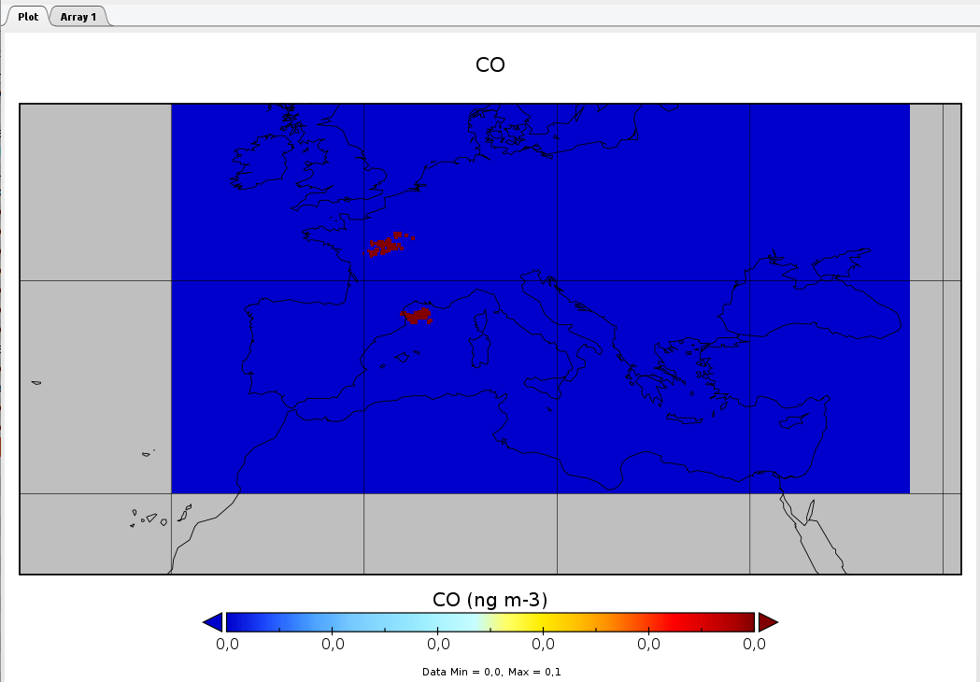

*Figure 11 : FLEXPART output in netCDF format, opened with Panoply*

## 2.2 SOFT-io tool

SOFT-IO tool is a Python library and an implementation of the methodology of source attribution using FLEXPART and carbon monoxide emission inventories. This tool allows the estimation of the geographical origin of pollutants and emission sources which are at origin of CO increases in the troposphere and lower stratosphere.

The tool takes as input a FLEXPART backward trajectories output to analyze it and compare it to the emission sources. The current version of the SOFT-IO tool works with CO emission inventories CEDS (A Community Emissions Data System for Historical Emissions, anthropogenic emissions) [5] and GFAS (CAMS Global Fire Assimilation System) [6].

The output of the SOFT-IO tool is a dataset with estimated contributions for different geographical regions and for two of the mentioned inventories. As shown on Fig. 12, for a FLEXPART simulation for SIRTA station on a certain day, the anthropogenic contributions are between 0.001 and 10 ppb CO for CEDS inventory and between 0.01 and 0.1 ppb CO for GFAS inventory. As for the geographical regions, it seems to come mostly from regions EURO (Europe), BONA (Boreal North America), TENA (Temperate North America) and BOAS (Boreal Asia) (Fig. 13).

|  |  |
| --- | --- |
| *Figure 12 : Estimated contribution of CO from the different geographical regions to the measurement of the SIRTA station on 04/17/2024, calculated by SOFT-IO from the results of FLEXPART.* | *Figure 13 : GFAD map of the geographic regions used in the SOFT-IO [7]* |

It is possible to concatenate results from FLEXPART and SOFT-IO in order to create a time series of CO contributions.

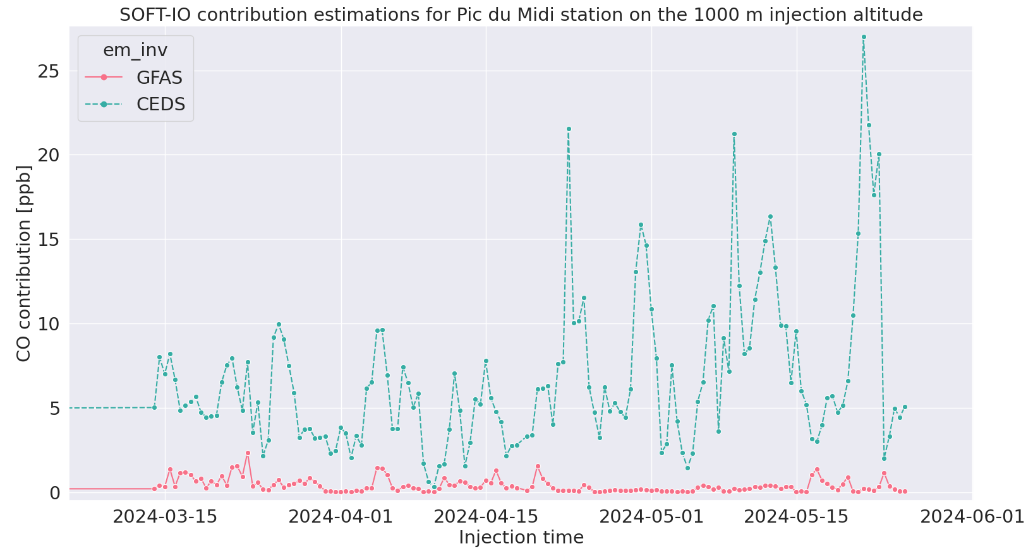

*Figure 14 : Time series of the SOFT-IO estimation for Pic du Midi station on 1000m injection altitude*

# 3. ACTRIS simulation for user

The two main steps of the ACTRIS processing chain are FLEXPART simulation for the backward trajectories calculation and the application of the SOFT-IO algorithm on the FLEXPART result. User interfaces for these steps and the tools installation are detailed below in this section.

On top of the FLEXPART executable and configuration, an overlay of Python and Bash scripts were created to facilitate user experience with the tool and chain production integration. The Python script represents the user interface for the FLEXPART tool and allows to configure the simulation through one simple configuration xml file, without changing manually every FLEXPART input file. The Bash script can then be used over the Python script in order to automate the process and handle multiple simulations and steps (FLEXPART and SOFT-IO) one by one and for multiple stations. These scripts will be detailed later in this document.

## 3.1 ACTRIS Singularity container

FLEXPART and SOFT-IO tools, as well as their dependencies, are containerized into a Singularity container, which allows any user to run it without previous library installation (except the installation of the Singularity application itself).

The file actris-container.def is a Singularity Definition File. A Singularity Definition File is a set of blueprints explaining how to build a custom container. It includes specifics about the base OS to build or the base container to start from, software to install, environment variables to set at runtime, files to add from the host system, and container metadata. The command which allows the build of a .sif Singularity image is:

| $ sudo singularity build actris-container.sif actris-container.def |
| --- |

⚠️ One must have sudo rights on the system where the container is built. If it is not possible, the option --fakeroot can be used in order to build a container without sudo rights. In case of a multi-user server or machine, if the --fakeroot option throws an error, the one should contact the administrator of the machine to add one’s user to white list. Once the container is built, the image can be run anywhere and without sudo rights.

## 3.2 FLEXPART Python interface

As it was presented in the previous section, FLEXPART tool requires a certain number of input configuration files to be set by the user. It can be tedious to edit all these files manually and go through them one by one, especially in the case of a production chain where things must be performed smoothly and in an automatic way. Thus, firstly, to overcome this disadvantage and start preparing the processing chain, a Python interface for FLEXPART was created in order to facilitate the use of the model.

The interface is a Python script actris.py which requires one configuration file from the user as input, actris-config.xml. The script then writes FLEXPART input files based on the parameters set up by the user in the XML file and launches the simulation itself. This Python script must be executed inside of the ACTRIS Singularity container as it relies on the Python libraries and FLEXPART tool itself.

Below is the --help message of the Python script which shows the usage of the script :

| Singularity> python ./actris.py -h  usage: actris.py [-h] [--config CONFIG]  Python code that prepares all FLEXPART inputs and launches a backward FLEXPART simulation for an ACTRIS station based on the user’s configuration file.  options:  -h, --help show this help message and exit  --config CONFIG Filepath to your configuration xml file.  Singularity> |
| --- |

The configuration file is structured as follows :

| <config>  <actris> |  |
| --- | --- |
| <simulation_start>  <date>20230501</date>  <time>000000</time>  </simulation_start>  <simulation_end>  <date>20230510</date>  <time>233000</time>  </simulation_end> | *simulation start and end date and time, knowing that the simulation will be ran backward from the end_date to the start_date* |
| <ecmwf_time>  <dtime>3</dtime>  </ecmwf_time> | *time between two ECMWF fields in hours (ECMWF fields provided by the user)* |
| <flexpart>  <root>/usr/local/flexpart_v10.4_3d7eebf/</root> | *root node is not to change, it is the FLEXPART installation path inside the Singularity container* |
| <par_mod_parameters>  <nxmax> 361 </nxmax>  <nymax> 181 </nymax> | *number of point of meteorological fields in x and y direction* |
| <nuvzmax> 138 </nuvzmax>  <nwzmax> 138 </nwzmax> | *maximum dimension of (u,v) and (w) wind fields in z direction (for fields on eta levels)* |
| <nzmax> 138 </nzmax>  </par_mod_parameters> | *maximum dimension of wind fields in z direction for the transformed Cartesian coordinates* |
| <out_grid>  <longitude>  <min> -15 </min>  <max> 42.5 </max>  </longitude>  <latitude>  <min> 75 </min>  <max> 30 </max>  </latitude>  <resolution> 1 </resolution> | *the latitude and longitude boundary of the region for which the simulation will be executed (f.ex. -180/180 and -90/90 is for global simulation) and the spatial resolution of the output* |
| <height>  <level> 100 </level>  <level> 200 </level>  <level> 500 </level>  </height>  </out_grid> | *altitude levels on which simulation will be performed (upper boundaries of each desired level)* |
| <command>  <forward>-1</forward>  <time>  <output> 3600 </output>  </time>  <iOut> 9 </iOut>  </command> | *forward flag set to -1 indicates that the simulation is to be performed backward; node time/output is the output timestep in seconds (f.ex. 3600 means that the particle concentrations will be estimated every hour between simulation start and end date/time) and iOut is output type/format (option 9 is mandatory for the ACTRIS processing chain, it produces netCDF output)* |
| <releases>  <species> 24 </species> | *the node release concern the particle injections (emitted by the human activities or f.ex. forest fires); here we use the number 24 to indicate the AIR-TRACER species which was configured specifically for the backward simulations)* |
| <release>  <start_date>20230501</start_date>  <start_time>230000</start_time>  <duration>00000000</duration>  <altitude_min>10</altitude_min>  <altitude_max>100</altitude_max> | *each release is characterized by the start date YYYYMMDD, time HHMMSS and its duration DDHHMMSS; the release date/time(s) indicate the injection date/time(s) between indicated minimum and maximum altitudes (meters above ground); the emitted mass will be unitary with 100 000 particles injected* |
| <zones>  <zone *name=”Landes”*>  <latmin>43.799231645</latmin>  <latmax>44.411882453</latmax>  <lonmin>-1.267829619</lonmin>  <lonmax>-0.378441805</lonmax>  </zone>  </zones>  </release>  </releases>  </flexpart> | *for each date/time release it is possible to define multiple release ROI(s) with corresponding names and latitude/longitude boundaries* |
| <paths>  <working_dir>/home/actris/work</working_dir>  <ecmwf_dir>/home/actris/data</ecmwf_dir>  </paths>  </girafe>  </config> | *paths node is where must be indicated paths to the :*   * *working directory (simulation run-time files, executables etc)* * *directory with ECMWF files* |

The actris.py script does not perform any post-processing after the simulation is done. The only output is the FLEXPART native netCDF output file. However, the file is used later by other processing steps of the ACTRIS chain.

## 3.3 SOFT-IO user interface

The Python FLEXPART user interface allows managing only one of the processing steps, FLEXPART. To continue preparing the processing chain for the production and integration, the second step, SOFT-IO tool, was studied.

As the SOFT-IO tool is a Python library itself, it was decided to create a Python script apply-softio.py in order to manage this processing step. This script allows to apply SOFT-IO to a FLEXPART output of the ACTRIS use case and to save results as a standalone output file. If requested by the user, the results can also be added to a common database where CO contribution estimations are concatenated into a single variable with multiple dimensions (geographical region, emission inventory type etc). In our case, this common database solution is used for the time-series creation and for the latter visualization.

The apply-softio.py Python interface works as follows:

| Singularity> /usr/local/micromamba/envs/softio_env/bin/python3 ./apply-softio.py -h  usage: apply-softio.py [-h] [-f FILE] [-n NAME] [-d DIR] [-o OUTPUT]  Applying SOFT-IO to the FLEXPART output for the ACTRIS stations  options:  -h, --help show this help message and exit  -f FILE, --file FILE Path to the FLEXPART output netCDF file  -n NAME, --name NAME Short name of the ACTRIS station in question  -d DIR, --dir DIR Path to the directory where to store the output SOFT-IO file  -o OUTPUT, --output OUTPUT  Path to the SOFT-IO merged database file where to add new data  Singularity> |
| --- |

The argument -n/--name is used to identify results for the same station in the common database and also to keep track of this information in the standalone output. The output netCDF from the SOFT-IO has the following structure :

| <xarray.Dataset>  Dimensions: (release_time: 1, geo_region: 15, em_inv: 2, height: 1,  station_id: 1)  Coordinates:  * release_time (release_time) datetime64[ns] 2021-12-31T23:00:01  release_lon float32 -5.033  release_lat float32 6.217  release_pressure float32 1.25e+04  release_npart int32 100000  * geo_region (geo_region) object 'TOTAL' 'BONA' ... 'EQAS' 'AUST'  * height (height) float32 100.0  * station_id (station_id) object 'LTO'  * em_inv (em_inv) object 'GFAS' 'CEDS'  Data variables:  CO_contrib (em_inv, height, station_id, release_time, geo_region) float64 ... |
| --- |

The CO_contrib variable contains values of the CO contribution estimated by the SOFT-IO tool. The dimensions of this variable are (em_inv, height, station_id, release_time, geo_region). Even if some of these dimensions have only one possible value in the standalone output, it allows easier management of multiple SOFT-IO outputs when merging them in the common database. The data from this file alone allows to obtain Fig. 15 with footprints on a given day for a given station/height combination.

## 3.3 Creation of footprints images

The last step of the processing is the creation of the summary footprint images for each of the FLEXPART outputs. These images are then intended to be used in the visualization tool for an easier analysis and easier representation of rich information given by the initial FLEXPART output.

The Python code that creates these images were based on the image creation used for the IAGOS Footprints portal [8]. The calculations allow to integrate FLEXPART result on the vertical levels and also reproject it onto a special latitude/longitude grid that can be overlayed with a global map for a visual representation (Fig. 15).

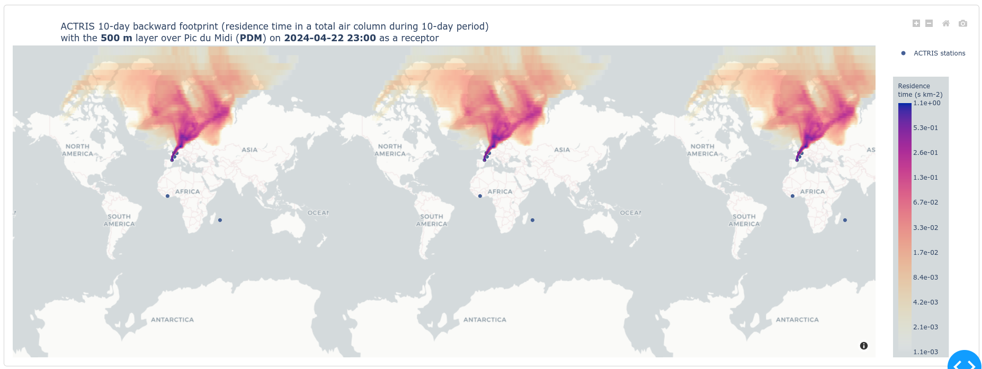

*Figure 15 : FLEXPART footprint image overlays on a global map; the colorbar is the scale of the residence time of the particles estimated by FLEXPART*

The output image data is saved into .zarr format via xarray Python library and can be opened as a Dataset in Python to access the data as in a simple netCDF file with variables, dimensions and attributes. Below is the example of such footprints database saved in a .zarr format and re-opened with xarray:

| <bound method Dataset.load of <xarray.Dataset>  Dimensions: (height: 5, latitude: 180, longitude: 360, time: 450,  station_id: 6)  Coordinates:  * height (height) float32 100.0 500.0 1e+03 1.5e+03 2e+03  * latitude (latitude) float32 -89.5 -88.5 -87.5 ... 87.5 88.5 89.5  * longitude (longitude) float32 -179.5 -178.5 -177.5 ... 178.5 179.5  * station_id (station_id) <U3 'LTO' 'OPE' 'PDM' 'PUY' 'RUN' 'SAC'  * time (time) datetime64[ns] 2021-12-31T23:00:00 ... 2024-05-2...  Data variables:  res_time_per_km2 (time, station_id, height, latitude, longitude) float16 ... |
| --- |

The variable res_time_per_km2 still represents the residence time calculated by FLEXPART, but here it is reprojected and integrated over the vertical column in order to get only one 2D matrix for a given simulation. ‘height’ is the release height of particles in the simulation, and ‘time’ is the release time of the particles in the simulation.

## 3.4 Bash User Interface

In order to incorporate all of the processing steps together and to facilitate the integration of the processing chain and a batch processing for the future, an additional Bash script was created. With a few configuration setups and input arguments, this script allows to easily manage all of the steps of the processing chain for a given ACTRIS station on a given simulation date.

The usage of the Bash script is as follows :

| user@pc:~/git/actris-footprints> ./launch_simulation_cron.sh -h  ### | *  ### | *  ### | *  ### ,,gg|dY""""Ybbgg,,  ### ,agd""' | `""bg,  ### ,gdP" A C T R I S "Ybg,  ### FRANCE  ###  ### This script is intended for FLEXPART simulation, SOFT-io CO contribution computation and creation of the CO receptor-  ### -source footprints for an ACTRIS station. Simulation will be performed in the backward mode to the J-10 days time limit. The  ### user should just select the station, the date/time of the simulation, from which the J-10 period will be counted, and  ### provide the configuration file where paths to working and output directories are indicated. Options --flexpart, --softio and  ### --footprint allow to activate one or multiple processings.  ###  ### Usage : launch_simulation_cron.sh [options] arguments  ###  ### Options:  ### -h|--help Show this help message and exit  ### --flexpart Activate FLEXPART simulation  ### --softio Activate SOFT-io computations  ### --footprint Activate creation of the footprint image  ###  ### Arguments:  ### -n station_name_code ID code (short_name) of one of the stations from your configuration file  ### -d YYYYMMDDHH date and time of the simulation  ### -c,--conf configuration.file configuration file with paths |
| --- |

The user’s inputs are :

* [-n] ACTRIS station code name/identifier from the configuration file (detailed later in this section)
* [-d] simulation start date and hour in YYYYMMDDHH format, the simulation is ran backward from this date
* [-c] configuration file itself (detailed later in this section)
* [--flexpart, --softio, --footprint] processing flags that can activate different processing steps (at least one if the flags must be set up)

The summary of the steps performed by this Bash script is presented on Fig. 16 below.

[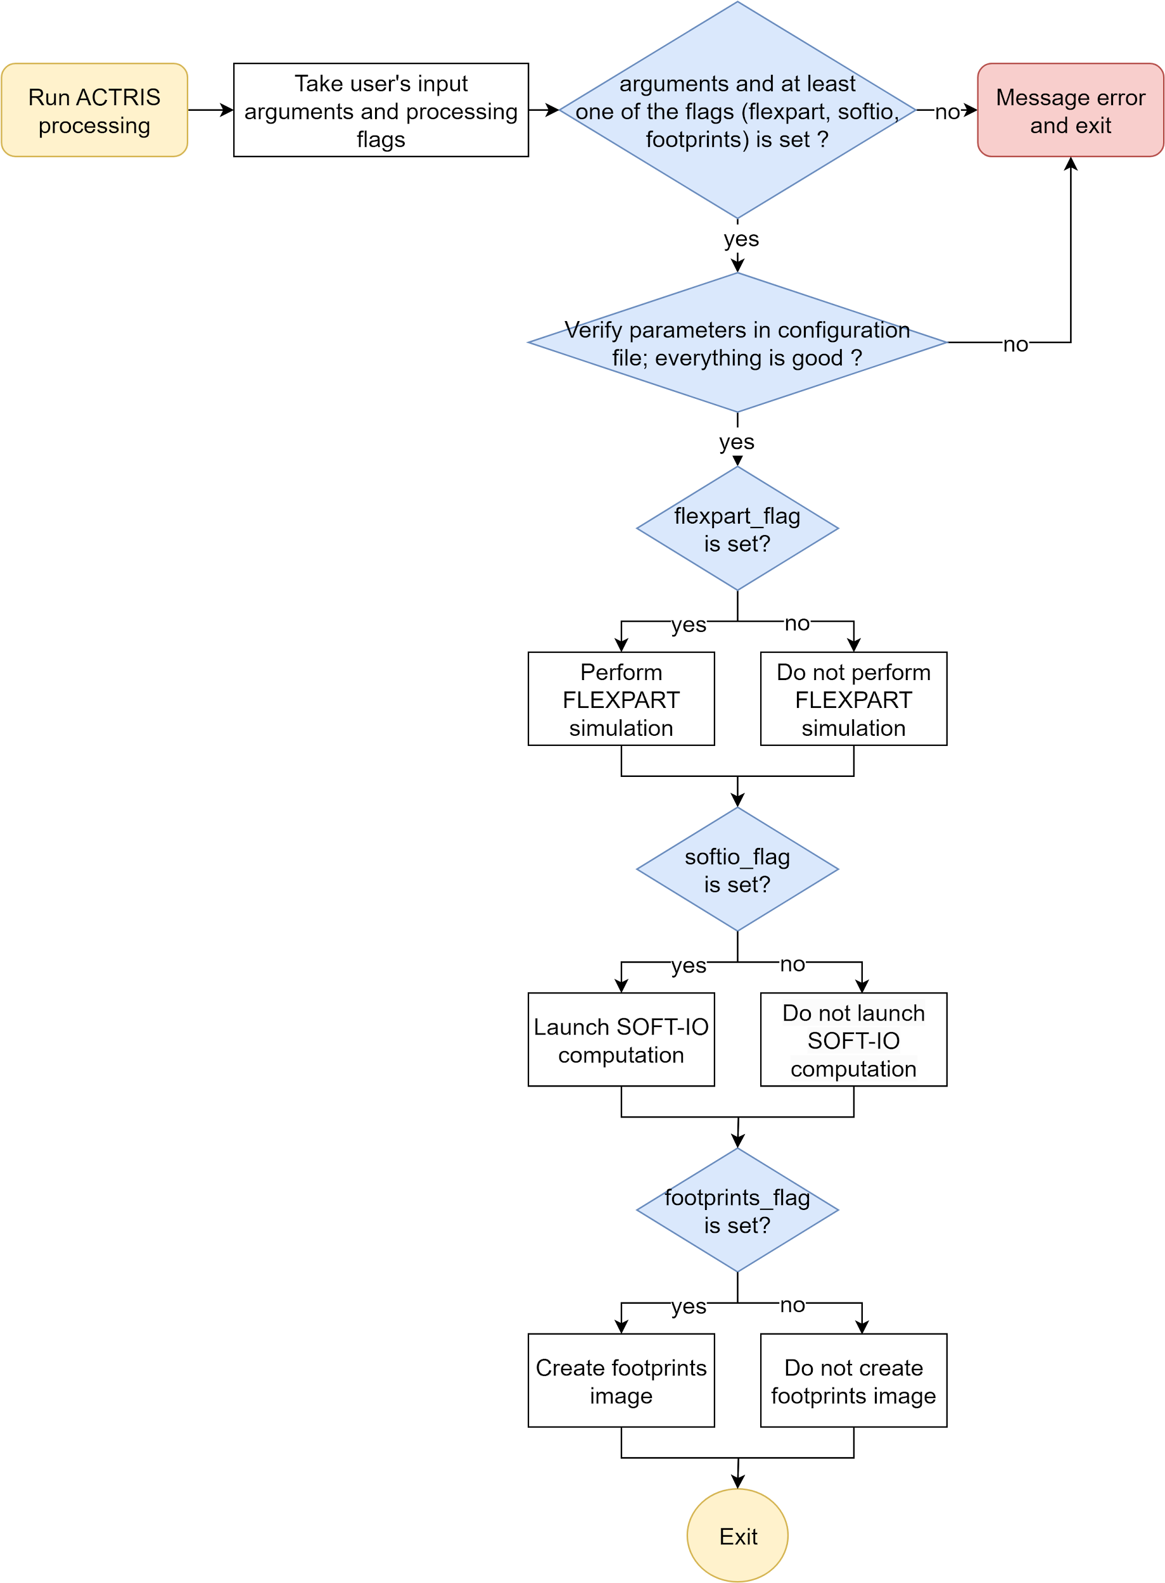](https://app.diagrams.net/?page-id=eTJleRZ4M7a09VrhzGEw&scale=auto#G1zTjAJhYo_0OS5C_VTIOaMg-ly95jQKHr)

*Figure 16 : flowchart of the Bash script interface for the ACTRIS processing chain*

The FLEXPART processing includes : getting information about chosen station, based on this information and user’s data writing the configuration XML file for Python script, launch Python script with this configuration file through a Singularity container; if simulation was successful, renaming the output file and move it to the user request output directory.

The SOFT-IO processing consists of finding requested FLEXPART simulation and running SOFT-IO on this output.

The footprint creation step consists of creating a 2D footprint image from FLEXPART output and adding it to the .zarr database of the footprints.

### 3.4.1 User paths configuration

A path configuration is required by the Bash script in order to define where to find input data and where to store output data. This configuration file is a simple ASCII file that will be sourced in the Bash script. Its syntaxe is as follows:

| SRC_DIR="/path/to/folder/with/python/source/codes"  DATA_DIR="/path/to/folder/with/ecmwf/grib/data"  IMAGE_FILEPATH="/path/to/the/singularity/image.sif"  ROOT_WDIR="/path/to/root/working/folder/for/subfolders"  FLEXPART_OUT_DIR="/path/to/folder/for/flexpart/output"  SOFTIO_OUT_DIR="/path/to/folder/for/softio/output"  SOFTIO_DATABASE="/path/to/output/softio/database.nc"  FOOTPRINTS_DATABASE="/path/to/output/footprints/images/database.zarr"  STATIONS_CONF="/path/to/file/with/stations/configuration.json" |
| --- |

ROOT_WDIR is the root working directory where the sub folders for each simulation will be created. FLEXPART_OUT_DIR and SOFTIO_OUT_DIR will host output files directly without subfolders. The working directory tree will then be as follows :

| root_wdir/  ├─PDM/  │ ├─wdir-2022011012-500/  │ ├─wdir-2022011012-1000/  │ └─...  └─LTO/  ├─wdir-2022050512-100/  ├─wdir-2022050512-500/  ├─wdir-2022050512-1500/  └─... | flexpart_out_dir/  ├─PDM-2022011012-20211231-500.nc  ├─PDM-2022011012-20211231-1000.nc  ├─...  ├─LTO-2022050512-20220425-100.nc  ├─LTO-2022050512-20220425-500.nc  └─LTO-2022050512-20220425-1500.nc  softio_out_dir/  ├─softio-PDM-2022011012-20211231-500.nc  ├─softio-PDM-2022011012-20211231-1000.nc  ├─...  ├─softio-LTO-2022050512-20220425-100.nc  ├─softio-LTO-2022050512-20220425-500.nc  └─softio-LTO-2022050512-20220425-1500.nc |
| --- | --- |
| *Structure of the root working directory* | *Structures of the output directories for FLEXPART and SOFT-IO outputs respectively* |

PDM and LTO are short names of Pic Du Midi and Lamto station respectively that were passed to the script as -n argument; their working directories and FLEXPART/SOFT-IO output files are also named with these short names in order to identify them. The first datetime values in the output filenames and in working directories names indicate the simulation start date passed to the script with -d argument. The second datetime, which is only in the output filenames, indicates the “end date” of the simulation which corresponds to the J-10 days. This simulation duration to J-10 days is configured directly in the script. This duration was defined as the best compromise between uncertainty of the results and the diffusion scale. The last value in the names corresponds to the height where the particles were injected for the simulation. These values are configured in the stations configuration file which will be discussed in the section *3.4.2 Station JSON configuration*.

### 3.4.2 Stations JSON configuration

A JSON configuration file must be set up with general information about ACTRIS stations in question. The syntaxe of the file is as follows:

| [  {  "short_name":"PUY",  "long_name":"Puy de Dôme",  "longitude":2.964886,  "latitude":45.772223,  "altitude":1465,  "release_heights":"500 1500"  },  {  "short_name":"SAC",  "long_name":"SIRTA Atmospheric Research Obs",  "longitude":2.1588888889,  "latitude":48.7086111,  "altitude":162,  "release_heights":"500"  },  …  ] |
| --- |

“short_name” allows users to identify a station by its short and unique ID name that is easy to use when calling scripts for a particular station or to identify its data in a common database. This ID will also allow to identify the station in question throughout the entire processing chain between different processing steps, and this short name must be used when calling the Bash script for one of the stations. “altitude” is the station altitude in meters, and “release_heights” is the list of release heights for the FLEXPART simulations. Each value in this list will correspond to its own independent simulation. These values have to be defined depending on what phenomenon one seeks to observe and study (global diffusion, regional diffusion etc.). Annex 1 of this document presents the configuration of chosen ACTRIS stations that have been defined in the scope of this project by the scientist in charge of the study. This file can be changed if a new station is added to that list or if an already existing station has to be updated.

### 3.4.3 Processing flags

Processing flags --flexpart, --softio and --footprint allows to activate respective processing steps. At least one of the flags must be set up when calling the script. When calling --softio or --footprint steps, the script will search for already existing FLEXPART output files. If FLEXPART simulation fails or if FLEXPART output were not found for SOFT-IO computations and footprints visualization the script will throw an error/warning message and exit with exit status = 1.

## 3.5 ACTRIS batch production

For a continued production of the whole processing chain for all of the defined ACTRIS stations a production Bash script was created. This script can be launched in two different modes which will be detailed later in this section after a general presentation of the script. The actris-production.sh script’s interface is as follows :

| ### | *  ### | *  ### | *  ### ,,gg|dY""""Ybbgg,,  ### ,agd""' | `""bg,  ### ,gdP" A C T R I S "Ybg,  ### FRANCE  ###  ### This script allows to handle multiple ACTRIS simulations in the produciton mode. Processing steps are called via Bash  ### user interface with --flexpart, --softio or --footprint flags. This script can be called via cron tool as well.  ###  ### Usage : [options] arguments  ###  ### Options:  ### -h|--help Show this help message and exit  ###  ### Arguments:  ### -d list_of_dates.txt list of the date/hours to process  ### -c,--conf configuration.file configuration file  ###  ### Configuration file is an ASCII file containing paths to source codes and workingd/data directories. The syntaxe is as follows :  ### SERVER_USER="username"  ### LOGS_DIR="/path/to/the/directory/where/to/save/log/files"  ### PATHS_CONF_FILEPATH="/path/to/the/source/configuration.conf"  ### LOG_CATALOGUE_FILEPATH="/path/to/the/common/log/database.txt"  ### FLEXPART_HOUR="00"  ### DELAY_N_DAYS=5  ###  ### --> PATHS_CONF_FILEPATH is the configuration file used by the actris-processing.sh. In this files parameters such as  ### SRC_DIR, SINGULARITY_FILEPATH and others are set up by the user.  ### --> FLEXPART_HOUR is the start hour of the simulation. For the ACTRIS project it was defined that the simulation will be launched  ### twice a day, at 00h and 12h.  ### --> DELAY_N_DAYS is the number of days to delay the simulation start from the 'today' date. This can number can be 0,  ### meaning that the simulation date will be the same as the processing date, but dû to the ECMWF data availability it is not  ### always possible. Thus this parameter should be adapted based on the delay between 'today' date and the data availability  ### of the user.  ###  ### List of the dates is a simple ASCII file where each line is a simulation date/hour to process. Dates should be in the  ### format YYYYMMDDHH. This list is not mandatory (f.ex. in a case of a cron production this file is not required), but if it  ### is provided it will overwrite parameters FLEXPART_HOUR and DELAY_N_DAYS set up in the configuration file. This list of dates  ### can be used to process a particular time period or to re-process particular dates that were not processed or threw an error  ### during the automatic production. |
| --- |

Figure 17 shows the steps of this Bash script which can be used for an automatic continued production via tools such as cron that allows cyclic / scheduled script launches. All of the processing steps (FLEXPART, SOFT-IO and footprints images creation) are done via calling the Bash user interface presented in the section *2.2.4*.

| *Figure 17 : flowchart of the Bash script for an automatic ACTRIS production* |
| --- |

All of the processing steps are launched via SLURM tool in order to use the computing resources of the server. FLEXPART jobs are launched in parallel in order to gain time. SOFT-IO and footprints visualization are launched sequentially for each of the stations because of the concurrent input/output access to their respective output databases. Since these two processing steps do not take as much time as FLEXPART simulations, it is not binding to perform these steps sequentially.

Error, warning and “successful” messages are traced in a log file defined by the user, which allows to keep track of production and processing. If FLEXPART simulation was not successful, the warning message is written for all of the three processing steps since SOFT-IO and footprints visualization require FLEXPART output and it was not created dû to the failed FLEXPART simulation.

Each of the processing steps is logged into an output log file defined by the user. For continued production, this log file should be the same, as it will allow to gather all of the important information about failed steps in one place. The log messages have the following syntax :

| {'processing_date':'29/04/2024 13:04:56 CEST', 'station_id':'PUY', 'simulation_date':'2024042412', 'log_filepath':'/sedoo/resos/actris/LOGS_CRON/PDM/PDM-2024042412.out', 'processing_step':'flexpart', 'status':0}  {'processing_date':'29/04/2024 13:05:44 CEST', 'station_id':'PUY', 'simulation_date':'2024042412', 'log_filepath':'/sedoo/resos/actris/LOGS_CRON/PUY/PUY-2024042412.out', 'processing_step':'softio', 'status':0}  {'processing_date':'29/04/2024 13:06:40 CEST', 'station_id':'PUY', 'simulation_date':'2024042412', 'log_filepath':'/sedoo/resos/actris/LOGS_CRON/PUY/PUY-2024042412.out', 'processing_step':'footprints', 'status':0}  {'processing_date':'29/04/2024 13:10:20 CEST', 'station_id':'LTO', 'simulation_date':'2024042412', 'log_filepath':'/sedoo/resos/actris/LOGS_CRON/LTO/LTO-2024042412.out', 'processing_step':'softio', 'status':0}  {'processing_date':'29/04/2024 13:11:40 CEST', 'station_id':'LTO', 'simulation_date':'2024042412', 'log_filepath':'/sedoo/resos/actris/LOGS_CRON/LTO/LTO-2024042412.out', 'processing_step':'footprints', 'status':0} |
| --- |

‘processing_date’ is the date when the processing was launch; ‘station_id’ is the short name of the station in question; ‘simulation_date’ is the simulation start date in the simulation tool; ‘log_filepath’ is the log file with all of the processing messages for this station/date combination (messages from FLEXPART, SOFT-IO etc); ‘processing_step’ correspond to either one of the steps (FLEXPART, SOFT-IO or footprints images creation); ‘status’ is the status of the corresponding processing step (0 means that the processing was successful; 1 means that there were an error). The key ‘status’ can be used to quickly check if there are any errors in the production process (via Bash, Python or other parsing/reading tools). The key ‘log_filepath’ allows users to quickly access respective log files with more details about processing steps.

The configuration file (listed below) passed to this script is a more general configuration than the one used in the Bash interface of section 3.4. In this configuration, PATHS_CONF_FILEPATH is the configuration file used by the actris-processing.sh. In this file parameters such as SRC_DIR, SINGULARITY_FILEPATH and others are set up by the user. FLEXPART_HOUR is the start hour of the simulation. For the ACTRIS project it was defined that the simulation will be launched twice a day, at 00h and 12h. LOGS_DIR is a directory where simulation log files with details about processing steps will be stored. DELAY_N_DAYS is the number of days to delay the simulation start from the 'today' date. This number can be 0, meaning that the simulation date will be the same as the processing date, but dû to the ECMWF data availability it is not always possible. Thus this parameter should be adapted based on the delay between 'today' date and the data availability of the user.

| SERVER_USER="username"  LOGS_DIR="/root/actris/log_files"  PATHS_CONF_FILEPATH="/root/actris/actris.conf"  LOG_CATALOGUE_FILEPATH="/root/actris/production.log"  FLEXPART_HOUR="00"  DELAY_N_DAYS=5 |
| --- |

*Configuration file content for the cron script*

The second argument -d is an optional argument and it is a list of dates to process. This mode can be useful when there is a need to process particular dates or to reprocess dates that have thrown error in the production mode processing. The behaviour of the script will depend on whether this list is provided or not:

* no list is provided : the simulation date and hour are calculated from the ‘today’ date, DELAY_N_DAYS and FLEXPART_HOUR parameters; this date is the only simulation date for this script launch
* a list of dates/hours is provided (example listed below) : the parameters DELAY_N_DAYS and FLEXPART_HOUR are not taken into account, the script loops through the dates provided in the list and launches simulations for these dates one by one. This mode can be used to process a particular time period or to reprocess dates that were not processed in the automatic production mode dû to the circumstances.

| 2022050100  2022050112  2022050312  2022050412 | |
| --- | --- |

*Example of dates to process that can be passed as a list with -d option*

# Bibliography

[1] ACTRIS - Climat et qualité de l’air

[*https://www.actris.fr/*](https://www.actris.fr/)

[2] The Lagrangian particle dispersion model FLEXPART version 10.4

*Pisso, I., Sollum, E., Grythe, H., Kristiansen, N. I., Cassiani, M., Eckhardt, S., Arnold, D., Morton, D., Thompson, R. L., Groot Zwaaftink, C. D., Evangeliou, N., Sodemann, H., Haimberger, L., Henne, S., Brunner, D., Burkhart, J. F., Fouilloux, A., Brioude, J., Philipp, A., Seibert, P., and Stohl, A.: The Lagrangian particle dispersion model FLEXPART version 10.4, Geosci. Model Dev., 12, 4955–4997,* [*https://doi.org/10.5194/gmd-12-4955-2019*](https://doi.org/10.5194/gmd-12-4955-2019)*, 2019*

[3] Source attribution using FLEXPART and carbon monoxide emission inventories: SOFT-IO version 1.0

*Sauvage, B., Fontaine, A., Eckhardt, S., Auby, A., Boulanger, D., Petetin, H., Paugam, R., Athier, G., Cousin, J.-M., Darras, S., Nédélec, P., Stohl, A., Turquety, S., Cammas, J.-P., and Thouret, V.: Source attribution using FLEXPART and carbon monoxide emission inventories: SOFT-IO version 1.0, Atmos. Chem. Phys., 17, 15271–15292,* [*https://doi.org/10.5194/acp-17-15271-2017*](https://doi.org/10.5194/acp-17-15271-2017)*, 2017*

[4] Flex_extract v7.1.2 – a software package to retrieve and prepare ECMWF data for use in FLEXPART

*Tipka, A., Haimberger, L., and Seibert, P.: Flex_extract v7.1.2 – a software package to retrieve and prepare ECMWF data for use in FLEXPART, Geosci. Model Dev., 13, 5277–5310,* [*https://doi.org/10.5194/gmd-13-5277-2020*](https://doi.org/10.5194/gmd-13-5277-2020)*, 2020*

[5] Historical (1750–2014) anthropogenic emissions of reactive gases and aerosols from the Community Emissions Data System (CEDS)

*Hoesly, R. M., Smith, S. J., Feng, L., Klimont, Z., Janssens-Maenhout, G., Pitkanen, T., Seibert, J. J., Vu, L., Andres, R. J., Bolt, R. M., Bond, T. C., Dawidowski, L., Kholod, N., Kurokawa, J.-I., Li, M., Liu, L., Lu, Z., Moura, M. C. P., O’Rourke, P. R., and Zhang, Q.: Historical (1750–2014) anthropogenic emissions of reactive gases and aerosols from the Community Emissions Data System (CEDS), Geosci. Model Dev., 11, 369-408,* [*https://doi.org/10.5194/gmd-11-369-2018*](https://doi.org/10.5194/gmd-11-369-2018)*, 2018*

[6] Biomass burning emissions estimated with a global fire assimilation

system based on observed fire radiative power

*Kaiser, J. W., Heil, A., Andreae, M. O., Benedetti, A., Chubarova, N., Jones, L., Morcrette, J.-J., Razinger, M., Schultz, M. G., Suttie, M., and van der Werf, G. R. (2012). Biomass burning emissions estimated with a global fire assimilation system based on observed fire radiative power. BG, 9:527-554*

[7] The interactive global fire module pyrE (v1.0)

*Mezuman, Keren & Tsigaridis, Kostas & Faluvegi, Gregory & Bauer, Susanne. (2020). The interactive global fire module pyrE (v1.0). Geoscientific Model Development. 13. 3091-3118. 10.5194/gmd-13-3091-2020.*

[8] AGOS viewer of FLEXPART (Lagrangian model) footprints and modelled SOFT-IO CO contributions

[*https://services.iagos-data.fr/atmo-access/footprint*](https://services.iagos-data.fr/atmo-access/footprint)

# Annexe

## Annexe 1: ACTRIS stations configuration

| [  {  "short_name":"PUY",  "long_name":"Puy de Dôme",  "longitude":2.964886,  "latitude":45.772223,  "altitude":1465,  "release_heights":"500 1500"  },  {  "short_name":"SAC",  "long_name":"SIRTA Atmospheric Research Obs",  "longitude":2.1588888889,  "latitude":48.7086111,  "altitude":162,  "release_heights":"500"  },  {  "short_name":"PDM",  "long_name":"Pic du Midi",  "longitude":0.141944,  "latitude":42.936667,  "altitude":2877,  "release_heights":"500 1000"  },  {  "short_name":"OPE",  "long_name":"Observatoire Perenne de l'Environnement",  "longitude":5.50555556,  "latitude":48.562222,  "altitude":392,  "release_heights":"500"  },  {  "short_name":"RUN",  "long_name":"La Réunion – Maïdo atmospheric observatory",  "longitude":55.383006,  "latitude":-21.076449,  "altitude":2160,  "release_heights":"500 1500 2000"  },  {  "short_name":"LTO",  "long_name":"Lamto",  "longitude":-5.03333333,  "latitude":6.216666667,  "altitude":105,  "release_heights":"100 500 1500"  }  ] |
| --- |