**Polytechnic of Milan**



Group number: 3

|  |  |
| --- | --- |
|  | |
|  |  |
|  |  |
|  |  |
|  |  |
|  |  |
|  |  |
|  |  |

**Abstract**

The aim of this report is to analyse the performances of an Ariane 5-ECA, in terms of thrust vector control (TVC) and thrust, in the boosting phase, while a thrust imbalance of the system is generated due to possible engine issues to both the solid boosters that leads to a power loss and a reduction of thrust with respect to expected values.

The thrust imbalance considered in this study can be explained as a disturbance moment generated by an off-design performance of the boosters. The resulting couple of the solid boosters’ thrusts tend to make the rocket turning. In design condition the moments generated by the boosters are perfectly balanced between themselves; in real application some disturbances may cause the generation of the imbalance effect even if boosters are working near to optimal performance condition. TVC is used to compensate the rotation and to follow the desired attitude during the launch.

The thrust imbalance, even if compensated by TVC, causes some issues to the rocket performances as will be explained later. Briefly, in the best case just a loss of total thrust is sensed due to the rotation of the thrust vectors by TVC, in the worst case it would cause the loss of trajectory control and the complete failure of the mission. As for the actually used engines for this launcher, TVC systems are effective both on main engine nozzle and boosters’ ones even if deflection angles are different.

The thrust losses are modelled as random variations of thrust levels that can be expressed statistically as a rectangular distribution.

The analysis will cover many important aspects regarding the launcher starting from a managerial study of the project through a House of Quality and project triangular scheme, then a presentation and evaluation of technical aspects of Ariane 5-ECA during interesting flight phases will follow. Propulsion, aerodynamics, mass distribution and TVC values during unbalanced flight will be shown together with a presentation of the launcher characteristic and dimensions through a CAD model made with SolidWorks ®.

Table of contents

1. Introduction
2. Requirements & Specifications
3. Aerodynamics
4. Propulsion
5. Mass distribution
6. Thrust vector control
7. Summary and conclusions
8. List of references

List of figures

List of tables

Nomenclature

1. Introduction

2. Requirements & Specifications

2.1 Requirements

The customer requirements [relative weight] are:

* Similar-to-target altitude and velocity at boosters’ detachment [30.3%]: due to an imbalance in the thrust the preliminary target can be unreachable and an acceptable similar one should be reached
* Full control of trajectory [24.2%]: during the whole flight, the rocket trajectory must be fully controllable
* High precision attitude control [21.2%]: to manage the thrust imbalance an effective attitude control system is required
* Lightweight system [6.1%]: a lightweight system is preferable due to many advantages
* Cheap system [6.1%]
* Robustness to atmospheric disturbances [12.1%]: a minor effect of atmospheric disturbances (e.g. transversal winds) should help in focusing on the management of thrust imbalance

2.2 Specifications

2.2.1 Project management triangle



As managerial approach the best decision results in focusing on performances (*best performance approach*), with a minimum weak limitation on cost and risk: risk in schedule delays is not an issue because it is unlikely.

2.2.2 Functional requirements

The functional requirements [relative weight] are:

* TVC angle excursion [13.0%]: a higher angle is preferable to obtain a larger controllability window for rocket attitude dynamics
* Aerodynamic drag [4.0%]: a low aerodynamics effect is important to reduce stresses and losses
* Sustainer thrust fraction [4.6%]: a higher fraction would guarantee a minor sensibility to boosting phase imbalance, however losses due to parallel configuration are increased
* Boosters thrust fraction [10.1%]: a higher fraction would cause a major sensibility to boosting phase imbalance, but it would grant a smaller system due to a lower propellant volume
* Centre of mass excursion [5.1%]
* Misalignment of thrust with respect to centre of mass [9.8%]: the boosting phase unbalance generates an arm for the vertical component of thrust, that causes an undesired moment
* Velocity at boosters’ detachment [7.8%]
* Altitude at boosters’ detachment [9.1%]
* Sensors responding time [13.7%]
* Attitude angular position sensitivity [10.1%]
* Attitude angular velocity sensitivity [10.1%]
* GPS/Radar visibility [2.6%]: important parameter to keep track of the rocket during its flight trajectory

2.2.3 Competitive analysis

Two main competitors to Ariane V ECA are considered:

1. SpaceX – Falcon Heavy
2. Nasa – Delta IV Heavy

As shown in Fig (), the strongest competitor is the SpaceX -Falcon Heavy which assure higher performances in most of the customer requirements.

However, Falcon Heavy has never flown in a real mission and because of this its data are just theoretical.

The Delta IV Heavy has accomplished many missions, but it has lower performances in all the meaningful mission parameters exception made for the lightweight system parameter.

2.2.4 House of Quality analysis

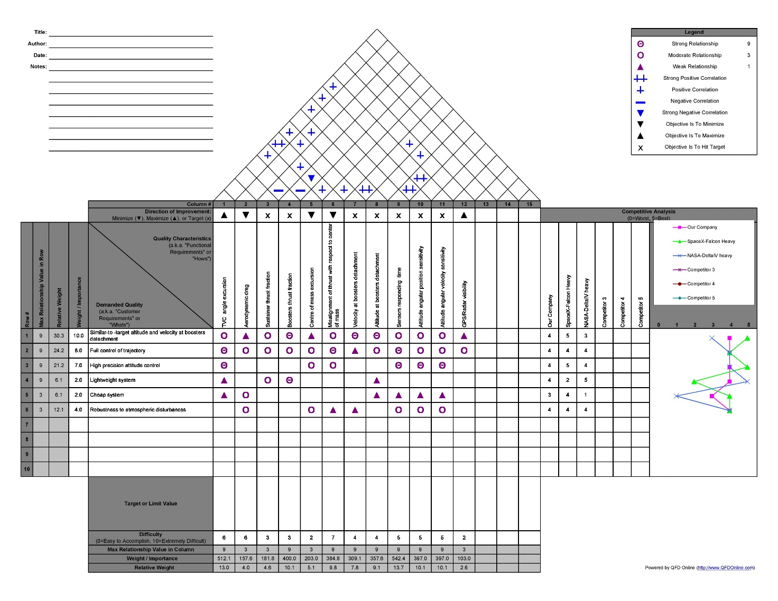

2.2.5 Baseline

Ariane V ECA in the nominal condition is the baseline to this study. The nominal system is composed by a parallel first stage with a liquid cryogenic couple (LH2-LOX) main engine and two solid rocket boosters that provide almost 90% of the total thrust at lift-off. There is also a cryogenic upper stage, but it is of no interest for this project.

|  |  |  |  |  |  |  |
| --- | --- | --- | --- | --- | --- | --- |
|  | Weight at lift-off [tons] | Diameter [m] | Height  [m] | Thrust  [kN] | Isp  [s] | Chemical composition |
| Main engine | 170.3 |  | 30.5 | 960 | 432 | LH2/LOX |
| Booster | 240 |  |  | 7000 | 274.5 | HTPB |
| First stage |  |  |  |  |  |  |

3. Aerodynamics

In this chapter it will be analysed the Ariane 5 ECA rocket aerodynamics. Aerodynamics is a very complex aspect to model during a design phase, and the behaviour of the flow around a rocket is very complicated and difficult to foresee. In this case the configuration of a parallel rocket complicates more the study. The model of the rocket has been created with SolidWorks ® using the real dimensions and masses [Figure **]. The main aspect that are analysed are the drag coefficient, the normal force coefficient (useful for the thrust vector control) and the position of the centre of pressure (useful for the thrust vector control).

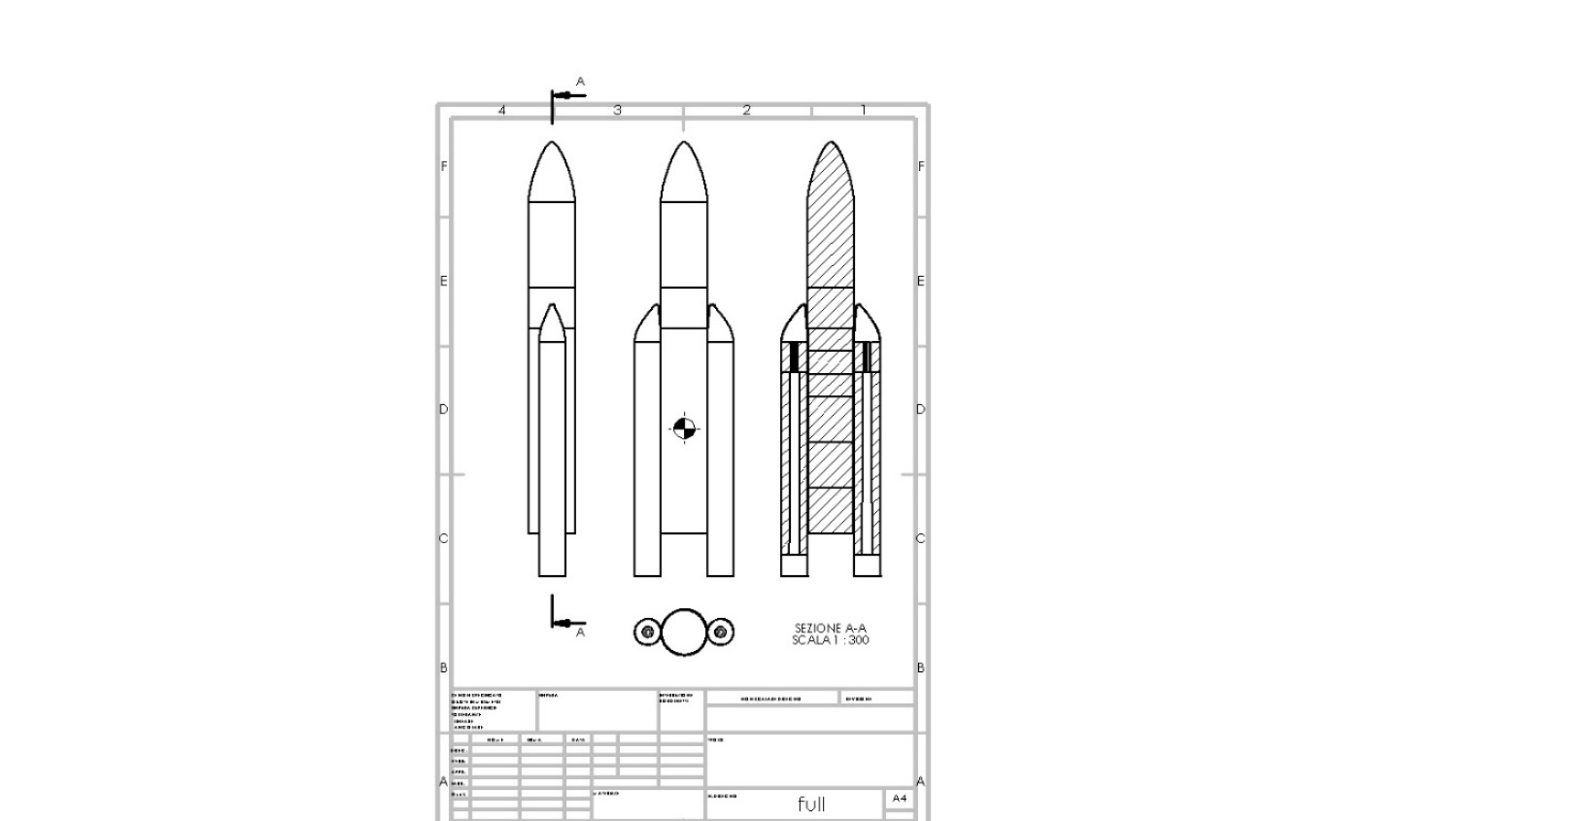

3.1 Drag coefficient

First it is evaluated the drag coefficient of the rocket. From our baseline is possible to obtain the real profile of drag coefficient in function of the Mach number. Extrapolating the data from [*], the real profile has been obtained, as can be seen in Figure **. From the data a function has been created, using the interpolation function of Matlab ®: in this way it is possible to have an approximated drag coefficient for each Mach number. In general, the drag coefficient contains different contributions, such as wave drag, skin friction, base drag, parasitic drag, …

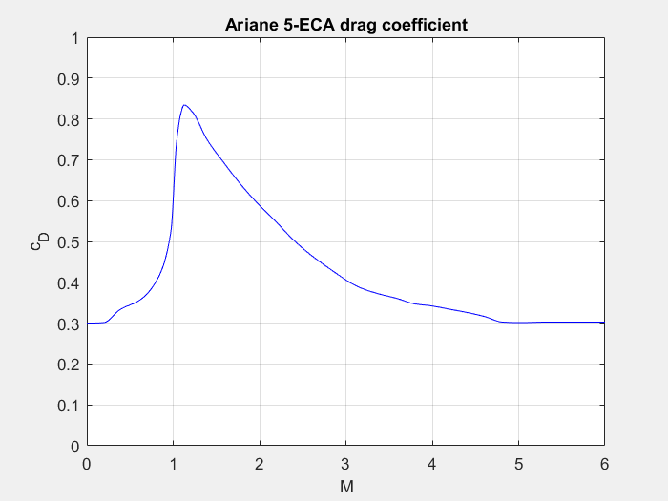

3.2 Normal force coefficient

The normal force coefficient is an important parameter, especially for the evaluation of the normal force effect on an aerodynamic model. It must be evaluated since it will be important; moreover, its derivative with respect to the angle of attack is important for the study of the cross-wind effect and the thrust vector control. From the model described previously, it can be noticed that the cross-section changes along the rocket. To obtain a result in a simple way, consider the coefficient of the two sections separately, and then we make a weighted average with the lengths. The empirical relation adopted is the following:

Since the cross section of the rocket changes, a simple approached is to consider the contribution to the coefficient of the upper part with a circular cross section (axisymmetric body), and the lower one with an elliptical cross section (lifting body). Then a weighted averaged will give the final value, weighting on the lengths. The problem is that the empirical relation is valid for a fineness ratio greater than 5, and the respective values for the two parts are both less than 5. So, a single body is considered with the length of the rocket and the elliptical section of the lower part. All the fineness ratios are reported in Table **.

|  |  |
| --- | --- |
|  | |
|  |  |
|  |  |
|  |  |

It is worth remembering that the aerodynamic coefficients must be referred to the same reference area. As a result, the relation becomes:

The behaviour is shown in Figure **.

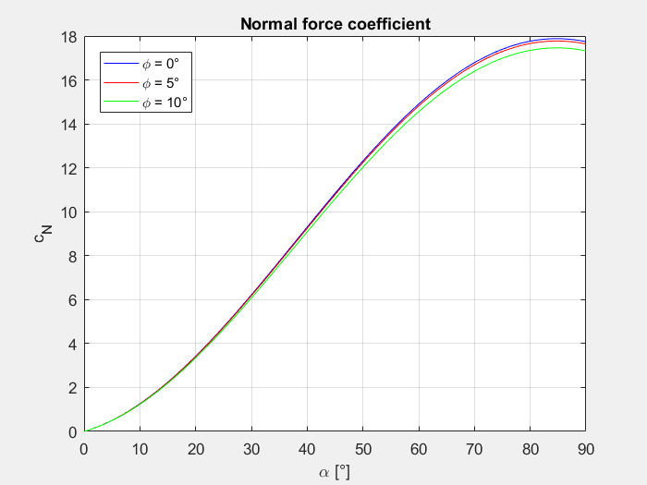

At this point is important to derive the derivative of the normal force coefficient, since it will be useful next:

Its behaviour is shown in Figure **.

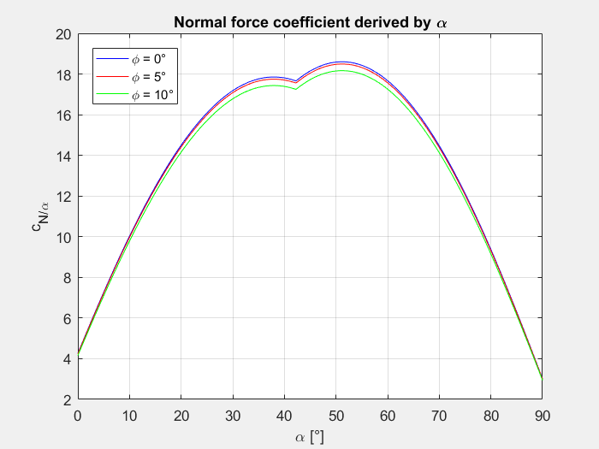

3.3 Centre of pressure

For the evaluation of the position of the centre of pressure it is adopted the slender body theory result:

2

3

1

In this relation are considered the effects of the nose (1), body (2), and flare (3). To be more precise, but without complicating too much the problem, two values are considered: one related to the main body, and the other related to the boosters. Then a weighted averaged is executed based on the lengths of the two parts. Mathematically:

It is made the assumption that the centre of pressure will remain always in that position from the nose of the Ariane.

4. Propulsion

In this chapter we will analyze the propulsion parameters of the Ariane 5 ECA rocket, trying to focus on the characteristics of its first stages: EPC (Cryogenic Main Core Stage) and EAP (Solid Rocket Boosters). The ECA version of this launcher (Evolution Cryotechnique type A) uses an improved Vulcain 2 first-stage engine, a more efficient nozzle with a more efficient flow cycle and a denser propellant ratio in order to provide an improvement in terms of Thrust. Thrust is the main parameter on which we want to focus our analysis, as we want to have a clear idea of the forces acting on our launcher during first times of the flight in order to simulate and correct the possible scenario of an imbalance between the twin and external solid rocket boosters.

4.1 EPC cryogenic main core stage

Ariane 5’s cryogenic H173 main stage is a 30.5 meters high tank divided in two compartments, one for liquid oxygen and one for liquid hydrogen. The tank ends with the Vulcain 2 engine we were talking about, characterized by a vacuum thrust of 1.390 KN. The H173 EPC weights about 189 tons (including around 175 tons of propellant). We used the data provided by the A5prop document to calculate the parameters of the Main Cryo stage in order to obtain the thrust profile variation with the altitude.

In order to understand the variation of Thrust towards the altitude we studied the trend of temperature and pressure along the atmosphere in a range from ground quote to 11000 m.

So that:

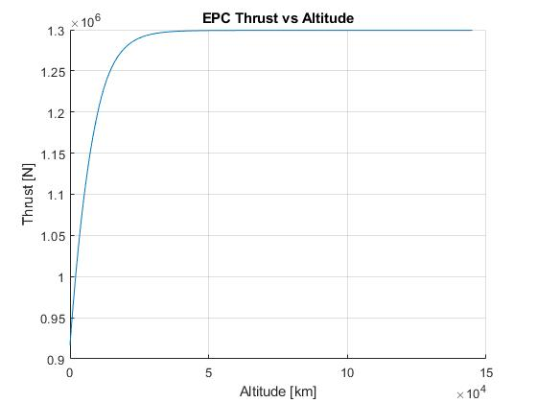

4.2 EPC cryogenic main core stage

On the sides of the EPC we find two P241 solid rocket boosters, each weighting about 277 tons full and delivering a thrust of about 7080 kN. They are fueled by a mix of ammonium perchlorate (68%), aluminium fuel (18%) and HTPB (14%), with a time burning of 130 s before being dropped.

Our aim is again to obtain the thrust profile of the Solid Rocket Boosters. In order to do this, this time we used the linear interpolation method, starting from graphical data computed using the document A5prop.pdf. In this way we obtained the trend of thrust over time during the the whole working of the boosters before the detachment of the rockets.

Moreover we integrated the EAP prop mass flow rate in order to calculate the exact amount of propellant used at a specific time instant.

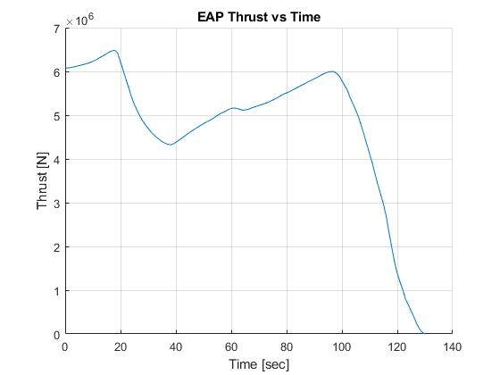

5. Mass distribution

**CENTER OF GRAVITY COMPUTATION**

|  |  |  |  |  |
| --- | --- | --- | --- | --- |
| Size solite  Mass in tons | full-of-ptopellant case | semi-full of propellant case | semi-empty case | empty case |
| Fairing | 3.41 | | | |
| second stage | 4.54 | | | |
| Main stage structure | 14.7 | | | |
| Main stage hydrogen | 37.5 | 25 | 12.5 | 0 |
| Main stage oxigen | 150 | 100 | 50 | 0 |
| Booster structure | 39 | | | |
| Booster propellant cylinder | 214.1 | 142.73 | 71.36 | 0 |
| Booster propellant star | 23.4 | 15.6 | 7.8 | 0 |

Using the data regarding size in fig () and the ones regarding masses shown in fig (), through the SolidWorks software a cad model has been realized (Ariane V full-of-ptopellant case). Then by subtracting the mass of propellant used during the different phases of the mission the center of mass has been computed. In particular four cases have been used and their section views are shown below:

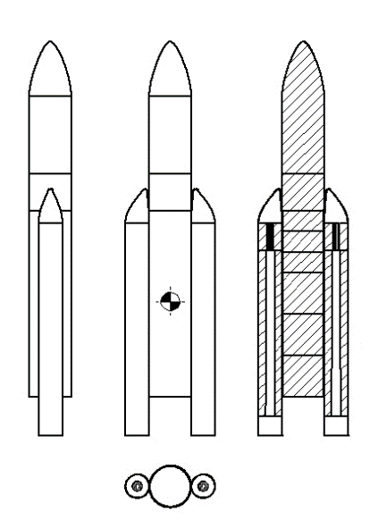 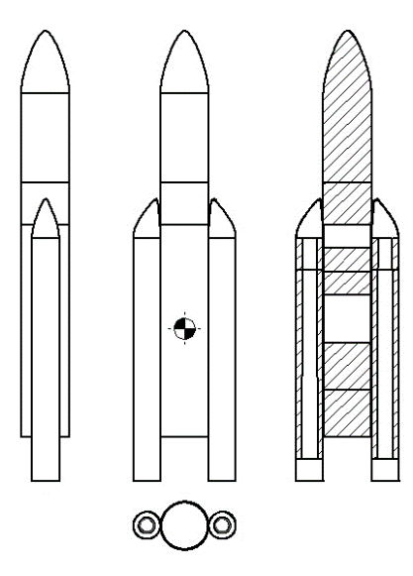

Ariane V full-of-ptopellant case Ariane V semi-full of propellant case

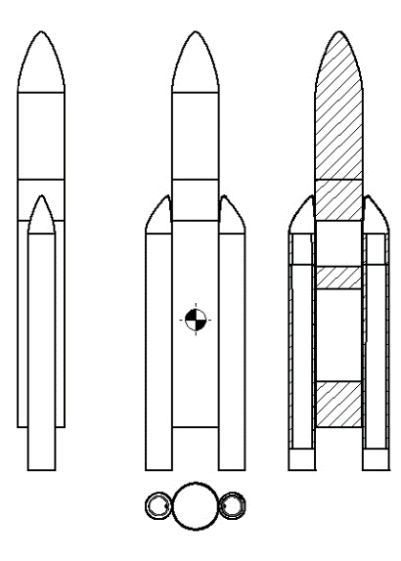 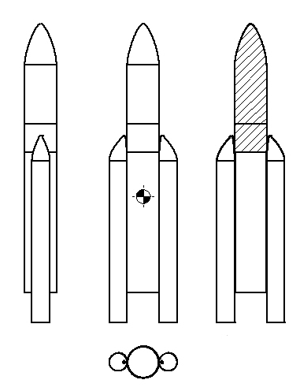

Ariane V semi-empty case Ariene V empty case

6. Thrust vector control

At this point it’s important to analyse the effect of the imbalance on the rocket when flying at a certain attitude and altitude. We will analyse two cases: vertical launch and maximum dynamic pressure condition. In addition, for each case it’s considered the shift of the CG of the Ariane after the burning of the propellant for each of the two conditions: the evaluation of CG is obtained with the software SolidWorks ®. The results on the deflection angles of all the three nozzles (1 EPC, 2 SRM), with the resulting thrust in the direction of motion, are shown. First, it will be analysed the imbalance modelling. The maximum deflection angles for the nozzles are reported in Table **.

|  |  |
| --- | --- |
|  | |
|  |  |
|  |  |

6.1 Imbalance

The imbalance is defined as the difference between the thrust given by the two external boosters:

The imbalance comes out from the variability of the parameters related the combustion process [**]. To model it simply, it is considered a maximum value of imbalance equal to the 5% of the thrust of the single SRM. First are created random variations of the thrust for the two SRMs, but different, with a maximum value of 2.5%. Then, they are summed to give a random thrust imbalance. 1000 samples will be considered, with zero mean and 1σ of standard deviation, using the function *rand* of Matlab ®: in this way the level of thrust change will be equally distributed. Mathematically it means:

In this way the imbalance can be given by a random effect of increasing or decreasing thrust of both the SRMs.

6.2 Vertical launch

The first case analysed is the vertical launch with conditions and parameters reported in Table **, coming from aerodynamics, propulsion, and mass distribution. It is analysed only the effect of the imbalance of the twin external rocket since a zero angle of attack is considered.

|  |  |
| --- | --- |
|  | |
|  |  |
|  |  |
|  |  |
|  |  |
|  |  |

To compute the effect of the imbalance is shown the deflection of the TVC for the two SRMs in function of the level of imbalance. For each possible imbalance simulated it is evaluated the deflection of the left and the right booster nozzle. The scheme is shown in Figure **: positive rotations are counter clockwise, also for the deflection angles. Then it is considered the equilibrium around the CG of the rocket; the following equations comes out. If the imbalance is positive, it’s rotating the left nozzle to compensate it, obtaining:

, while if the imbalance is negative rotates the other, obtaining:

To solve for the deflection angle has been used the function *fsolve* of Matlab ®. The resulting deflection angles are shown in Figure **. It can be noticed that the angles are always less than the limiting ones. The ideal thrust is given by:

Finally, the resulting overall thrust is evaluated as follows:

The result is reported in Figure **, where it is also shown the ideal thrust without imbalance.

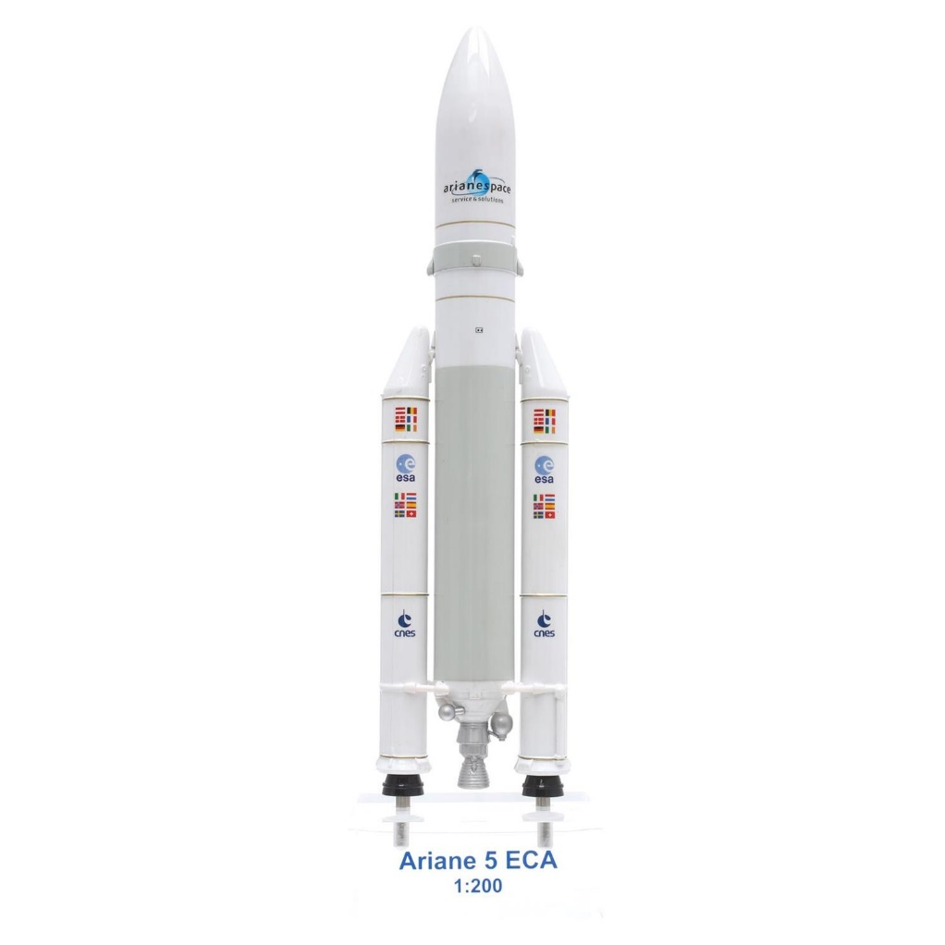

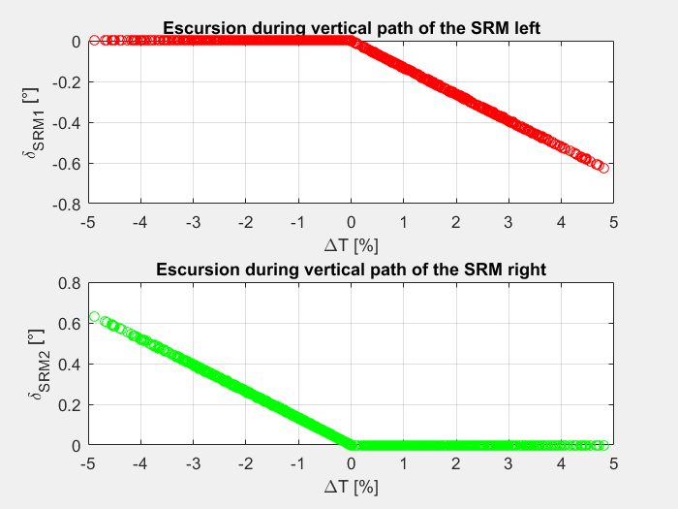

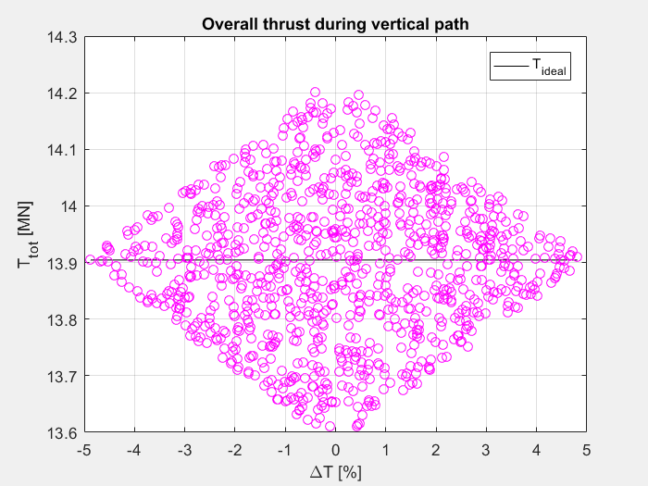

6.3 Maximum dynamic pressure

After the gravity turn, the rocket is at a certain attitude represented by its angle of attack. In this case will be considered the imbalance together with the stability against the action of the normal aerodynamic force, in case of maximum dynamic pressure. First it is rotated the nozzle of the EPC to counteract the aerodynamic force. Then are rotated the two SRM nozzles to counteract the imbalance. Since there is a limit on the deflection angle, when it is exceeded, it is set to the maximum value possible and then are rotated the two SRM nozzle together. Finally, it’s rotated the proper SRM nozzle to counteract also the imbalance. The scheme for this case is shown in Figure **.



The conditions and parameters reported in Table **.

|  |  |
| --- | --- |
|  | |
|  |  |
|  |  |
|  |  |
|  |  |
|  |  |
|  |  |
|  |  |
|  |  |

For the imbalance it is used the same equation for the vertical launch, while for the counteracting of the aerodynamic force it’s followed the subsequent reasoning:

1. Rotate the EPC nozzle without rotating the SRM nozzles, using the following relation:

where the angle of attack is positive.

1. Rotate the proper SRM nozzle to counteract the imbalance (as in 1.1).
2. If the limiting value is overcome, the other two nozzles are rotated simultaneously to compensate the remaining moment. This is done solving the following equation of balance (again using *fsolve*):

where δ is the angle of which rotates the two SRM nozzles. Then this angle is added properly to the previous value resulting from the imbalance.

1. Then it is evaluated also the ideal thrust without imbalance:
2. Finally, the resulting real thrust is obtained as:

At this point, for the simulation are considered three levels of angles of attack (1°, 3°, 5°). The resulting deflection angles are shown in Figure ** **, while the overall thrust is shown in Figure **.

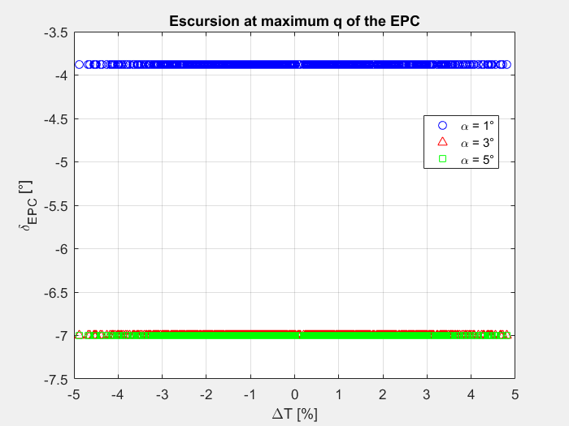

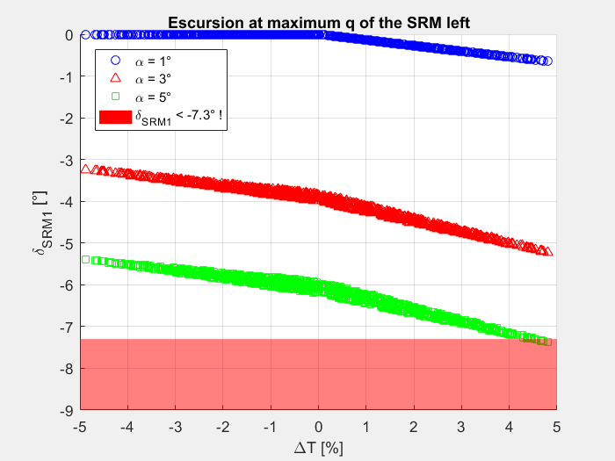

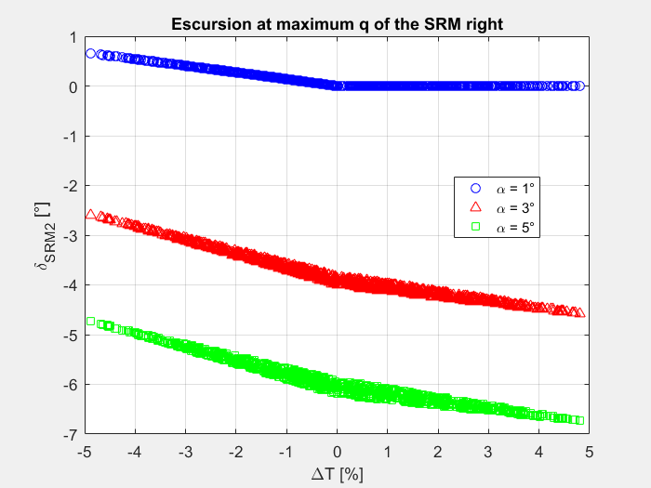

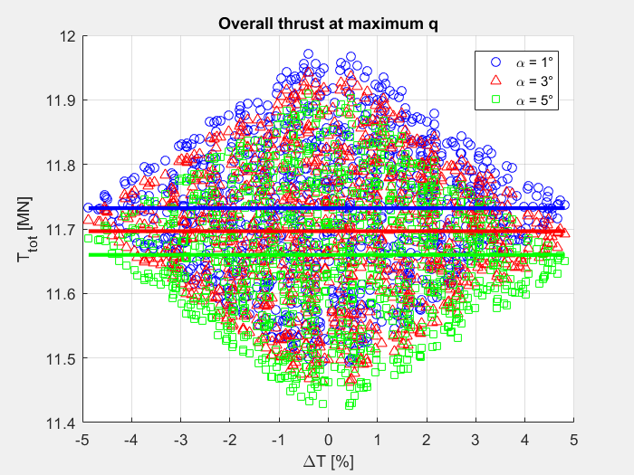

7. Summary and conclusions

8. List of references

1. W.A. Foster, R.H. Sforzini, B.W. Schackelford, “Thrust Imbalance of the Space Shuttle Solid Rocket Motors”, *AIAA*, AIAA Paper 1981-1610.
2. W.A. Foster, R.H. Sforzini, P.H. Shu, “Thrust Imbalance of Solid Rocket Motors Pairs on Space Shuttle Flights”, *AIAA*, AIAA Paper 1986-1375.
3. W.A. Foster, W. Crowder, T.E. Steadman, “A Monte Carlo Analysis of the Thrust Imbalance for the Space Launch System Booster during Both the Ignition Transient and Steady State Operation”, *AIAA*, AIAA Paper 2014-12532.