

|  |  |
| --- | --- |
|  | |
|  |  |
|  |  |
|  |  |
|  |  |
|  |  |
|  |  |

Final Report of Task No. 3

**Course of Launch Systems**

**School of Industrial Engineering**

**Academic Year 2017 -2018**

Abstract

This report contains the results of the analysis of the thrust imbalance between the twin external solid rocket motors (SRMs) used on the *Ariane 5-ECA*. All the real characteristics of the rocket (geometry, masses, deflection angles limits, …) have been taken. A first analysis of the aerodynamic, propulsion and mass distribution was performed to develop the thrust imbalance study. The study is focused on the thrust vector control (TVC) system, consisting on the movable nozzles of the two boosters and the central liquid rocket engine. The single SRM thrust is modelled with two different rectangular distributions and then is evaluated the resulting imbalance to give more generality to its formation. The report will cover many important aspects regarding the launcher starting from a managerial study of the project through a House of Quality analysis and a project triangular scheme. The results obtained are then compared to the limiting angles to see if they are overcome. Two critical conditions are considered: maximum SRM thrust and maximum dynamic pressure. At the end, the TVC systems are able to counteract a normal force for small angles of attack, in which the rocket typically works.

Table of contents

1. Introduction 8

2. Requirements & Specifications 9

2.1 Requirements 9

2.2 Specifications 10

2.2.1 Project management triangle 10

2.2.2 Functional requirements 10

2.2.3 Competitive analysis 11

2.2.4 House of Quality analysis 12

2.2.5 Baseline 13

3. Aerodynamics 14

3.1 Drag coefficient 15

3.2 Normal force coefficient 15

3.3 Centre of pressure 18

4. Propulsion 20

4.1 EPC cryogenic main core stage 20

4.2 EAP boosters 22

5. Mass distribution 23

6. Thrust vector control 25

6.1 Imbalance 25

6.2 Maximum EAP thrust 26

6.3 Maximum dynamic pressure 29

7. Summary and conclusions 30

8. List of references 37

List of figures

Figure 1: Project management triangle 10

Figure 2: House of Quality 12

Figure 3: Ariane 5-ECA scheme: outside view (left) and inside view (right) 14

Figure 4: Zero-lift drag coefficient 15

Figure 5: Normal force coefficient 17

Figure 6: Normal force coefficient derivative 18

Figure 7: EPC thrust vs altitude 21

Figure 8: EAP thrust vs altitude 22

Figure 9: Ariane 5-ECA mass distribution at 18 s (left) and 71 s (right) 24

Figure 10: Ariane 5-ECA TVC scheme 26

Figure 11: Excursion at maximum EAP thrust of the EPC nozzle 30

Figure 12: Excursion at maximum EAP thrust of the EAP left nozzle 31

Figure 13: Excursion at maximum EAP thrust of the EAP right nozzle 31

Figure 14: Overall thrust at maximum EAP thrust 32

Figure 15: Excursion at maximum q of the EPC nozzle 33

Figure 16: Excursion at maximum q of the EAP left nozzle 33

Figure 17: Excursion at maximum q of the EAP right nozzle 34

Figure 18: Overall thrust at maximum q 34

List of tables

Table 1: Fineness ratios l/d 16

Table 2: Ariane 5-ECA data 23

Table 3: Maximum EAP thrust condition at 18 s 23

Table 4: Maximum dynamic pressure condition at 71 s 23

Table 5: Maximum deflection angles 25

Table 6: Parameters for maximum EAP thrust 27

Table 7: Parameters for maximum dynamic pressure 28

Nomenclature

|  |  |
| --- | --- |
|  |  |
|  |  |
|  |  |
|  |  |
|  |  |
|  |  |
|  |  |
|  |  |
|  |  |
|  |  |
|  |  |
|  |  |
|  |  |
|  |  |
|  |  |
|  |  |
|  |  |
|  |  |
|  |  |
|  |  |
|  |  |
|  |  |
|  |  |
|  |  |
|  |  |
|  |  |
|  |  |
|  |  |
|  |  |
|  |  |
|  |  |
|  |  |
|  |  |
|  |  |
|  |  |
|  |  |
|  |  |
|  |  |
|  |  |
|  |  |
|  |  |
|  |  |
|  |  |
|  |  |
|  |  |
|  |  |
|  |  |
|  |  |

Data

|  |  |
| --- | --- |
|  |  |
|  |  |
|  |  |
|  |  |
|  |  |
|  |  |
|  |  |
|  |  |
|  |  |
|  |  |
|  |  |
|  |  |
|  |  |
|  |  |
|  |  |
|  |  |

|  |  |  |  |  |
| --- | --- | --- | --- | --- |
|  |  |  |  |  |
|  |  |  |  |  |
|  |  |  |  |  |

# 1. Introduction

Thrust imbalance is an important issue in case of external solid rocket motors. The rocket launcher under study is the *Ariane 5-ECA*, which has been chosen as baseline, and as competitors Falcon Heavy and Delta IV Heavy. Its origin has been studied for different rockets. A first study was performed on the Space Shuttle solid rocket motors [1, 2]. These studies performed Monte Carlo simulations to see the resulting thrust imbalance in two cases: ignition and transients. The nature of the imbalance is related to the internal behaviour of the motor. They introduced random variations for the main variables defining the propulsion parameters from which the thrust has been evaluated for the couple of motors, and then they have simulated the thrust imbalance. Also, recent works has been done, as the one on the Space Launch System by NASA [3]. The main effect due to thrust imbalance considered in this study can be explained as a disturbance moment generated by an off-design performance of the boosters. The resulting couple of the solid boosters’ thrusts tends to make the rocket turn. In design conditions, the moments generated by the boosters are perfectly balanced between themselves; in real applications, some disturbances may cause the generation of the imbalance effect even if boosters are working near to optimal performance condition. TVC is used to compensate the rotation and to follow the desired attitude during the launch. A normal aerodynamic force *N* has been introduced to be counteracted by the TVC systems, in addition to the imbalance. Different levels of *N* are analysed, changing the angle of attack. The thrust losses are modelled as random variations of thrust levels that can be expressed statistically as a rectangular distribution around the average nominal value. The study is focused on the boosting phase explaining briefly the ideal case and providing an insight of a hypothetic thrust imbalance scenario due to possible engine issues to both the solid boosters, leading to thrust variations in a range between +/- 5%. For this analysis have been used two software: Matlab® (for the simulations and parameters computations) and SolidWorks® (for the model creation and the mass distribution).

# 2. Requirements & Specifications

## 2.1 Requirements

The customer requirements [relative weight] are:

* *Similar-to-target altitude and velocity at boosters’ detachment* [30.3%]: due to an imbalance in the thrust the preliminary target can be unreachable and an acceptable similar one should be reached.
* *Full control of trajectory* [24.2%]: during the whole flight, the rocket trajectory must be fully controllable.
* *High precision attitude control* [21.2%]: to manage the thrust imbalance an effective attitude control system is required.
* *Lightweight system* [6.1%]: a lightweight system is preferable due to many advantages.
* *Cheap system* [6.1%].
* *Robustness to atmospheric disturbances* [12.1%]: a minor effect of atmospheric disturbances (e.g. transversal winds) should help in focusing on the management of thrust imbalance.

## 2.2 Specifications

### 2.2.1 Project management triangle



Figure 1: Project management triangle

As managerial approach, the best decision results in focusing on performances and time, with a minimum weak limitation on cost. In terms of performances it’s needed to fulfil the customer requirements; in addition, in order to achieve those requirements a fast approach has been selected. The scheme is shown in Figure 1.

### 2.2.2 Functional requirements

The functional requirements [relative weight] are:

* *TVC angle excursion* [13.0%]: a higher angle is preferable to obtain a larger controllability window for rocket attitude dynamics.
* *Aerodynamic drag* [4.0%]: a low aerodynamic effect is important to reduce stresses and losses.
* *Sustainer thrust fraction* [4.6%]: a higher fraction would guarantee a minor sensibility to boosting phase imbalance, however losses due to parallel configuration are increased.
* *Boosters thrust fraction* [10.1%]: a higher fraction would cause a major sensibility to boosting phase imbalance, but it would grant a smaller system due to a lower propellant volume.
* *Centre of mass excursion* [5.1%].
* *Misalignment of thrust with respect to centre of mass* [9.8%]: the boosting phase unbalance generates an arm for the vertical component of thrust, that causes an undesired moment.
* *Velocity at boosters’ detachment* [7.8%].
* *Altitude at boosters’ detachment* [9.1%].
* *Sensors responding time* [13.7%].
* *Attitude angular position sensitivity* [10.1%]: parameter that defines how much sensors’ sensitivity to angular position affects the precision in attitude reconstruction.
* *Attitude angular velocity sensitivity* [10.1%]: parameter that defines how much sensors’ sensitivity to angular velocity affects the precision in attitude reconstruction.
* *GPS/Radar visibility* [2.6%]: important parameter to keep track of the rocket during its flight trajectory.

### 2.2.3 Competitive analysis

Two main competitors to Ariane 5-ECA are considered:

* SpaceX – *Falcon Heavy*
* Nasa – *Delta IV Heavy*

As shown in Figure 2, the strongest competitor is the SpaceX - *Falcon Heavy* which assures higher performances in most of the customer requirements. However, *Falcon Heavy* has never flown in a real mission and because of this its data are just theoretical. The *Delta IV Heavy* has accomplished many missions, but it has lower performances in all the meaningful mission parameters exception made for the lightweight system parameter.

### 2.2.4 House of Quality analysis

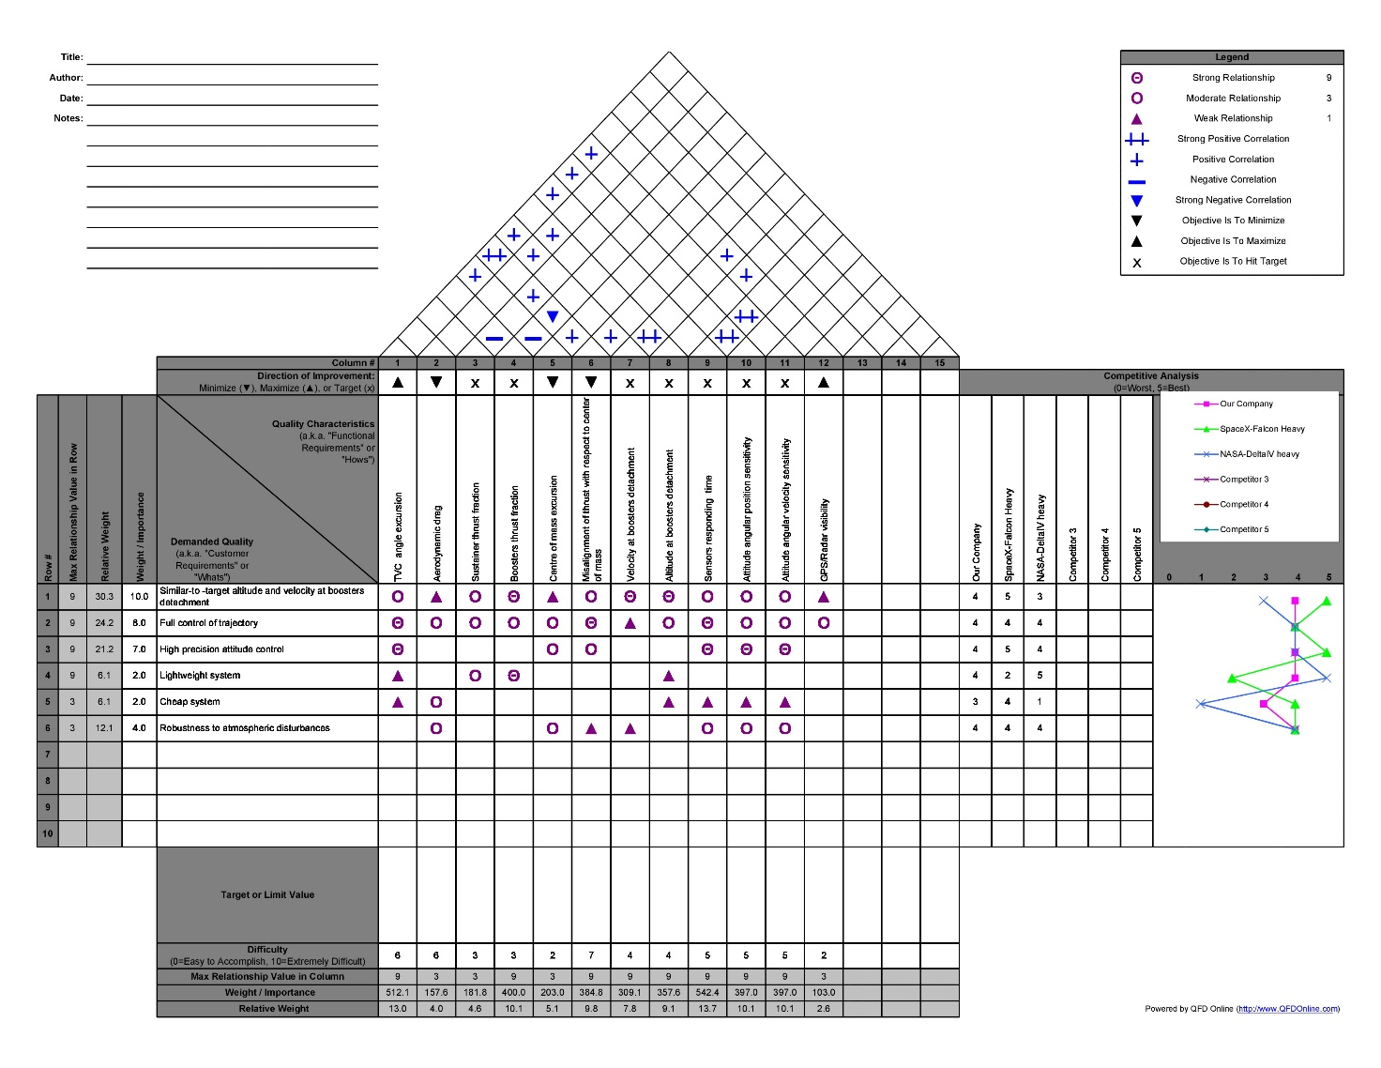

Figure 2: House of Quality

The House of Quality results are shown in Figure 2. The most important functional requirements according to the House of Quality are *Sensor Responding Time* (13.7% with respect to the weight of all the other ones) and *TVC angle excursion* (with a relative weight of 13.0%). In addition, precision in the attitude determination is an important parameter and it is defined by two tied requirements in third place (10.1% for *Attitude Angular Velocity Sensitivity* and *Attitude Angular Position Sensitivity*). In addition, *Boosters thrust fraction* is tied at 10.1% and it affects the attitude control and determination because lowest is their thrust fraction, lowest will be also the imbalance generated by them. All the other functional requirements have lower relative weights that make them of low importance to this study. Suitable time of response and high precision of the sensors are essential in order to reconstruct the attitude of the system, while a suitable TVC control system is strictly needed to correct the attitude and to follow the desired configuration. The combination of these two requirements leads to an effective active attitude control of the launcher able to counteract imbalance effects. In our analysis, a proper attitude reconstruction by sensors data is assumed as given and the whole work is focused on the use of TVC system.

### 2.2.5 Baseline

*Ariane 5-ECA* in the nominal condition is the baseline for this study. The nominal system is composed by a parallel first stage with a liquid cryogenic couple main engine and two solid rocket boosters that provide almost 90% of the total thrust at lift-off. There is also a cryogenic upper stage, but it is of no interest for this project. All the data are listed in the *Data* section for the sake of clarity. All the additional parameters needed for this study (aerodynamic, propulsion, mass distribution, …) will be evaluated next.

# 3. Aerodynamics

In this chapter it will be analysed the Ariane 5-ECA rocket aerodynamics. Aerodynamics is a very complex aspect to model during a design phase, and the behaviour of the flow around a rocket is very complicated and difficult to foresee. In this case the configuration of a parallel rocket complicates more the study. The model of the rocket has been created with SolidWorks ® using the real dimensions and masses [Figure 3]. The main aspect analysed are the zero-lift drag coefficient, the normal force coefficient (useful for the thrust vector control) and the position of the centre of pressure (useful for the thrust vector control).

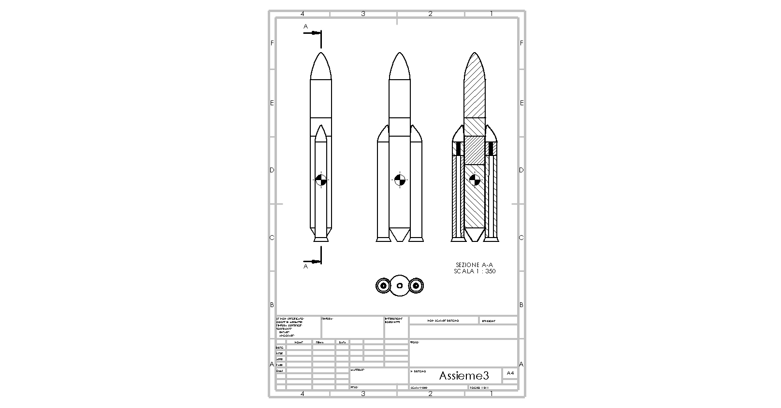

Figure 3: Ariane 5-ECA scheme: outside view (left) and inside view (right)

## 3.1 Drag coefficient

First, the zero-lift drag coefficient of the rocket is evaluated. From our baseline is possible to obtain the real profile of drag coefficient in function of the Mach number. Extrapolating the data from [4], the real profile has been obtained, as can be seen in Figure 4. From the real data a function has been created, using the interpolation function of Matlab®: in this way it is possible to have an approximated drag coefficient for each Mach number. In general, the drag coefficient contains different contributions, such as wave drag, skin friction, base drag, parasitic drag, …

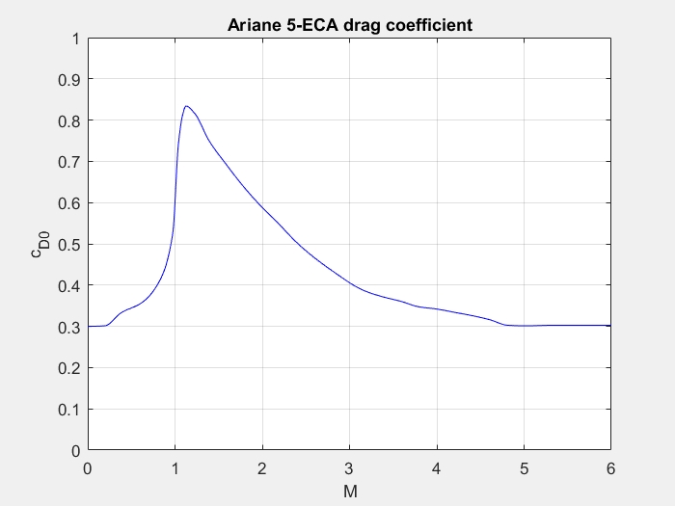

Figure 4: Zero-lift drag coefficient

## 3.2 Normal force coefficient

The normal force coefficient is an important parameter, especially for the evaluation of the normal force effect on an aerodynamic model. It must be evaluated since it will be important; moreover, its derivative with respect to the angle of attack is important for the study of a normal aerodynamic force effect and the thrust vector control. From the model described previously, it can be noticed that the cross-section changes along the rocket. To obtain a result in a simple way, consider the coefficient of the two sections separately, and then we make a weighted average with the lengths. The empirical relation adopted is the following:

Since the cross section of the rocket changes, a simple approach is to consider the contribution to the coefficient of the upper part with a circular cross section (axisymmetric body), and the lower one with an elliptical cross section (lifting body). Then a weighted averaged will give the final value, weighting on the lengths. The issue is that the empirical relation is valid for a fineness ratio greater than 5, and the respective values for the two parts are both less than 5. So, a single body is considered with the length of the rocket and the elliptical section of the lower part. All the fineness ratios are reported in Table 1.

Table 1: Fineness ratios l/d

|  |  |
| --- | --- |
|  |  |
|  |  |
|  |  |

It is worth remembering that the aerodynamic coefficients must be referred to the same reference area. As a result, the relation becomes:

The behaviour is shown in Figure 5. It is worth noting that this relation is not properly correct for this case, also due to the great complexity of the rocket itself; however, it is useful since it gives a good estimation of the normal force coefficient, which will be used, with its derivative with respect to the angle of attack, for the evaluation of the normal aerodynamic force in the plane of the thrust.

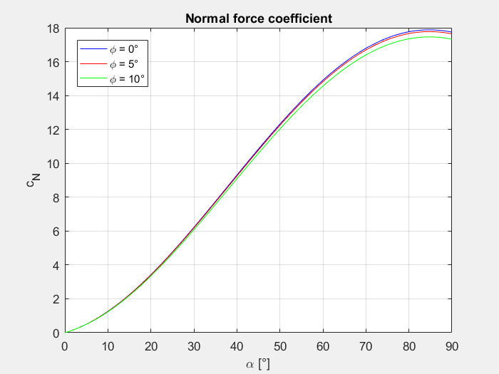

Figure 5: Normal force coefficient

At this point is important to derive the derivative of the normal force coefficient, since it will be useful next:

Its behaviour is shown in Figure 6.

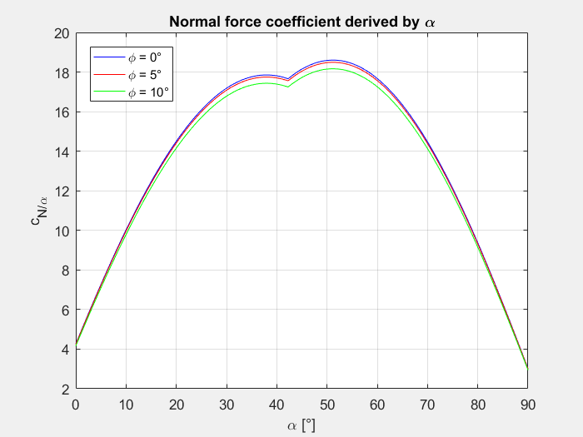

Figure 6: Normal force coefficient derivative

## 3.3 Centre of pressure

To evaluate the position of the centre of pressure, the slender body theory is adopted and the result is (valid for small angles of attack):

3

2

1

In this relation are considered the effects of the nose (1), body (2), and flare (3). To be more precise, but without complicating too much the problem, two values are considered: one related to the main body, and the other related to the boosters. Then a weighted averaged is executed based on the lengths of the two parts. Mathematically:

The assumption that the centre of pressure will remain always in that position from the nose of the rocket has been made.

# 4. Propulsion

In this chapter we will analyze the propulsion parameters of the Ariane 5 ECA rocket, trying to focus on the characteristics of its first stages: EPC (Cryogenic Main Core Stage) and EAP (Solid Rocket Boosters). The ECA version of this launcher (Evolution Cryotechnique type A) uses an improved Vulcain 2 first-stage engine, a more efficient nozzle with a more efficient flow cycle and a denser propellant ratio in order to provide an improvement in terms of Thrust. Thrust is the main parameter on which we want to focus our analysis, as we want to have a clear idea of the forces acting on our launcher during first times of the flight in order to simulate and correct the possible scenario of an imbalance between the twin and external solid rocket boosters.

## 4.1 EPC cryogenic main core stage

Ariane 5’s cryogenic H173 main stage is a 30.5 meters high tank divided in two compartments, one for liquid oxygen and one for liquid hydrogen. The tank ends with the Vulcain 2 engine we were talking about, characterized by a vacuum thrust of 1.390 KN. The H173 EPC weights about 189 tons (including around 175 tons of propellant). We used the data provided by the A5prop document to calculate the parameters of the Main Cryo stage in order to obtain the thrust profile variation with the altitude.

In order to understand the variation of Thrust towards the altitude we studied the trend of temperature and pressure along the atmosphere in a range from ground quote to 11000 m.

So that:

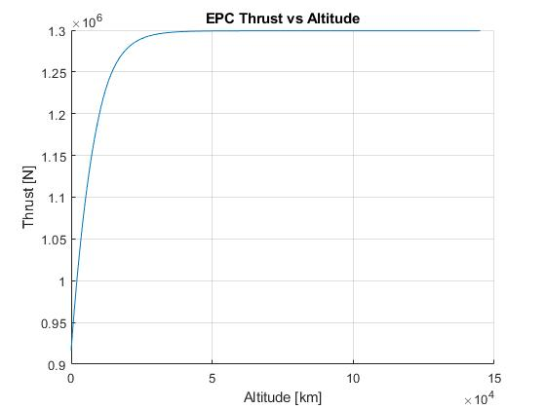

Figure 7: EPC thrust vs altitude

## 4.2 EAP boosters

On the sides of the EPC we find two P241 solid rocket boosters, each weighting about 277 tons full and delivering a thrust of about 7080 kN. They are fueled by a mix of ammonium perchlorate (68%), aluminium fuel (18%) and HTPB (14%), with a time burning of 130 s before being dropped.

Our aim is again to obtain the thrust profile of the Solid Rocket Boosters. In order to do this, this time we used the linear interpolation method, starting from graphical data computed using the document A5prop.pdf. In this way we obtained the trend of thrust over time during the the whole working of the boosters before the detachment of the rockets.

Moreover we integrated the EAP prop mass flow rate in order to calculate the exact amount of propellant used at a specific time instant.

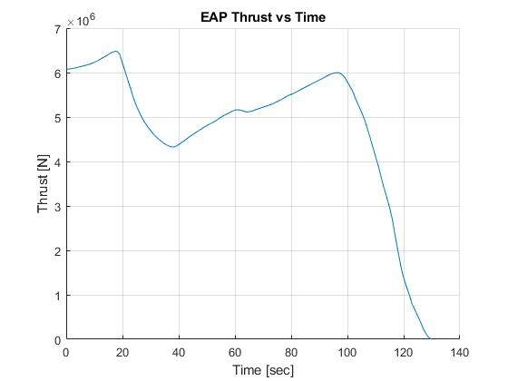

Figure 8: EAP thrust vs altitude

# 5. Mass distribution

Using the data from the baseline, the main parameters have been calculated to evaluate the mass distribution: all the values are reported in Table 2. Through the SolidWorks® software a cad model has been realized (Ariane 5-ECA full-of-propellant case, at zero seconds). By subtracting the mass of propellant used during the different phases of the mission the center of mass has been computed for each case of interest using the software. Two cases were taken under investigation: the one at maximum thrust and the one at maximum dynamic pressure.

Table 2: Ariane 5-ECA data

|  |  |  |  |
| --- | --- | --- | --- |
|  |  |  |  |
|  |  |  |  |
|  |  |  |  |
|  |  |  |  |
|  |  |  |  |

At this point it’s requested to know how much propellant mass has to be removed to simulate the shift of the CG. The maximum thrust case corresponds to time = 18 seconds. During this phase, using a Matlab® code, the consumption of the propellant has been computed (thanks to the mass flow rates). In Table 3 are reported the results.

Table 3: Maximum EAP thrust condition at 18 s

|  |  |  |  |
| --- | --- | --- | --- |
|  |  |  |  |
|  |  |  |  |

Removing the corresponding part of propellant, taking in account its burning behavior, from the full-of-propellant case, the center of gravity results to be of 16.2341 meters (from the base of the launcher). Can be noticed that the top part of the SRM has a star-shaped component, that guarantees the higher thrust profile. The maximum dynamic pressure case corresponds to time = 71 seconds. In an analogous way to the maximum thrust case, the mass of propellant burned has been found. In Table 4 are reported the results.

Table 4: Maximum dynamic pressure condition at 71 s

|  |  |  |  |
| --- | --- | --- | --- |
|  |  |  |  |
|  |  |  |  |

Removing the corresponding part of propellant from the full-of-propellant case, the center of gravity results to be of 17.3815 meters. In particular, it can be noticed that the top part of the SRM is no more star-shaped. The resulting mass distributions inside the rocket for the two cases are shown in Figure 9.

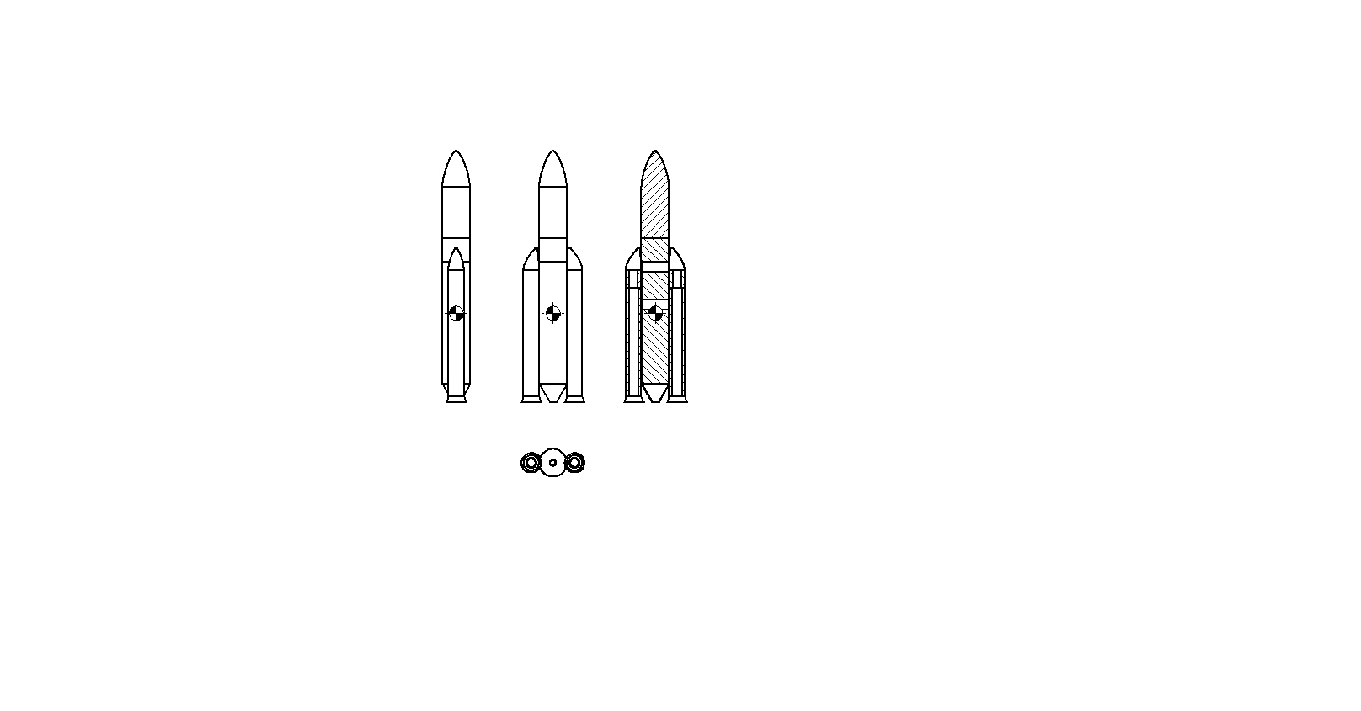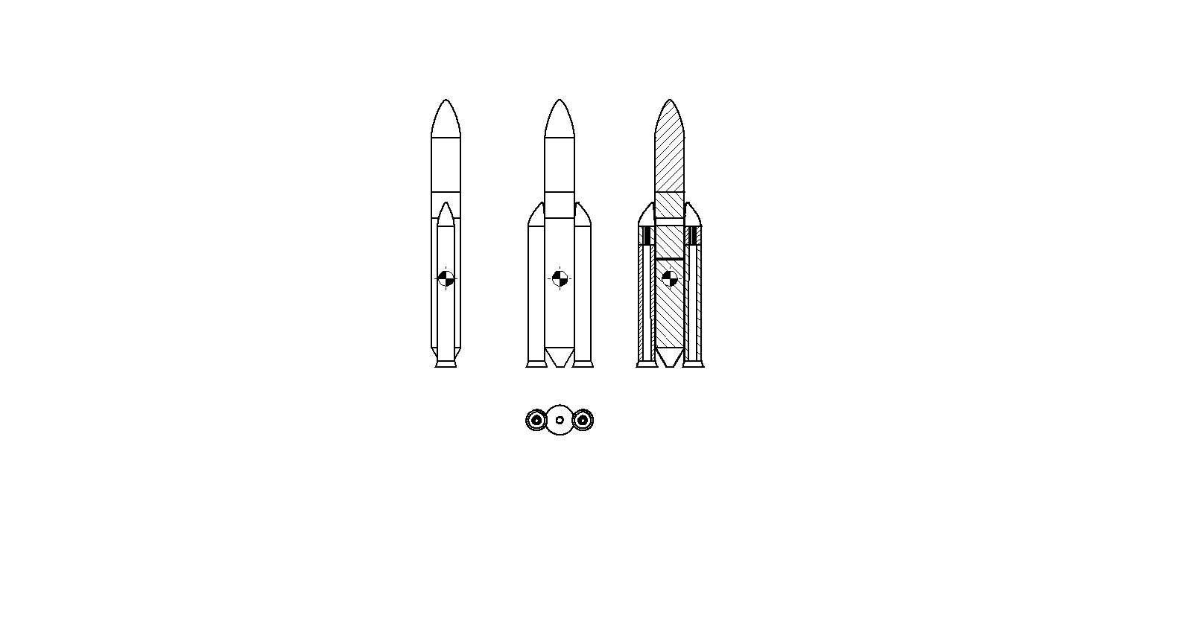

Figure 9: Ariane 5-ECA mass distribution at 18 s (left) and 71 s (right)

# 6. Thrust vector control

At this point it’s important to analyse the effect of the imbalance on the rocket when flying at a certain attitude and altitude. We will analyse the effect of a normal aerodynamic force *N* in two critical cases: maximum EAP thrust and maximum dynamic pressure. In addition, for each case it’s considered the shift of the CG of the Ariane after the burning of the propellant for each of the two conditions: the evaluation of CG was obtained in chapter 4. The results on the deflection angles of all the three nozzles (1 EPC, 2 EAP), with the resulting thrust in the direction of motion, are shown. First, it will be analysed the imbalance modelling. The maximum deflection angles for the nozzles are reported in Table 5.

Table 5: Maximum deflection angles

|  |  |
| --- | --- |
|  |  |
|  |  |

## 6.1 Imbalance

The imbalance is defined as the difference between the thrust given by the two external boosters:

To model it simply, it is considered a maximum value of imbalance equal to the 5% of the thrust of the single SRM. First random variations of the thrust for the two SRMs are created, but different, with a maximum value of ±2.5%. Then, they are subtracted to give a random thrust imbalance. 1000 samples will be considered, with zero mean and 1σ of standard deviation, using the function *rand* of Matlab ®: in this way the level of thrust change will be equally distributed. Mathematically it means:

In this way the imbalance can be given by a random effect of increasing or decreasing thrust of both the SRMs. It is important to underline that the two random parameters are considered uncorrelated.

## 6.2 Maximum EAP thrust

The first case analysed is the condition of maximum EAP thrust. It will be considered the imbalance together with the stability against the action of the normal aerodynamic force: the scheme for this case is shown in Figure 9, where positive rotations are counter clockwise (also for the deflection angles). The approached followed is the subsequent. First it is rotated the nozzle of the EPC to counteract the aerodynamic force. Then is rotated the proper SRM nozzle to counteract the imbalance. Since there is a limit on the deflection angle of the EPC, when it is exceeded, it is set to the maximum value possible and then are rotated the two SRM nozzles together, analysing if they are able to counteract the normal force. A 2 degrees of freedom model has been selected for this design.

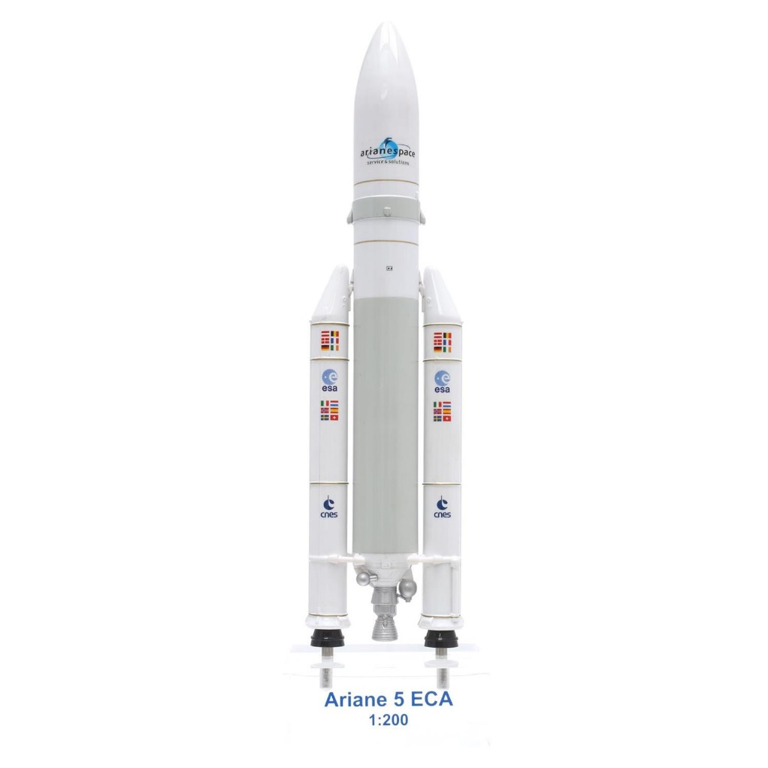

Figure 10: Ariane 5-ECA TVC scheme

The conditions and parameters are reported in Table 6, coming from aerodynamics, propulsion, and mass distribution.

Table 6: Parameters for maximum EAP thrust

|  |  |
| --- | --- |
|  |  |
|  |  |
|  |  |
|  |  |
|  |  |
|  |  |
|  |  |
|  |  |

It is considered the equilibrium around the CG of the rocket. To counteract the aerodynamic force, the subsequent reasoning has been followed:

1. Rotate the EPC nozzle without rotating the SRM nozzles, using the following relation:

where the angle of attack is positive.

1. If the imbalance is positive , it’s rotating the left nozzle to compensate it, obtaining:

, while if the imbalance is negative rotates the other, obtaining:

The resulting deflection angle is obtained, using the function *fsolve* of Matlab ®.

1. If the limiting value of the EPC nozzle is overcome, the other two nozzles are rotated simultaneously to compensate the remaining moment. This is done solving the following equation of balance (again using *fsolve*):

where δ is the angle of which rotates the two SRM nozzles. Then this angle is added properly to the previous value resulting from the imbalance.

1. Then it is evaluated also the ideal thrust without imbalance:
2. Finally, the resulting real thrust is obtained as:

At this point, for the simulation five values for the angle of attack are considered (0°, 3°, 5°, 7°, 10°).

## 6.3 Maximum dynamic pressure

The second condition is that of maximum dynamic pressure. The conditions and parameters are reported in Table **. It will be follow the same procedure seen before. The resulting deflection angles are shown in Figure ** **, while the overall thrust is shown in Figure **.

Table 7: Parameters for maximum dynamic pressure

|  |  |
| --- | --- |
|  |  |
|  |  |
|  |  |
|  |  |
|  |  |
|  |  |
|  |  |
|  |  |
|  |  |

# 7. Summary and conclusions

Finally, the results obtained from the simulations are described below. First consider the case of maximum EAP thrust condition. In this case the dynamic pressure has a low value and the associated normal aerodynamic force will be not so large. In Figure 11 is shown the deflection angle of the EPC motor used to counteract the normal force. As it can be seen, up to 5° is able alone to counteract it. Then, it’s necessary to use also the two boosters. In Figures 12 and 13 are shown the deflection angles for the left and the right EAP nozzles respectively. In this case the results show that there are no problems in counteracting the normal force, also at 10°, since the limiting value is never reached. Finally, the plot of the resulting thrust in the axial direction is shown (compared to the ideal one) [Figure 14].

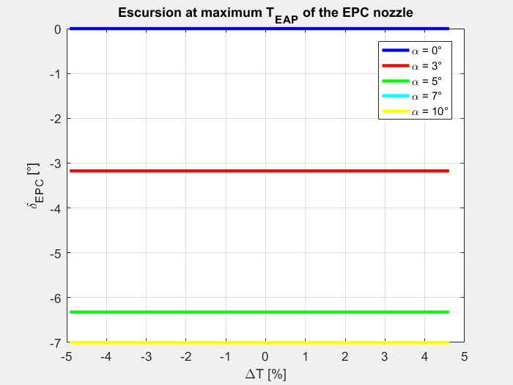

Figure 11: Excursion at maximum EAP thrust of the EPC nozzle

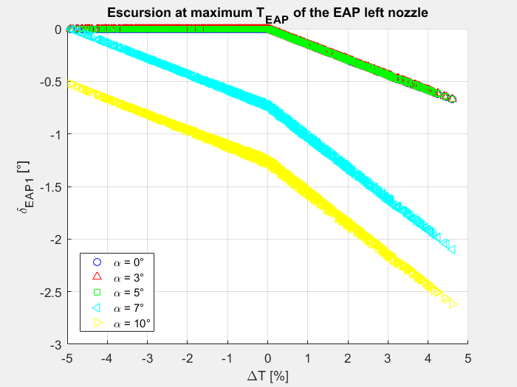

Figure 12: Excursion at maximum EAP thrust of the EAP left nozzle

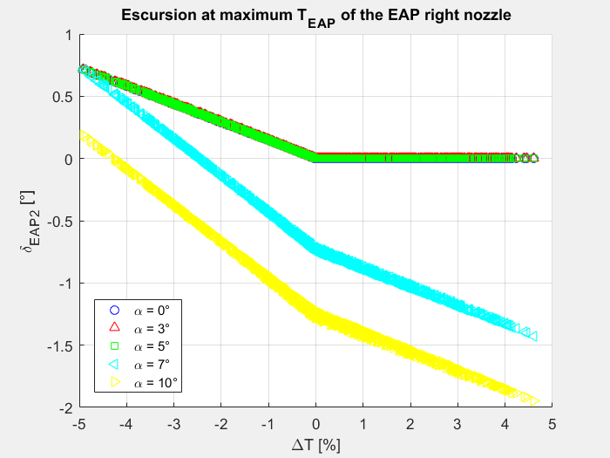

Figure 13: Excursion at maximum EAP thrust of the EAP right nozzle

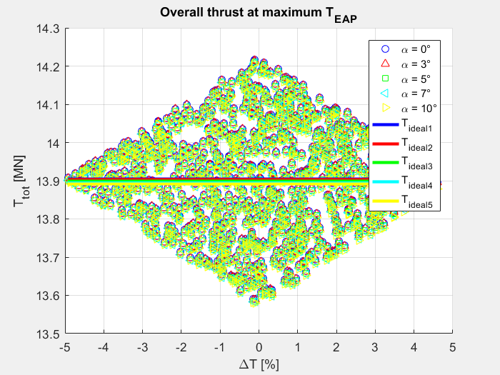

Figure 14: Overall thrust at maximum EAP thrust

In the second case, the level of the EAP thrust is reduced (not too much), but the dynamic pressure is very high. From Figure 15 it is evident that the EPC nozzle isn’t able alone to counteract the normal force. So, the EAP nozzle must be rotated. From Figures 16 and 17 it can be noticed that up to 7° is again possible to counteract the normal force, even if almost close to the limiting deflection angles. Then, at 10° the limiting values are exceeded. However, 10° is typically a high value for a rocket, and it has been introduced as an upper limit for this study. Finally, the resulting thrust is shown in Figure 18: it can be noticed wider variations of the values.

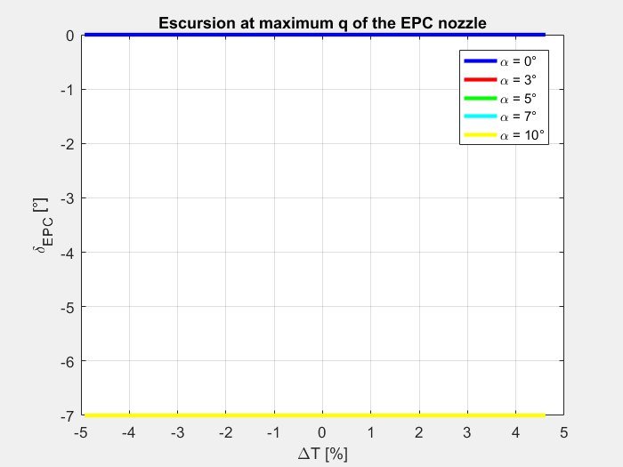

Figure 15: Excursion at maximum q of the EPC nozzle

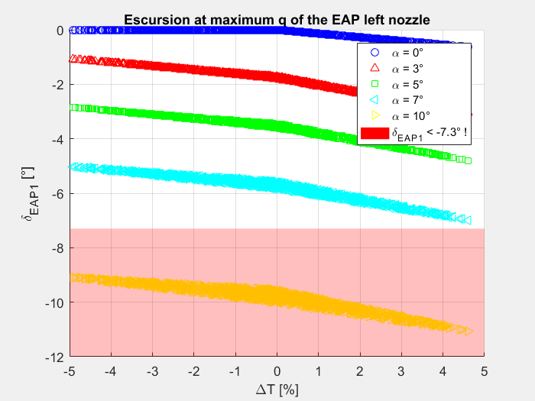

Figure 16: Excursion at maximum q of the EAP left nozzle

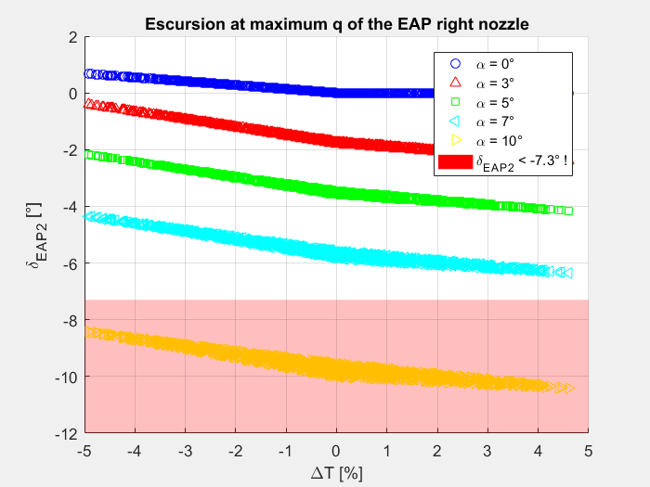

Figure 17: Excursion at maximum q of the EAP right nozzle

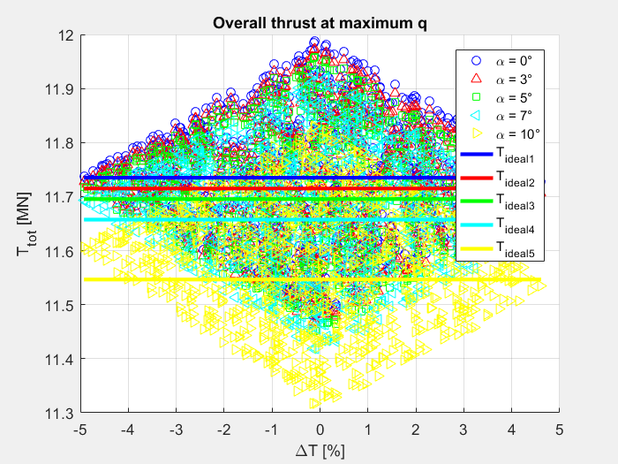

Figure 18: Overall thrust at maximum q

By the previous analysis, the needed TVC deflection angles to compensate a random thrust imbalance are obtained as main result. These results focus on two fundamental flight phases performed by the complete configuration of Ariane 5-ECA (main body + boosters):

1. Max boosters thrust phase (time of flight t = 18s)
2. Max dynamic pressure (time of flight t=71s)

In phase 1 the TVC angles excursion capabilities are never exceeded for all the studied angles of attack (0°,3°,5°,7°,10°). The deflection of the main engine’s nozzle combined with a proper rotation of one of the boosters’ nozzle or both depending on the level of thrust disturbance percentage is enough to counteract fully the generated imbalance. At maximum angle of attack considered (10°) the deflective capacity of EPC’s nozzle is saturated, but the needed deflection of boosters’ nozzles is well beyond the saturation and in safe region.

In phase 2 the situation is definitely different. At zero angle of attack the imbalance is counteracted by a proper deflection of boosters’ nozzles while at all the other considered angles (3°,5°,7°,10°) the EPC’s nozzle deflective capability is saturated. The boosters’ nozzles are able to counteract the generated imbalance without difficulties for angles of attack of 3° and 5° while for 7° the deflection of the needed nozzle is near to saturation. At 10° angle of attack the Ariane 5-ECA TVC system cannot counteract the imbalance at maximum dynamic pressure because too large deflection angles for boosters’ nozzles would be needed. In this situation it’s very likely that the mission would result in a complete loss of the launcher.

It is easy to deduce that the most demanding condition in terms of attitude control by TVC is the maximum dynamic pressure situation. This is true for the whole flight phase and not only for the phases analysed previously.

The previous study may be improved by adding complexities to the used models already described in order to pass from a conceptual analysis to a design phase one. In particular these changes in modelling may be applied to obtain a more complete analysis:

1. More complex aerodynamic model: the aerodynamic model used to evaluate fluid dynamics effects on the launcher is a very general one and it is based on assumptions that are brought to their limits by the Ariane 5-ECA shape and configuration. An ad hoc aerodynamic model based on the launcher shapes would be far more effective in foreseeing the effective aerodynamic loads on the launcher. Also, the analysis of the of the generated aerodynamic moments due to the launcher shape should be added to perform a more precise analysis.
2. Elastic body model of the launcher and mechanical peculiar behaviours: the launcher has been considered throughout the previous analysis as a perfect rigid body in order to avoid the study of its structural dynamics. Surely mechanical couplings may affect the attitude of the launcher during flight. In addition, the rotation of the nozzles has been considered as perfectly matching the needed rotation needed to counteract the imbalance while it should be affected by uncertainties. The TVC system introduces some changes in the structural load distribution on the launcher that should be considered to perform a more complete study.
3. Main engine performances uncertainties: the main engine performances are considered as exactly matching the nominal ones. In reality some uncertainties about them should be considered as well as the uncertainties about the boosters’ performances have been considered in this work. Main engine performances uncertainties would not generate an imbalance moment, but they may affect the overall performances of the launcher.

# 8. List of references

1. W.A. Foster, R.H. Sforzini, B.W. Schackelford, “Thrust Imbalance of the Space Shuttle Solid Rocket Motors”, *AIAA*, AIAA Paper 1981-1610.
2. W.A. Foster, R.H. Sforzini, P.H. Shu, “Thrust Imbalance of Solid Rocket Motors Pairs on Space Shuttle Flights”, *AIAA*, AIAA Paper 1986-1375.
3. W.A. Foster, W. Crowder, T.E. Steadman, “A Monte Carlo Analysis of the Thrust Imbalance for the Space Launch System Booster during Both the Ignition Transient and Steady State Operation”, *AIAA*, AIAA Paper 2014-12532.
4. F. Castellini, A. Riccardi, M. Lavagna, C. Büskens, “Global and Local Multidisciplinary Design Optimization of Expendable Launch Vehicles”, report 11-09 December 2011.
5. <http://spaceflight101.com/ariane-5-va226/ariane-5-va226-launch-profile>.
6. Ariane 5 User’s Manual from [www.arianespace.com/vehicle/ariane-5/](http://www.arianespace.com/vehicle/ariane-5/).
7. Fiche_vulcain2_vulcain_ang_2011.pdf from Safran (Snecma).