13th Cantanhede International Open Competition
Aerobic Gymnastics – Age Groups & Seniors
Portugal
19th to 23rd March, 2025


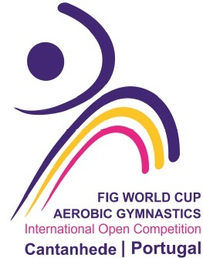

Form to be sent to:
Organizing Committee
ACADEMIA CANTANHEDEGYM
Rua da Concórdia, Lote 12, 3060 – 149 Cantanhede - Portugal
Contact Person: João Dias Mobile Phone: +351 925123182
E-mail: academia.cantanhedegym@gmail.com Website: www.cantanhedegym.com
Deadline: 19th of February of 2025

Nominative Entry Form
(No maximum number of participants by nation, category or age group)

Federation
Contact Person | Last name: |  | First name:
Address | Street: |  | Post Office Box:
Address | ZIP/Postcode: | Place: |  | Country:
Telephone / Fax | Telephone: | Mobile: |  | Fax:
E-mail

Please insert more lines as necessary!

SENIORS
Category | Name | FIG License Number | Gender  M/F
Individual Woman 1 |  |  | F
Individual Woman 2 |  |  | F
Individual Men 1 |  |  | M
Individual Men 2 |  |  | M
Mixed pair 1
Mixed pair 2
Trio 1
Trio 2

Group 1
Group 2
AERODANCE
GROUP 1
AERODANCE
GROUP 2

JUNIORS (15-17 years)

Category | Name | FIG License Number | Gender  M/F
Individual Woman 1 |  |  | F
Individual Woman 2 |  |  | F
Individual Men 1 |  |  | M
Individual Men 2 |  |  | M
Mixed pair 1
Mixed pair 2
Trio 1
Trio 2
Group 1
Group 2
AERODANCE
GROUP 1
AERODANCE
GROUP 2

YOUTH (12-14 years)

Category | Name | FIG License Number | Gender  M/F
Individual Woman 1 |  |  | F
Individual Woman 2 |  |  | F
Individual Men 1 |  |  | M
Individual Men 2 |  |  | M
Mixed pair 1
Mixed pair 2
Trio 1
Trio 2
Group 1
Group 2
AERODANCE
GROUP 1
AERODANCE
GROUP 2

Head of Delegation name
Team Manager name
Coaches Names
Judges names, FIG ID Number & categories |  | FIG ID  Cat.
Judges names, FIG ID Number & categories |  | FIG ID  Cat.
Doctor / Physiotherapist |  | FIG ID

Place and date | Seal of the NF | NF authorised signature
……………………………………………. |  | ……………………………………………..  Signature of the President or Secretary General of the FIG affiliated NF.

