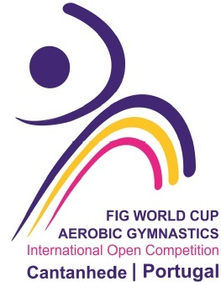
13th Cantanhede International Open Competition
Aerobic Gymnastics – Age Groups & Seniors
Portugal
19th to 23rd March, 2025


Form to be sent to:
Organizing Committee
ACADEMIA CANTANHEDEGYM
Rua da Concórdia, Lote 12, 3060 – 149 Cantanhede - Portugal
Contact Person: João Dias Mobile Phone: +351 925123182
E-mail: academia.cantanhedegym@gmail.com Website: www.cantanhedegym.com
Deadline: 20th of November of 2024

Provisional Entry Form

Federation
Contact Person | Last name: |  | First name:
Address | Street: |  | Post Office Box:
Address | ZIP/Postcode: | Place: |  | Country:
Telephone / Fax | Telephone: | Mobile: |  | Fax:
E-mail

(Insert the necessary lines; No limit by nation / Categ / AG Group)

YOUTH / 12-14 YEARS | Number of participants

Individual Woman
Individual Man

Mixed pair
Trio
Groups
Aerodance Groups
JUNIORS / 15-17 YEARS | Number of participants

Individual Woman
Individual Man

Mixed pair
Trio
Groups
Aerodance Groups
SENIORS 18+ YEARS | Number of participants

Individual Woman
Individual Man

Mixed pair
Trio
GR
Aerodance Groups
Officials | Number of officials
Head of Delegation
Team Manager
Judges
Coaches
Doctor / Therapist
TOTAL NUMBER OF DELEGATION PERSONS

Place and date | Seal of the NF | NF authorised signature
……………………………………………..
Signature of the President or Secretary General of the FIG affiliated NF.

