SPLUNK LABS ENVIRONNEMENT
Write-Up
by Raphael Beauregard

[FIRST-TIME LAB SETUP]
Setting up a lab environment for future labs

Table of Contents
Goal 3
Objective 3
Considerations 3
Expectations 3
Methodology 4
Tools 4
Operating Systems 4
Execution 5
Getting the VMs to post 5
Networking 6
Web Server Dummy Setup 8
SIEM Server Splunk Initial Setup 8

Goal

Objective
The main objective of this venture is to have four machines within the same network:
  - A service server
  - A SIEM Server/Log aggregation server
  - A client
  - An attacker
The virtual machines must be able to connect to each other and the internet.

Considerations
Four virtual machines might be a bit much for the average computer. That is why I have a server set up, mainly for this purpose. I must also ensure that the service ports I open do not get forwarded outside of the virtual LAN to avoid complications with outside attackers. I am stating this because there is a high chance future I will purposefully make some services vulnerable for pen-testing and research purposes.

Expectations
I expect things to go smoothly. I have significant experience with virtualisation and networking. The setup should be operational rather quickly.

Methodology
Instead of using CLI to setup virtual machines and install OSes from scratch with ISO images, I will be using tools to make the process quicker.

Tools
- Vagrant
- libvirtd & virsh
- Virtual Machine Manager (Client APP)
Using the QEMU/KVM protocol, I will be able to manage and access virtual machines Vagrant will have created for me (as user session VMs). The management of a virtual network will be easy and convenient from there thanks to the GUI. For the creation of the network itself, however, I will use the CLI.
Once the network connections are established. It’s only a matter of installing Splunk of the SIEM Server, and forwarders on both the service server and client.

Operating Systems
Machine | OS | Why?
Service Server | Ubuntu | Industry Standard for web servers
SIEM Server | Debian | Stable and LTS
Client | Windows 10 | Most clients use Windows
Attacker | Kali Linux | Pre-loaded with tools

Execution

Getting the VMs to post

Since I’m using Vagrant, I can use pre-made boxes I can find at the Vagrant Public Registry. Since I use libvirtd, I am seeking boxes that support that provider in particular.
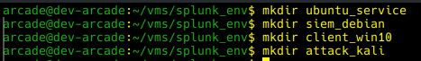Figure 1: Creating of directories for vagrant files.
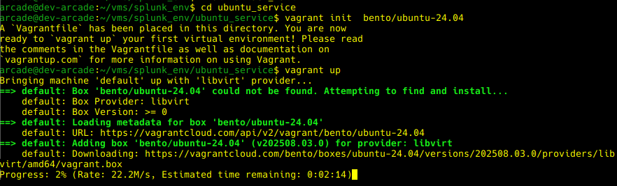Figure 2: Vagrant downloading and setting up the image
Once the download is finished, the machine will boot on its own, and I will be able to access it through VMM (Virtual Machine Manager) from my work computer.

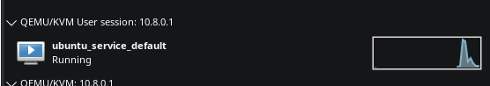
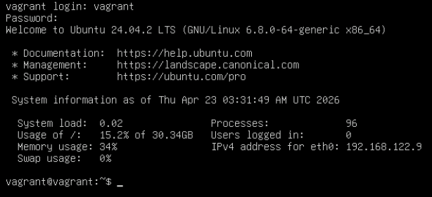

I just have to repeat these steps for the three other OSes now.

Networking
Now that all my machines are up and running, I must ensure they can locally reach other while being in their own LAN (as in not be in my home Local LAN). Here’s the XML for my custom LAN network.
<network>
<name>lan</name>
<forward mode="nat"/>
<bridge name="virbr1" stp="on" delay="0"/>
<ip address="192.168.100.1" netmask="255.255.255.0">
<dhcp>
<range start="192.168.100.100" end="192.168.100.200"/>
</dhcp>
</ip>
</network>
I need to assign the machines to the right network bridge now.
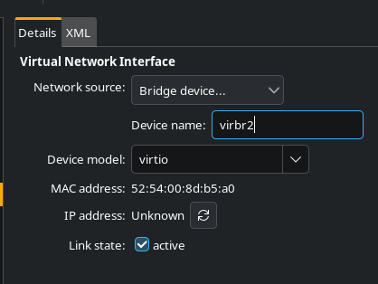
And finally, allow the bridge to be built by QEMU.
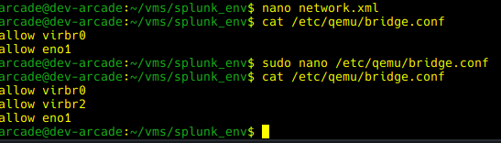

And we’ve got our network.

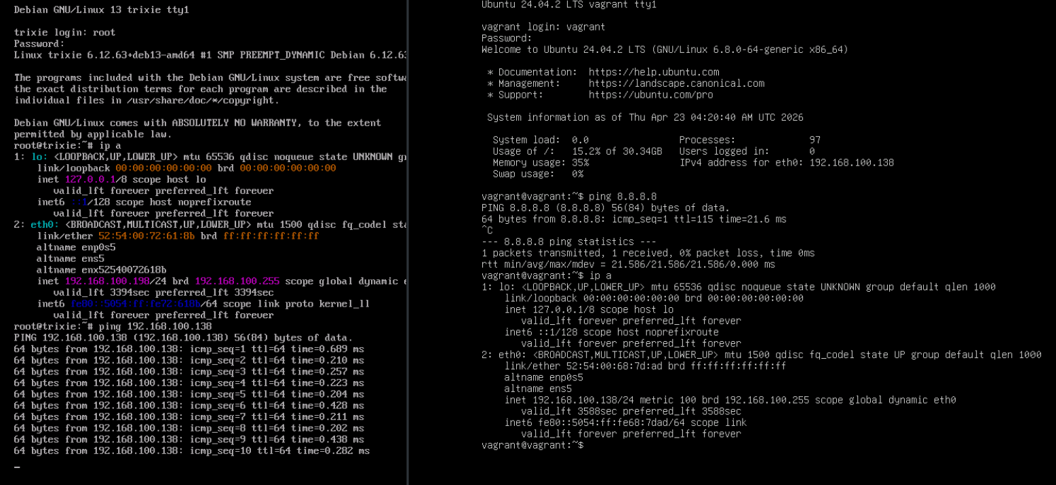

Web Server Dummy Setup
For the Ubuntu machine, I will setup a base HTTP-only NGINX service. It is rather simple in concept. I changed the NGINX config to show a dummy page and started the service.

I ran into a permission issue because I decided to write HTML code under a /home/ folder, but I was able to get through it.

SIEM Server Splunk Initial Setup
I’ll be using the trial of Splunk Enterprise for now. I am aware of its data limitation of 500MB or so, but I will deal with it once the problem arises. The password for the admin user will be VagrantMachine.

...aaaand we are in!
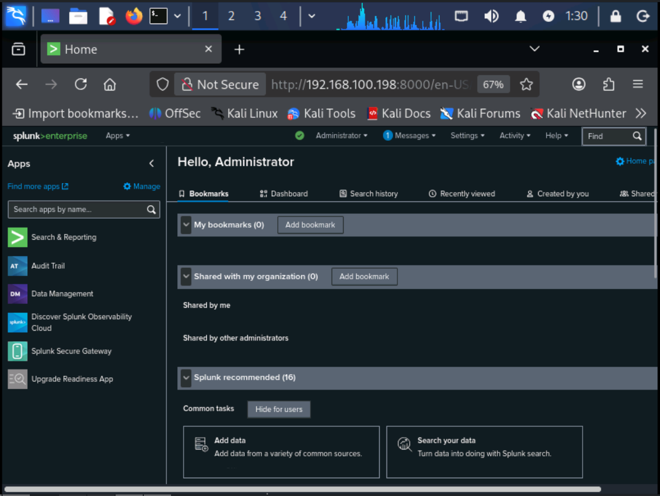
There was no firewall on the Debian machine (we’ll have to fix that in another report), and Splunk listened from all available interfaces for the web interfaces, so I just accessed it from another machine on the virtual LAN: the attacking machine.

Forwarding Logs
Our SIEM server will be listening on port 9997 for logs.
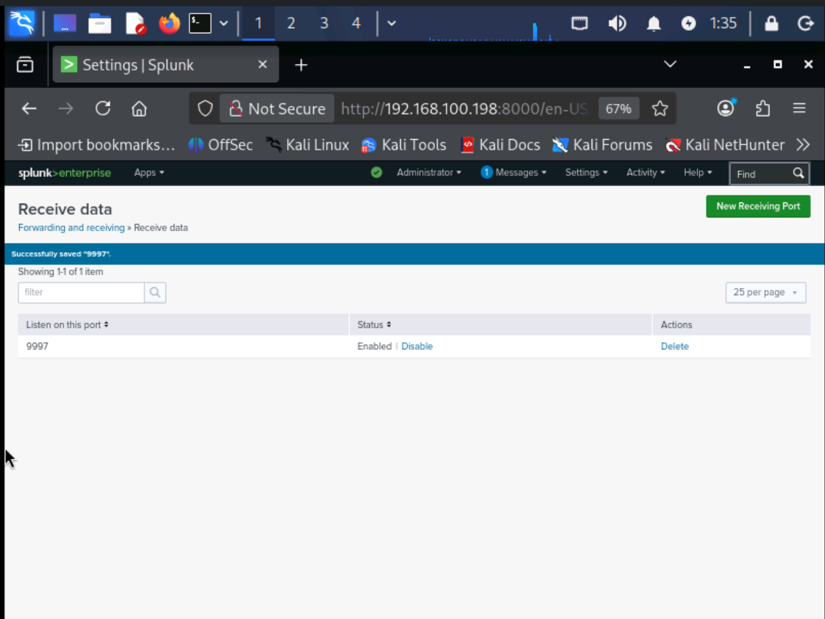
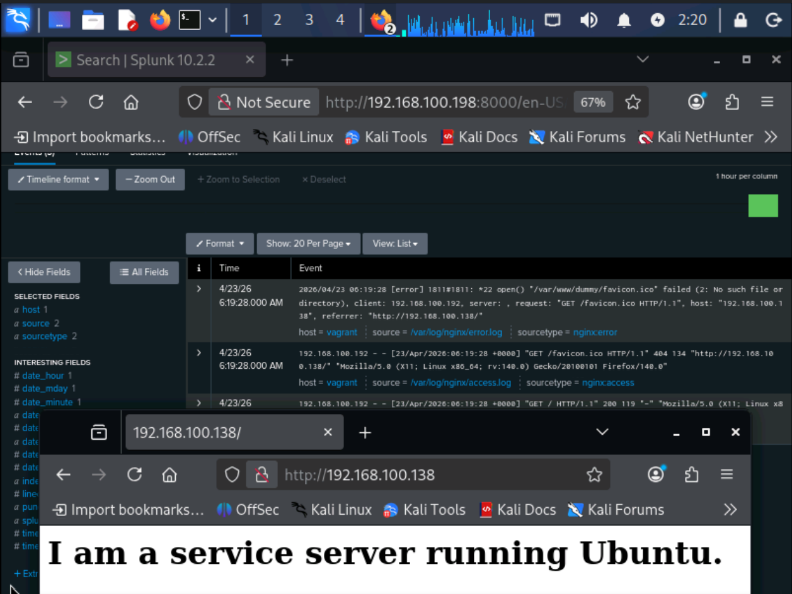

We must install Splunk Forwarder on the web server and the Windows 10 client, and then tell them what to send.
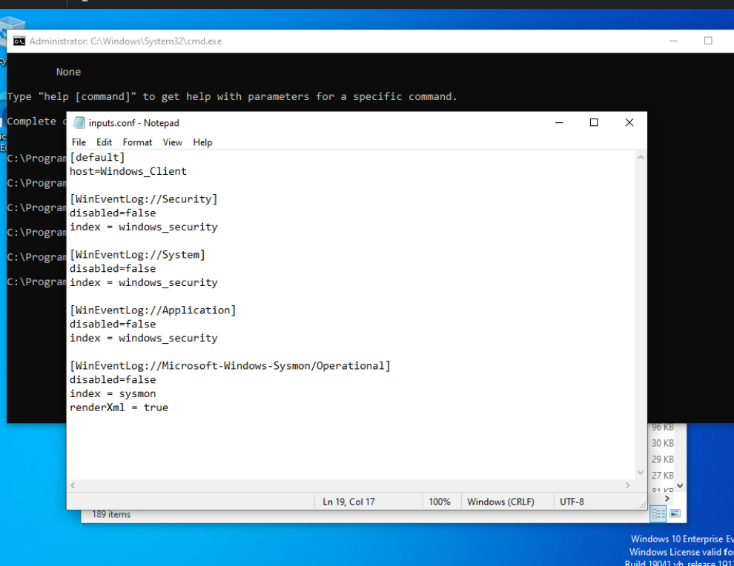

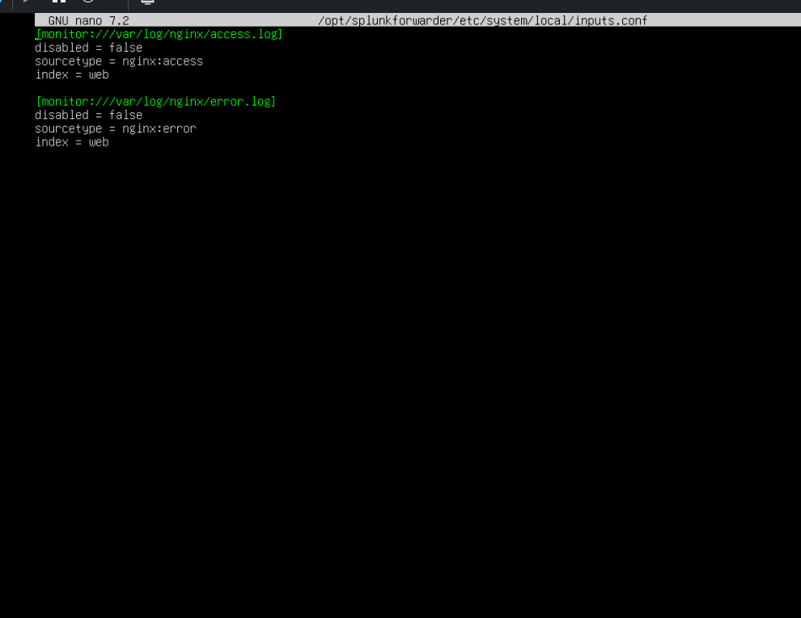
I had actually forgotten to create the indexes I was pointing to in the inputs.conf, so I was not getting any logs. I troubleshooted for a dozen of minutes thinking it was something wrong with my network, but nope. Always create the indexes in advance, or else the logs will not be registered.

So there we have it now. Two machines sending their logs to our SIEM server! This is only the very start of my adventure with this setup, and I hope you will read my other reports to see where I go from here.

Conclusion
I have done something similar in the past in college, but this is my first time setting it up from scratch myself on my home lab. I’m pretty happy with what I’ve learned while writing this report: more virsh, KVM XML, and to configure indexes BEFORE trying to fill them.
My next idea is to pen-test my own web server, and see how traceable I will be through the logs. Afterwards, I can recognize attack patterns and create alerts based on that... and eventually, set up a SOAR system. So much LAB potential with these babies... it makes my head spin!

