SECURE GATEWAY SETUP
Write-Up
by Raphael Beauregard

[MAKING SURE THE LABS ENV. IS SECURE]
by adding an IDS & Firewall rules

Table of Contents
Goal 3
Objective 3
Considerations 3
Expectations 3
Methodology 4
Tools 4
Execution 5
Creation of new LANs 5
Setting up the routing 7
Snort Configuration 10
Configuring an extra Firewall 13
Choosing the firewall 13
Conclusion 14

Goal

Objective
The objective of this venture is to route all traffic through one machine. This machine can inspect packets, block/allow them, and generate alerts based on a set of rules. Our security gateway will act as a guard between not only the LAN and the internet, but also as a shield for each client against other clients.

Considerations
Since I do not have infinite resources, I have to set up this on the same machine as the SIEM. This means one machine I will call a security server will act as a log aggregator + Gateway + IDS. In a real scalable environment, I would do things differently for performance purposes, but since there will never be more than 5-10 clients on here, I can just adjust the CPU and RAM allocation of the VM to fit needs as we go.

Expectations
I expect things to be easy enough, as I have experience with routing in Linux. I have also set up a basic pfSense instance in the past, which is similar to this LAB, just without the SIEM and the IDS.

Methodology

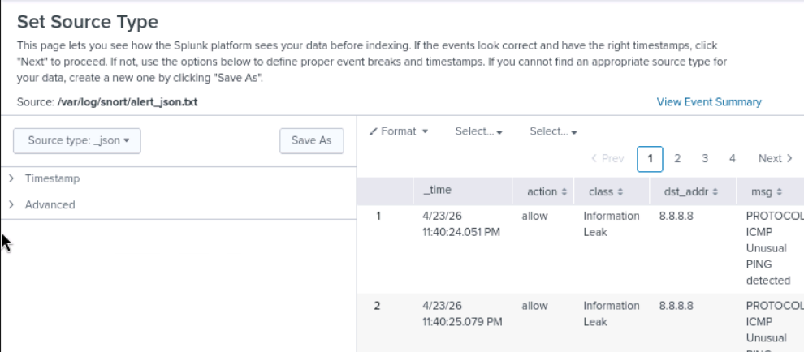
Tools
- Splunk
- Snort
- virsh
- QEMU/KVM
- nftables
I am going to create a seperate internal LAN interface that has no bridge to the host server (the ones running the VMs). It will be fully isolated. The gateway will point to the security server. The security server will have two interfaces: the isolated LAN and another network that will be bridged for Internet access. Even if a client changes their configuration, it will not be able to access the Internet unless it passes through the security server.

I will also have to add the logs of Snort and nftables (or global networking logs) as data sources in Splunk.

Execution

Creation of new LANs
Figure 1: Creation of XML to define the network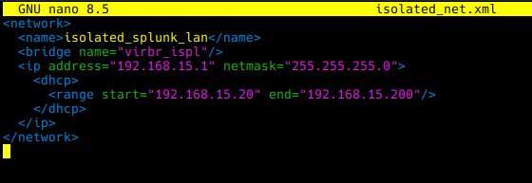
As I was setting this up, I’ve also decided to delete the original splunk_lan I had to use a more distinct IP range.
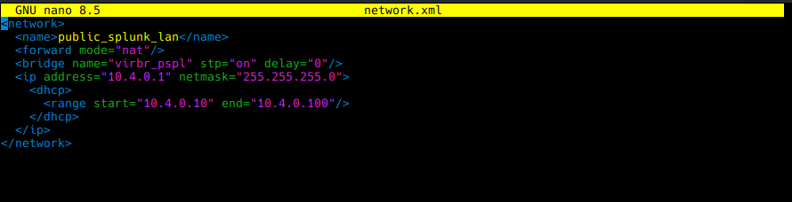
I also have to allow the bridge to be created by QEMU.
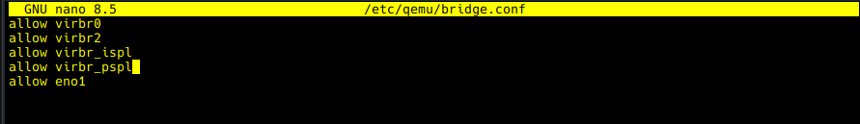

Now, we have to create a new network card for the security server, and change the existing one.
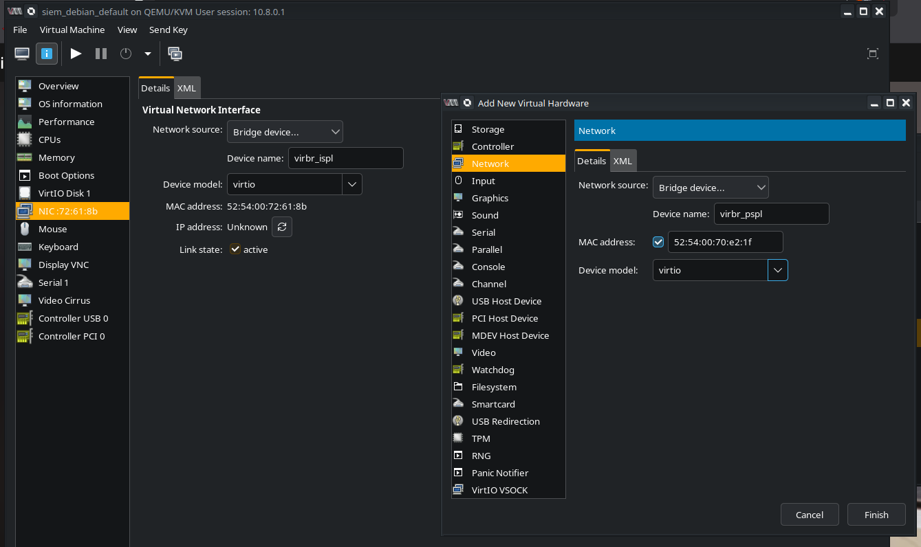
For every client, I assigned their only network interfaces to virbr_ispl which is the isolated LAN.

Setting up the routing
So now that we have both interfaces with ready, with eth0 having the static IP of the default gateway...
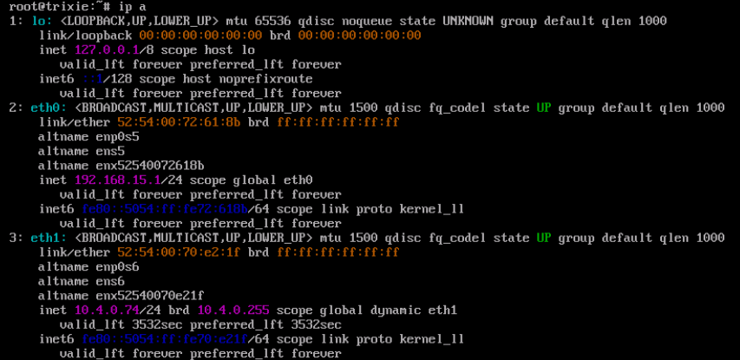

We can start routing and forward traffic.
- We enable IP forwarding
- We hide the original source IP with NAT
- We allow forwards from eth0 to eth1
- We allow forwards from eth1 to eth0 only if there’s an existing relationship for the packet
These rules are, by default, temporary. However, you can use the iptables-persistent package to save your configuration.

Since I have not created a DHCP server, and I do not want to fight with XML Network creation stuff, I will set static IP confgurations, DNS settings, etc... for the clients. Once that’s done, they can access the Internet. Consider DNS and DHCP server future
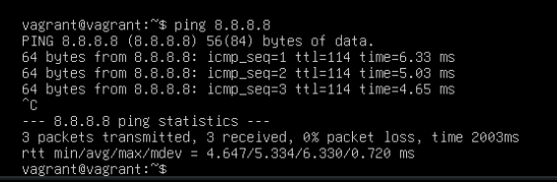Figure 2: Ubuntu Service Server with Internet access
I ran into some issues afterwards because the virtual network gateway also uses 192.168.15.1. Finding the source of some issues took me a while. I changed it to .2 to avoid conflicts.

Net.ipv4.ip_forward also resets itself after a reboot, so I had to add it to /etc/systctl.conf. LAN devices also still have access to local services, of course.

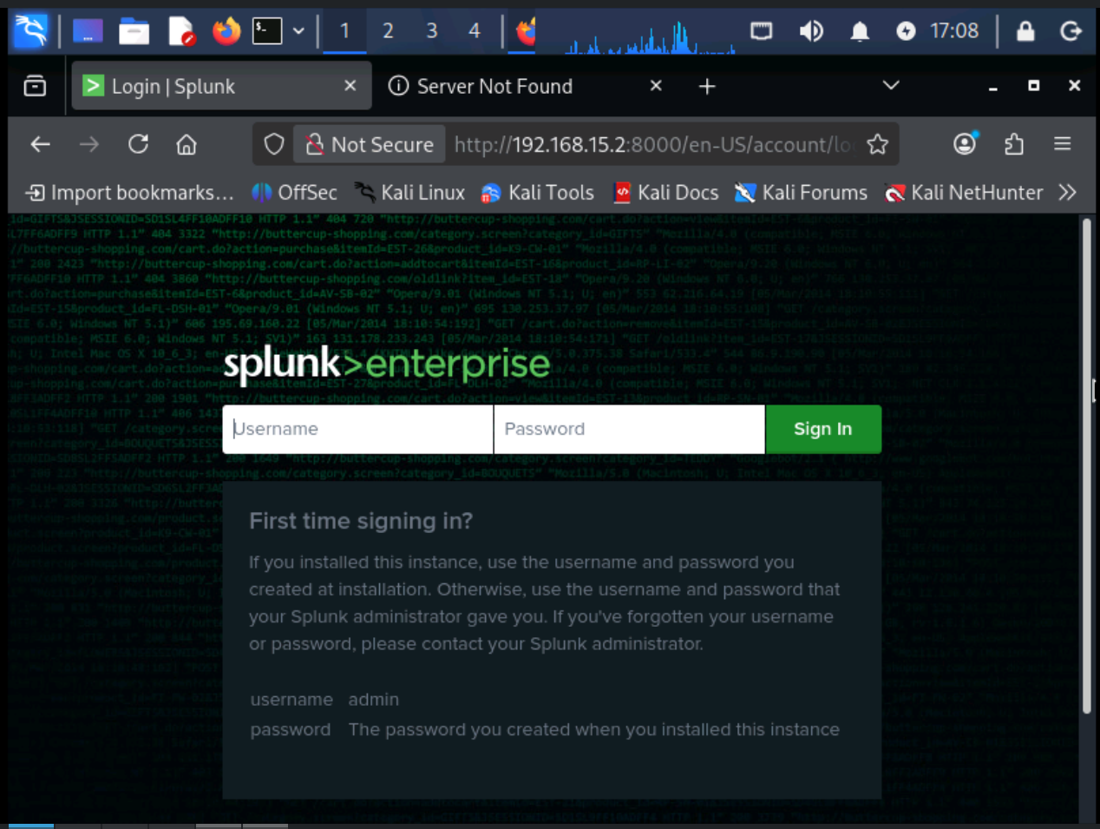

Snort Configuration
After building Snort 3 and installing its dependencies (libdaq and other libraries), it was time to configure it. I first created the necessary directories.
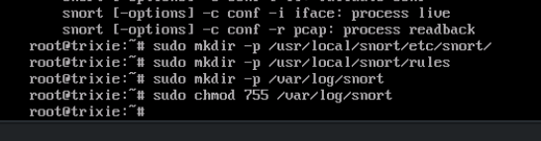
Then, I set up the lua configuration under /usr/local/snort/etc/snort/snort.lua
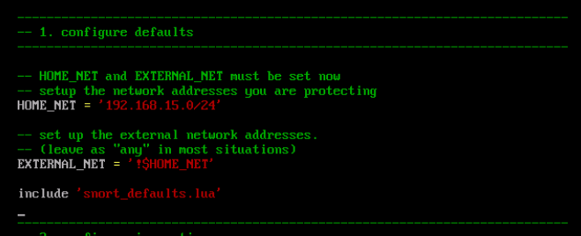
I will only run Snort in IDS mode, because I want to use this environment to learn attack patterns later on (blocking the attack altogether would not allow me to study them).

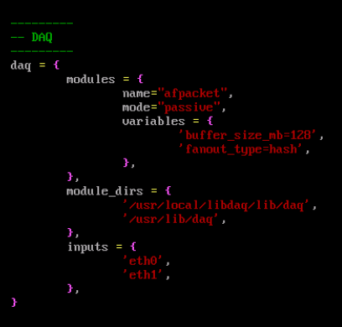
Next up, we have to ensure Snort outputs in JSON so that Splunk can easily parse the data and also make Snort act as an IDS, not an IPS in the configuration file.

After this, all that’s left for the initial configuration is to make Snort run on boot with a systemd service. I added some arguments to Snort because I had issues with the config file.
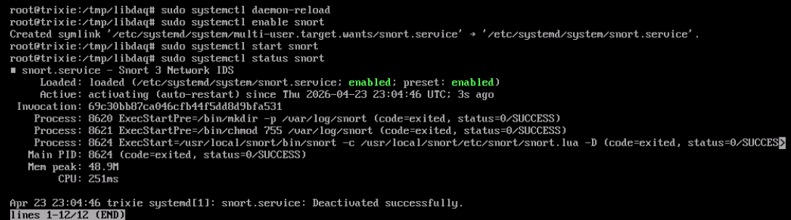

...and here, we now have logs for unusual activity.

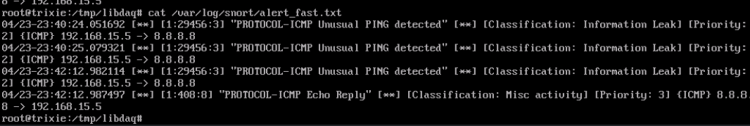
I’ve added a custom test rule as well:

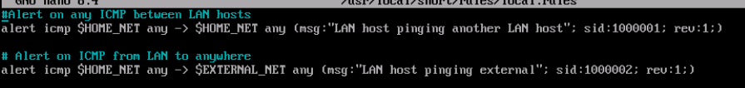
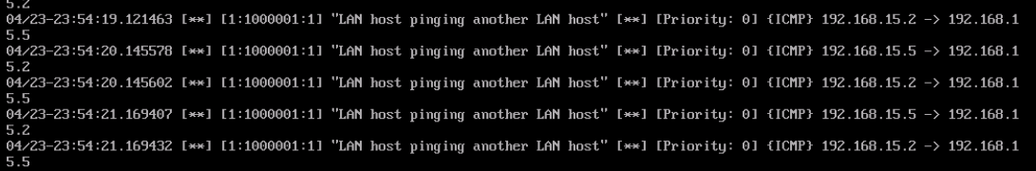
We can now add the JSON version as a data source in Splunk.

Configuring an extra Firewall
I could use Snort to black some traffic, but that would be too easy. Using another application will also allow me to just turn that firewall off to try pen-testing things, but still get my Splunk logs due to Snort still being active. I want to familiarize myself with another tool too.

Choosing the firewall
I decided to use UFW, as it is native to the Debian ecosystem. It has simple and intuitive syntax, which will reduce chances of accidental misconfiguration. In a more complex environment, I might go for firewall-cmd instead.
UFW is very easy to install through APT, and enabling it is as simple as one command.
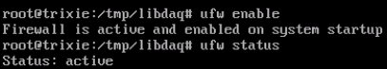
Now, I will add a rule to block SSH traffic over port 22 from the internet.
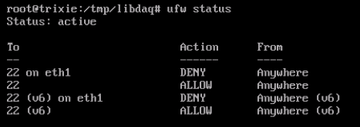
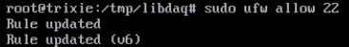
I’m going to add rules as time goes on, and see what kind of rules could prevent certain attacks from passing through. I can also add UFW logs to Splunk!

Conclusion
...and there you have it! The SIEM is actively aggregating logs from clients and itself. The hard (or more so boring) part of setup is done. I can now attack my own machines, and defend against those attacks using the logs as threat intelligence.

