PART 2

(L3SW Intervlan) Static Route ,WAN, STP Portfast, Priv Exec Sec, and Port Aggregation

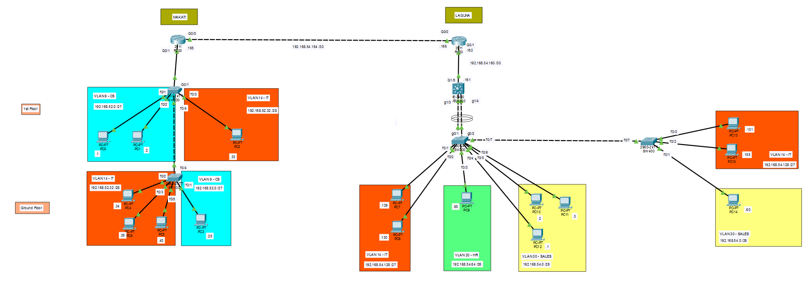
This project is a small improvement on the previous simple Inter-VLAN lab without WAN connectivity. All commands required to recreate this project are included in this document.

In this lab, I used several shortcut commands that helped me complete multiple tasks more efficiently and enter configurations more quickly without ambiguity.

If you have any questions regarding subnetting or configuration, please feel free to email me at aeroncharlies@gmail.com.

128 64 32 16 8 4 2 1
Given network: 192.168.52.0 /x - MAKATI

Network A / VLAN 9 | CS – 25 Hosts
2^n-2 = usable hosts, n = number of host bits
2^5-2 = 30 usable hosts
To find subnetmask, we subtract 32 to the number of host bits. 32 – 5 = 27
/27 = 255.255.255.224

Network Address: 192.168.52.0 255.255.255.224
First Usable Address: 192.168.52.1 255.255.255.224
Last Usable Address: 192.168.52.30 255.255.255.224
Broadcast Address: 192.168.52.31 255.255.255.224

Next Subnet: 192.168.52.32

Network B / VLAN 14 | IT – 10 Hosts
2^n-2 = usable hosts, n = number of host bits
2^4-2 = 14 usable hosts
To find subnetmask, we subtract 32 to the number of host bits. 32 – 4 = 28
/28 = 255.255.255.240

Network Address: 192.168.52.32 255.255.255.240
First Usable Address: 192.168.52.33 255.255.255.240
Last Usable Address: 192.168.52.46 255.255.255.240
Broadcast Address: 192.168.52.47 255.255.255.240

Next Subnet: 192.168.52.48

Given network: 192.168.54.0 /x – LAGUNA

Network C / VLAN 30 | Sales – 60 Hosts
2^6-2 = 62 usable hosts
/26 = 255.255.255.192

Network Address: 192.168.54.0 255.255.255.192
First Usable Address: 192.168.54.1 255.255.255.192
Last Usable Address: 192.168.54.62 255.255.255.192
Broadcast Address: 192.168.54.63 255.255.255.192

Next Subnet: 192.168.54.64

Network D / VLAN 20 | HR – 32 Hosts
2^6-2 = 62 usable hosts
/26 = 255.255.255.192
Network Address: 192.168.54.64 255.255.255.192
First Usable Address: 192.168.54.65 255.255.255.192
Last Usable Address: 192.168.54.126 255.255.255.192
Broadcast Address: 192.168.54.127 255.255.255.192

Next Subnet: 192.168.54.128

Network E / VLAN 14 | IT – 27 Hosts
2^5-2 = 30 usable hosts
/27 = 255.255.255.224

Network Address: 192.168.54.128 255.255.255.224
First Usable Address: 192.168.54.129 255.255.255.224
Last Usable Address: 192.168.54.158 255.255.255.224
Broadcast Address: 192.168.54.159 255.255.255.224

Next Subnet: 192.168.54.160

WAN A / L3SW100 <> R100 | 2 Hosts
2^2-2 = 2 usable hosts
/30 = 255.255.255.252

Network Address: 192.168.54.160 255.255.255.252
First Usable Address: 192.168.54.161 255.255.255.252
Last Usable Address: 192.168.54.162 255.255.255.252
Broadcast Address: 192.168.54.163 255.255.255.252

Next Subnet: 192.168.54.164

Note1: Pwede naman /31 para sa point-to-point connection, pero /30 na ang gamitin.
Note2: 2 offices are using ethernet copper cable only as a sample. Sa totoong practice, ang gamit na dyan ay fiber optic dahil sa layo ng location.

WAN B / R200 <> R100 | 2 Hosts
2^2-2 = 2 usable hosts
/30 = 255.255.255.252

Network Address: 192.168.54.164 255.255.255.252
First Usable Address: 192.168.54.165 255.255.255.252
Last Usable Address: 192.168.54.166 255.255.255.252
Broadcast Address: 192.168.54.167 255.255.255.252

Next Subnet: 192.168.54.168

Configuration
Hostname Configuration
SW400
Switch>en
Switch#conf t
Switch(config)#host SW400

SW300
Switch>en
Switch#conf t
Switch(config)#host SW300

MSW500
Switch>en
Switch#conf t
Switch(config)#host MSW500

R100
Router>en
Router#conf t
Router(config)#host R100

Access Ports Configuration on Switches w/ VLAN creation/enrollment
SW400
SW400>en
SW400#conf t
Enter configuration commands, one per line. End with CNTL/Z.
SW400(config)#int ran f0/2-3
SW400(config-if-range)#sw mo ac
SW400(config-if-range)#sw acc vlan 14
% Access VLAN does not exist. Creating vlan 14
SW400(config-if-range)#int f0/1
SW400(config-if)#sw mo ac
SW400(config-if)#sw ac vlan 30
% Access VLAN does not exist. Creating vlan 30
SW400(config-if)#exit
SW400(config)#vlan 14
SW400(config-vlan)#name IT
SW400(config-vlan)#vlan 30
SW400(config-vlan)#name SALES

SW300
SW300>en
SW300#conf t
SW300(config)#int ran f0/1-2
SW300(config-if-range)#sw mo ac
SW300(config-if-range)#sw ac vlan 14
% Access VLAN does not exist. Creating vlan 14
SW300(config-if-range)#int f0/3
SW300(config-if)#sw mo ac
SW300(config-if)#sw ac vlan 20
% Access VLAN does not exist. Creating vlan 20
SW300(config-if)#int ran f0/4-6
SW300(config-if-range)#sw mo ac
SW300(config-if-range)#sw ac vlan 30
% Access VLAN does not exist. Creating vlan 30
SW300(config-if-range)#exit
SW300(config)#vlan 14
SW300(config-vlan)#name IT
SW300(config-vlan)#vlan 20
SW300(config-vlan)#name HR
SW300(config-vlan)#vlan 30
SW300(config-vlan)#name SALES

Trunk Port Configuration on Switches SW300 and SW400
SW300
SW300>en
SW300#conf t
SW300(config)#int f0/7
SW300(config-if)#sw mo tru
SW300(config-if)#sw tru allowed vlan 14,30

SW400
SW400#conf t
SW400(config)#int f0/7
SW400(config-if)#sw mo tru
SW400(config-if)#sw trunk allowed vlan 14,30

Port Aggregation on SW300 <> MSW500 link
SW300
SW300>en
SW300#conf t
SW300(config)#int ran g0/1-2
SW300(config-if-range)#channel-group 1 mode desirable

MSW500
MSW500>en
MSW500#conf t
MSW500(config)#int ran g1/3-4
MSW500(config-if-range)#channel-group 1 mode desirable

Trunk Port Configuration on Switches SW300 and MSW500
SW300
SW300(config)#int p1
SW300(config-if)#sw mo tru
SW300(config-if)#sw trunk allowed vlan 14,20,30

MSW500
MSW500>en
MSW500#conf t
MSW500(config)#int ran g1/3-4
MSW500(config-if-range)#sw mo tru
MSW500(config-if-range)#sw trunk allowed vlan 14,20,30
Inter-VLAN via SVI on MSW500
MSW500
MSW500>en
MSW500#conf t
Enter configuration commands, one per line. End with CNTL/Z.
MSW500(config)#int vlan 14
MSW500(config-if)#ip add 192.168.54.158 255.255.255.224
MSW500(config-if)#int vlan 20
MSW500(config-if)#ip add 192.168.54.126 255.255.255.192
MSW500(config-if)#int vlan 30
MSW500(config-if)#ip add 192.168.54.62 255.255.255.192

Routed Port Config on MSW500 <> R100
MSW500
MSW500>en
MSW500#conf t
Enter configuration commands, one per line. End with CNTL/Z.
MSW500(config)#int g1/5
MSW500(config-if)#no switchport
MSW500(config-if)#ip add 192.168.54.161 255.255.255.252
MSW500(config-if)#no shut

R100
R100>en
R100#conf t
Enter configuration commands, one per line. End with CNTL/Z.
R100(config)#int g0/1
R100(config-if)#ip add 192.168.54.162 255.255.255.252
R100(config-if)#no shut

Connecting R200 <> R100
R100
R100>en
R100#conf t
R100(config)#int g0/0
R100(config-if)#ip add 192.168.54.166 255.255.255.252
R100(config-if)#no shut

R200
R200>en
R200#conf t
Enter configuration commands, one per line. End with CNTL/Z.
R200(config)#int g0/0
R200(config-if)#ip add 192.168.54.165 255.255.255.252
R200(config-if)#no shut

Creating Static Routes to connect MAKATI branch <> LAGUNA branch
MSW500
MSW500>en
MSW500#conf t
MSW500(config)#ip route 192.168.52.0 255.255.255.224 192.168.54.162
MSW500(config)#ip route 192.168.52.32 255.255.255.240 192.168.54.162

R100
R100>en
R100#conf t
R100(config)#ip route 192.168.52.0 255.255.255.224 192.168.54.165
R100(config)#ip route 192.168.52.32 255.255.255.240 192.168.54.165
R100(config)#ip route 192.168.54.128 255.255.255.224 192.168.54.161
R100(config)#ip route 192.168.54.64 255.255.255.192 192.168.54.161
R100(config)#ip route 192.168.54.0 255.255.255.192 192.168.54.161
R200
R200>en
R200#conf t
R200(config)#ip route 192.168.54.128 255.255.255.224 192.168.54.166
R200(config)#ip route 192.168.54.64 255.255.255.192 192.168.54.166
R200(config)#ip route 192.168.54.0 255.255.255.192 192.168.54.166

STP Portfast Configuration on all end hosts
SW100
SW100>en
SW100#conf t
SW100(config)#int ran f0/1-3, f0/5
SW100(config-if-range)#span port
SW200
SW200>en
SW200#conf t
SW200(config)#int ran f0/1-2, f0/3
SW200(config-if-range)#span portf
SW300
SW300>en
SW300#conf t
SW300(config)#int ran f0/1-6
SW300(config-if-range)#spann portfa

SW400
SW400>en
SW400#conf t
SW400(config)#int ran f0/1-3
SW400(config-if-range)#span por

Privilege Exec mode protection (type 5 hashing)
SW100
SW100>en
SW100#conf t
SW100(config)#enable secret hulaanmo

SW200
SW200>en
SW200#conf t
SW200(config)#enable secret hulaanmo

SW300
SW300>en
SW300#conf t
SW300(config)#ena sec hulaanmo

SW400
SW400>en
SW400#conf t
SW400(config)#ena sec hulaanmo

R200
R200>en
R200#conf t
R200(config)#ena sec hulaanmo

R100
R100>en
R100#conf t
R100(config)#ena sec hulaanmo

MSW500
MSW500>en
MSW500#conf t
MSW500(config)#ena sec hulaanmo

//naglagay na ko kaunting security para naman may line of defense yung config dun sa device.

