xCelerator ExcelUtil Installation and User Guide
Version 1.0

Preface

Purpose
The following xCelerator enables xCP workflows to read and write Microsoft Excel files. It supports
Office 97-2003 and 2007 (*.xlsx) files (*.xls).
Reading Excel files can be a significant advantage of an xCP solution, as this format is very popular
among business users. Populating sheets on the other hand introduces a new level of potential
interaction with system users. Potential applications include reporting (with graphs and sophisticated
formulas based on the populated data) and interaction with users or systems that do not directly
interact with the Documentum system (by sending populated Excel sheet outside).

Intended audience
Information in this guide can be found helpful for xCP developers implementing documents-centric
Documentum solution. The xCelerator can be particularly useful when dealing with reporting
requirements – simple ones can be fulfilled without using BAM.

Support information
The xCP ExcelUtil xCelerator is not supported by EMC.

Related documentation
The EMC Documentum xCelerator home page (https://community.emc.com/docs/DOC-6143) provides access to xCP xCelerators.

Revision history
Date | Version | Change
Jan 2011 | Initial version
Jan 2011 | Version 1.1 | Supporting .xlsx files
Nov 2012 | Version 2.0 | Migration to xcp 2.0

Contents
Preface 2
Purpose 2
Intended audience 2
Information in this guide can be found helpful for xCP developers implementing documents-centric 2
Documentum solution. The xCelerator can be particularly useful when dealing with reporting 2
requirements – simple ones can be fulfilled without using BAM. 2
Support information 2
Related documentation 2
Revision history 2
Contents 3
Overview 4
What is an xCelerator? 4
xCP ExcelUtil xCelerator 4
Bill of Materials 4
Installing xCP ExcelUtil xCelerator 6
Prerequisites 6
Install the ExcelUtil xCelerator file 6
Installation troubleshooting 8
Using the ExcelUtil xCelerator 9
Configuration 9
Method 11
Considerations 18

Overview

What is an xCelerator?
An xCelerator is one or more artifacts that can be used to accelerate the creation, adoption, and/or implementation of an EMC Documentum xCelerated Composition Platform (xCP) solution. An xCelerator is not necessarily a running application; instead, it is intended to hasten application development by providing key pieces of functionality out-of-the-box. Examples of this include:
- A sample business process flow created by xCP Designer
- A sample high fidelity form using xCP Designer
- A sample Business Activity Monitor (BAM) dashboard
- A sample bit of code or configuration that connects the workflow with a third-party product
- Documentation that focuses on best practices and troubleshooting when developing and implementing an xCP solution
- A sample application
xCelerators are:
- Technology focused and can be samples, examples, starting points, or guides that accelerate the creation of an xCP solution
- Free and are not EMC-supported products, yet they do go through a formal release cycle, including quality assurance and documentation
- EMC intellectual property
- Sharable with multiple partners or anyone who wants to download them from the xCP community site

xCP ExcelUtil xCelerator

Bill of Materials
The xCP ExcelUtil xCelerator is accessible through the EMC Documentum xCelerator home page
(https://community.emc.com/docs/DOC-9530) by selecting the xCP ExcelUtil xCelerator download
link.
The ExcelUtil contains:
Artifact | Path / File Name
Overview guide (this document) | xcelerator-excelutil.pdf
Installation files | Package/xcp2_excelutil.jar
Source Code | Source

Installing xCP ExcelUtil xCelerator

Prerequisites
In addition to Documentum Content Server 7, the following must also be installed prior to installation of this xCelerator:
- Documentum XCP Designer 2.0

Install the ExcelUtil xCelerator file
Download the xcp2_excelutil xCelerator.zip file which is accessible through the EMC Documentum xCelerator community home page by selecting the ExcelUtil xCelerator link.
Unzip the xcp2_excelutil xCelerator.zip file and locate the xcp2_excelutil.jar at the following path: <Install folder>/xcp2_excelutil xCelerator/Package/xcp2_excelutil.jar
Open your application in xCP Designer and select “Model” in the “Application” tab
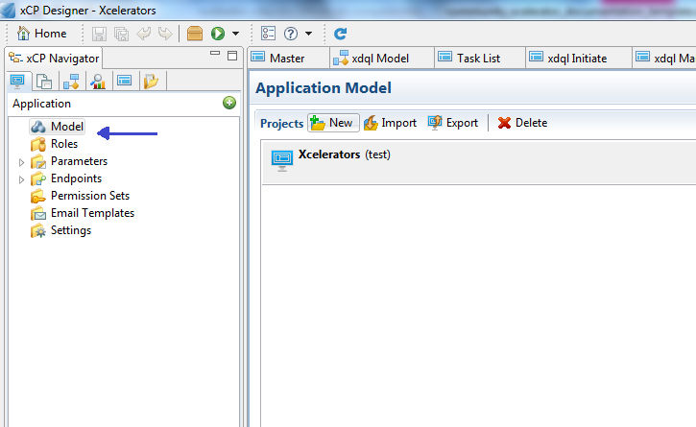
Figure 1 Model window of application

In the Libraries part, click on the “ADD” button. A pop-up will open. Click the “Browse” button and navigate to the folder <Installed folder>/xcp2_excelutil xCelerator/Package and select xcelerator in “Libraries to copy”. Click on the Next Button
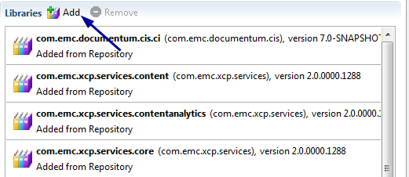
Figure 2 Add library

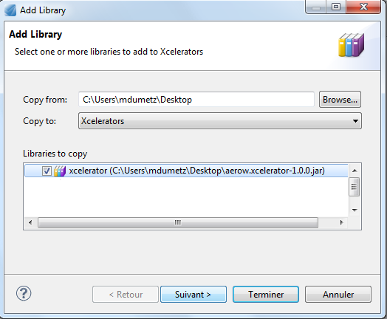
Figure 3 Choose library
Check if the same name and the Namespace are well filled and click on the “Finish” Button
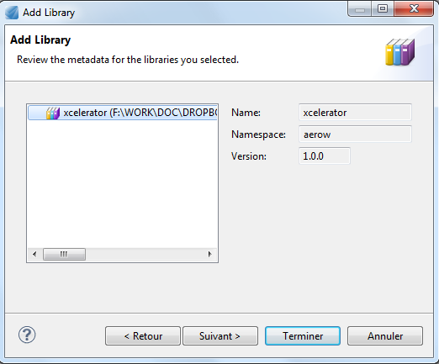
Figure 4 Confirmation adding library

Installation troubleshooting

Using the ExcelUtil xCelerator

Configuration
ExcelUtil xCelerator is provided as a java extension. This makes the xCelerator available in all environments straight after the jar files and the java module file had been installed, no additional steps are required.
In order to select the module proceed with the following steps:
- Drag the “Execute Java Service” activity template to your process
- In the activity inspector select Execute Java Service configuration tab
- Click on “Select” button to select Java Module
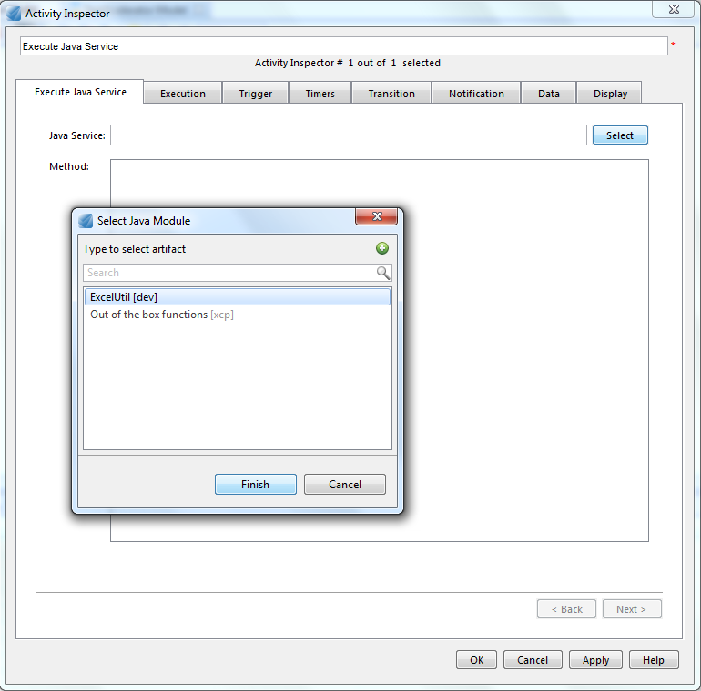
Figure 5 Select ExcelUtil module
- Select ExcelUtil and click Finish
- Make sure the module is selected and the methods appears as following:
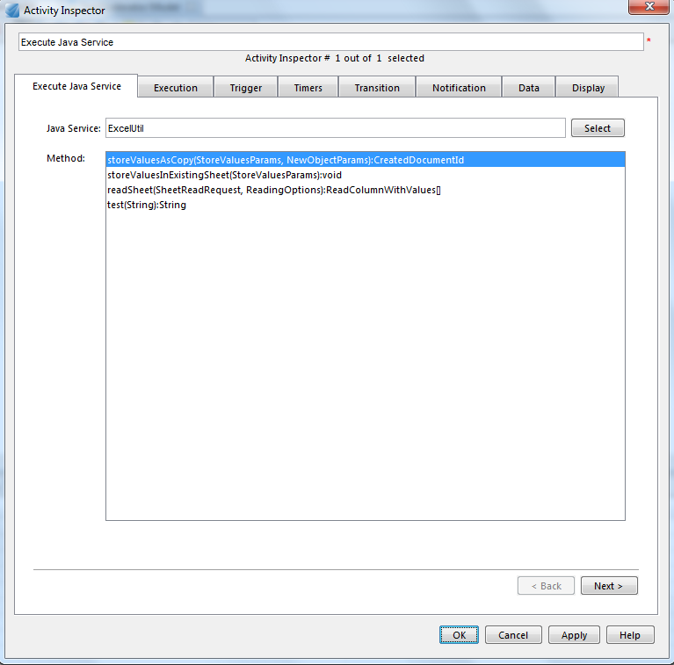
Figure 6 Configure Java Service
- Select an appropriate method (storeValuesAsCopy for creating a new repository object for the result, or storeValuesInExistingSheet for overwriting the source sheet; see following chapters for details)

Method

Reading Excel sheets
The ExcelUtil xCelerator enables xCP workflows to read values from a particular sheet in an excel
workbook.

Reading an Excel sheet is provided by the readSheet method:
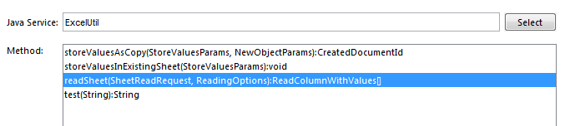
Figure 7 Method readSheet
Input parameters

Two arguments are required by the module, both are attributes of the SheetReadRequest bean:
- workbookObjectId: the r_object_id of the repository object containing the Excel sheet to be read
- sheetName: name of the worksheet. It must correspond to an existing worksheet (such as New employees on the Figure 12 Sample sheet containing data to be read

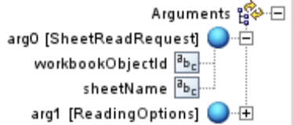
Figure 8 Inputs Read Sheet

Optional parameters can be specified in the ReadingOptions bean:
- dateFormat: specifies the format of the date fields read from the sheet
- rowsToSkip: specifies how many leading rows should be skipped when a sheet is read. Particularly useful if the first rows include columns’ titles. Setting this value to one when reading the sheet from Image 8 Sample sheet containing data to be read will cause row 1 being ignored.
- strictMode: if set to true, values that cannot be read (of type that is not supported by the xCelerator) will be ignored. The default value is true, which causes an exception being thrown in such case.

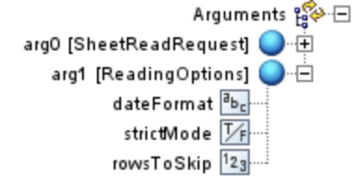
Figure 9 Optionnal attributes Read Sheet

Result retrieving

Result is delivered as an array of ReadColumnWithValues beans. Each of them represents a column read from the sheet. Result cells are available in an array called rows. Each entry in this array contains a particular cell read from the column. Two values are provided for each cell: its address (the address attribute) and the actual value (the value attribute).

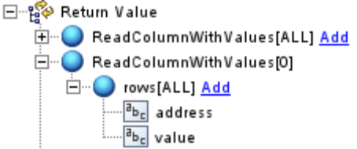
Figure 10 Result of Read Sheet

ReadColumnWithValues[0] represents column A, ReadColumnWithValues[1] represents column B and so on. Cell C2 would be accessible in ReadColumnWithValues[2]/rows[1].

Sample workflow reading Excel sheets
The sample workflow consists of 2 steps, however there is only one step related to Excel reading. The
PLACEHOLDER for further processing activity is included for demo purposes only.

Figure 11 Sample workflow using Read Sheet

The sample workflow will read values from an Excel sheet and store it in 3 repeating process variables: col1, col2, col3. In a real-world example these values would could processed – stored in an object’s attributes, written into a database, used to control the flow of the workflow and so forth.

The sample sheet is the following:

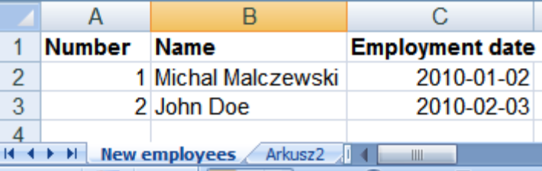
Figure 12 Sample sheet containing data to be read

Data mapping is very straightforward and involves storing values from columns A,B,C in the process variables mentioned:
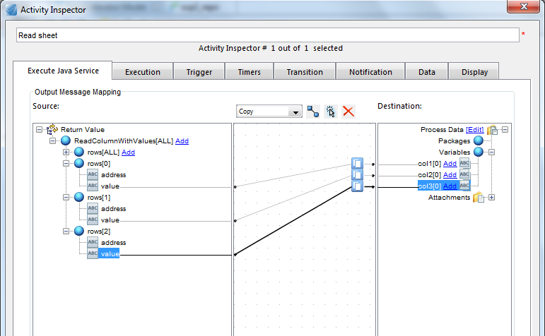
Figure 13 Mapping result readSheet

Starting the workflow show that 2 rows from 3 columns have been read:
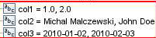

Populating sheets with values
This part of the xCelerator enables xCP workflows to manipulate Excel files’ contents. There are two result persistence options available: storing the result (i.e. sheet populated with values) as the same repository object, or creating a new one. The following arguments are common for sheet manipulations, regardless of the result persistence option selected:
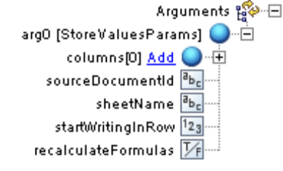
Figure 14 Basic options
- sourceDocumentId (required): r_object_id of the repository object containing Excel sheet to be filled in
- sheetName (required): name of the worksheet in the Excel workbook:
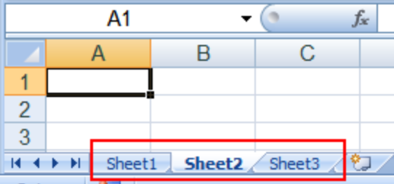
Figure 15 Sheets in a workbook
The value passed to sheetName must correspond to an existing sheet (Sheet1, Sheet2, and Sheet3 in the example), an exception is thrown in the runtime otherwise.
- startWritingInRow (optional): specifies the first row that would be filled with data (0 – based). Useful if first rows contain data that should not be overwritten (such as headers).

Figure 16 default startWritingInRow


Figure 17 startWritingInRow = 2
- recalculateFormulas (optional): if set to true, all formulas in the workbook will be recalculated after values have been set. If a sheet contains formulas based on values written by the xCelerator, this should be set to true; formulas will not be recalculated automatically by Excel and will contain obsolete values otherwise.
- columns: the actual data that is supposed to be written in the sheet:

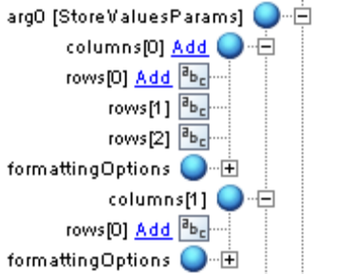
Figure 18 Columns and rows configuration

In order to fill a sheet as in example on the Image 13, the following configuration is required:

columns[0]/rows[0]=A1
columns[0]/rows[1]=A2
columns[0]/rows[2]=A3
columns[1]/rows[0]=B1
columns[1]/rows[1]=B2
columns[1]/rows[3]=B3

This can be easily achieved by mapping data from an electronic form (see the Sample workflow)
- columns[i]/formattingOptions (optional): specifies format of the cells in the column. Values are stored as text by default, but this behavior can be modified by selecting one of the formatAsXXX options:
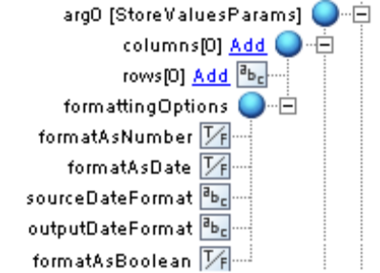
Figure 19 Formatting options
The following options can be set:
a. formatAsNumber: cell will be formatted as number
b. formatAsBoolean: cell will be formatted as a true/false value
c. formatAsDate: cell will be formatted as date. This option requires the following parameters to be provided as well:
i. sourceDateFormat: source format in which date value is passed to the rows parameter
ii. outputDateFormat: format in which date is to be stored in Excel cells in the column

Result persisting options
Depending on the module’s method selected, the result (modified Excel file) will overwrite the source object, or create a new one.
Overwriting the template object
In order to overwrite the source sheet with the result, the storeValuesInExistingSheet method needs to be selected in the Execute Java Service Configuration tab:
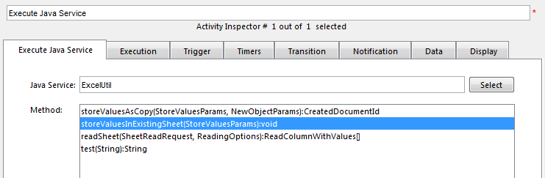
Figure 20 Configuration for overwriting the source Excel sheet
No additional configuration is required.

Creating a new object for the result

This approach should be used if the source Excel sheet is to be treated as a read-only template.
In order to use this approach, the storeValuesAsCopy method needs to be selected in the Execute Java Service Configuration tab:
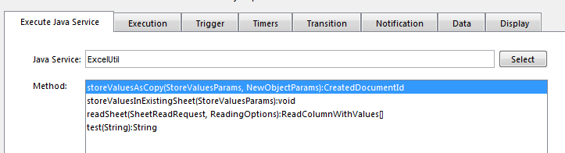
Figure 21 Configuration for creating a new object for the result

The resulting object can be mapped into a workflow package from the CreatedDocumentId result
bean:

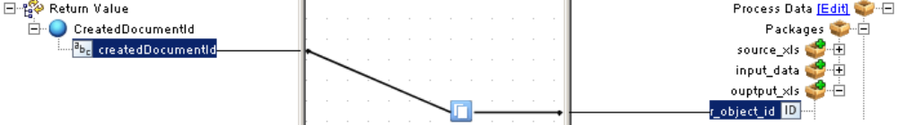
Figure 22 Mapping the resulting object

Additional configuration options in regards to the new object can be specified (all of them are optional):

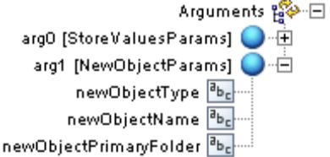
Figure 23 NewObjectParams
- newObjectType: repository type of the new object. An instance of dm_document is created by default
- newObjectName: object_name of the created object.
- newObjectPrimaryFolder: primary folder of the created object

Considerations

