xCelerator TransformXMLToDOC Installation and User Guide
Version 1.0

Preface

Purpose
This document provides step-by-step instructions on how to install and configure the xCP xCelerator TransformXMLToDOC. Basically the xcelerator generates Office word Documents from XSL templates based on given inputs.

Intended audience
Information in this guide can be found helpful for xCP developers implementing documents-centric Documentum solution. The XML Documents approach can also be significant during system’s planning phase - when required software components are evaluated. It might be the case that documents generation requirements can be met using the method described.

Support information
The xCP TransformXMLToDOC xCelerator is not supported by EMC.

Related documentation
The EMC Documentum xCelerator home page (https://community.emc.com/docs/DOC-6143) provides access to xCP xCelerators.

Revision history
Date | Version | Change
May 2011 | Initial version
Nov 2012 | Version 2.0 | Migartion to XCP 2.0

Contents
Preface 2
Purpose 2
Intended audience 2
Support information 2
Related documentation 2
Revision history 2
Contents 3
Overview 4
What is an xCelerator? 4
xCP TransformXMLToDOC xCelerator 4
Bill of Materials 4
Installing xCP TranformXMLToDoc xCelerator 6
Prerequisites 6
Install the TranformXMLToDoc xCelerator file 6
Installation troubleshooting 9
Using the TransformXMLToDoc xCelerator 10
Configuration 10
Method 13
Considerations 15

Overview

What is an xCelerator?
An xCelerator is one or more artifacts that can be used to accelerate the creation, adoption, and/or implementation of an EMC Documentum xCelerated Composition Platform (xCP) solution. An xCelerator is not necessarily a running application; instead, it is intended to hasten application development by providing key pieces of functionality out-of-the-box. Examples of this include:
- A sample business process flow created by XCP Designer
- A sample high fidelity form using XCP Designer
- A sample Business Activity Monitor (BAM) dashboard
- A sample bit of code or configuration that connects the workflow with a third-party product
- Documentation that focuses on best practices and troubleshooting when developing and implementing an xCP solution
- A sample application
xCelerators are:
- Technology focused and can be samples, examples, starting points, or guides that accelerate the creation of an xCP solution
- Free and are not EMC-supported products, yet they do go through a formal release cycle, including quality assurance and documentation
- EMC intellectual property
- Sharable with multiple partners or anyone who wants to download them from the xCP community site

xCP TransformXMLToDOC xCelerator
The TransFormXMLToDoc xCelerator generates Office XML Document from XSL templates based on some given Inputs.

Bill of Materials
The xCP TransFormXMLToDoc xCelerator is accessible through the Community xCelerator xChange home page (https://community.emc.com/docs/DOC-7597) by selecting the xCP TransFormXMLToDoc xCelerator download link.
The TransFormXMLToDoc contains:
Artifact | Path / File Name
Overview guide (this document) | Xcelerator-TransformXMLToDoc.pdf
Installation files | Package/xcp2_TransformXMLToDoc.jar
Source Code | Source Code

Installing xCP TranformXMLToDoc xCelerator

Prerequisites
In addition to Documentum Content Server 7, the following must also be installed prior to installation of this xCelerator:
- Documentum XCP Designer 2.0

Install the TranformXMLToDoc xCelerator file
Download the xcp2_TranformXMLToDoc.zip file which is accessible through the EMC Documentum xCelerator community home page by selecting the TranformXMLToDoc xCelerator link.
Unzip the xcp2_TranformXMLToDoc.zip file and locate the xcp2_TranformXMLToDoc.jar at the following path: <Install folder>/xcp2_TransformXMLToDOC xCelerator/Package/ xcp2_TranformXMLToDoc.jar
Open your application in xCP Designer and select “Model” in the “Application” tab
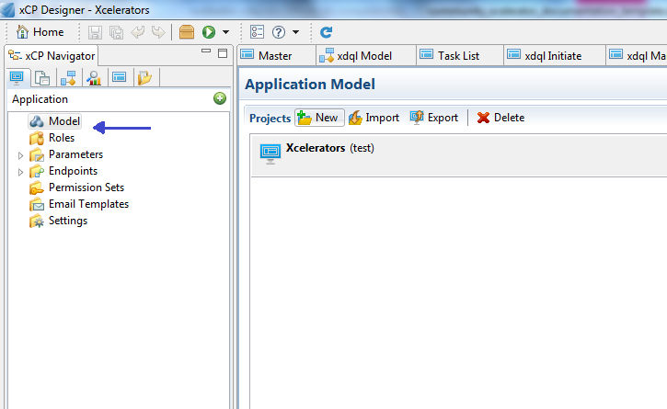
Figure 1 Model window of application

In the Libraries part, click on the “ADD” button. A pop-up will open. Click the “Browse” button and navigate to the folder <Installed folder>/xcp2_TransformXMLToDoc xCelerator/Package and select xcelerator in “Libraries to copy”. Click on the Next Button
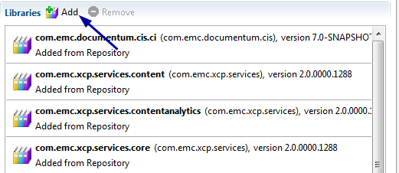
Figure 2 Add library

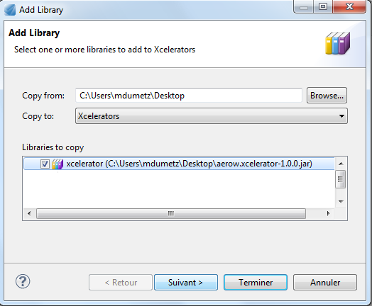
Figure 3 Choose library
Check if the same name and the Namespace are well filled and click on the “Finish” Button
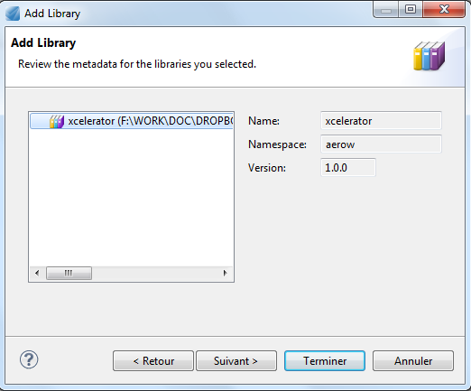
Figure 4 Confirmation adding library

Installation troubleshooting

Using the TransformXMLToDoc xCelerator

Configuration
TransformXMLToDoc xCelerator is provided as a java extension. This makes the xCelerator available in all environments straight after the jar files and the java module file had been installed, no additional steps are required.
In order to select the module proceed with the following steps:
- Drag the “Execute Java Service” activity template to your process
- In the activity inspector select Execute Java Service configuration tab
- Click on “Select” button to select Java Module

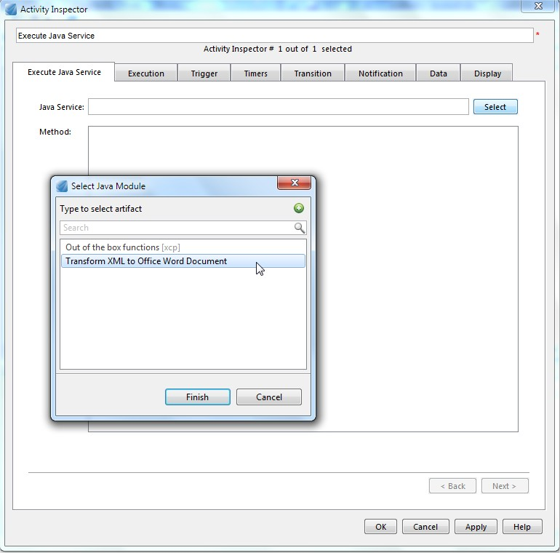
Figure 5 Select TransformXMLToDoc module

- Select TransformXMLToDoc and click Finish
- Make sure the module is selected and the methods appears as following:
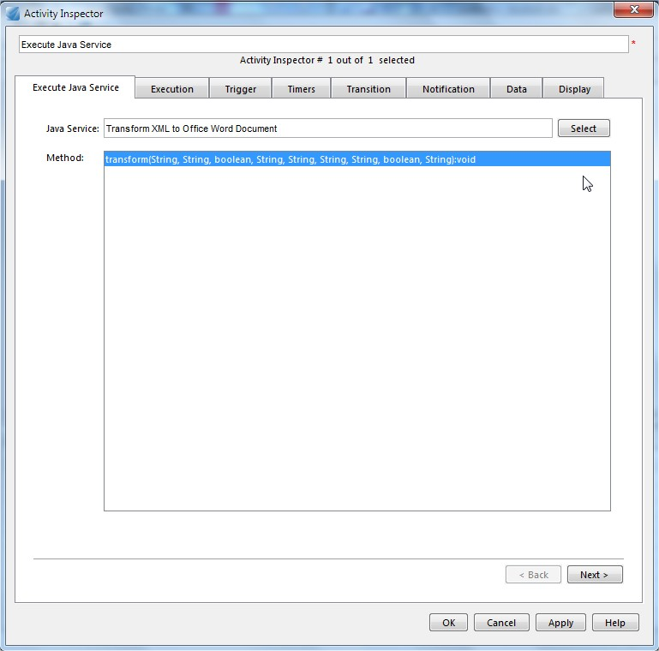
Figure 6 Configure Java Service
- Select the method transform which is used to generate the word documents based on XSL templates and click on next.

- Data mapping of the attributes.

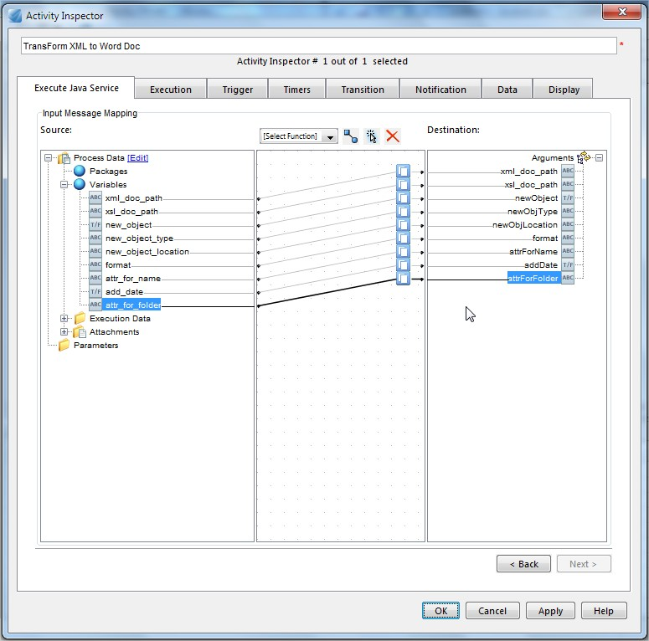
Figure 7 Mapping of the attributes

Method
Input parameters

The method transform of the module will require the following nine arguments:
- xml_doc_path : the path where the XML document is stored (e.g. : /Temp/xcp 2.0/xml/xml_doc)
- xsl_doc_path : the path where the XSL document template is stored (e.g. : /Temp/xcp 2.0/xsl/xsl_doc)
- newObject : boolean value which when true will create a new object else set teh document as rendition.
- newObjType : the type of document to be created in docbase (e.g. : dm_document)
- newObjLocation : the path where the Office Word document is stored after creation. (e.g: /Temp/xcp 2.0/word)
- format: the format of the document to be created (here it is a word document e.g. : doc)
- attrForName : the name of the document to be created.
- addDate : boolean value if true date qill be appended to the document name.
- attrForFolder : append to base folder (optional).

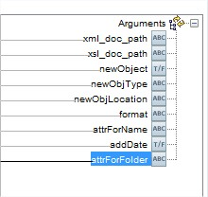
Figure 8Attributes for tramsform method

Result retrieving

No output will be displayed but the word document created can be viewed in the folder “Temp/xcp 2.0/word”.

Sample workflow Transforming XML to Office Word Document

The sample workflow consist only of an Execute Java Service activity

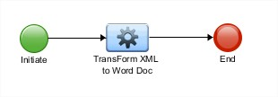
Figure 9 Sample Workflow using transform

Considerations

