xCelerator PDF_form_Reader Installation and User Guide
Version 1.0

Preface

Purpose
This document provides step-by-step instructions on how to install and configure the xCP xCelerator PDF Form Reader.

Intended audience
The information in this guide is intended for PDF Form Reader. The objective of this xCelerator is to provide Property lookup.

Support information
The xCP PDF Form Reader xCelerator is not supported by EMC.

Related documentation
The EMC Documentum xCelerator home page (https://community.emc.com/docs/DOC-9863) provides access to xCP xCelerators.

Revision history
Date | Version | Author | Change
20110216 | 1.0 | Benoit Mittau | Created
20121024 | 2.0 | J Chadet / Aerow | Migration to xcp 2.0

Contents
Preface 2
Purpose 2
Intended audience 2
Support information 2
Related documentation 2
Revision history 2
Contents 3
Overview 4
What is an xCelerator? 4
xCP PDF Form Reader xCelerator 4
Bill of Materials 5
Installing xCP PDF Form Reader xCelerator 6
Prerequisites 6
Install the PDF Form Reader xCelerator file 6
Installation troubleshooting 6
Using the PDF Form Reader xCelerator 7
How to Use PDF Form Reader in Your Process 7
Overview of the provided methods 8
Arguments 9
Property files 10
Considerations 10

Overview

What is an xCelerator?
An xCelerator is one or more artifacts that can be used to accelerate the creation, adoption, and/or implementation of an EMC Documentum xCelerated Composition Platform (xCP) solution. An xCelerator is not necessarily a running application; instead, it is intended to hasten application development by providing key pieces of functionality out-of-the-box. Examples of this include:
- A sample business process flow created by Process Builder
- A sample high fidelity form using Forms Builder
- A sample Business Activity Monitor (BAM) dashboard
- A sample bit of code or configuration that connects the workflow with a third-party product
- Documentation that focuses on best practices and troubleshooting when developing and implementing an xCP solution
- A sample application
xCelerators are:
- Technology focused and can be samples, examples, starting points, or guides that accelerate the creation of an xCP solution
- Free and are not EMC-supported products, yet they do go through a formal release cycle, including quality assurance and documentation
- EMC intellectual property
- Sharable with multiple partners or anyone who wants to download them from the xCP community site

xCP PDF Form Reader xCelerator
The "PDF Form Reader" xCelerator illustrates the benefits of xCP to easily implement a business process in organizations, thanks to reusable components.
"PDF Form Reader" is able to read and extract data from Adobe PDF Forms. These data can be used to update the metadata of the document, or as process variables (which can be freely used/controled/transformed/enriched during the rest of the process).
This xCelerator is based on a Java extension module which can be easily plugged into any process template configured with xCPDesigner. It is configurable and can be used in many different use cases. 3 samples processes are provided with this xCelerator to show how it can be configured, and how the data can be retrieved.
.

Bill of Materials
The previous version of xCP PDF Form Reader xCelerator is accessible through the Community xCelerator xChange home page (https://community.emc.com/docs/DOC-7597) by selecting the xCP PDF Form Reader xCelerator download link.
The PDF Form Reader contains:
Artifact | Path / File Name
Overview guide (this document) | xCelerator_PDF_Form_Reader.pdf
Installation files | Package/xcp2_PDFFormReader.jar
Source code | Source code

Installing xCP PDF Form Reader xCelerator

Prerequisites
XCP Designer 2.0 must be installed

Install the PDF Form Reader xCelerator file
Download the xcp2_PDFFormReader_xcelerator.zip file which is accessible through the EMC Documentum xCelerator community home page (https://community.emc.com/docs/DOC-10586) by selecting the PDF Form Reader xCelerator link.
Unzip the xcp2_PDF Form Reader_xcelerator.zip file and locate the xcp2_PDF Form Reader.jar at following path : <Install folder>/ xcp2_PDFFormReader_xcelerator.zip /Package/xcp2_PDFFormReader.jar
Open your application in xCPDesigner and select “Model” in the “Application” tab:
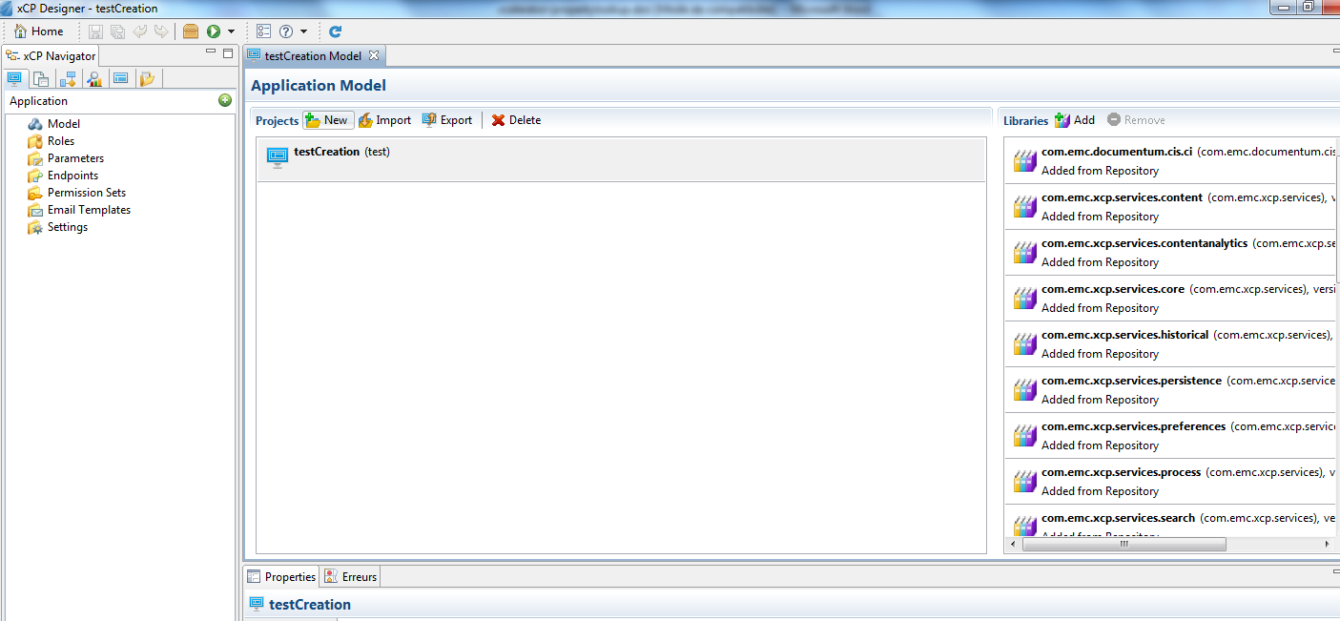

In the Libraries part, click on the button “Add”. A pop-up will open. Click on the “Browse” button and navigate to the folder <Install folder>/xcp2_PDFFormReader_xcelerator/Package and select PDF Form Reader in “Libraries to copy”. Click on Next button.

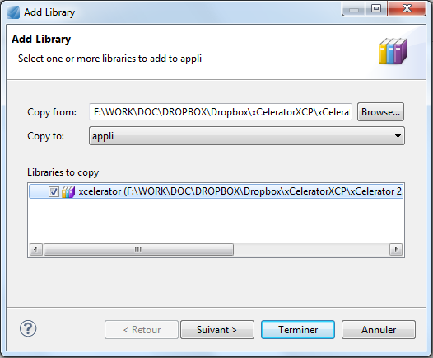

Check if the name and the namespace are well filled and click on Finish button.
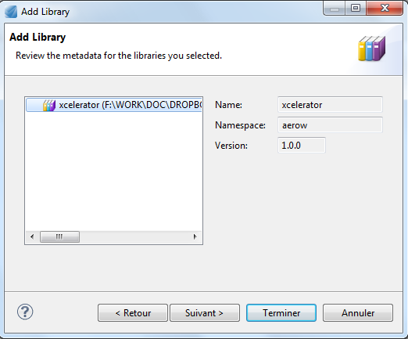

Using the PDF Form Reader xCelerator

How to Use PDF Form Reader in Your Process
Using the PDF Form Reader methods in your process is an easy 4 step process.
Add an Execute Java Service Activity Template to your process. In the Execute Java Service Configuration tab, choose the PDF Form Reader as the Java Module.
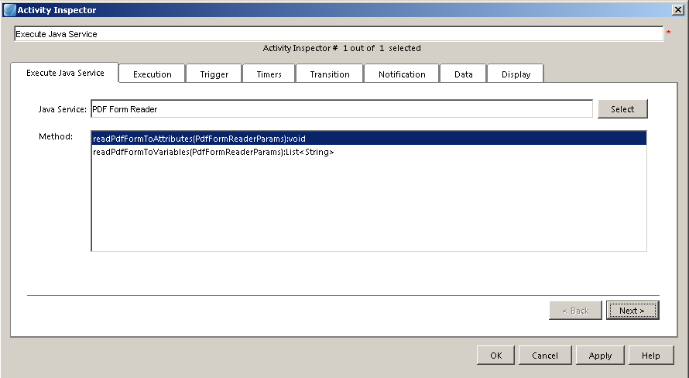

Choose which method you want to invoke (refer to the next chapter for an overview of what methods exists and what argument they take).
Map your process data into the functions.
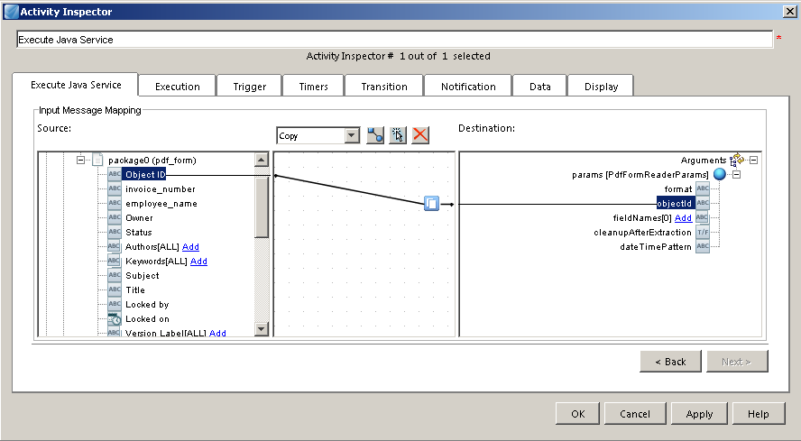

Map the result into your Process data if needed.
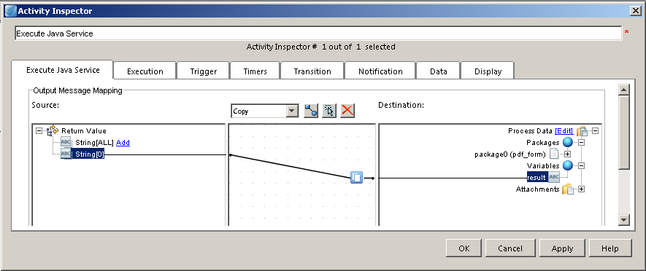

Overview of the provided methods
There are two methods that can be used by the PDF Form Reader xCelerator.
Read Pdf Form To Attributes
void readPdfFormToAttributes( PdfFormReaderParams params )

Reads the PDF Form and update the metadata of the document (for each field name matching with an attribute name).
Read Pdf Form To Variables
List<String> readPdfFormToVariables( PdfFormReaderParams params )
Reads the PDF Form and returns the extracted data (fields names and fields values) from the form and update a process variable or the metadata of the document.

Arguments
Below is a description of the arguments.
PdfFormReaderParams params
Input: PdfFormReader Params
Parameter name | Data type | Mandatory/ | Description
Parameter name | Data type | Optional | Description
format | String | Optional | Format of the rendition (or primary content) corresponding to the PDF form. It must be a valid dm_format (usually: 'pdf').
format | String | Optional | If this parameter is not provided, the module considers that the PDF Form to read is the primary content of the document.
objectId | String | Mandatory | Object ID of the document handling the PDF form. It is usually mapped with the "r_object_id" of a process package.
fieldNames | String[] | Optional | List of fields to be extracted from the PDF Form. The fields are identified by their name. If this parameter is not provided, the module reads the entire form and then update the document metadata.
fieldNames | String[] | Optional | The ordering of the list is not important.
cleanupAfterExtraction | Boolean | Optional | Enable/Disable the deletion of the PDF form file (from the temporary folder on the Content Server) after the processing. Default value is "True".
dateTimePattern | String | Optional | Pattern used to read date & time field in the PDF Form. Default value is "dd/mm/yyyy hh:mi:ss".

Output: List<String>
Parameter name | Data type | Mandatory/ | Description
Parameter name | Data type | Optional | Description
fieldValues |  |  | Values are not formatted and are provided as they have been read in the PDF Form. For instance, the date&time pattern depends on the format which has been configured in the PDF Form at design time.
fieldValues |  |  | When a list of fields has defined in calling parameters ("PdfFormReaderParams.fieldNames"), the returned list has the same number of items, in the same order (except fileds which are not found in the form). If not, the ordering of this list depends on the fields order in the PDF form.

